
Guild of Healthcare Pharmacists
Unite the Union
128 Theobalds Road
Holborn
WC1X 8TN

5th February 2024

To whom it may concern,
This is a letter in full support of Declan O’Sullivan for consideration for joining the board of the European Association of Hospital Pharmacists (EAHP).
Declan leads the pharmacy department at the Cherry Orchard Hospital and currently represents Ireland at the EAHP General Assembly.
He is an ambassador for pharmacy in the role he occupies and cares deeply about developing the workforce and the profession as a whole. Declan leads as a role model to others. He exhibits sincere dedication and commitment at a national level and therefore there is no doubt that he would also be a great asset to the board of EAHP.
Yours faithfully,
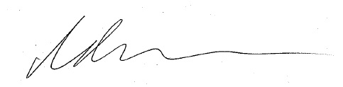
Nathan Burley
President of the Guild of Healthcare Pharmacists

