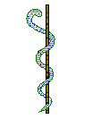
European Union Of General Practitioners / Family Physicians
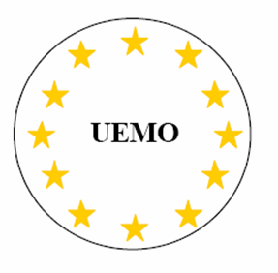
Union Européenne des Médecins Omnipraticiens / Medecins de Famille

President: Dr Aldo Lupo (Italy)
Vice-President: Dr Daniel Widmer (Switzerland)
Vice-President: Dr Kjartan Olafsson (Norway)
Vice-President: Dr Mary McCarthy
Vice-President: Dr Calin Bumbulut (Romania)
Secretary General: Dr Giuseppe Enrico Rivolta (Italy)
Treasurer: Dr Giuseppe Augello (Italy)

Brussels 08/03/2017
The European Union of General Practitioners/Family Physicians (UEMO) would like to present Dr Daniel Widmer as permanent representative of the Health Provider Group of the Stakeholder pool to HTA network.
The European Union of General Practitioners (UEMO) is an organisation of the most representative national, non-governmental, independent organisations representing general practitioners/family physicians in the countries of Europe and defends the role of general practitioners/family physicians in the healthcare system. Roughly 420 000 doctors in Europe are represented by UEMO.
The UEMO members are engaged in the EU health policy developments. They can offer their expertise on the ground regarding the sustainability of health technologies. UEMO is participating in the stakeholder group on e-health and has a close relation with EMA. General practitioners have an important role to coordinate health care interventions centred on the patient and use to work in collaboration with different medical professions.
UEMO presents the candidature of Dr Daniel Widmer, UEMO vice-president. Dr Widmer is active in various EU policy forums. He participated to the ENS4care project initiated by EFN. He is working on a new development of the institute of family medicine, in Lausanne (Prof. N. Senn) with a research interest on new technologies in family medicine. He has significant academic work and publications in medical journals and was responsible for the development of qualitative research in general medicine.
To carry this role of coordination, UEMO will make sure that the flow of information to the Health Providers pool and from the different members will be continuous and smooth. UEMO will also ensure the transmission of all points of view with the support of its Secretariat and office based in Brussels.

