From: "Doesburg, F (icv)" <f.doesburg@umcg.nl>
Date: Monday, May 4, 2020 at 11:38
To: Petr Horak <Petr.Horak@eahp.eu>
Cc: Jennie De Greef <Jennie.DeGreef@eahp.eu>, Daan Touw <daantouw@xs4all.nl>, neef0195 <c_neef@planet.nl>
Subject: Re: request for help

Dear Petr,

In the meantime I have become the proud father of a healthy little girl. You were very right about the long nights!

As promised, I have drafted a questionnaire that can be shared with the EAHP members. If you have any additions, feel free to comment.
The questionnaire can be viewed here: https://forms.gle/QYnrQaSqAGW9UQnR8

Thank you again for your help in this project.

Kind regards,
Frank
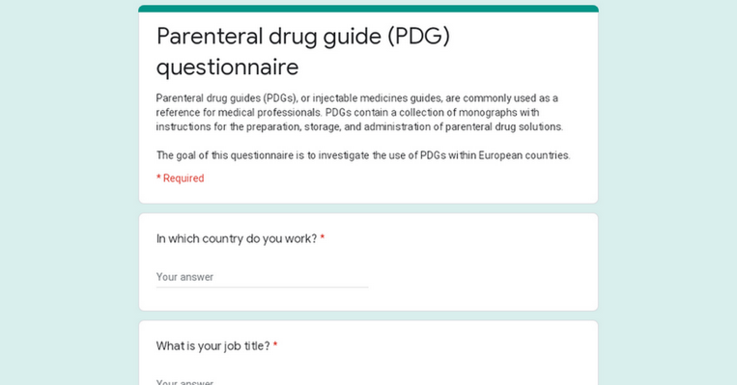 | Parenteral drug guide (PDG) questionnaire  forms.gle  Parenteral drug guides (PDGs), or injectable medicines guides, are commonly used as a reference for medical professionals. PDGs contain a collection of monographs with instructions for the preparation, storage, and administration of parenteral drug solutions. The goal of this questionnaire is to investigate the use of PDGs within European countries.

Van: Petr Horak <Petr.Horak@eahp.eu>
Verzonden: woensdag 15 april 2020 16:17
Aan: Doesburg, F (icv)
CC: Jennie De Greef; Daan Touw; neef0195
Onderwerp: Re: request for help

Dear Frank,

congratulations, I hope you are already enjoying a bigger family! Being father of two, let me guess that the nights now seem longer while the sleep is definitely shorter :-)

Of course, we will wait for the draft questionnaire, please provide it at your convenience.

Kind regards,

Petr

———
Petr Horák
President
European Association of Hospital Pharmacists (EAHP)
Boulevard Brand Whitlock 87 Box 11 (4th floor)
1200 Brussels
petr.horak@eahp.eu

10. 4. 2020 v 13:53, Doesburg, F (icv) <f.doesburg@umcg.nl>:
Dear dr. Horák,

First of all, thank you kindly for your help. I fully understand that you cannot share email addresses of EAHP members, and a questionnaire form is an excellent alternative. I will create a questionnaire that can be shared by the EAHP secretariat.

Please be aware that my wife can give birth to our first child at any moment now, in that case it will take a little longer before I can supply the questionnaire.

I wish you a happy Easter in good health.

Kind regards,

Frank Doesburg

Van: Petr Horak [mailto:Petr.Horak@eahp.eu]
Verzonden: donderdag 9 april 2020 17:41
Aan: neef0195
CC: Jennie De Greef; Doesburg, F (icv); Daan Touw
Onderwerp: Re: request for help

Dear Kees, dear dr. Doesburg,

apologies that the response took me a while - as you can imagine, the workload has been immense lately.
To your request - I am finding the activity very interesting and useful. Kees might remember that I often advocate for sharing best practices, so the patients can benefit from them while the precious capacity of hospital pharmacists can be spared for something else.
However, our policy (to a significant extent enforced by GDPR) is that we cannot share the contact information of our members directly. Given the valuable concept, I suggest something else, though. Would it be possible to draft an online questionnaire that would cover the need for information collection for the work; and EAHP secretariat would then disseminate the questionnaire to the relevant members?
Also, I understand that the results would be used for the thesis, but I will appreciate if the relevant results/publication is shared with EAHP and the members in an appropriate way.

Would this solution fit for the requested?
I wish you all Happy Easter!

Kind regards,

Petr

— — — —

Petr Horák, PharmDr.

President
European Association of Hospital Pharmacists (EAHP)
Boulevard Brand Whitlock 87 Box 11 (4th floor)
1200 Brussels
Belgium
petr.horak@eahp.eu
http://www.EAHP.eu

–––––––––––––––––––––––––––––––––––––––––

Chief Pharmacist
University Hospital Motol
V Úvalu 84
150 06 Praha 5
Czech Republic
petr.horak@fnmotol.cz
horak@hospitalpharmacy.cz

6. 4. 2020 v 14:08, neef0195 <c_neef@planet.nl>:

Sorry, here is the attachment
Kind regards
Kees

C.Neef
Dorpstraat 16
6265AL Sint Geertruid
Email: c_neef@planet.nl
Tel 06-53310398

Van: Petr Horak [mailto:Petr.Horak@eahp.eu]
Verzonden: maandag 6 april 2020 10:22
Aan: neef0195 <c_neef@planet.nl>
CC: president@eahp.eu; Jennie De Greef <Jennie.DeGreef@eahp.eu>; Doesburg, F (icv) <f.doesburg@umcg.nl>
Onderwerp: Re: request for help

Dear Kees,

it is so nice to hear form you. I hope both Ingrid and you are well and safe!

To your request - I haven’t found the attached letter, would you mind to forward it once again, please?

Kind regards,

Petr

— — — —

Petr Horák, PharmDr.

President
European Association of Hospital Pharmacists (EAHP)
Boulevard Brand Whitlock 87 Box 11 (4th floor)
1200 Brussels
Belgium
petr.horak@eahp.eu
http://www.EAHP.eu

–––––––––––––––––––––––––––––––––––––––––

Chief Pharmacist
University Hospital Motol
V Úvalu 84
150 06 Praha 5
Czech Republic
petr.horak@fnmotol.cz
horak@hospitalpharmacy.cz

4. 4. 2020 v 21:58, neef0195 <c_neef@planet.nl>:

Dear Petr,

How are you doing to day? No congress and a lot of trouble in healthcare in our countries….

Petr, I send ypu a letter from a hospital resident, PhD student, working in Groningen who approached me with the question
If I was able to contact him with hospital pharmacists in Europe who are responsible or who are involved in quality controll
of parenteral drugs. We – in the Netehrlands – have made a book/collection of monographs of parenteral administrede drugs. Each monograph
describes de use and preparation of tht particular drug. This PhD student studies the ins and outs of this book in terms of quality assurance.
One of the chapters (or maybe more) will be a comparison of similar monographs being used in other countries in Europe.
He needs therefor contact with collaegues in other EU countries who can inform him about the situation in their country.

My question now is if EAHP can help him by asking the countries representatives or the delegates if the GA whom in their country can be approached with this research question.
I know that we had the policy not to spread email adresses of delegates among third parties. But , maybe, EAHP can participate in this project, or adopt it on behalf of the EDQM activities. Than it is much easier to accept it as a project.

Please let me know what your opinion is about this request

Kind regards
Kees

C.Neef
Dorpstraat 16
6265AL Sint Geertruid
Email: c_neef@planet.nl
Tel 06-53310398

 | Deze e-mail is door AVG-antivirussoftware gecontroleerd op virussen.  www.avg.com

<Request regarding study on parenteral drug guides.docx>

De inhoud van dit bericht is vertrouwelijk en alleen bestemd voor de geadresseerde(n). Anderen dan de geadresseerde(n) mogen geen gebruik maken van dit bericht, het niet openbaar maken of op enige wijze verspreiden of vermenigvuldigen. Het UMCG kan niet aansprakelijk gesteld worden voor een incomplete aankomst of vertraging van dit verzonden bericht.
The contents of this message are confidential and only intended for the eyes of the addressee(s). Others than the addressee(s) are not allowed to use this message, to make it public or to distribute or multiply this message in any way. The UMCG cannot be held responsible for incomplete reception or delay of this transferred message.

De inhoud van dit bericht is vertrouwelijk en alleen bestemd voor de geadresseerde(n). Anderen dan de geadresseerde(n) mogen geen gebruik maken van dit bericht, het niet openbaar maken of op enige wijze verspreiden of vermenigvuldigen. Het UMCG kan niet aansprakelijk gesteld worden voor een incomplete aankomst of vertraging van dit verzonden bericht.
The contents of this message are confidential and only intended for the eyes of the addressee(s). Others than the addressee(s) are not allowed to use this message, to make it public or to distribute or multiply this message in any way. The UMCG cannot be held responsible for incomplete reception or delay of this transferred message.

