Standard Operating Procedure – EAHP AISBL

Subject: Scientific Committee

- Scope and goals

Educational Mission

The European Association of Hospital Pharmacists is committed to providing educational innovation and training of hospital pharmacists to a level of specialisation and maintain continuing professional development (CPD). EAHP will facilitate and enhance the professional growth of European hospital pharmacists and develop hospital pharmacy in order to promote the best and safest use of medicines and medical devices for the benefit of patients in Europe.

Educational Goals

- To identify the educational needs of EAHP members and prepare educational programmes to meet those needs
- To provide knowledge and application based educational programmes to assist pharmacists who practice in hospitals meet their patient care responsibilities and expand their professional roles and goals.
- To share best practice, innovation and educational programmes that can be applied to daily practice
- To promote hospital pharmacy practice research

*EAHP defines Continuing Pharmacy Education (CPE) as per the ACPE definition which states that "Continuing education for the profession of pharmacy is a structured educational activity designed or intended to support the continuing development of pharmacists and/or pharmacy technicians to maintain and enhance their competence. Continuing pharmacy education (CPE) should promote problem-solving and critical thinking and be applicable to the practice of pharmacy. "

- Abbreviations

  - European Association of Hospital Pharmacists: EAHP
  - Scientific Committee: SC
  - Director of Education, Science & Research: DESR
  - Chief Operating Officer: COO
  - Project Assistant: PA
  - Learning objectives: LOs
  - Association without lucrative purpose: AISBL

- Responsible person(s)/owner(s) of the project
  - Owner of the project: SC
  - Execution: COO, PA
  - Supervision: DESR

- Membership

- The Chairman of the Scientific Committee
- The Chief Operating Officer (COO)
- SC Committee members will vote to add new SC members provided budgeting allows it

- Scientific Committee Chair

The Chairman of the Scientific Committee is decided by the current SC committee members. It is preferable but not mandatory that the SC Chair also be the Director of Education, Science and Research (DESR) who is elected by the EAHP Board of Directors. Once the incoming SC Chair has been elected by the committee, the former DESR continues and is the Scientific Chairman until the next congress, whereas the new DESR joins the SC as vice-chairman of the SC and begins the transition to Chairman. The transition should begin 2 (two) years prior the last congress of the current Chair.

The responsibilities of the SC Chair are:

- To chair all meetings of the Scientific Committee
- To co-ordinate all aspects of planning for the scientific and professional aspects of educational events to ensure success.
- The Scientific Committee Chairperson reports to the Congress Organising Committee via the COO and/or SC Chair in the fulfilment in the above duties.

- Election of Scientific Committee Chair

  - The SC Chairman will notify the committee when his/her term is coming to an end at least 2 years prior. He will put out a call for interest to the current committee members.

  - Interested committee members will notify the Chair and meet the below criteria.

Criteria must include:

  - senior hospital pharmacist
  - proven leadership skills
  - a proven scientific curriculum/background, preferably a PhD
  - may not have a conflict of interest such as serving on another scientific committee, etc.

  - Candidates must present CV including:

- area of interest
- practical experience / network
- knowledge of English
- ability to speak in public in English
- academic degree
- published work including several international publications
- knowledge about EAHP
- motivation letter
- should be a senior hospital pharmacist

  - The SC will first review the candidate CVs considering the criteria. Provided that the criteria have been met, the potential candidate(s) will be invited to give a presentation at the next SC meeting at which time, the SC may vote on the new SC Chair.

  - Votes will be done via secret ballot.

Recommendation of candidates’ national organization is not necessary to avoid political decisions and to remain independent and scientific as a SC.

- Committee Member responsibilities

The Scientific Committee will:

- Report to the congress Organising Committee and/or Board via the Scientific Committee Chairman or COO;
- Define the scientific and professional programme for each educational event subject to the agreement of the congress Organising Committee and/or Board;
- Be responsible for keynote presentations.
- Control the selection of contributions and topics presented whether as posters, verbal presentations or workshops;
- Be responsible for allowing a maximum of two speakers per congress session and 6 speakers for all other educational events in accordance with the congress budget (Should a third speaker be requested, the SC will decide during an SC meeting.)
- Allow a maximum of 4 speakers for congress Synergy programmes
- Liaise with speakers to give presentations; recruit suitable persons as moderators and invited speakers within the scientific program;
- Define and ensure adherence to regulations in relation to the submission of material for presentation at the Congress including selection and grouping of abstracts submitted for oral and poster presentations;
- Review guidelines for chairpersons, oral presenters, seminar leaders in accordance with ACPE standards
- Present and facilitate sessions at the
- Promote all educational events and support EAHP in ensuring as far as is reasonably practical its financial, educational, social and organisational success.
- Be responsible for fulfilling the standards as provider of ACPE CE-credits or other accrediting organisation to which EAHP reports
- Be responsible for providing the abstracts and Learning Objectives (LOs) for all educational events in time to create the Program Description Form of ACPE not later than 6 months before the start of the educational event
- Be responsible for disclosure of conflict of interest according to the ACPE standards by all speakers and committee members
- Represent the views of European countries not represented by the members on the Scientific Committee as much as possible
- Fulfil other requests from the EAHP Board of Directors as much as possible

- Committee communication and meetings

Meeting attendance:

The Scientific Committee will meet five times per year including once during the annual congress if needed. Further meetings will be held if necessary for specific events. A staff member from the EAHP office will take the meeting minutes. Except in case of emergencies, all committee members must attend the meetings except in the case of unavoidable circumstances

Communication:

SC members will promptly communicate with the EAHP Staff and fulfil responsibilities within the agreed time frame.

- Election of new committee members

  - New candidates must be assessed by the SC in two sequential meetings. The SC will first review the candidate CVs considering the below criteria. Provided that the criteria have been met, the potential candidate(s) will be invited to attend the next SC meeting at which time, the SC may vote to appoint the new SC member.

Criteria must include:
  - geographic diversity
  - domains/interest areas needed by the SC
  - a proven scientific curriculum/background, preferably a PhD

  - New candidates must apply via the EAHP website (If a current SC member wishes to recommend a candidate, they are to direct them to the EAHP website.

  - Candidates must present CV including:
- area of interest (is it relevant for the SC?)
- practical experience / network
- knowledge of English
- ability to speak in public in English
- academic degree
- published work including at least one international publication
- knowledge about EAHP
- motivation letter
- should be a hospital pharmacist

Recommendation of candidates’ national organization is not necessary to avoid political decisions and to remain independent and scientific as a SC.

- Terms

Committee members are elected for an indefinite period based on the fact that committee members tend to leave voluntarily due to other professional ambitions or retirement.

Should a committee member announce his/her resignation, point 9 will be initiated.

- Expenses

- Members of the Scientific Committee are entitled to have the expenses incurred reimbursed while attending EAHP educational events. Allowable expenses are outlined in the EAHP Standing Financial Instructions (Reimbursement of costs table) on the EAHP web site at http://www.eahp.eu/events/ga/eahp-standing-financial-instructions-sfis :
- Miscellaneous expenses as approved by the Director of Finances and/or COO
- In addition, Scientific Committee members receive travel, hotel accommodation and free registration to the educational events and related social programme if applicable.
- An expense claim form must be used to claim reimbursement. Original expense receipts must be supplied as well as IBAN and SWIFT numbers.
- Expense claim forms must be submitted within 3 months following the event or expenses will not be reimbursed.

- Other

Should questions or other issues arise not covered by this SOP, the SC will discuss and make decisions as a group.

- Deliverables

Time frame:
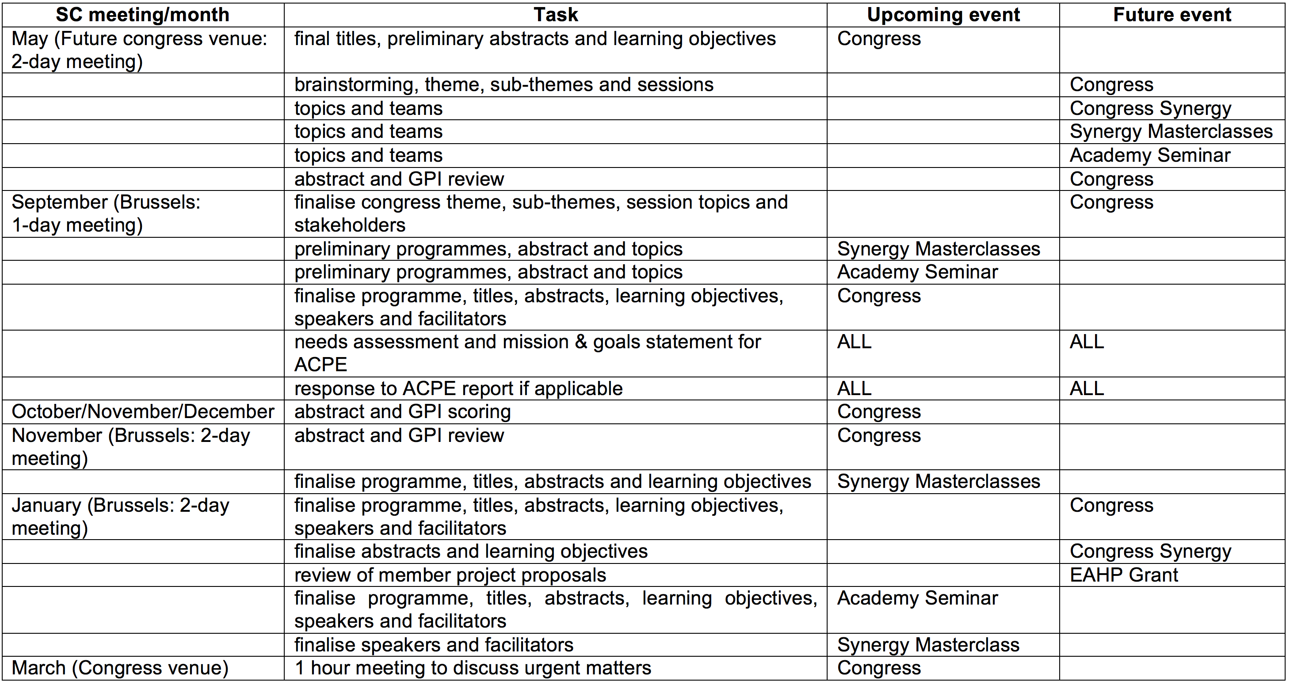

 | Date | Name | Signature
Developed | 8 July 2017 | Jennie De Greef, COO
Audited
Approved

- Revisions

Dates | Point | Reasons/

