Position paper on primary package identification

This position paper provides good practice recommendations which enable enhanced medication administration processes in care settings such as in hospitals, nursing homes, or at patient’s home for chronic diseases.
It is adopted by stakeholder organisations which recognise how important it is to support efforts for enhanced safety in the medication process by adopting a joint and shared vision to make this a reality.

Multiple dose blister | Package which fully encloses the drug. Each dosage form is individually packaged. The individually blistered identical dosage forms are attached to each other to one strip. The labelling is imprinted on the complete strip but not on the individual blistered dosage forms | EAHP  (in scope)
Single dose blister package | Drug blister package for a single dose. A number of single doses might be attached to each other, but are easy to separate through a perforation. Each single-dose is individually and fully labelled | EAHP  (scope?)

Positioning the problem
Medication errors are recognised as an important failure point in care processes. Studies have been conducted to measure such errors and their impact on patients, as well as to measure the benefits of processes that are supported by electronic means (e.g. prescription, dispensation, administration). It is recognised that medication administration at the point of care is significantly more accurate if it is supported by scanning a medicinal product’s bar code, matching this with the patient’s identification, the physician’s computerised order entry and other process factors such as time and route of administration.
Identification of primary packages such as vials, pre-filled syringes or solid forms in blister cavity is an important prerequisite for successful point of care verification and registration in electronic health records.
Several stakeholders or regulators already require manufacturers to identify primary packages with bar codes. Hospital implementation can be observed in various places, but their number is limited since a critical mass of source bar coded primary packages has not been reached in many regions.
As healthcare providers see this critical importance, many hospitals today are re-labelling all medications to enable scanning at the point of care. This is a time and cost intensive process which ideally should not take place at the hospital, but at the source of manufacture, where the right equipment, control and expertise exists.

Purpose of this position paper
By supporting this position paper, the supporting organisations noted wish to stress the importance of enabling safer processes at the point of care. This can be done with appropriate identification of primary packages, this avoiding errors due to “sound-alike” or “look-alike” medicinal product packages.

These organisations recognise the importance of focusing on the same vision, identification and labelling of primary packages in such a way that scanning at the point of care is enabled. This labelling effort should be undertaken without delay when existing packages provide sufficient space; if packaging modifications would be necessary, labelling with bar code should be considered each time packaging redesign is required.

Each organisation additionally recognises that Healthcare Providers should strongly consider investment in IT system development which supports prescription-dispensation-administration processes. This investment will enable efficient process deployment progressively when labelled primary packaging becomes increasingly available.

Primary packaging: some examples

Following are some examples of primary packaging. Each is identified with its own GTIN, and optionally with variable information such as lot/batch and expiry date.

Single vials, or combinations of vials and their diluent, identified each with its own GTIN


Ampoules, identified with their GTIN, provided label size and mandatory texts allows.

Pouches, with medicinal product

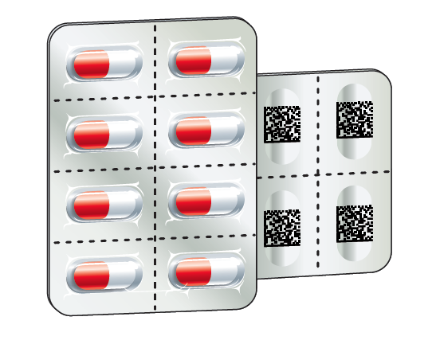
Medicinal Product in solid form, each blister cavity having the same GTIN, identifying the solid form included in that cavity

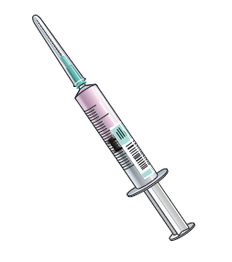
Prefilled syringe: combined product – medical device including medicinal product.

What does product identification look like?
The most appropriate symbology type to carry information on primary packages where available space is generally limited is a “two dimensional” or “matrix” symbology.. In these implementation examples, this position paper supports the used of GS1 DataMatrix as noted. The symbol example and human readable interpretation have been enlarged to facilitate readability; the GS1 General Specifications provide guidance on the recommended sizes for the symbols:

- Product identification only, when technical or space constrains do not allow including additional information in the bar code.

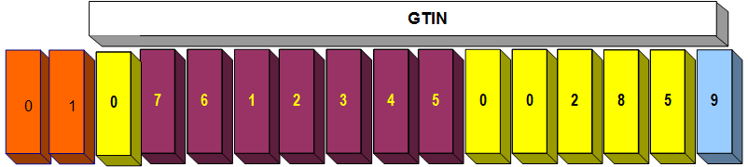
​​

- Product information with additional information in the bar code (expiry date only)

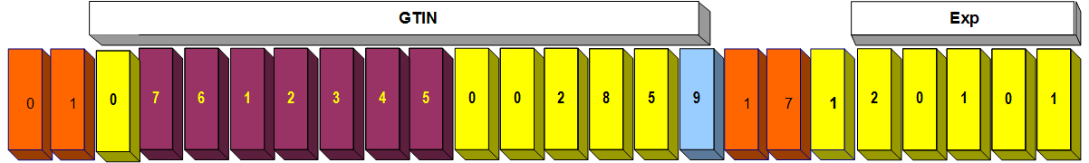
​​

- Product information with additional information in the bar code (expiry date and lot/batch)

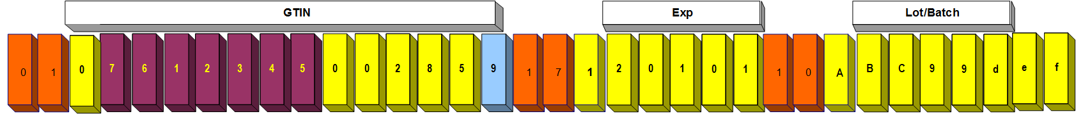

The orange digits correspond to “application identifiers”, which define the semantics or format of the data element that follows. They are shown with parenthesis in the human readable interpretation; these parentheses are not encoded within the bar code.

- Human readable information
The human readable interpretation shown follows the GS1 General Specifications and regulatory requirements. If these permit, the following example can help implementers:


​​
GTIN(01) 07612345002859
Expiry: Jan. 2012
Batch/Lot (10)ABC99def

Priorities and timelines
The organisations supporting this position paper do not envisage any formal timelines for implementation of the concepts within this position paper. The priorities that should guide implementation by manufacturers are as follows:

First priority is to support care processes with appropriate human readable information on the packaging, considering particularly readability and solutions to avoid product confusion (e.g. tall man letters).

Second priority is to extend primary package label information by adding item identification with a GS1 GTIN, as appropriate in a GS1 DataMatrix data carrier (bar code). This stable, static information is the simplest to implement and already supports care processes (e.g. avoiding dosage confusion).

Third priority is to provide product identification (GS1 GTIN) and variable information (batch/lot, expiry date) on every primary package. This has priority for high-alert medicinal products (or regulated products such as blood derivative).

Healthcare Providers will consider their priorities by taking the above into consideration, and engage similar identification and labelling processes for their internal productions (e.g. compounding).

Call to action
Stakeholders in the Healthcare market are invited to consider this position paper when planning their forward looking strategies and investments. In the future, market requirements will become even stronger, so high expectations exist that demands and offers will come together on this topic, as patient safety in the medication administration process is recognised a high priority.

Definitions

Term | Definition | Source
Application Identifier (AI) | GS1 AIs identify generic and simple data fields for use in cross-sectorial and international supply chain applications. The GS1 General Specifications provide rules for the definition, format and structure of the data fields. | ISO 15418, § 4.1
GTIN | A Global Trade Item Number (GTIN) is used to identify any item (trade item or service) upon which there is a need to retrieve pre-defined information and that may be priced or ordered or invoiced at any point in any supply chain. | GS1 General Specification, v16 § 4.3.1.1
Medicinal Product | any substance or combination of substances that may be administered to human beings for treating or preventing disease, with the view to making a medical diagnosis or to restore, correct or modify physiological functions | EN ISO 11615, § 3.1.49
Multiple dose blister | Package which fully encloses the drug. Each dosage form is individually packaged. The individually blistered identical dosage forms are attached to each other to one strip. The labelling is imprinted on the complete strip but not on the individual blistered dosage forms | EAHP  (in scope)
Secondary package | A level of packaging marked with an AIDC carrier that may contain one or more primary packages or a group of primary packages containing a single item. | GS1 General Specification, v16 (out of scope)
Single dose blister package | Drug blister package for a single dose. A number of single doses might be attached to each other, but are easy to separate through a perforation. Each single-dose is individually and fully labelled | EAHP  (scope?)
Single unit package / blister | A healthcare primary package that contains one discrete pharmaceutical dosage form, i.e. a tablet, a certain volume of a liquid or that is the immediate package for a medical device like a syringe. A number of single units may be attached to each other, but are easy to separate through a perforation.  Synonyms:  immediate container ; immediate packaging : immediate packaging in which a manufactured item or pharmaceutical product is contained and with which it is in direct contact (EN ISO 11615, § 3.1.23) | GS1 General Specification, v16 (in scope)
Unit dose package | A unit dose package contains the particular dose of the drug for a specific patient according to the patient-specific prescription. Unit-dose packages are dispensed for one or several days by a centralized supply service unit and are labelled specifically for a patient | EAHP  (out of scope)

E.g. Amgros, in Denmark
E.g. US FDA
E.g. Belgium, Netherlands, Portugal, Brazil, USA, Spain, Switzerland, Argentina, Singapore
See List of High-Alert Medications of the Institute for Safe Medication Practices (ISMP): http://www.ismp.org/Tools/highalertmedications.pdf

