

EAHP
CTF - Cluster 3. Management competencies

Delphi Round 1

Synmind BV / FB
Haarlem, 21 March 2017

Group 1: Procurement – and management of medicines and medical devices 3
Group 2: Hospital and medication safety management 21
Group 3: Collaborative work 92
Group 4: Clinical Governance 105
Group 5 Staff management 121:
Group 6: Development and research 143
Group: 1 Procurement – and management of medicines and medical devices (Group 13 of 26)
1.1 Sourcing - Knows where medicines and medical devices can be sourced from or is able to suggest suitable alternatives.
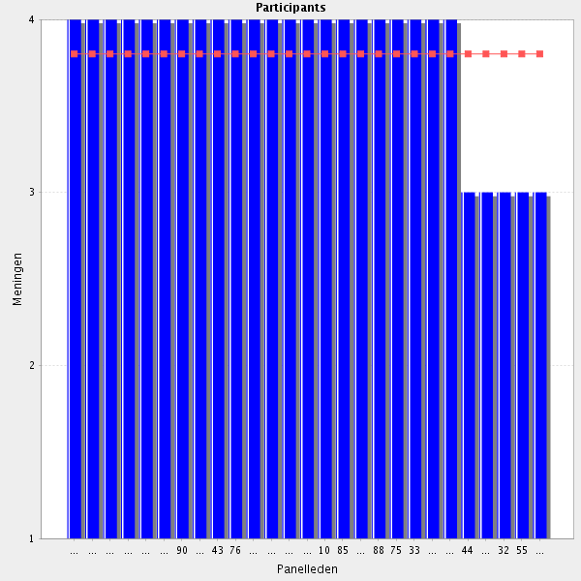
Average score: 3.8
Summary: good agreement. Minor rewording only.
Proposal: Amend to:-
Knows where medicines and medical devices can be sourced from, and is able to suggest suitable alternatives when required.
Comments:
The hospital pharmacist is THE expert in this.
Necessary part of the role
medical devices is not in all countries the responsibility of hospitalmpharmacy. They of course participate in the committee who decides on the specifications needed for those medical devices used in drug administration.
This is one of the key task of a hospital pharmacist.
This is one of the key task of a hospital pharmacist.
Very important
Is basic that the pharmacist know where obtain the products needed
key role of hospital pharmacists
Core competency.
I believe that it will be more productive if the search for alternatives and the knowledge of the suppliers of medicines/medical devices is delegated to the pharmacist responsible for purchasing.However, this should not prevent each pharmacist from knowing the suppliers of the medicines/medical devices in the areas that he/she provides support.
Provided that there is adequate infrastructure to support the decision
Procurement is often managed by technical or support staff.
1.2 Sourcing - Source pharmaceuticals and medical devices in a timely manner.
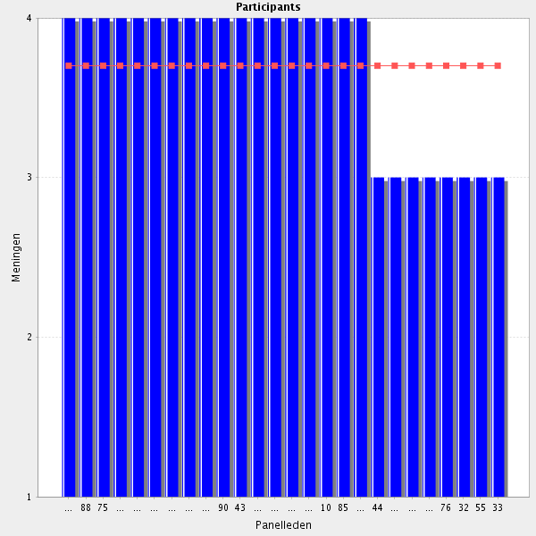
Average score: 3.7
Summary: good agreement but can be merged with 1.1.
Proposal: merge with 1.1.
It is not enough to know the suppliers of a particular medicine. It is necessary that in case of rupture the pharmacist quickly finds an alternative. In my view, the problem is not in finding a particular medicine/medical device, but in getting approval for that purchase.
HP is a member of team.
strongly agree
Necessary part of the role
see 1.1
key task of a hospital pharmacist
Key task of a hospital pharmacist.
Important but maybe not always under the pharmacist's control
Pharmacists has to ensure that there is stock of the products under his/hers responsability
Partly out of the hospital pharmacist's scope.
Systems should support the hospital pharmacist. And vice versa
Important but difficult if not supported by institution rules and regulations

1.3 Supply chain management - Ensure patients receive the medicines and medical devices they need in a timely fashion.
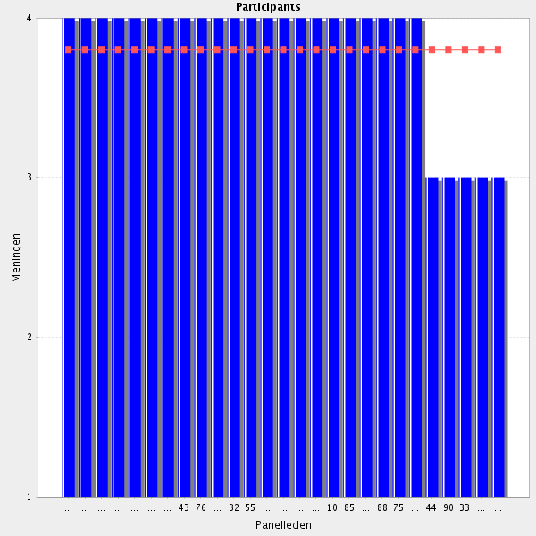
Average score: 3.8
Summary: good agreement but can be mereged with 1.1.
Proposal: merge with 1.1.
Comments:
That's part of the 7 'Rights'
Necessary part of the role
ok Ensure in a timely fashion is important but as a result of errors in the delivery drug and medical devices to patients, the management of such product flow should be carefully analyzed and the techniques for its securization (robotic delivery, bar-coding, RFID ...) be clearly understood.
see 1.1
The ultimate goal
Important but maybe not always under the pharmacist's control
Even the pharmacist cannot have all the control, he or she has to ensure to obtain them or to find a solution in case of shortage
This is not allway in our hands. As it concerns your job and opportunities I strongly agree.
Cannot always ensure this. Should strive for it though.
It is essential that the pharmacist try to avoid drug/medical device disruptions. But that does not just depend on him/she. It is necessary that the hospital's Board of Directors approve in a timely manner the purchase orders made by the pharmacy.
1.4 Supply chain management - When supply problems occur arranges alternative products for patients, including in out of hours or on-call emergency situations.
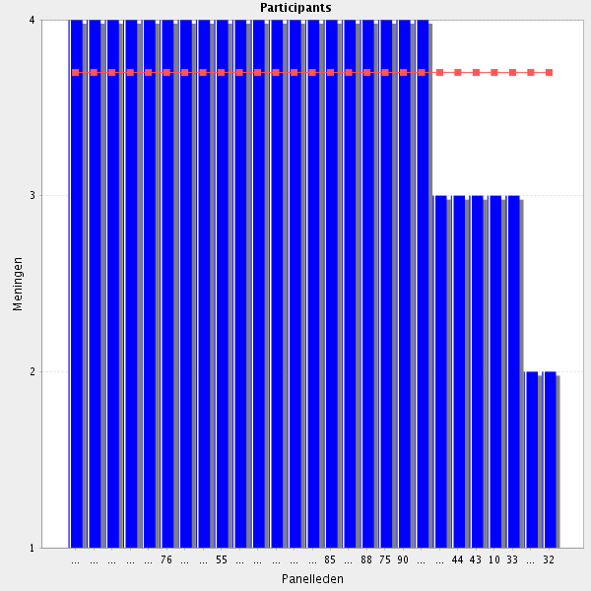
Average score: 3.7
Summary: good agreement, no change required.
Proposal: no change
Yes - and ideally also out of hours and in emergency situations.
As I said before, pharmacists have to have skills for solving these problems
We should try to do our best to serve the patients in a timely manner.
I agree that the pharmacist should try to find alternatives to the ruptures. However, it is not up to the pharmacist to make these changes in prescription, but rather to the doctor.
Not all services provide out of hours/on call.
In our country other health professionals usually take care of the supply of medicines on out of office hours in order to keep their competence, and to use the pharmacists competence for other things.

1.5 Cost effectiveness - Gives consideration to effectiveness when purchasing and dispensing stock and advising on prescribing choices (e.g. dispensing generics, bulk buying, selecting a product from several therapeutic equivalents, using sources that are recognised in each country as being best value for money. This may include wholesaler discount offers or contract purchasing).
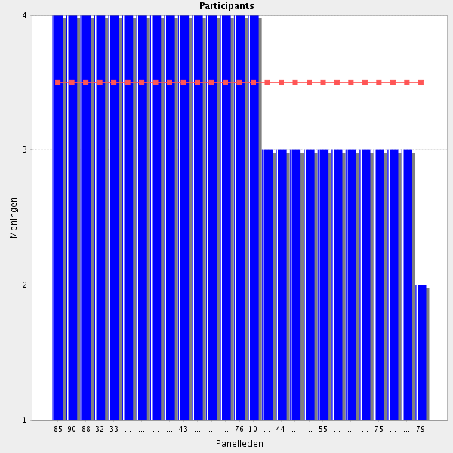
Average score: 3.5
Summary: some need to mention collaborating with others in comments.
Proposal: Amend to:-
Often in collaboration with others, considers cost effectiveness when purchasing and dispensing stock and advising on prescribing choices (e.g. dispensing generics, bulk buying, selecting a product from several therapeutic equivalents, using sources that are recognised in each country as being best value for money. This may include wholesaler discount offers or contract purchasing).
Comments:
It is a valuable work done by hospital pharmacists
This my in clude the option not to buy a specific product!
In many health systems, this competency lies with procurement bodies, tendering departments, etc. I definitely think that pharmacy managers should have this level of freedom (and responsibility) back within their mandate.
you can win money when you are buying something cheaper not selling
concepts of EOQ (Economic Order Quantity) and of the regulations of purchase orders should be understood.
Important but needs support from institution infrastructure
Again - purchasing is often a technician / admin staff role with supervision from a pharmacist.
In setting up the specifications in procurement, the hospital pharmacist can do best. In the process of procurement, the hospital pharmacist can be supported by the procurement department of the hospital.
In Sweden the procurement in county councils is regulated by the public procurement act (LOU).
1.6 Before going to the next group: do you have a remark, suggestion and or question on this group of competencies?
To ensure the availability of products and how to manage shortages is a very valuable job done by pharmacists. their knowledge of this products made them in a better position than purchashing agents.
This section is partly other professionals task, not necessarily a clinical pharmacists.
The CTF is about hospital pharmacy including clinical pharmacy; not only clinical pharmacy
It's essential to avoid drugs stock out and treatment disruption.
Agree with other comments. Based on technical roles now often automated or performed by technical/support staff under supervision.
This section ist related to traditional tasks of hosptial pharmacists. It is perhaps onlyin parts task of a clinical pharmacist.
In some jurisdictions/hospitals these roles may be better performed by technicians. However, pharmacists still need to be competent in these areas
I'll make a reference to shared risk agreements somewhere in this section.
Group: 2 Hospital and medication safety management (Group 14 of 26)
2.1 Systems approach to medication safety - Understands the role of medication safety as part of patient safety and quality of healthcare.

Average score: 3.9
Summary no change indicated. Align with medicines management.
Proposal: no change.
Comments:-
In my country this is very difficult because health care insurances do have contract directly with pharmceutical companies and therefore patients will recieve only the contracted product withour regards of the prescription in the ambulatoy care setting! Unfortunately!
Necessary part of the role
Almost a dogma for high quality healthcare services
Of course
It is basic that an hospital pharmacist know that medication safety is a vital part of the patient safety
strongly agree

2.2 Systems approach to medication safety - Is familiar with systems approach to patient safety and rational medication therapy promotion.
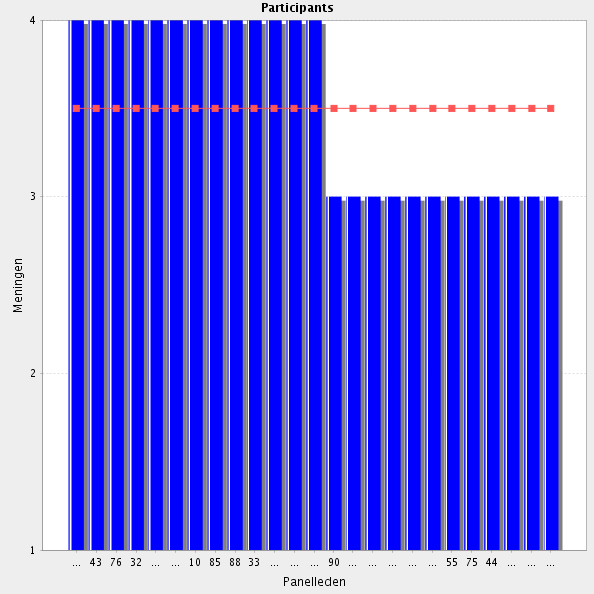
Average score: 3.5
Summary: no indications to modify. Can be linked with other medicines managment elements of the CTF.
Proposal: no change, link with similarly focussed CTF elements.

Comments:
Pharmacists have to know all that is related with the management of patient safety and in particular medication problems
strongly agree
Necessary part of the role
I am not sure that promoting safe and rational therapy will be of any advantage.
In collaboration with other healthcare professionals
A little bit vague, but yes indeed.

2.3 Systems approach to medication safety - Understands the role of safety culture in organisation-wide patient safety risk management and how this culture could be promoted.

Average score: 3.9
Summary: good agreement. Can be linked with other medicines managment elements of the CTF.
Proposal: no change, link with similarly focussed CTF elements.

Comments:
Necessary part of the role
safety culture should be promoted
After adequate training so understanding is objective and not subjective
Oviously, because I think that pharmacists should have a lider role in the organizations in all that is related with the patient safety.
strongly agree
It is necessary to have such a culture but instead share holder value ist the driving force in many settings.

2.4 Tools for medication safety risk management - Understands the principles of medication risk management and is familiar with the basic patent safety risk management tools related to medication.
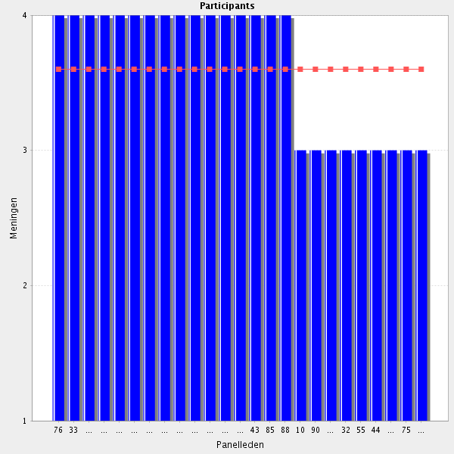
Average score: 3.6
Summary: good agreeemnt. Minor rewording as below. Link with
Proposal: Amend as below and link with other similarly focussed statements.
Understands the principles of medicines risk management and is familiar with the basic patient safety risk management tools related to medicines.

Comments:
strongly agree
Necessary part of the role
Typo - patent vs patient
In order to have a predominant role in patient safety, pharmacists have to know all related to risk management
Understanding does not mean that those principles are in place.
clear definitions should be provided, so that understanding is possible

2.5 Role of pharmacy - Understands and advocates the role of the pharmacist in a hospital setting in medicine efficacy and safety and also in cost containment.

Average score: 4.0
Summary: strong agreement. Can be shortened to both emphasise and reflct the many roles, and be linked into professionalism elements of the CTF.
Summary: amend to:
Advocate for the role of the pharmacist in a hospital setting

Otherwise the profession will not be recognized.
important role for pharmacists , strong involvement required
As long as first priority is medicine efficacy and safety
Otherwise the profession will not be recognized.
It is a very important role, that should be well performed
By all means!
strongly agree
Necessary part of the role

2.6 Role of pharmacy - Is familiar with the country’s healthcare system, it’s functioning an the role of the pharmacy as a part of the healthcare system.

Average score: 3.9
Summary: good agreement; can be improved with simplified wording.
Proposal: amend to:
Can describe and discuss the country’s healthcare system and how it functions, and the role of hospital pharmacy within it.
Comments:
Otherwise you re not able to find your place in the system.
Necessary part of the role
knowledge of health system regulations and functioning is essential
Typo - "and the role"
You need to know the healthcare system before you can be a vital part in it
No only for this reason, pharmacists should have a high level of understanding and knoledge of the healthcare system
Yes, this level of "outside the box" thinking is vital for hospital pharmacists.
strongly agree
it depends on how fast changes are demanded in the healthcare system and how soon and accurately tese changes are incorporated in everyday clinical practice

2.7 Information and education - Understands and advocates for the need to provide appropriate, independent and objective information and education to healthcare professionals and patients (in the way they can understand).

Average score: 4.0
Summary: as identified by one particioant, this duplicates other elements.
Proposal: delete.
Comments:
This is tailored information on medicins and medical problems.
Very similar to statements in other categories.
Objective criteria and evaluation of methods to do that should be developed
Objective criteria and evaluation of methods to do that should be developed.
Besides advocating, pharmacists have an important role in the information and education of other professionals
(Hospital) pharmacist should definitely identify themselves as hubs of therapeutic information, including safety, real-world-use data and EBM interpretation.
strongly agree
Necessary part of the role
2.8 Financial information - Has a working knowledge of hospital finances and relevant legal framework and an advanced understanding of division medicines budgets.
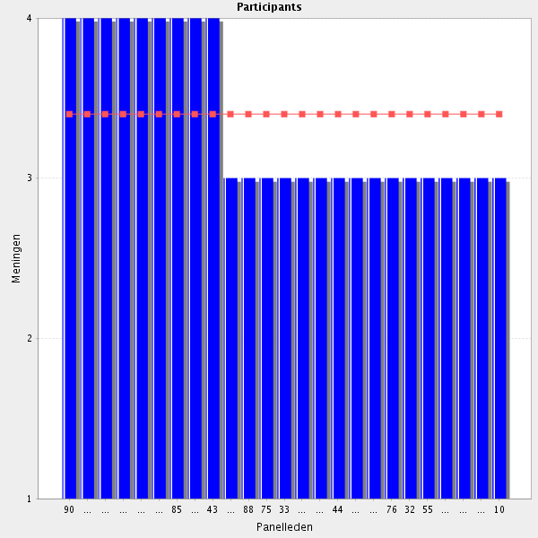
Average score: 3.4
Summary: no change indicated; link with service provision elements.
Proposal: no wording change; link with service provision elements of the CTF.
Will help to understand constraints.
Objective criteria and evaluation of methods to do that should be developed.
Besides advocating, pharmacists have an important role in the information and education of other professionals
(Hospital) pharmacist should definitely identify themselves as hubs of therapeutic information, including safety, real-world-use data and EBM interpretation.
strongly agree
Necessary part of the role

2.9 Financial information - Understands the complexities of how medicines therapy is financed including specialised funding streams and arrangements.
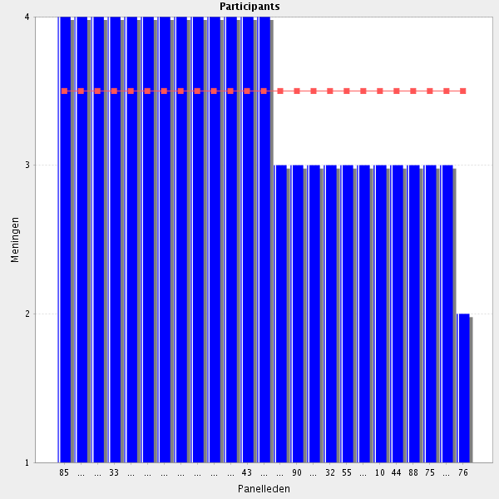
Average score: 3.5
Summary: some dissenting voices but seems entirely reasonable to have an understanding even if not personally responsible. Minor phrasing improvements possible.
Proposal: amend to:
Can describe and discuss the complexity of how medicines are financed within the health care system, including specialised funding streams and arrangements.
Comments:
Pharmacist has to manage a budget for the drugs used in the hospital and in some institutions also some medical devices. Therefore she/he has to know all the financial details
Important because of the team work. The pharmacist needs to be able to talk not only with doctors and nurses but also with the managers.
see comm. 2.8
Absolutely necessary. Without this, pharmacists can not influence when required
Is a very complex topic.
details should not be mandatory
Useful for the decision making of the appropriate medication but should not determine this choice as a key factor
Should have a basic understanding
This task should be fulfilled by hospital managements.
I mean, that not all hospitals pharmacists (as e.g. those engaged in clinical work) must understand the financial Groups of medicines procurement. This is a typical administrative task, and it should be performed by hospital managers or other persons involved in hospital pharmacoeconomy (it could be also a pharmacist).
2.10 Financial information - Understands the financial position regarding medicines uses to each department or division and comment on how costs can be controlled.
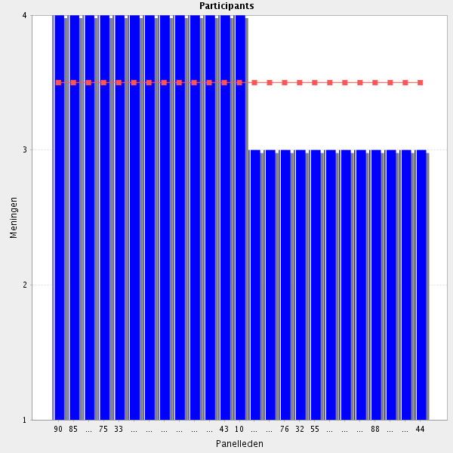
Average score: 3.5
Summary: reasonable agreement but can be merged.
Proposal: Merge with previous statement so the composite reads
Has a working knowledge of hospital finances and relevant legal framework, an advanced understanding of division medicines budgets, and can make clinically appropriate suggestions to contain costs.
Comments:
Basic task of phospital pharmacist and clinical pharmacist
Pharmacists have a level of knowledge about the medicines use, that can be indispensable when studing problems of treatment costs in the different hospital departments. They can help to optimize drug costs using guidelines or evaluation cost/effectivity
see comm 2.8
Basic task of hospital pharmacist and clinical pharmacist that may give advice on how costs can be controlled ensuring patient safety.
Necessary part of the role
see comment in the question before
As long as basic training in Health Economics is provided
I don't think the question is clear - is it medicines use in each department or supply to each department? Also would suggest "and can comment on how costs can be controlled"
Should have a basic understanding

2.11 Financial information - Draws upon the underpinning clinical knowledge of specific therapies, without impacting upon patient safety and medicines efficacy.
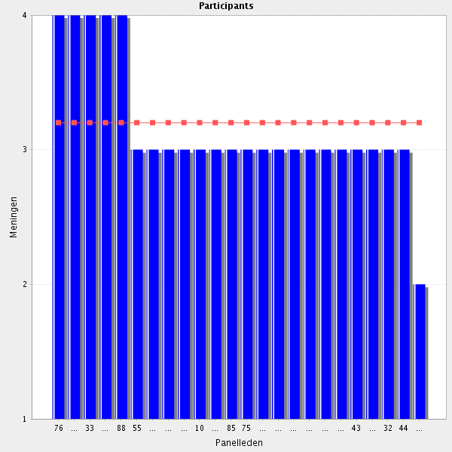
Average score: 3.2
Summary: not great agreement. Already represented in the previously merged element:
Has a working knowledge of hospital finances and the relevant legal framework, an advanced understanding of division medicines budgets, and can make clinically appropriate suggestions to contain costs.
Proposal: delete as duplication.
Comments:
very difficult to access medicines efficacy and patient safety impact, without the collaboratoin with other professionals in the institution
To do what?! Financial information is title so presume "Draws upon the underpinning clinical knowledge of specific therapies, without impacting upon patient safety and medicines efficacy, when providing financial information." But providing financial information should not impact on medicines efficacy?!
For me is not very clear this statement
Rather vague statement. Should be more specific.
This statement is not very clear to me.
DOn't believe this competency is clearly worded. I'm not sure what is meant
2.12 Financial information - Is able to work with departmental managers to deliver medicines related cost improvements programmes.
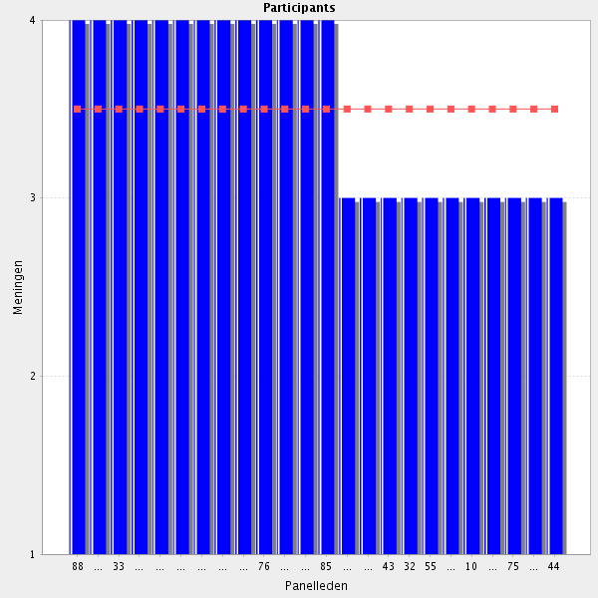
Average score: 3.5
Summary: Can be merged into previous elements to read:
Has a working knowledge of hospital finances and the relevant legal framework, an advanced understanding of division medicines budgets, and working collaboratively can make clinically appropriate suggestions and deliver improvement programmes to contain costs.

Comments:
strongly agree
skills to be developed for manager of pharmacy department (specialization)
If pharmacists work in collaboration with managers, a lot of benefits can be drawn.
as a member of a team or/and a committee
In a team, yes
Is this a basic competence? Perhaps advanced?

2.13 Financial information - Understands and advocates for the need of hospital pharmacists to provide support on the development and maintenance of appropriate user-friendly software for medicines information.
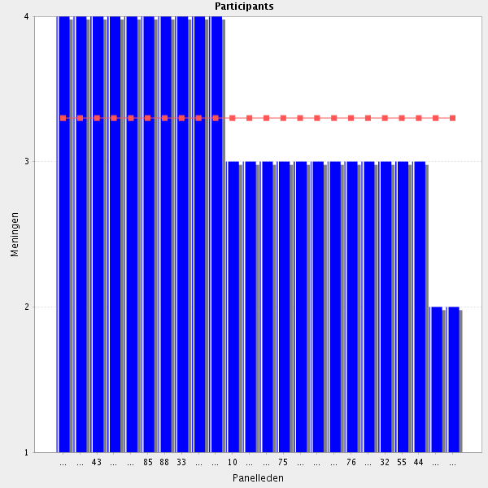
Average score: 3.3
Summary: see comments.
Proposal: reword accordingly to:-
Can describe, discuss and provide data to support the development and maintenance of appropriate user-friendly software for medicines information.
Comments: impactful comments in red
Softwares can be very usefull to study use and costs of medications. However the software has to meet some characteristics and the information given by pharmacists has to be taken in account by software developers. However, in order to obtain this, pharmacists have to be able to express their needs in an understanding way to software developers, and havesome knowledge of how soflwars for these purposes work.
As consultants and users
I don't believe we should have a competence of "advocates for the need of hospital pharmacists" - surely it should be that we can use an evidence base to support proposals. The way this is worded could be interpreted as self-serving
Not sure if this is a general skill needed for all HPs.

2.14 Hospital organisation - Is able to understand hospital organisation and participate in medication management in hospitals. This must encompass the entire way in which medicines are evaluated (hta reports) selected, procured, delivered, prescribed, administered and reviewed to optimise the contribution that medicines make to producing informed and desired outcomes.
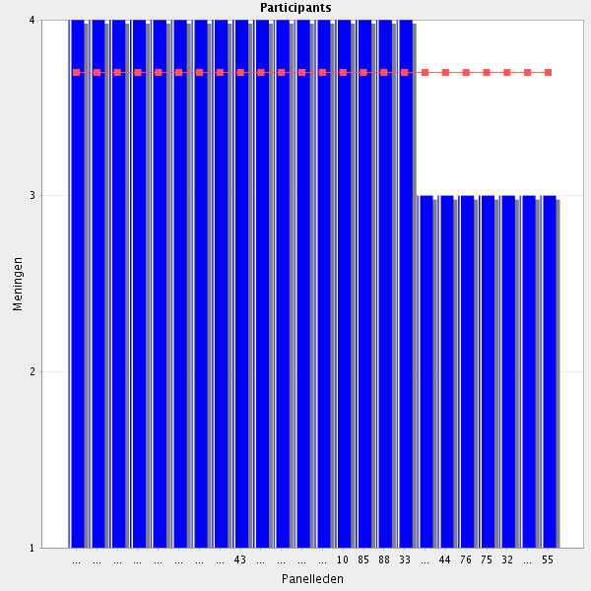
Average score: 3.7
Summary: good agreemnt. Some simplification requested by participant.
Proposal: amend to:-
Understands organisational structures and functions of hospitals, and seeks to maximise the contribution medicines management makes. This encompasses how medicines are evaluated (HTA reports), selected, procured, delivered, prescribed, administered and reviewed.
Can be placed with other medicines management elements.
Comments: impactful comments in red
Necessary part of the role
ok prerequisite for a manager
Suggest simplifying to: "This encompasses how medicines are evaluated, selected, procured, delivered, prescribed, administered and reviewed to optimise the contribution that medicines make to producing the desired outcomes."
Should definitely have a basic understanding of hospital organisation
I think that the pharmacist has to be the leading person organizing all this.
As an additional expertise, not an ability demanded for employment

2.15 Hospital organisation - Is able to enhance the safety and quality of all medicines and their use related processes affecting patients of the hospital.
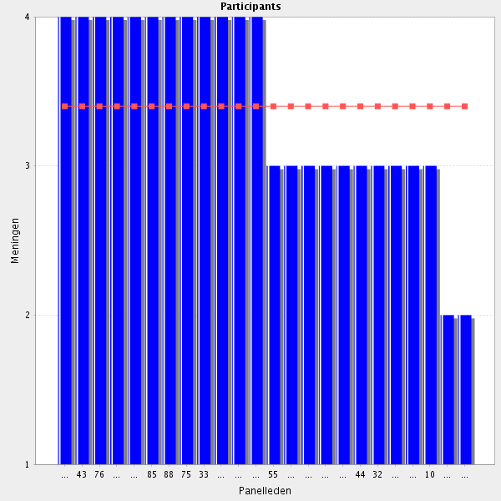
Average score: 3.4
Summary: reasonable support, team approach needs enhancing, and can be amalgamated with another element:-
Understands the role of medication safety, working with others to enhance the safety and quality of medicines and their use as part of wider patient safety and quality of healthcare programmes.
Proposal: merge.

Comments: impactful comments in red.
ok but multi-disciplinary involvement
Yes, but working with other healthcare professionals and other people of the organization
Necessary part of the role
As a member of the multidisciplinary team.
I think this statement has to be rewritten: "is able to enhance the safety and quality of all medicines" is a bit bold. The second half of the sentence is OK.
Enhancing the quality of all medicines? A tiny bit bold statement, I think.
I don't understand this question.
Specifically I don't understand the term "use related processes"

2.16 Hospital organisation - Is able to ensure the 7 “rights” are respected in the hospital: right patient, right dose, right route, right time, right medicine with the right information and documentation.
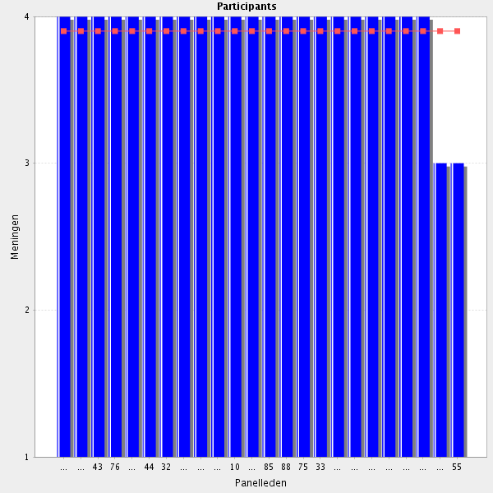
Average score: 3.9
Strong agreement; 7 Rights already in another element.
Proposal: delte as a discrete element of the CTF – duplicated.

Comments:
Very important!!!!!!
Necessary part of the role
It has to be a leading part but also in collaboration with others
ok why not for 7
In collaboration with the rest of the healthcare professionals

2.17 Technology automation - Understands and advocates automation technology in hospitals like semi automated warehouse management systems, automated cabinets, dispensing robots, barcode and RFID (add all the words) technology and software for electronic prescribing.
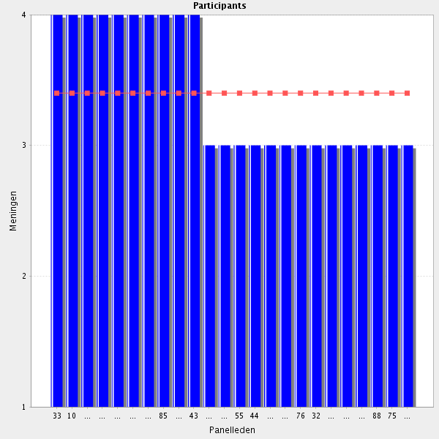
Average score: 3.4
Summary: reasonable agreement but some comments signal more cautious language is indicated.
Proposal: Amend to:-
Can describe, discuss and provide data to support, where appropriate, the development and maintenance of automation technology e.g. semi automated warehouse management systems, automated cabinets, dispensing robots, barcodes, radiofrequency identification and electronic prescribing.

Comments: impactful comments in red
ok to be promoted
usually the leading person to initiate an aucotmation process is the pharmacists. Howerver, in order to succed it is basic that other professionals related with the automation are also convinced and play an important role
It is a very special for HP. I think HP needs only basic information (knowledge).
May not be applicable to all hospital settings/countries - Could be tempered by the use of "where applicable, understands" - again - I don't believe we should include a requirement for advocacy - given limited funding, this might not be the appropriate approach in some settings, and advocacy for other issues may be more important than automation. Are we letting biases filter into this framework?
After the appropriate training and as a user
"Where appropriate" - may not be in some small regional hospitals. Typo - "﻿RFID (add all the words) "
Would probably require additional training?
"And know their limitations."

2.18 Technology automation - Understands the role of technology and automation in medication safety promotion.
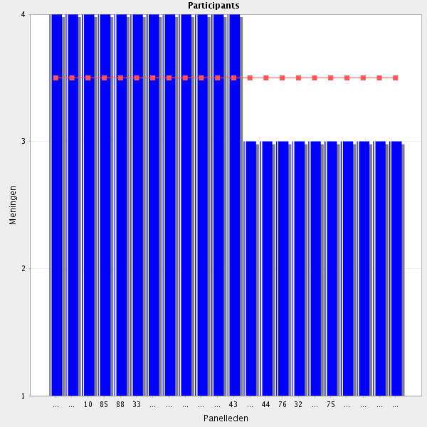
Average score: 3.5
Summary: reasonable agreement on limited sample size. No helpful comments; suggest amend to relfect wording of other related elements and test in Delphi 2.
Proposal: amend to:
Can describe, discuss and provide data to support the role of technology and automation in medicines safety.
Comments:
For me is obvious, you cannot advocate for an automation without taking in acount the safety
Necessary for development of the profession
Should have a basic understanding, yes
see comm 2.18

2.19 Medical devices sterilisation (if applicable) -Is able to evaluate the clinical effectiveness, safety for patient and cost of medical devices.
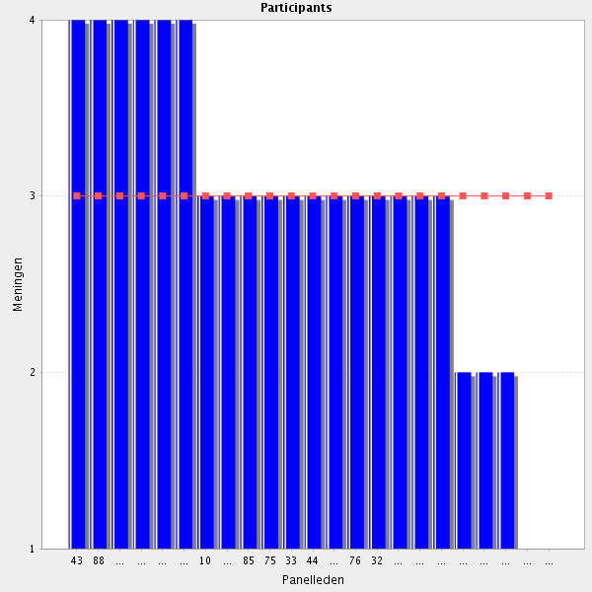
Average score: 3.0
Summary: lower level of agreement. Seems unclear whether there is a typo or genuine dissent.
Proposal: remove for Delphi 2.

Comments: impactful comments in red
"If applicable" is important here
Hard to say, if pharmacist is the rigth specialist for sterilisation....maybe it is nesured by microbiologist
Only in some institutions
The heading is wrong. OK if needed. Pharmacists are not much involved in medical devices procurements in my country.
I don't agree that it is a pharmacist role to evaluate medical devices sterilisation.
Should this be medical devices selection?! I don't agree that it is a pharmacist role to evaluate medical devices sterilisation.
I also think the heading in 14.8 is wrong for the first 4 bullet points. Selection is OK for questions 1, 2 and 4. It doesn't cover question 3. A proper heading for question 3 is maybe medicovigilance?
This point probably belongs to the medical devices section. I also don't think that sterilization processes are within the scope of the hospital pharmacy skillset.
is not the responsibility of hospital pharmacy in our country. Is not part of our curriculum

2.20 Medical devices sterilisation (if applicable) - Is able to compare medical devices, which are homogeneous in technical features.
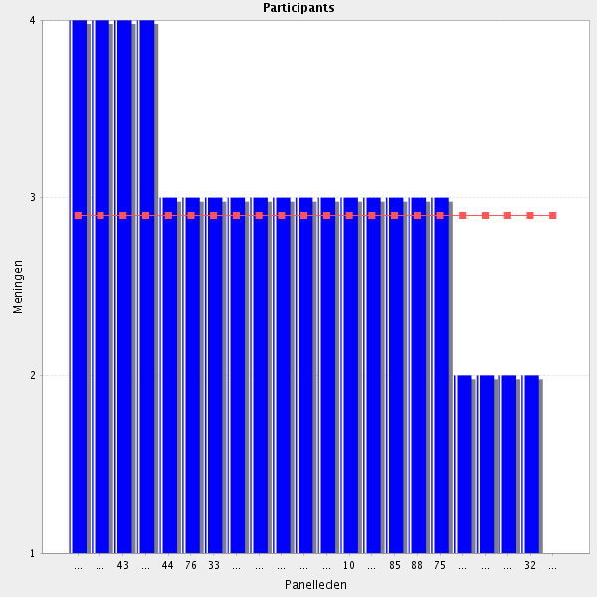
Average score: 2.9
Summary: lower level of agreement. Seems unclear whether there is a typo or genuine dissent.
Proposal: remove for Delphi 2.

Comments: impactful comments in red
"If applicable" is important here
I agree, but this point should be in the medical devices section.
The heading is wrong. OK if needed. Pharmacists are not much involved in medical devices procurements in my country.
In collaboration with other health care professionals involved in the use of these devices
Again, should it be medical device selection?
I agree that selection of medical devices is relevant to hospital pharmacists. Sterilization not!
not applicable in my hospital
Not applicable. Sterile compounding is done at special departments where you need to specialize to work. Pharmacists do usually not handle medical devices. Sterilisation is done by technicians.
see 2.19

2.21 Medical devices sterilisation (if applicable) - Reports medical devices incidents and investigates them.
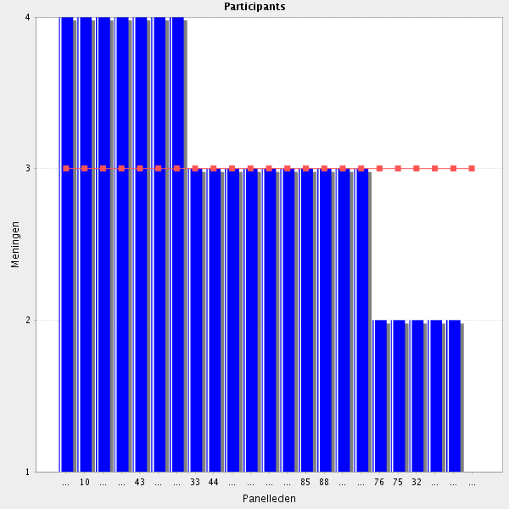
Average score: 3.0
Summary: lower level of agreement. Seems unclear whether there is a typo or genuine dissent.
Proposal: remove for Delphi 2.

Comments: impactful comments in red
"If applicable" is important here
As before sterilisation vs selection.
Reporting yes, but I'm not sure if investigating is the pharmacist's job.
In some level, but not as unique responsible
The heading is wrong. OK if needed. Pharmacists are not much involved in medicovigilance in my country.
Reporting might sound reasonable, but investigation? Not sure.
Strerilsation? pharmacists play a role in reporting medical devices incidents mas not investigating them
see 2.19

2.22 Medical devices sterilisation (if applicable) - Formulates specifications for medical device purchase and monitors consumption.
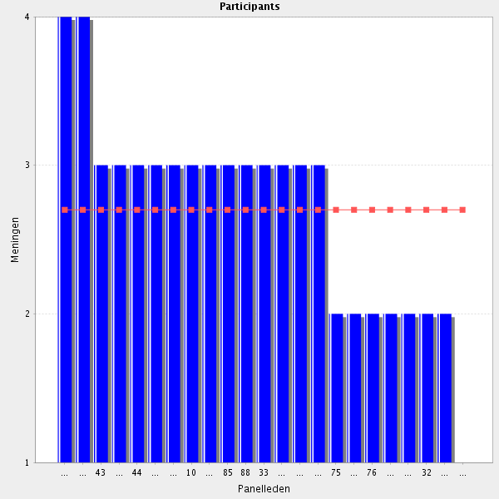
Average score: 2.7
Summary: lower level of agreement. Seems unclear whether there is a typo or genuine dissent.
Proposal: remove for Delphi 2.

Comments: impactful comments in red
"If ok in relationship with physicians (surgeons)applicable"
is important here
Only in some institutions is this required
The heading is wrong. OK if needed. Pharmacists are not much involved in medical devices procurements in my country.
As part of team work.
Depends on the device e.g. inhalers yes, surgical instruments no. Amend sterilisation to selection.
Again, sterilisation?
We have to choose the medicines or the medical devices.
Not applicable. Sterile compounding is done at special departments where you need to specialize to work. Pharmacists do usually not handle medical devices. Sterilisation is done by technicians
"sterilisation" shoud be deleted as the rest of the text is not about sterilisation.
see 2.19
2.23 Medical devices sterilisation (if applicable) - Is able to draw up and maintain procedures for cleaning, disinfecting and (re)sterilisation of medical devices.
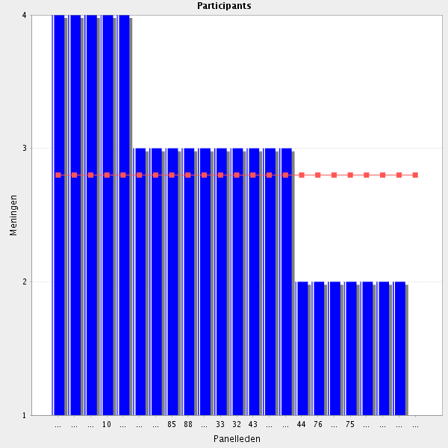
Average score: 2.8
Summary: lower level of agreement. Seems unclear whether there is a typo or genuine dissent.
Proposal: remove for Delphi 2.

Comments: impactful comments in red
"If applicable" is important here
re-sterilisation should be mentionned if applicable
OK but re-sterilisation should be mentionned ("if applicable according to national rules")
Only to some degree, if the institution requires it. It can be done by other professionals
OK if needed. Pharmacists are not much involved in the supply of medical devices in my country.
This is not within pharmacy's remit in my country.
In my opinion, this is not within the scope of hospital pharmacy.
Not a role for hospital pharmacists in my opinion
see 2.19

2.24 Medical devices sterilisation (if applicable) - Is able to supervise sterilisation of medical devices by means of process checks.
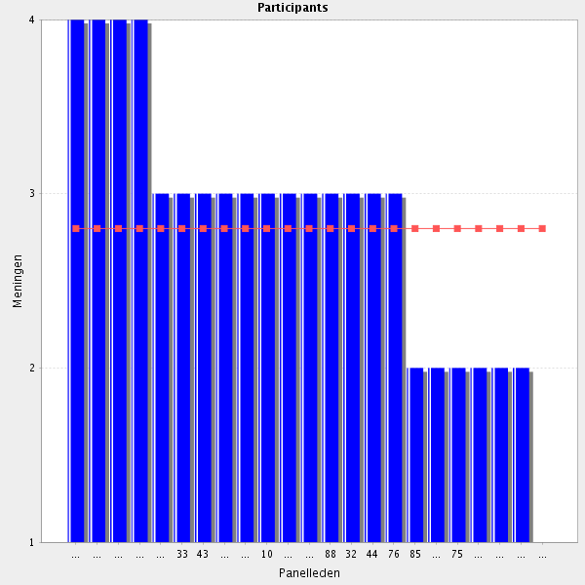
Average score: 2.8
Summary: lower level of agreement. Seems unclear whether there is a typo or genuine dissent.
Proposal: remove for Delphi 2.

Comments: impactful comments in red
"If applicable" is important here
OK if needed. Pharmacists are not much involved in the supply of medical devices in my country.
I do not think that this is a job for pharmacists (1 other agrees with this)
This is not within the remit of pharmacy in my country.
Not within the scope of hospital pharmacy in my opinion.
Not a pharmacists responsability
see 2.19

2.25 Medical devices sterilisation (if applicable) - Is able to supervise compliance with storage and transport directives for sterile medical devices.
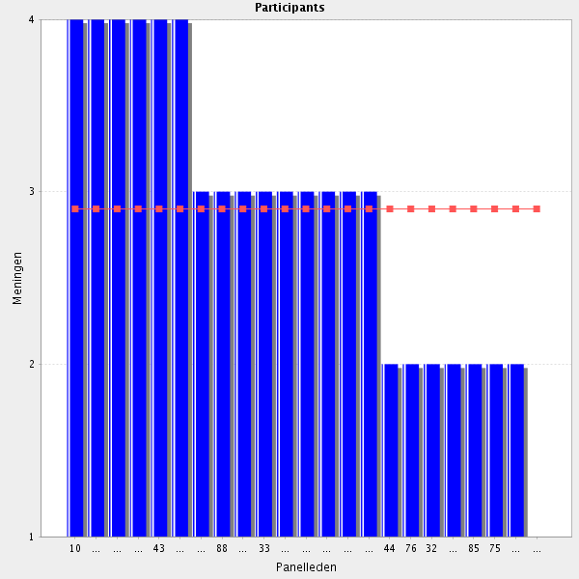
Average score: 2.9
Summary: lower level of agreement. Seems unclear whether there is a typo or genuine dissent.
Proposal: remove for Delphi 2.

Comments: impactful comments in red
"If applicable" is important here
OK if needed. Pharmacists are not much involved in the supply of medical devices in my country.
Should be able yes, but I'm not really sure it's the pharmacist's job
Not applicable. Sterile compounding is done at special departments where you need to specialize to work. Pharmacists do usually not handle medical devices. Sterilisation is done by technicians
Not a pharmacy role in my country.
Not a pharmacy role in my country.
If it is to be part of the common training framework should it be something that is part of the pharmacy role in each participating country? Or will there be an option to "opt out" where certain parts don't apply?
I do not think is a job for pharmacists
see 2.19

2.26 Medical gases - Understands the pharmacist’s role in medicines purchasing including procurement, distribution, surveillance, and control of medical gases.
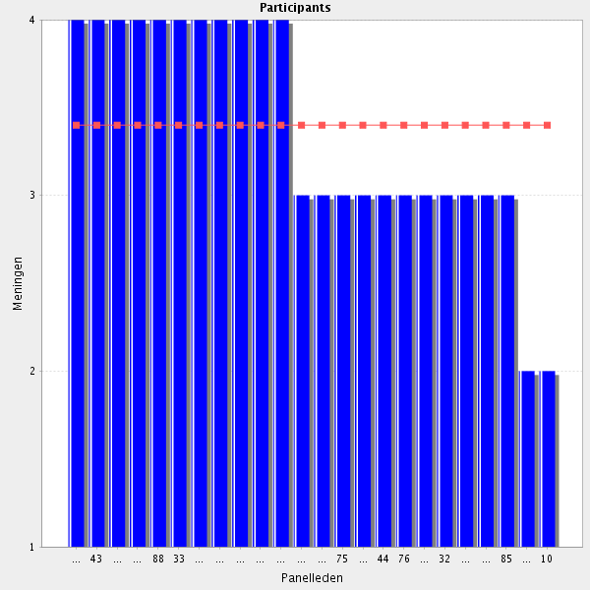
Average score: 3.4
Summary: average agreement. Some modification based on comments may mean better agreement in Delphi 2. Small sample size.
Proposal: amend to:
For medical gases, performs the pharmacist’s role as appropriate including procurement, distribution, surveillance, safety and control.

Comments: impactful comments in red
For sure the pharmacist should understand the pharmacist's role
And safety!!!!!
Safety as well!
stock management of oxygen central and various cylinders
"If applicable"
Medical gases are usually considered a drugs and their regulations apply and as such do not deserve a specific chapter. From a prospective point of view it should be more interesting for the next generation of hospital pharmacists to include a chapter on the "safety management" of Advanced Therapy Medicinal Products.
In my country the pharmacist rarely has involvement in medical gasses.
In collaboration with other professionals, Mantenance staff has an important role
"if applicable" should be added. In many coutries medicinal gases are outside the responsibilty of hospital pharmacies.
ın hospitals medical gases is in the responsibility of bıomedical engineers
2.27 Medical gases - Knows the law related to medical gases.
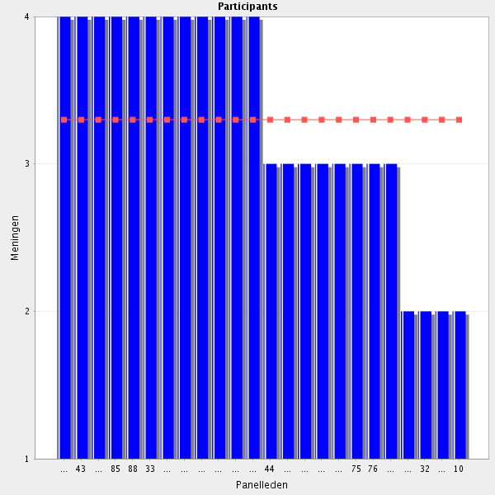
Average score: 3.3
Summary: reasonable agreement. Can be meges into previous elelemnt.
Proposal: Merge

Comments: impactful comments in red
Only in a level of knowledge to answer possible questions.
"if applicable"
Probably should know the law related to those medical gases he/she needs to work with
do not understand the question
Only a few pharmacists work with medical gases and then they need to specialize. I think that this is outside of this framework and not something that every pharmacist needs to know.
"if applicable" should be added.
dont know

2.28 Medical gases - Understands the therapeutical role of medical gases.
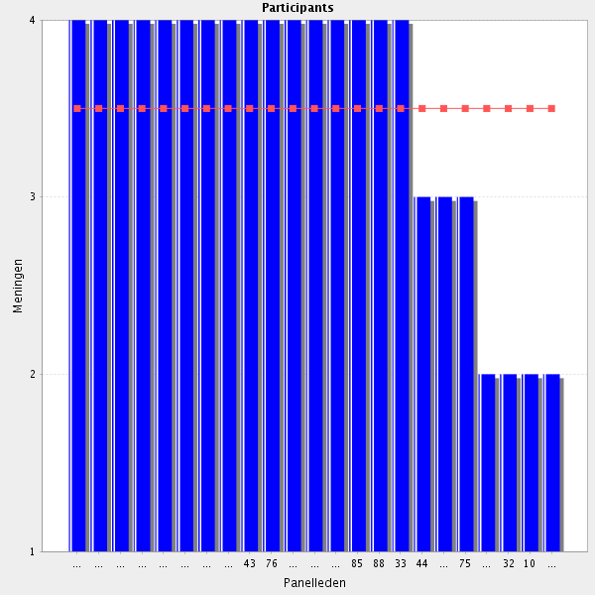
Average score: 3.5
Summary: limited comments but some concerns about the detail re gases. Seems implicitin existing element re medical gases.
Proposal” Delote for Delphi 2.

Comments: impactful comments in red
Important
Yes as their form part of the treatment
"if applicable" should be added.
Only a few pharmacists work with medical gases and then they need to specialize. I think that this is outside of this framework and not something that every pharmacist needs to know
dont know
?
?

2.29 Before going to the next group: do you have a remark, suggestion and or question on this group of competencies?

The whole medical devices block should be re-evaluated. Do they fit into this category? Is sterilization really a hospital pharmacist's competency?
Medical device sterilisation is not a pharmacists responsability in my country
In relation to medical devices it is not clear the degree of knowledge becaus it depens on the institution where the pharmacist is working. In some hospitals pharmacists do not have any contact with the medical devices and in others they are the resposible of selectin, bying and dispensing. Therefore, in this last case the level of knowledgment has to be hight. I think that in part is a problem of staff. If the staff is large is better to focus the work of the pharmacists in all related to medicines, because there are other kind of professionals or workers in the hospitals that could manage medical devices.
some pharmacists are involved with medicinal product derived from human blood or plasma In the section hospital organisation we must speak about storage and transport of drugs containing narcotics or psychotropic drugs
Many of these subjects are good to have knowledge about, but not to know in detail within this training framework. Some pharmacists will work with this, but then they will need to specialize in that area, for instance
Too detailed.
Reformulate the heading for the first 4 bullet points of 14.8 (please see my comment to the EAHP admin in that section).
Pharmacists are rarely involved with medical gasses and rarely/never involved in sterilisation of medical devices in my country. Many of the questions are unclear.
management of human ressources (within the department) has not been discussed and should be part of the formation of hospital pharmacists
Pharmacists are rarely involved with medical gasses and rarely/never involved in sterilisation of medical devices in my country. Many of the questions are unclear
Group: 3 Collaborative work (Group 15 of 26)
3.1 Drug & Therapeutic Committee - Is able to work

Average score: 4.0
Summary: good agreement but can be merged into the next 2 elements.
Proposal delete as stand alone elment of the CTF.

Comments:
pharmacists should be active members of P&T committees
Is one of the main values of the hospital pharmacist
Necessary part of role

3.2 Drug & Therapeutic Committee - Is able to critically appraise formulary applications and peer review documents including having an appreciation of the financial and medication safety implications of each application.

Average score: 4.0
Summary: good agreement. The 3 separate DTC elements can be merged into a single one as below:
As an active member of a hospital Drug and Therapeutics Committee can critically appraise formulary applications including the financial and medication safety implications of each application, and can construct, assess and professionally comment on treatment pathways and protocols, medicines policies, patient group directions and process national safety alerts.
Proposal: merge.
Comments:
Is one the professionals better situated to do this job
Necessary part of role

3.3 Drug & Therapeutic Committee - Is able to construct, assess and professionally comment on treatment pathways and treatment protocols, medicines policies, patient group directions and process national safety alerts.
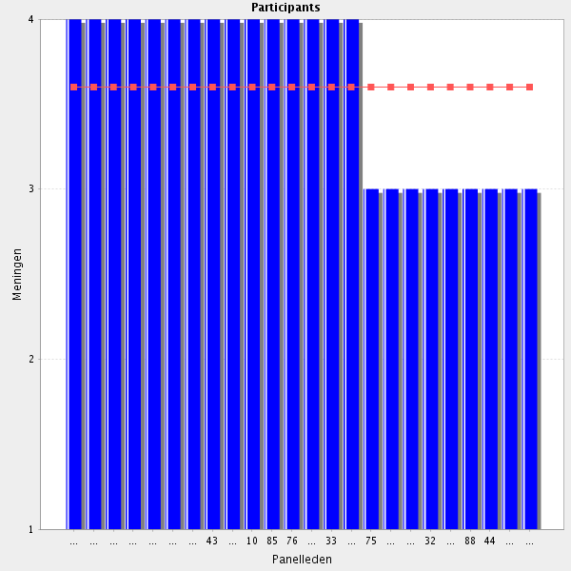
Average score: 3.6
Summary: resonable agreement. The 3 separate DTC elements can be merged into a single one as below:
As an active member of a hospital Drug and Therapeutics Committee can critically appraise formulary applications including the financial and medication safety implications of each application, and can construct, assess and professionally comment on treatment pathways and protocols, medicines policies, patient group directions and process national safety alerts.
Proposal: merge.

Comments:
Necessary part of role
Obviously, in order to do an optimum work in the D&T Committee,

3.4 Infections’ Control Committee - Is able to be the responsible member of the Infection Control Team.
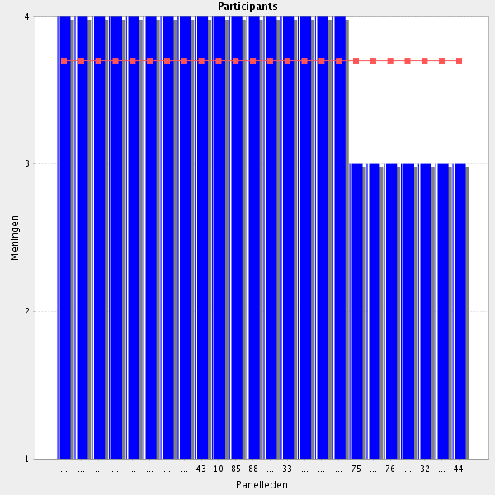
Average score: 3.7
Summary: reasonable agreement. This statement and the next can be merged as below:
As an active member of the Infection Control Team works to improve the rational use of antibiotics to reduce antibacterial resistance.
Proposal: merge.
Could be reworded to " Is able to be an active and responsible member of the Infection Control Team".
Some rewording needed ("...a responsible member...")
Yes - should be able, but that may not mean that they are
Yes, pharmacists are prepared to take this responsibility
Should be an active member
at least work as active member of ....
Should be able to be a member

3.5 Infections’ Control Committee - Improve the rational use of antibiotics to reduce antibacterial resistance.

Average score: 4.0
Summary: good agreement. This can be merged as below:
As an active member of the Infection Control Team works to improve the rational use of antibiotics to reduce antibacterial resistance.
Proposal: merge.

Comments:
Together with physicians and microbiologists
in collaboration with ..
the most ımportant thıng
Pharmacists have the most wide knowledge on antibiotics
Necessary part of role
Responsibly

3.6 Before going to the next group: do you have a remark, suggestion and or question on this group of competencies?

Concerning membership of other committees: Recommendation: Create learning objectives covering competencies generic to participation in sundry committees etc.
better term for collaborative work in this context maybe committee work or interprofessional committee work? work in the infection control committee, I would also add here (antimicrobial stewardship)
I agree. A generic statement in order to include other committees could be included?
I agree with R 87 concerning antibiotic stewardship. Concerning "interprofessional Committee" in stead of "D&T committtee": The tasks described are specific to the D&T Committee and therefore I think the wording should be kept as it is.
pharmacists also play an active role in other groups: ex: ethics commitee
what about pain or nutrition committee
The skills aren´t basic. To be member of committee HP needs more practice
Some pharmacists are involved in pain management committee Others ones are involved in liason committee for nutrition and health foods
Group: 4 Clinical Governance (Group 16 of 26)
4.1 Department’s SOPs - Uses and complies with relevant and up to date procedures to practice.
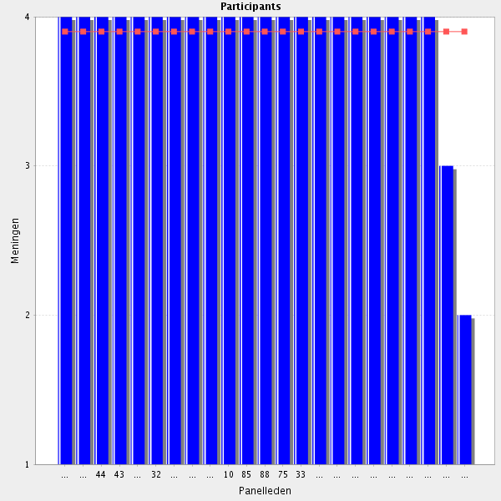
Average score: 3.9
Summary: good agreement but this is a duplication from Cluster 1.
Proposal: delete as a discrete element of the CTF.

Comments:
Necessary part of role
This learning objective should be deleted. Reason: This is a part of a job description rather than a learning objective.

4.2 Working Environment - Applies legal and professional requirements for a safe system of work, such as the Code of Ethics, Hygiene, Standards, Health and Safety at Work.

Average score: 4.0
Summary: strong agreement; can be linked with other management elments of the CTF.
Proposal: minor rewording and link as above.

Comments:
As a healthcare professional pharmacist have to apply to all of them
Basic requirements
I am unsure whether this is a learning objective. Could be reworded to "Should be able to apply......."

4.3 Working Environment - Understands the role of possible deficiencies (e.g. poor lighting, lack of information sources) in the working environment as contributing factors to medication errors and as a risk to patient safety.
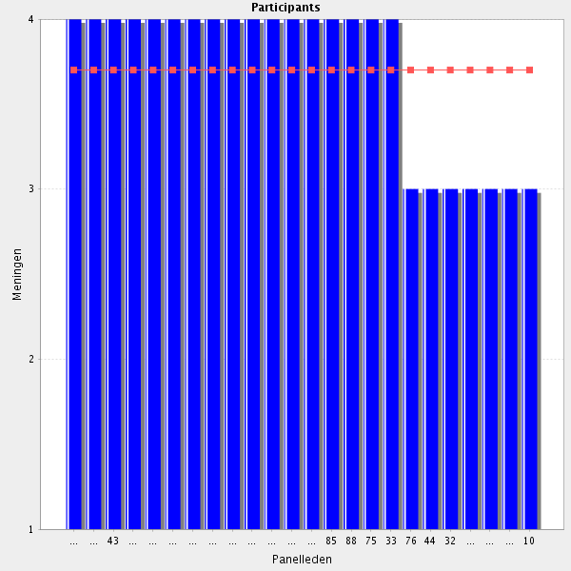
Average score: 3.7
Summary: minor rewording and can link with other patient safety elements.
Proposal: link below to patient safety elements:
Identifies possible deficiencies (e.g. poor lighting, lack of information sources) in the working environment as contributing factors to medication errors and as a risk to patient safety.

Comments:
Necessary part of role
Important for patient safety
As an experct in medication safety has to know all this

4.4 Working Environment - Is able to act upon the identified risks in the working environment.
Panel Participants
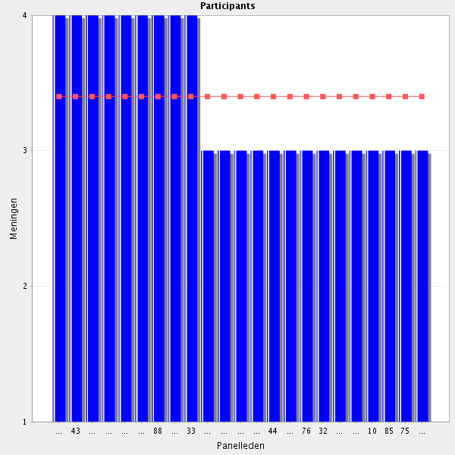
Average score: 3.4
Summary: moderate agreement; we should perhaps stick with identifies for Delphi 2 and see what the responses are.
Proposal: delete for Delphi 2

Comments:
Necessary part of role
Maybe the role of the pharmacist is to help identifying the risks? Depending on the risk identified it can be other personells responsibility to act upon.
Not always within your control.
"Is able to articulate a professional opinion about the identified..."?

4.5 Working Environment - Understands issues surrounding clinical governance and continuous quality and safety improvement.
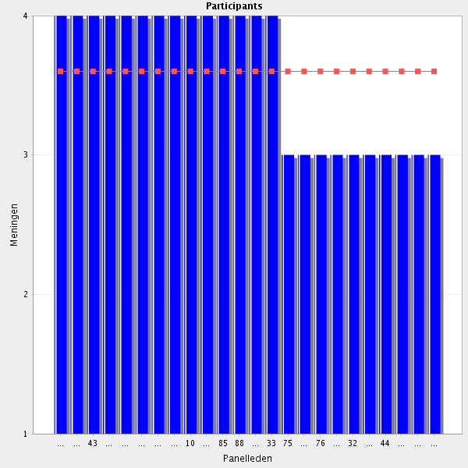
Average score: 3.6
Summary: can be merged into an exisiting element
Understands the role of medication safety and clinical governance, working to enhance the safety and quality of medicines and their use as part of wider, continuous patient safety and quality of healthcare programmes.
Proposal: merge.

Comments:
Necessary part of role
Yes, because pharmacists have to apply to their department all the rules, etc of quality and safety

4.6 Risk Management - Records and reports patient safety incidents such as dispensing and prescribing errors and patient complaints in line with local and national policies.
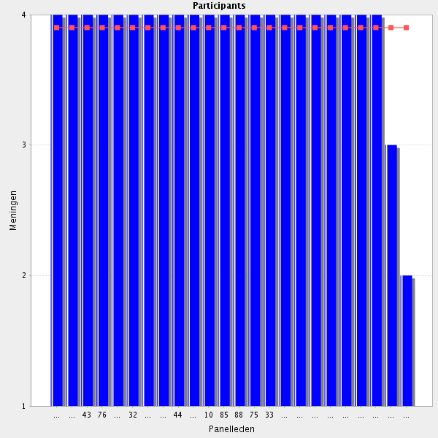
Average score: 3.9
Summary: no changes; merge with other patient safety elements.
Proposal: merge

Comments:
Of course
should favour and organise within the department of pharmacy self-reporting of errors
As a basic and central professional on medication safety
should be root cause analysis be include d?
Most definitely!
Special software
Necessary part of role
To become a learning objective the wording should be "Know how to record and report....."

4.7 Risk Management - Understands and applies quality systems.
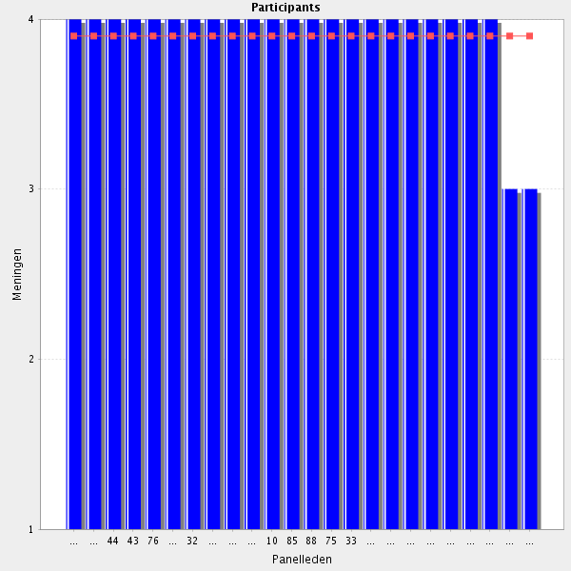
Average score: 3.9
Summary: duplication of other elements.
Proposal: delete as stand alone element of the CTF.

Comments:
Certenly. Is not possible to do the work as hospital pharmacists without it
Necessary part of role

4.8 Before going to the next group: do you have a remark, suggestion and or question on this group of competencies?

I do not understand the abbrevation: Department’s SOPs
Quality and Safety are basic and indispensable in the Pharmacy Service
Some of the competencies are worded in a way that makes them more like job descriptions than learning objectives. I have commented on some of them. I think all competencies should contain a verb like "know", "be able to" etc. Even "understand" is perhaps not appropriate as it is difficult to measure to what extent a competency/learning objective is "understood".
I do not understand the abbrevation: Department’s SOPs ﻿
All the health staff is concerned by clinical governance, not only the pharmacists It's necessary to describe each risk, its impact and degree of criticalness as well as the steps taken to control it

Group: 5 Staff management (Group 17 of 26)
5.1 Leadership - Knows the fundamentals of managing and supervision of staff.
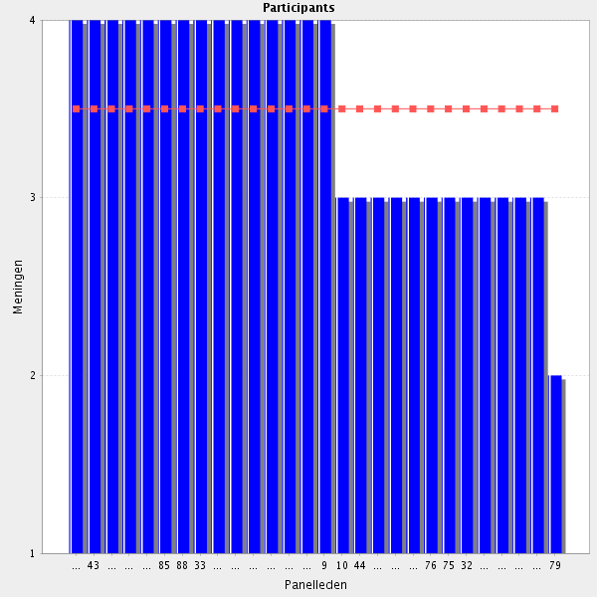
Average score: 3.5
Summary: minor rewording.
Propsal: Amend to:-
Can describe, discuss and apply the fundamental principles involved in managing and supervision of staff.

Comments:
It's essential for the management of the hospital pharmacy to know how to manage since to my opinion the hospital pharmacy should be one of the profit centers of the hospital.
management of human ressources are mandatory (especially for future managers
Hospital Farmacy is one of the core products of hospital services)
For pharmacy managers, definitely.
Necessary part of role
especially for chiefs
Should not be mandatory for every pharmacist. Depends on his position in the pharmacy
The fundamentals are OK, but not every pharmacist will be a leader.
ugh additional training required as not typically covered in undergraduate programmes here though
If that is a part of the job, of course
Out of scope
I think this is part of hospital pharmacy practice and should be kept.
5.2 Staff development - Supports staff in their professional and personal development.
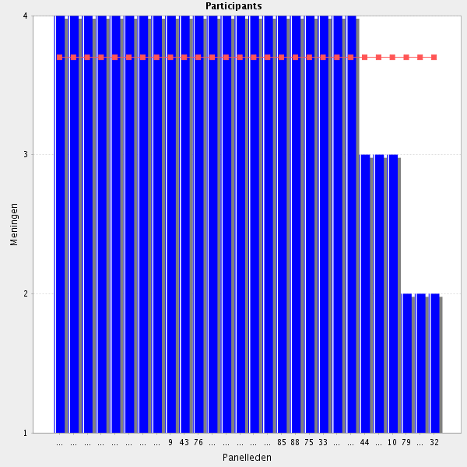
Average score: 3.7
Summary: see comment.
Proposal: Amend to:-
Knows how to support staff in their professional and personal development.

Comments:
Necessary part of role
it’s obvious
I think it's essential for any employee in any organisation the be supported in personal development with the goals to be educated, inspired and prepared for changes.
The more you can achieve that personal development is consistent with organisaton requirements, the better cooperation one can expect and the better results one can achieve.
Staff training is an important part of the role.
Always important in a field where there is constant development and progress
In order to have an uptodate Service and motivated staff, pharmacist have to encourage personal in their professional development
It is vital to engage and empower co-workers.
Out of scope
Should be reworded to "Should know how to support staff....." as this makes it a learning objective rather than part of a job description
Not every pharmacist is a boss or leader. Some pharmacists will specialize in this area, but it is nothing everybody needs to know.
5.3 Staff development - Promotes professional development to motivate the staff.
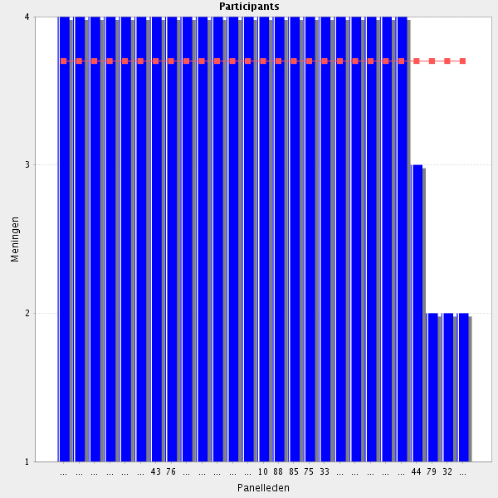
Average score: 3.7
Summary: see comment; duplication.
Proposal: delete.
Comments:
Absolutely
see 5.2
Please consider leadership development as part of professional development.
How is this different than 5.2?
Necessary part of role
Out of scope
Not every pharmacist is a boss or leader. Some pharmacists will specialize in this area, but it is nothing everybody needs to know
. Should be rephrased to "Knows how to promote Professional Development to motivate the staff"

5.4 Performance management - Carries out staff appraisals on a regular basis.
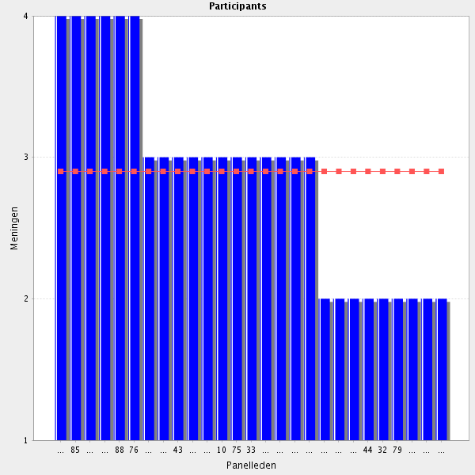
Average score: 2.9
Summary: low score but seems important to retian. Amend wording as per comment, link with other “developing people’ elements of the CTF and assess in Delphi 2.
Proposal: amend to:
Know how to carry out staff appraisals.
Comments:
Is basic if you what to have a motivated one. But even with motivated staff, i think is very important to recognize the well done work in a regular basis
For senior management role.
'Its a useful technique to monitor one's performance. Just don't make it bureaucratic.
It should be organisation appraisals and staff support and -development.
Applicable for pharmacy managers and/or chief pharmacists. Not applicable as a general competency.
No. Notivating system is the basis
Not to do with the hospital phamacist, but the manager.
Not every pharmacist is a boss or leader. Some pharmacists will specialize in this area, but it is nothing everybody needs to know.
Out of scope
"Carries out staff appraisals on a regular basis. " should be reworded to "Know how to carry out staff appraisals". Reason: As it stands is it more like a job description than a competency/Learning objective.
"If applicable" - you could be a hospital pharmacist without any line reports, and therefore are not in a position to carry out staff appraisals
Pharmacy managers and/or chief pharmarcists should. As a general competency, I don't think so.

5.5 Performance management - The appraisal process should realise potential, monitor performance and recognise contribution.
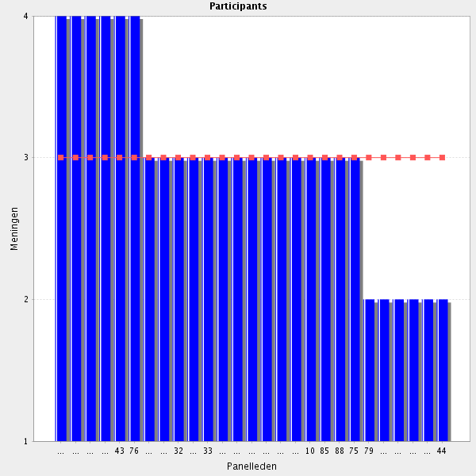
Average score: 3.0
Summary: comments expressing some reservations.
Proposal: if the previous element is reqorded this one becomes unnecessary. Test this in Delphi 2.
Comments:
not a process, it's a management task on which one may use technical aids.
Competency only of chief pharmacists
I agree with the content, but I think the statement is incomplete. For instance: "(If applicable) have an understanding of the appraisal process and that it's intention is to realise potential, monitor performance and recognise contribution".
Out of scope
As it is written this is not a competency, but rather a part of a Standard Operating Procedure (SOP). Could be worded "Knows what an appraisal process should comprise" with an explanatory note of what it should comprise.
Unclear? The pharmacists' own appraisal process? Or those they conduct on others? If the latter, then you're assuming they are in a position to undertake appraisals. Re: the former? - I'm not sure that the pharmacists' own performance management is considered in this framework? If this is where it is dealt with, it's unclear
It's a technique to monitor the performance. Realisation potential and recognition of contribution are done in the day to day work setting.
In a manager education, yes, but not in a hospital pharmacist education - in my opinion. This statement should be taken out completely.
5.6 Employment issues - Is aware of employment legislation, including statutory rights and disciplinary procedures and has competent interviewing skills.
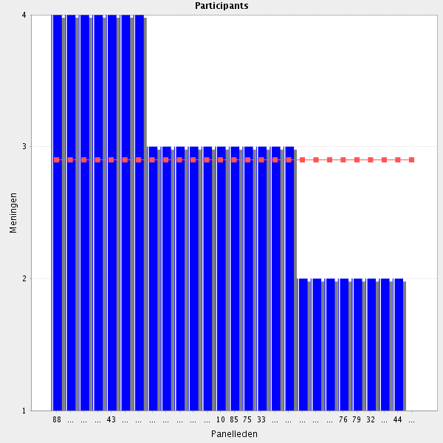
Average score: 2.9
Summary: not greast agreement. Seems important.
Proposal: link inot other “developing people” elements and see if that works better in Delphi 2.

Comments:
Pharmacy is as any other profession a peoples business.
Necessary part of role
With training.
To have a basic knowledge. When more in deph information is needed, pharmacists can address their questions to the hospital department dealing with these issues
Interviewing skills are very useful for management. Perhaps it's useful to know a little of legislation Groups, but this is typical a domain where the HR department should come in.
Out of scope
Interviewing skills are very useful for management. Perhaps it's useful to know a little of legislation Groups, but this is typical a domain where the HR department should come in. It is probably good for managers but not for every pharmacist. (this response references the one above, agreeing with it and copying it)
As said before, not in the hospital pharmacist education framework.
This is HR territory. We most certainly are amongst the last polyhistors in existence, but not to this extent.

5.7 Before going to the next group: do you have a remark, suggestion and or question on this group of competencies?
basic Groups from this group of competencies for all hospital pharmacists. Head of department of units need more advanced skills.
I have some doubts if staff management skills should be required for every hospital pharmacist. Management skills are very important for pharmacy managers, and group leaders, but not neccesarly for all pharmacists. One can be an excellent hospital pharmacist and a terrible managaer at the same time. Not everyone has predispositions to be a boss, not evereyone wants to be a boss either. I think that the learning process should include basic management knowledge, but shoud not require every pharmacist to be an excellent manager.
staff management requires dedicated skills especially for managers but not necessarily for every pharmacists (at least basics) (I other agrees with this)
Any pharmacist is manageing people, either as a leader in the column or as a professional being functional responsable or as a consultant for doctors and nurses. So yes, every pharmacist needs to know how to manage and what interaction does with people.
Managin staff is one of the most difficult jobs to do in any profession. it requieres some capacities and diplomatic performance.
some of the statements proceed to many professions, not only pharmacist, so maybe they are redundant
It is important for most hospital pharmacists to have basic management/leadership skills, wording should be careful though not to overstep our boundaries.
Behind every good leader one finds a team that is just as remarkable
THere may be too much emphasis on formal appraisal processes. Skills around negotiation, influencing etc - are these dealt with anywhere. Also a pharmacists own resposibility for maintaining CPD records, for focussing on their own development, does not appear to be featuring in this framework. Apologies if I just haven't come across it yet
In my opinion the management skills should be kept out of the CTF. Not every hospital pharmacist will be a chief pharmacist and I think it's the institutions responsibility to educate their managers.

Group: 6 Development and research (Group 18 of 26)
6.1 Application - Is able to contribute to the care of patients the application of research and education.
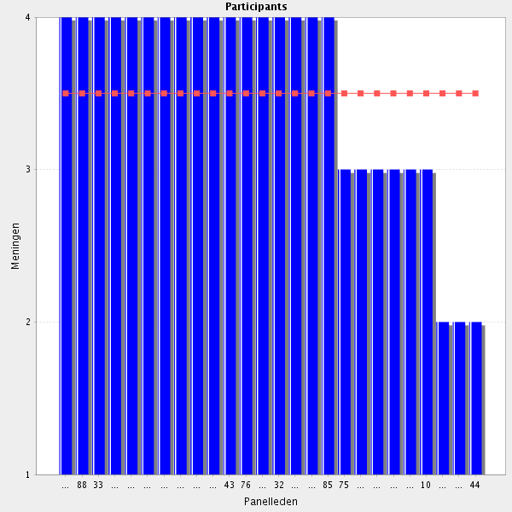
Average score: 3.5
Summary: cannot understand this. Ask for clarifiaction.
Proposal: delete for round 2.
Agree if this means "Is able to contribute to the care of patients through the application of research and education"
contribution to Res & Educ should be promoted
I agree, but this statement needs rewording. See examples from other participants.
Contribute yes, but one does not need to be an expert on every Group. Some are good in more care oriented work, some are good in more educational oriented work and some are good in more research oriented work. A basis level of understanding is needed on all Groups.
Presume this should read: "Is able to contribute to the care of patients through the application of research and education"
I understand the sentence, but the grammar is bad (sorry). Suggestion: "Is able to contribute to the care of patients by the appropriate application of evidence based medicine"
I don't understand the statement. Should it read: care of patients through the application of research and education?

6.2 Ethics committee - Is able to take an active role in the ethics committee and appreciate its pivotal role in research.
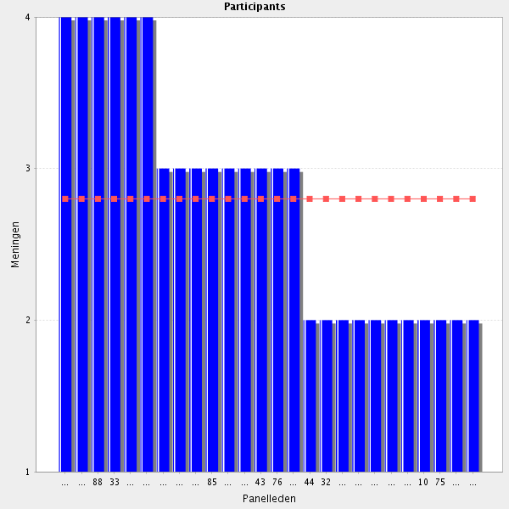
Average score: 2.8
I find this really important.
i think there is place for pharmacists in ethics commitete
In some degree
This should be voluntary
Not a requirement for all hospital pharmacists to be in the ethics committee, but to appreciate its role in research.
Optional
It is a specialization.

In a hospital organisation you only need one or two hospital farmacists who know all Group on this matter and the rest only need to now this subject on a higher level. Consultation with the specialists in a hospital is always possible when one needs to know more details or more new insights.
Not a requirement that a pharmacist is on the Ethics Committee in my opinion but certainly desirable where research involves medication.
Is this a core competency? I would query the reference to an "active role"
Not a pharmacist's job I think
ı m not ın that comıttee
Not a requirement for all hospital pharmacists
Is able to apply for ethical approval from the ethics committee and appreciate its pivotal role in research
a. There are two competencies in the same sentence. Suggestion: Divide the sentence into two competencies. b. Concerning role in the ethics committe: "If applicabl" should be added as pharmacists are members of the Committees in only some countries. c. Keep "appreciate its pivotal...." as it is.

6.3 Ethics committee - Understands the ethics of medical/practice research.
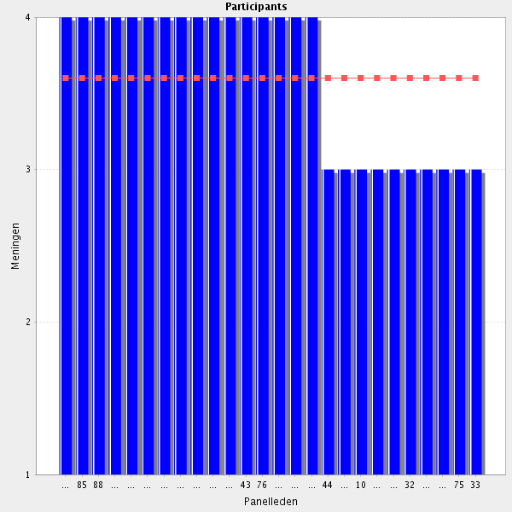
Average score: 3.6
Summary: misses educational aims and objectives.
Proposal: amend to:-
Can describe and discuss common ethical principles and their application in research.

Discuss:
As most pharmacists are involved in different kind of research, it is basic to have this understanding
It is difficult to measure to what extent something has been understood. Perhaps "Knows..." would be better.
at least the basics for all pharmacists

6.4 Clinical trials - Understands the differences and significance of clinical trials phases, the importance of good clinical practice and the role of pharmacy in clinical trials.
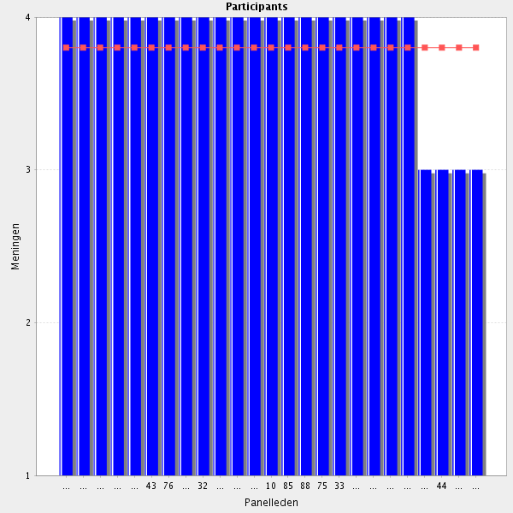
Average score: 3.8
Summary: no change required

Comments:
Necessary part of role
is part of the Pharm D program
Suggest amending to the role of the pharmacist Vs the role of pharmacy.
Very important
Understand yes, but not every pharmacist needs to be a clinical researcher.

6.5 Clinical trials - Is able to review protocols and the portfolio in terms of quality assessment.
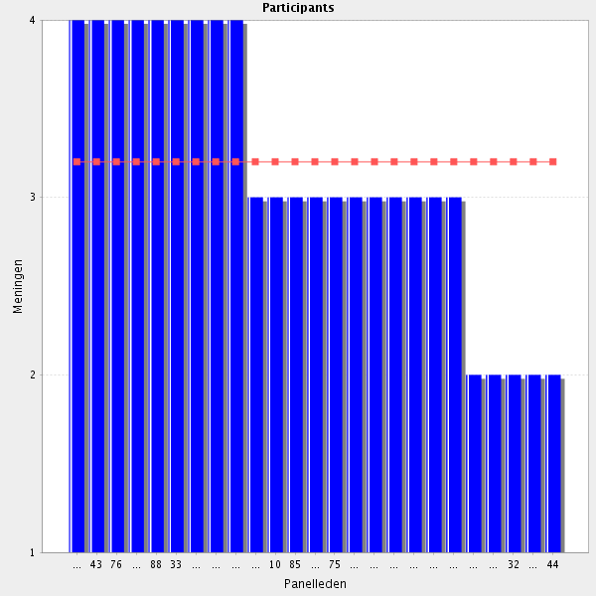
Average score: 3.2
Summary: inherent in taking an active role in the ethics committee. Therefore not required.
Proosal: delete for Delphi 2.
Comment:
Depending on the institution where they work or the degree of involvment in quality
"If applicable"
Not sure what "the portfolio" refers to? Is it the clinical trail protocol? If so no need to repeat it. Typo in the word Clinical.
"When employed as a specialist, is able to review..."
It is good to have some basic knowledge, but otherwise only if you are involved in research.
Not every hospital pharmacist needs to be involved this deep in Clinical trials/research. Basic knowledge or speciality?

6.6 Clinical trials - Is able to ensure the pharmacy role in storing, preparing and dispensing the investigational medicines.
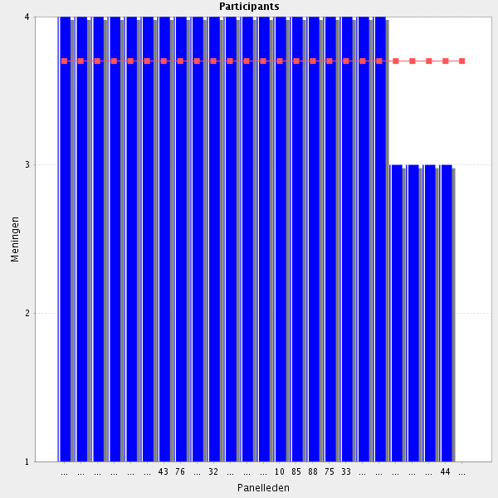
Average score: 3.7
Summary: reword as per participant suggestion:
Proposal: Amend as below:-
Assures the pharmacy role in storing, preparing, dispensing and destroying investigational medicines.

Comments:
"If applicable"
Amend phrasing. Suggest: "Is able to safeguard or ensure the quality of the pharmacy role in storing, preparing and dispensing the investigational medicines."
Yes, because managing investigational medicines is part of the pharmacy service activities
I would also like to add something regarding the procurement of investigational medicines, for instance "...the pharmacy role in procuring, storing, etc..." Working in a non-EU country it's actually quite time consuming to get all the import licences, agreements etc. and in the clinic this is the task of the pharmacy. Alternatively it can be changed to just "...the pharmacy role in handling the investigational medicines" as I also miss something regarding destruction in the statement.
I strongly disagree with this statement. The ability to do so basically has nothing to do with education. Ensuring the pharmacy role in these areas is a matter of national/regional/local legislation, the pharmacies' lobbying power and the principal investigators' "goodwill".

6.7 Before going to the next Cluster: do you have a remark, suggestion and or question on this group of competencies?

pharmacists must be fully integrated at any stage of clinical trials and medical research

