

EAHP
CTF - Cluster 2. Medicines and their use related competencies

Delphi Round 1

Synmind BV / FB
Haarlem, 21 March 2017

Group 1: Development, production, analyses and control of medicines 3
Group 2: Provision of medicine and medical devices 48
Group 3: Medicines and medical devices information and patient education 76
Group 4: Monitoring medicines therapy and medical devices 98
Group 5: Interface management 147
Group 6: Evaluation of outcomes 159
Group: 1 Development, production, analyses and control of medicines. (Group 7 of 26).
1.1 Development - Is able to understand the relevance of using different active ingredients from different sources.
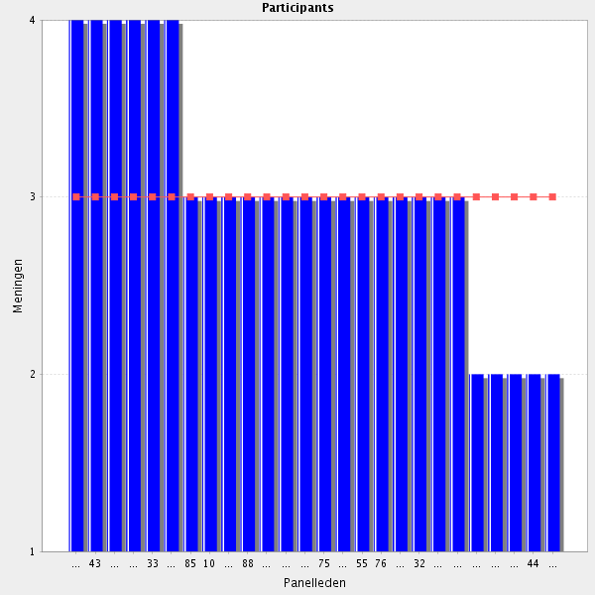
Average score: 3.0
Summary; lots of participants fon’t underand and neither do facilitators. And why is this the first item in this section? It certainly isn’t the most important is it?
Proposal: delete for Delphi 2. Ask for clarification.
core competence
Pharmacist have to have some knowlegde but it is not necessary I high level knowledge in their practice in the hospital
Strongly agree
not essential
ok but not mandatory
Important but not essential
I'm not sure why this states from different sources? Perhaps I'm misunderstanding the question?
It is not clear.
The competency should be clarified.
Should be clarified.

1.2 Development - Is able to apply an understanding of development, production, compounding, quality assurance (analysis and control) and distribution of pharmaceutical products.
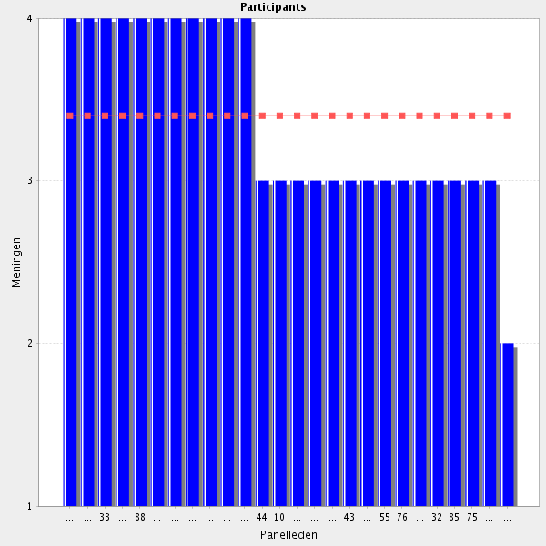
Average score: 3.4
Summary: as identified by particiapnt needs rewording to be educationally appropriate.
Proposal: Amend to:-
Can demonstrate a wide understanding of the processes required for the development, production, compounding, quality assurance (analysis and control) and distribution of pharmaceutical products.
Comments:
core competence
core skills
necessary for HP
Important - the pharmacist is the one with best knowledge of this in the clinic.
Necessary part of role
Important but not essential
Ok but not necessarily in depth
Should have knowledge but not be specialits.
Applying an understanding would suggest involvement in production to me - would "Has and understanding..." work better?

1.3 Development - Has an integrated vision of the role of the various disciplines that are involved in the development of a medicinal product.
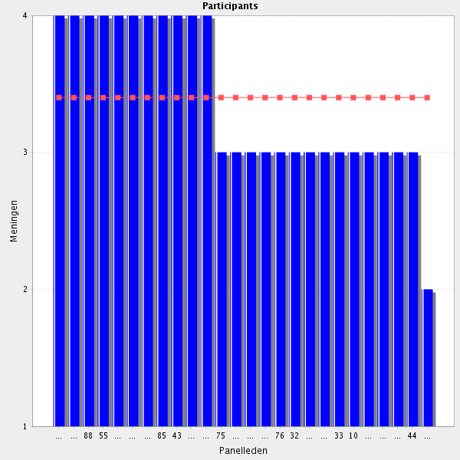
Average score: 3.4
Summary: is a duplication of:-
Can demonstrate a wide understanding of the processes required for the development, production, compounding, quality assurance (analysis and control) and distribution of pharmaceutical products.
Proposal: delete.
Comments:-
important to have a critical view of medicine development and in clinical trials where pharmacists are involved in
It is after all the area of expertise of pharmacists.
As pharmacists they have to know it, even if their will not apply directly to their every day practice
If the pharmacist doesn't have this, who does?
It is after all the area of expertise of pharmacists.
Please clarify what "Integrated vision" means.

1.4 Formulation - Applies knowledge related to the design, manufacture and performance of dosage forms and is able to critically appraise the inter-relationships between formulation (including excipients), medicines delivery and therapeutic product.
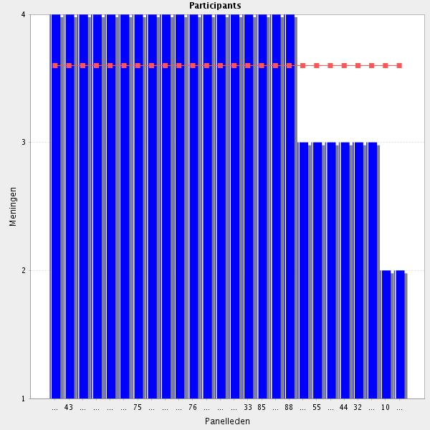
Average score: 3.6
Summary: minor rewording only for Delphi 2.
Proposal: Amend to:-
Applies knowledge related to the design, manufacture and performance of dosage forms and can critically appraise the inter-relationships between formulation (including excipients), medicines delivery and therapeutic product.

Comments:
If not the pharmacist, then who?
part of the curriculum to pharm D
I really agree
part of the curriculum to pharm D
Hospital pharmacist needs this knowlege in order to be able to use it for drug selection
As basic skills that may be advanced through training to become expertise
a hospital pharmacist can not do it some countries
a. There are two competencies in this sentence. Unless highly interlinked there should be one competency per sentence. Otherwise it is difficult to measure whether the competency is achieved. b. Suggested wording: "Knowa how to apply knowledge related to...." c. "Medicines delivery" is not the appropriate term in this context as it pertains to distribution rather than biopharmaceutical Groups.
1.5 Production - Is able to apply the knowledge related to the quality requirements for Good Manufacturing Practice (GMP) of pharmaceutical production on both a small and industrial scale, including Standard Operating Procedures (SOP) and the supervision standards required to achieve these quality levels.
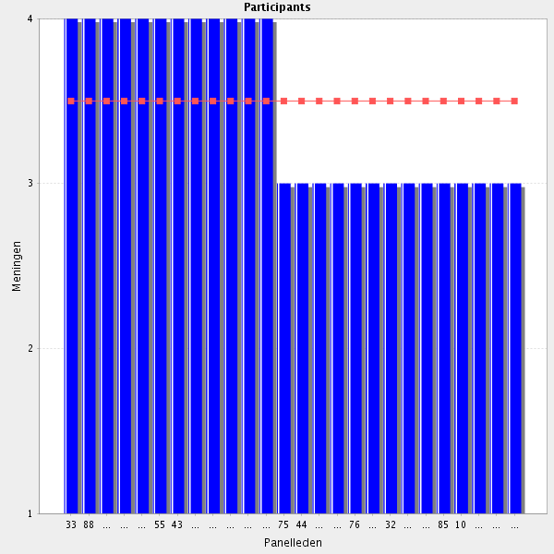
Average score: 3.5
Summary: minor rewording only.
Proposal: Amend to:-
Can apply the knowledge related to the quality requirements for Good Manufacturing Practice (GMP) of pharmaceutical production on both a small and industrial scale, including Standard Operating Procedures (SOP) and the supervision standards required to achieve these quality levels.
Comments:-
basic skills
As basic skills that may be advanced through training to become expertise
If not the pharmacist, then who?
As basic skills that may be advanced through training to become expertise
basic skills for all hospital pharmacists (especially concerning small scale production and making reading for administration) ; more in depth for those who specialize in production. Large scale production in hospital pharmacy is not a synonym for Industrial production in my opinion.
Not all pharmacists should be involved in this task, but only those who were extra trained in this matter.
not relevant in a in depth knowledge to all pharmacists but a prerequisite for those involved in (specialisation in this area required)
Only at small scale

1.6 Production - Is able to draw up and maintain procedures for sterile and aseptic production of medicines, total parental nutrition and radio-medicines.
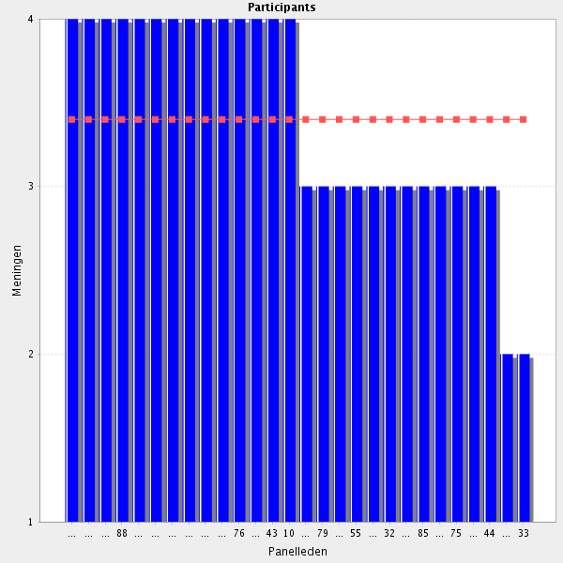
Average score: 3.4
Summary: minor rewording only
Proposal: Amend to:-
Can create and maintain written procedures for sterile and aseptic production of medicines, total parental nutrition and radio-medicines.

Comment:
If not the pharmacist, then who?
Only with proper procedures will it be possible to ensure and comply with the necessary environmental prodution conditions, to produce safe medicines and to protect those who prepare cytotoxics or radiopharmaceuticals.
core skills in clinical pharmacy
The sterile and aseptic production is a very important part of hospital pharmacies
It is very important that the pharmacist is involved in the procedures for the aseptic production taking place at the ward.
Yes
Section about qualified person dialysis and production of water for dialysis is missing.
As basic skills that may be advanced through training to become expertise. In addition, it is important to know the extend of the pharmacist's participation in such procedures and activities. Should other health professionals be involved in the drawing up and maintaining of procedures and production? Would it be work at bench level or just supervision for the production?
in depth knowledge mandatory for pharmacists involved in production and a general knowledge to all pharmacists
Depends on the kind of hospital
No common knowledge for every hospital pharmacist.
I understand that aseptic compounding is not mandatory in some countries but we should be careful with this. Compounding is the only exclusive competency of pharmacist. Even dispensing could be controversial!
Is it necessary that every Clinical pharmacist has knowledge to put SOPs in Place for this? Many Clinical pharmacists (for example in primary care) will never use this knowledge.
Agreed but the framework is for Hospital Pharmacy not Clinical Pharmacy.
An awareness of the need for SOPs etc. is essential and experience of the same also. However drawing up and maintaining such procedures are not essential for all hospital pharmacists e.g. those working in specialist areas such as mental health hospitals that would never have aseptic production.
It should say parental nutrition (PN) instead of total parenteral nutrition (TPN), since TPN is a type of PN. An explicit reference to advanced therapies products should be made somewhere in this document. [EU Regulation 1394/2007]
Is able to draw up and maintain procedures for sterile and aseptic production of medicines, including parenteral nutrition, hazardous drugs, radio-medicines and advanced therapy products.
is should be "PN" in stead of "TPN".

1.7 Active substances and excipients - Is able to apply knowledge related to the understanding the main sources of active substances and the major excipients and the ways in which they are purified, characterised and analysed.
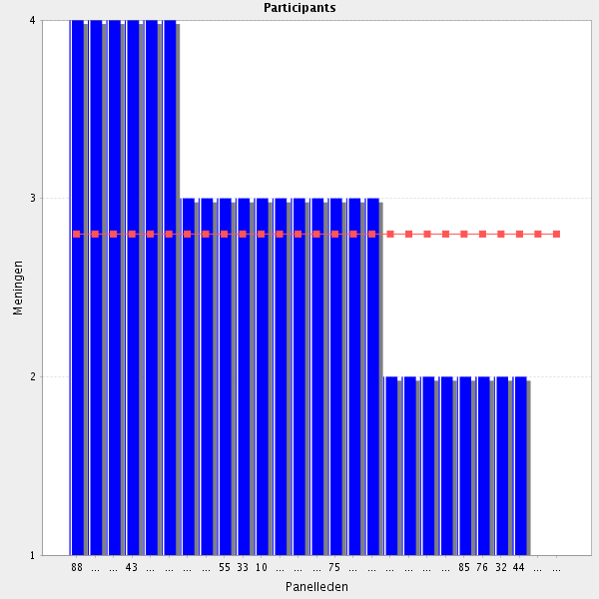
Average score: 2.8
Summary: merge with a previous element to produce:-
Can apply knowledge of the active substances and major excipients, their sources, and the ways in which they are purified, characterised and analysed, and can critically appraise the inter-relationships between formulation (including excipients), medicines delivery and therapeutic product.
Proposal: use above in Delphi 2.
Comment:
If not the pharmacist, then who?
As basic skills that may be advanced through training to become expertise
Pharmacists should be able to understand an analysis report of a raw material (active substance or excipient). They should also know that depending on the analytical technique used (eg HPLC), the purity of the raw material purchased might be higher or lower, as well as the impurities profile.
I agree, but a word is missing in the text. - "of" between "understanding" and "the"
Some knowledge needed, but maybe not in depth. Typo in the sentence ("to the understanding the".
it is not necessary for the routine skills
not relevant
I think that these skills are more related for industry
This is a task for chemists. Pharmacists may be involved in it, but performing this activity must not be compulsory.
This is a task for chemists. Pharmacists may be involved in it, but performing this activity must not be compulsory.
I agree with 129: Beyond the scope of a hospital pharmacist. Applicable to Industry Pharmacists only
Not a required routine skill in my opinion.
Beyond the scope of a hospital pharmacist. Applicable to Industry Pharmacists only.

1.8 Analysis of available medicines - Has an appropriate understanding of the role and application of the various techniques for the analysis of pharmaceutical products.
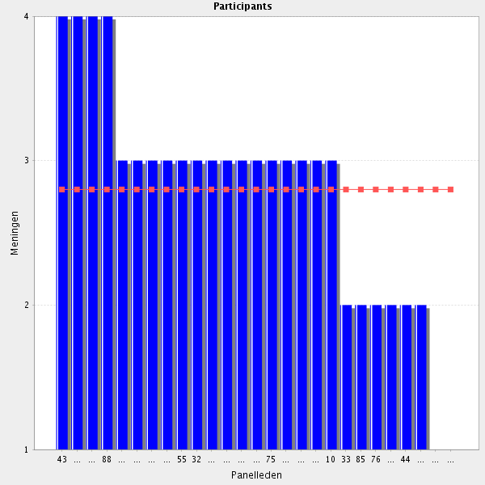
Average score: 2.8
Summary: duplication of better worded element from Cluster 1. \
Proposal: delete this for Delphi 2.
Comments:
If not the pharmacist, then who?
this may become in an advanced skills
Basic principles; advanced/in depth within a differentaition or specialisation/training after the basic specialisation/curriculum
As basic skills that may be advanced through training to become expertise
I agree that the pharmacist should know how to evaluate the products he/she prepares. In the case of the preparation of radiopharmaceuticals, such analytical control should always be carried out. For most radiopharmaceutical preparations this would mean to measure the percentage of labeling by thin layer chromatography before administering to the patient.
There are countries where this is not mandatory, but I understand it may be a need in some other countries. I agree then.
As the previous question, are more required for pharmacists working in industry
This should be reserved only for pharmacists who would like to participate in this task or for other proffesions.
Again, only applicable if involved in production of medicines i.e. in Industry.
only for some colleagues specialized (quality control and TDM services)
Beyond the scope of hospital pharmacy.

1.9 Quality - Is able to both apply the knowledge and understand the place of and importance of quality control and quality assurance principles in manufacturing in order to produce a quality product.
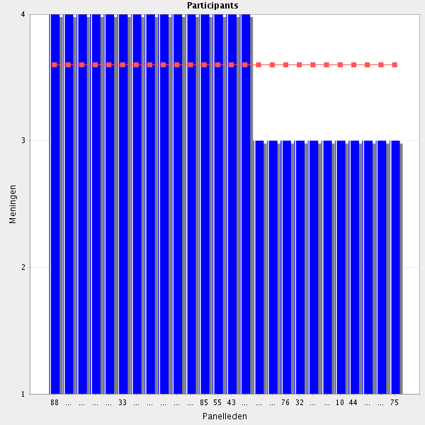
Average score: 3.6
Summary: another duplication.
Proposal: delete from CTF for Delphi 2.
Comments:
Q control and Q assurance are mandatory in a team for the different areas of hospital pharmacy (not only production)
If not the pharmacist, then who?
Important for patient safety
Yes in the degree of small production in the hospital

1.10 Distribution - Is able to apply an integrated understanding of the organisation and monitoring of the distribution of medicinal and other healthcare products including the regulations applying to pharmaceutical sales and marketing.
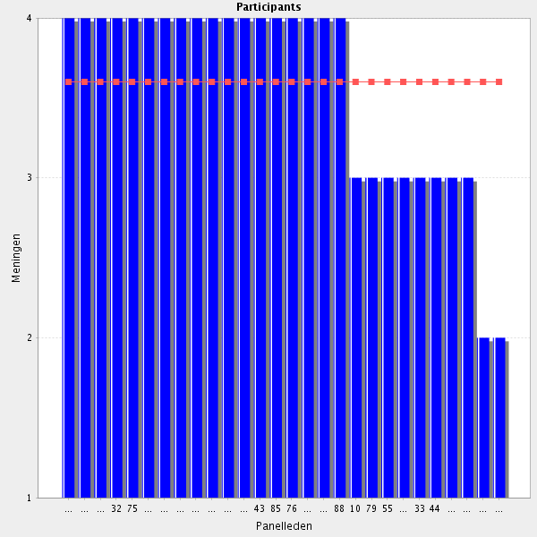
Average score: 3.6
Summary: badly pharased and two elements combined together, as noted by participant.
Proposal: separate out and link with similar elements describing procurement (distribution) and professionalism (re sales and marketing).
Comments:
a in depth understanding of the regulations is mandatory especially for organisation and distribution of medicines and Med devices
If not the pharmacist, then who?
At hospitals, drug distribution is the most visible Group of pharmaceutical activity. All distribution of medicines/medical devices should be done according to the Good Practices of Hospital Pharmacy. In the case of blood products, narcotics and clinical trials medicines, it is still necessary to comply with current national legislation.
Distribution is one of the main activities of hospital pharmacists
basic skills
Missing reference to Good distribution practice.
As basic skills that may be advanced through training to become expertise. In addition, assistance by other health professionals should be provided. It is a team work.
Not equally important across the field of hospital pharmacy jobs / activity areas. These are mainly importan for pharmacy managers and HPs involved in procurement and logistics.
There are two competencies in the sentence. Unless highly interlinked there should be one competence per sentence. Sales and marketing are distinct from distribution per se.
From my personal view, pharmaceutical sales and Marketing are no important competences that each hospital pharmacist must have
Partly agree, but in the Communication and support of prescribers it is essential to know regulations. That is why I chose "agree".

1.11 New technologies - Has knowledge of the production, quality assurance and applications of biotechnology, nanotechnology and genomics where they apply to medicines, medicines development and production. This includes handling and distribution of medicines, compounding, reconstitution, and advanced therapy medicinal products (ATMPs).
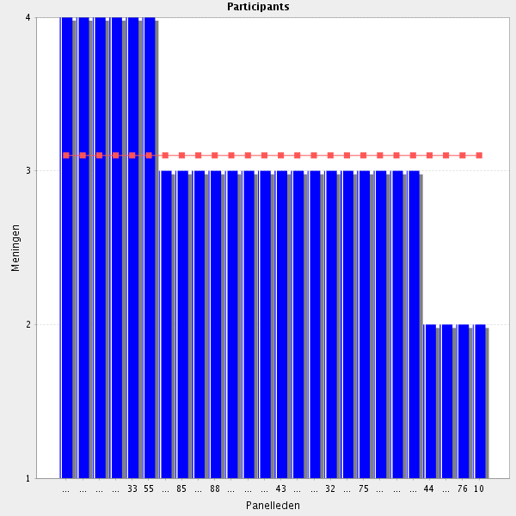
Average score: 3.1
Summary: needs rewording.
Propsal: amend to:-
Works with others to ensure the safe and effective introduction of new technologies including the production, quality assurance and applications of biotechnology, nanotechnology and genomics. This includes handling and distribution of medicines, compounding, reconstitution, and advanced therapy medicinal products (ATMPs).

Comments:
This is becoming increasingly important. Gene therapy distributed through hospital pharmacies is already on the market in Europe (Imlygic).
This is becoming more and more important. We have to invest!!!
As we proceed to the era of genetic therapy and we soon believe that the CRISPR-Casp9 applications will be proved a revolution for therapy, we should prepare ourselves for this.
Has to have knowledge but not at a level of high application
but only basic knowledge
Or knows where to find information thereof
should be considered for a close future ((ATMPs and diverse biotechnology products)
An awareness is recommend but not essential.
"If applicable
The grammar can be improved. I do not think it is grammatically correct to write "..production....of biotechnology".
Knowledge? Not so sure. Awareness? Definitely.
we dont know about ıt "

1.12 Qualified person - Understands the roles and responsibilities of the Qualified Person, accordingly to applicable legislation and guidelines, such as, Pharmaceutical Inspection Convention (PIC).
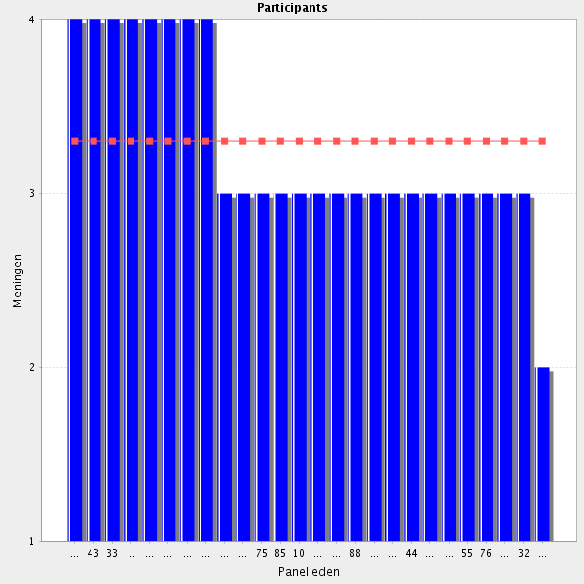
Average score: 3.3
Summary: can be simplified (see comments) and tested in Delphi 2.
Proposal: Amend to:-
Can describe the roles and responsibilities of the Qualified Person, accordingly to locally applicable legislation and best practice.

Comments:
Necessary to understand the respective roles and responsibilities
Some understanding is recommended but again more applicable to pharmacists working within the pharmaceutical industry than within hospital.
Is more applicable to industry
Some understanding is needed.
When and where such roles and activities exist and are well defined.
if applicable according to the national regulations. In some countries, the hospital pharmacist endorses the responsibility of the development, production and control of medicines.
I´m not sure that this is important for HP. The area is very complicated.

1.13 Quality management systems - Demonstrates familiarity with quality management systems applied to pharmaceutical products and pharmacovigilance (e.g. adverse reaction reporting systems).
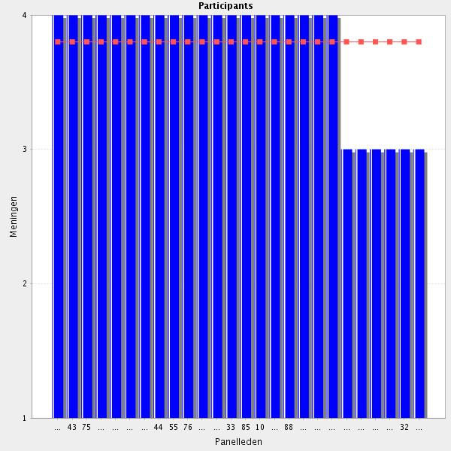
Average score: 3.8
Summary: better worded element in Clusiter 1. Duplication.
Proposal: delete as duplication.
Comments:
If not the pharmacist, then who?
It is an one way street to have such systems developed, implemented and evaluated, if we wish to improve patient safety.
Is a basic area to work for hospital pharmacists. They play an important role in reporting adverse effects.
quality management systems should be made familiar to pharmacists

1.14 Validation of medicines production processes - Understands the theory and practice of validation of medicines production processes.
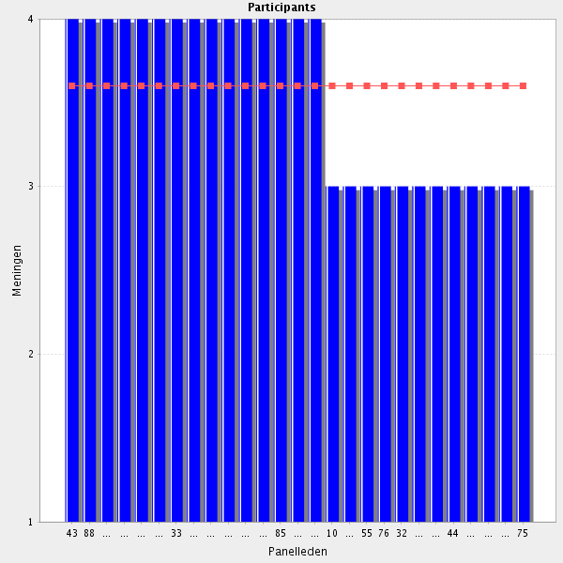
Average score: 3.6
Summary: this is already inherent in quality assurance ellents already covered in the CTF.
Proposal: remove as duplication.
Comments:
Eventhough not all hospital pharmacists have experience in drug production, everyone will have to know that no product produced at the hospital pharmacy can be released without having been previously validated by the pharmacist responsible for the production. This validation will include verifying the batches, shelf-life and quantities of the raw materials used, the Group of the final product and the labeling, among other requirements.
If not the pharmacist, then who?
In order to prepare medications in the pharmacy services is obvious that these skills are needed
not to all pharmacists but a basic level should be mandatory and expertise should be developed to some colleagues within a team
As basic skills that may be advanced through training to become expertise
But not essential for hospital pharmacists.
yes, but only basic knowledge.

1.15 Before going to the next group: do you have a remark, suggestion and or question on this group of competencies?

I think that some skills related to the drug manufacture, should be adapted to their applicability in hospitals
Many points in this chapter seem to apply more for industrial pharmacists and industrial production. Knowledge vs. awaraness should be considered for some points.
It is important to clarify if these skills apply to individual extemporaneous preparation of sterile and non-sterile products at the hospital pharmacy (e.g. preparing extempore capsules for children, cytostatics, targeted radiotherapeutics, TPN products) or team-work in research/development at pharmaceutical industry. But in both cases the competencies regarding the safe production are vital.
I think this section should be based on the quality by design principles. Here can be found a good review on this: https://www.ncbi.nlm.nih.gov/pubmed/26891559
Many points need training and technical evaluation of the pharmaceutical team. It is not for all the hospital pharmacy
I think the majority of these relate to pharmacists working within the pharmaceutical industry and would not be relevant to clinical pharmacists working in hospitals.
I agree. I think only pharmacovigil. is important for HP
These seem to be the basics of medicines. Someone in the hospital setting needs to be able to provide the necessary knowledge to other healthcare professions on these issues, if required. If it's not to be the hospital pharmacists' basic competence, whose should it be?
In this group of competencies product care, knowledge about production an quality control/quality assurance and able to set op large scale production or quality control programs and validation processes is mixed. In my/our opinion product care and knowledge of production is one of the main competencies a hospital pharamcists have to combine with patient care competencies. Besides that basic knowledge of preparation, production an QC/QA is also necessary for all hospital pharamcists. The more advanced/in depth knowledge and able to set up for instance a large scale production/procedure can be done in a differentiation module if applicable in a curriculum or after specialisation through additional training.
Group: 2 Provision of medicine and medical devices (Group 8 of 26)
2.1 Prescription - Ensures that the prescription is clear and that the intentions of the prescriber are understandable.

Average score: 4.0
Summary: cannot tell intentions from a prescription, nor can training ensure a prescription is “clear”.
Proposal: delete as a stand alone element. Replace with:-
Ensures prescriptions are clinically appropriate and meet national legal requirements.

Comments:
It is essential that it happens
Whenever a pharmacist has doubts regarding a prescription, he/she should contact the prescriber before realising any medicine. By doing so, pharmacists are contributing for the rational use of medicines, preventing in some cases medical errors.
To ensure that a presciption is clear, understandable and legal .... is not enough for a pertinent and safe medical care of the patients. Hence the analysis and validation of the prescription by the hospital pharmacist should be mentionned in a specific chapter.
It is essential that it happens.
Fundamental
If not the pharmacist, then who?

2.2 Prescription - Ensures the prescription is legal and accordingly to applicable legislation.
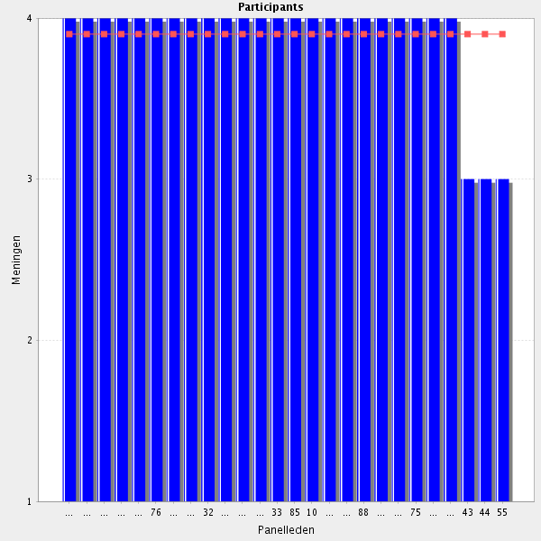
Average score: 3.9
Summary: rewording required.
Proposal: delete as a stand alone element. Replace with:-
Ensures prescriptions are clinically appropriate and meet national legal requirements.

Comments:
If not the pharmacist, then who?
When prescribing, doctors must obey national legislation. For instance, only neurologists working in the state hospital can prescribe medicines for mutiple sclerosis. So, pharmacists must know well the health legislation of their contries before starting to release medicines.
to be sure that the medicine are used in a pertinent manner (and avoid litigation) a precise knowledge of the regulations is mandatory
Typo - "Ensures the prescription is legal according to applicable legislation"
To be sure that the medicine are used in a pertinent manner (and avoid litigation) a precise knowledge of the regulations is mandatory.
Pharmacists have in any moment to know and be aware of legality relating to all their work
ıf the prescription wrıtten ın hospıtal for the hospitalized patiens ıtıs yes
Important but needs accurate and precise knowledge of legislation that is timely communicated to the pharmacist

2.3 Prescription - Participate in the development and updating of the hospital formulary.
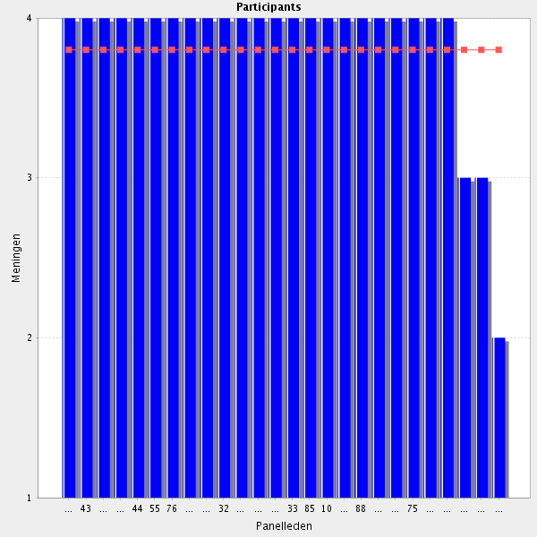
Average score: 3.8
Summary: minor rewording.
Proposal: Amend to:-
Participates in the development and updating of the hospital formulary
Comments:-
Formulary is more and more replaced by regional protocols ( non-specific hospital related drugs; drugs in the ambulatory or home setting)or specific protocols within different specialisms. In all cases hospital pharmacist has to participate so this has to be part of the curriculum
Core part of role
It should be obligatory to have a pharmacist participating!
Very important task!
Pharmacists are the best healthcare professionals for the development and updating of hospital formulary. Pharmacists background allow them to know a lot about medicines (e.g. mechanism of action, pharmacokinetics, pharmacoeconomics, etc).
pharmacists should always be involved in such task with other HC professionals
Pharmacists are the best healthcare professionals for the development and updating of hospital formulary. Pharmacists background allow them to know a lot about medicines (e.g. mechanism of action, pharmacokinetics, pharmacoeconomic...).
Pharmacists are the best positioned to give information and advice.
Not a competency as it is worded - should be reworded to "Able to participate in...."
2.4 Labelling the medicine (if applicable) - Ensures medicines are labelled accurately complying with all necessary labelling guidance (e.g. with clear dosage, instructions warnings, direction about error avoidance like look alike and sound alike (LASA) medicines and other required information) and that the label is appropriate for the patient and healthcare professional.
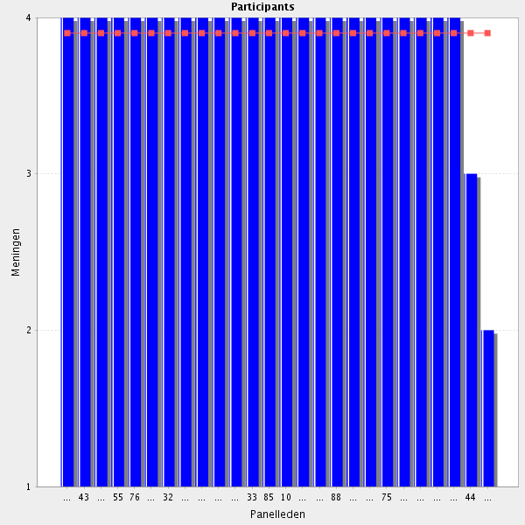
Average score: 3.9
Summary: minor rewording required.
Proposal: amend to:-
Ensures medicines are labelled accurately and comply with legislation and local and national guidance, and that the label is appropriate for the patient / carer or the healthcare professional.

Comments:-
Essential for patient safety and key component of pharmacist's responsibilities
It is very important, but in some countries such practice does not exist.
Only with correct labelling it is possible to prevent administration errors. Pharmacists should enforce labelling guidelines. For that, they must regullary inspect wards, operating rooms and emergency rooms. When giving medication to outpatients, pharmacists must be assured patients understand what is written in the label. If a patient does not know how to read, the label given to that patient should not have words, but drawings or signs (e.g. a plate and the moon if the medicine is to be taken at dinner time).
Essential for patient safety and key component of pharmacist's responsibilities
Obvious. This is a practically exclusive work of pharmacists
Core part of role
Should be reworded to "Be able to ensure that.....".
2.5 Stock management - Ensure effective stock management.
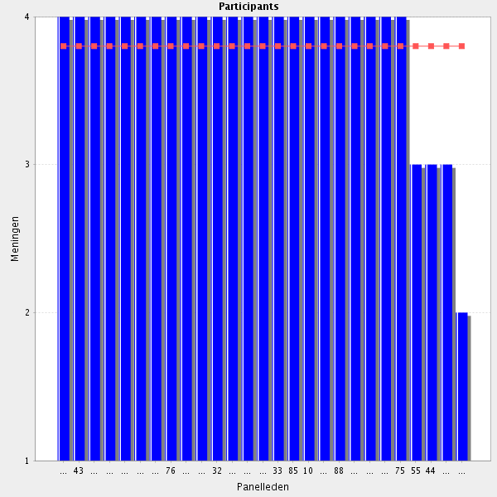
Average score: 3.8
Summary: minor rewording required.
Proposal: Amend to:-
Manages stock effectively.
Comments:-
Core part of role
It is extremely important to avoid run outs. Still, no one wants to have in the pharmacy stock for one year. Even those hospitals who have enough money, would not probably have space to keep one year stock of medicines/medical devices. So, it is important that the pharmacist is able to do stock management.
precision should be given to the word "effective". Quality insurance of the handling, packaging or warehousing could be mentionned, as well as qualification required for the professionnals in charge of these duties.
Provided that there is assistance from other personnel, infrastructure and budget.
One of the main issues that has to cover the hospital pharmacist
Provided that there is assistance from other personnel, infrastructure and budget
At least be able to delegate/coordinate stock management.
Should be reworde to "Be able to ensure effective....."
2.6 Stock management - Avoid excess and shortage of the medicines (and medical devices).
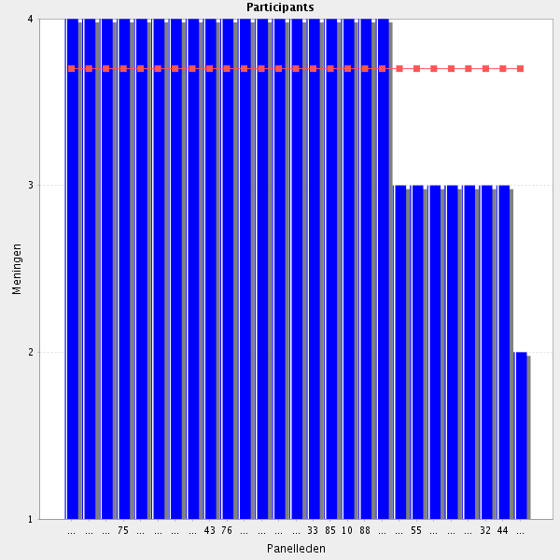
Average score: 3.7
Summary: duplication of previous element.
Proposal: delete.
Comment:
stock keeping of medical devices is not in every country the responsibility of hospital pharmacy
Optimal / sensible / reasonable inventory management would summarize this point. Basic hospital pharmacy skill, not relevant in the clinical setting though.
strongly agree
Core part of role
Pharmacists must try to do their best in order to avoid shortages, as well as excess of medicines/medical devices. Since resources are limited, before buying medicines/medical devices pharmacists must know their hospital consumption by service. Even when resources are not a limitation, space and storage conditions might be. If we want that outpatients comply with their treatments, it is essential that whenever they come to the hospital to get more medication, we have that medication to give.
a good knowledge of the stock management is necessary to be sure patients have access in a timely manner to the relevant medicines and Med devices
Provided that there is assistance from other personnel, infrastructure and budget.
Ok, but not all pharmacy services manage medical devices.
Effective inventory management
Add "wherever possible"
Provided that there is assistance from other personnel, infrastructure and budget
sometimes hard to avoid
Should be reworded to "Able to avoid excess......". Otherwise it sounds more like an item in a job description than a competence.

2.7 Stock management - Keeps track of expiry dates, production lot number (fundamental on safety recall), and storage conditions.
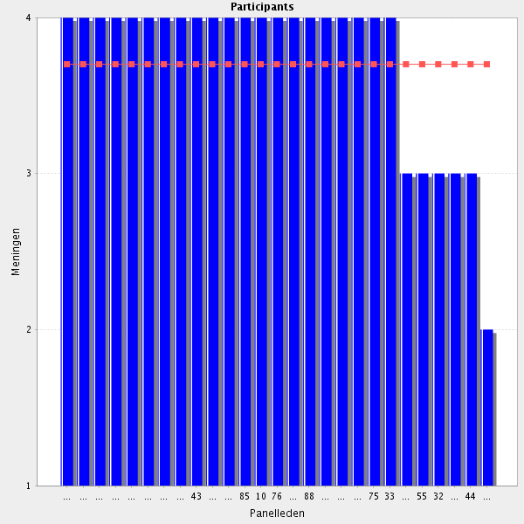
Average score: 3.7
Summary: can be merged with previous.
Proposal: Amend to:-
Manages stock effectively, including keeping track of expiry dates, production lot numbers, and storage conditions.

Comments:-By all means so. I wonder if "Stock management" competency really needs this level of detailing.
Or at least is involved in establishing the routines necessary to accomplish this (and the pharmacy technicians or nurses assist the pharmacists in the everyday work at the hospital).
Core part of role
It is extremely important that pharmacists have computer programmes which allow them to keep track of expiry date of the medicines/medical devices that exist in the pharmacy. Audits should be taken every 6 months to services (e.g. wards, operating rooms) in order to check expiry dates. Medicines prepared in the pharmacy should all have a production lot number. Records of production should be kept. In those recods it is not only essential the lot number of the medicine that it was produced, but also the lot of every ingridients used. Temperature should be monitored in all areas where medicines/medical devices are stored. Fridges should emit a sound alarm whenever the minimum/maximum temperature is exceeded.
technology should be made available for such task (that can be performed by other professionals under the supervision of a pharmacist)
Technology should be made available for such task (that can be performed by other professionals under the supervision of a pharmacist).
As the managers of stores and stock they are the professionals that have to do all these activities
Provided that there is assistance from other personnel, infrastructure and the administration of the institution
"Be aware of the need to keep track of expiry dates..." Often these tasks are performed by technical or administrative staff.
Should be rewoerded to "Knows how to keep track....".

2.8 Stock management - Ensure effective transportation of the medicines and medical devices.
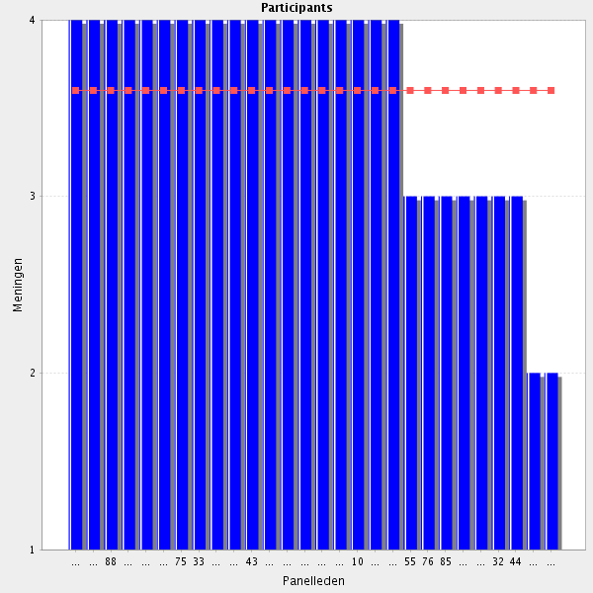
Average score: 3.6
Summary: rewording required.
Proposal: Amend to:-
Ensures safe and effective transportation of medicines and (where appropriate) medical devices.
Comments:
medical devices is not in every country the responsibility of hospital pharmacy.
Ensure the maintenance of an appropriate temperature
Core part of role
It is essential that all medicines/medical devices are correctly transported. Pharmacists must garantee that those products that need refrigeration are transported in a freezer. Radiopharmaceuticals should be transported in a proper container with a sign indicating radiation.
Stock management should be considered apart from the logistics of drugs and medical devices from the pharmacy department to the medical wards.
Add "when within their realm of responsibility" i.e. not responsible for delivery to the pharmacy.
Provided that there is assistance from other personnel, infrastructure and budget. It should be a team work
Including the safe transportation of individually prepared extemporaneous products to the patient in out of hospital /homecare (e.g. nutrition products, dialysis products).
Provided that there is assistance from other personnel, infrastructure and budget. It should be a team work
Together with other peple involed in the process of drug transport.
Has to participate but I do not think that has to have the sole responsability, and therefore a in depth knowledge
"Effective" is one Group, but "safe" is equally important to me. Keep in mind that the drugs we provide to the patients/wards can be quite harmful (cytotoxics, GMOs etc.)
I disagree that ensuring effective﻿ transportation is part of the HP skill set.
Should be reworded to "Knows how to ensure effective...."

2.9 Stock management - Ensures good distribution practice is always kept.
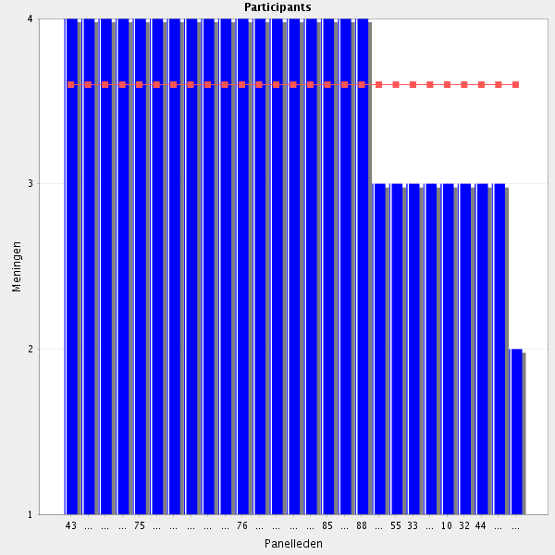

Average score: 3.6
Summary: can be merged into a previous element.
Proposal: merge to form:-
Works with others in the organisation and monitoring of the distribution of medicines and medicines-related products to efficiently maintain the supply chain, applying Good Distribution Practice.

Comments:-
Core part of role
It's up to the pharmacist to ensure that good distribution practice is always kept. For instance, medicines with lower expiry date should be stored in the front of the shelf, so that they would be the first to be picked. When all medicines have the same expiry date, those that arrived later should be stored at the back.
apply if the distribution circuit is under the responsibility of the pharmacist
It's up to the pharmacist to ensure that good distribution practice is always kept
As it is related to the patient safety it is basic for the pharmacist
Provided that there is assistance from other personnel, infrastructure and budget
Overlaps with previous question. To me distribution is to do with transportation of goods - does it mean something different here?
Should be reworded to "Knows how to ensure good distribution practice".
2.10 Before going to the next group: do you have a remark, suggestion and or question on this group of competencies?

It might be worth considering combining points detailing stock management skill-(sub)sets.
the physical flux of medicines and medical devices should be coordinated by pharmacists (from companies to department of pharmacy and from department of pharmacy to medical wards or patients)
but does it have to be a Clinical pharmacist (by definition)?
Group: 2 Provision of medicine and medical devices (Group 9 of 26)
3.1 Public health and health needs - Provides lifestyle advices appropriate to the needs of the patient. Is aware of local services and public health initiatives (e.g. screenings).
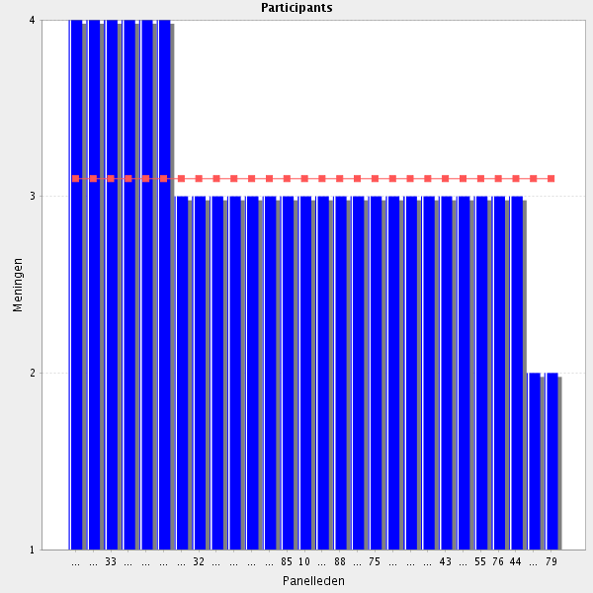
Average score: 3.1
Summary: needs ammendment; see comment.
Proposal: amend to:-
Where applicable, can provide lifestyle advice appropriate to the needs of the patient.
Comments:
Very important for pharmacists dealing with outpatients
"Where applicable" This could be counter productive in a team of dietician, physio etc - but could be crucial in small, out-patients clinic. I think the statement requires further contextualisation
Very important both for outpatient and bedside counseling.
I think it is mportant to advice this type of information for the patient
necessary information for out patients
in coordination with other HC professionals
This is particulary important when dealing with outpatients. For instance, if a patient starts a medicine that is eliminated by the kidney, one should reinforce the need to drink water (1,5 L/day) and explain to the patient why. In fact, all of us should drink water. Still, some of us don't do it... Whenever possible, medicines should be adapted to patient's routine. If a patient is overweighted, pharmacist might advise him/she to try to do some exercise, or at least to walk. Eventhoug I agree that pharmacists should be aware of local services and public health initiatives, sometimes it is a bit difficult to be informed about that. For the patient, it would be nice if the pharmacist could transmit that information.
Agree with first part but difficult to be aware of local services outside the hospital, especially if not within your area of expertise e.g. you may be working on a respiratory ward and advising an obese patient on weight loss but not be aware of community based weight loss clinics. Also typo - remove "s" from end of advices
Provided that there is assistance from other personnel, infrastructure and legislation
It is interesting but I do not see it as a central activity for hospital pharmacists.
This should be part of the hospital communication strategy such as leaflet distrubtion (to reinforce advice given in other hospital depts) and signage etc
Often provided by physicians and nurses as well
Provided that there is assistance from other personnel, infrastructure and legislation
Should be reworded to "Where applicable, be able to provide lifestyle advice appropriate to the needs of the patient".
Hesitant if this is a task for a pharmacist?
Agree, if the clinic provides only Life style advices. But in patient Contact it is mandatory to communicate other more important "solutions" than drug therapy (e.g. smoking cessation when COPD)

3.2 Public health and health needs - Takes into account the patient’s ethnic, cultural, linguistic and social background when assessing personal health needs.
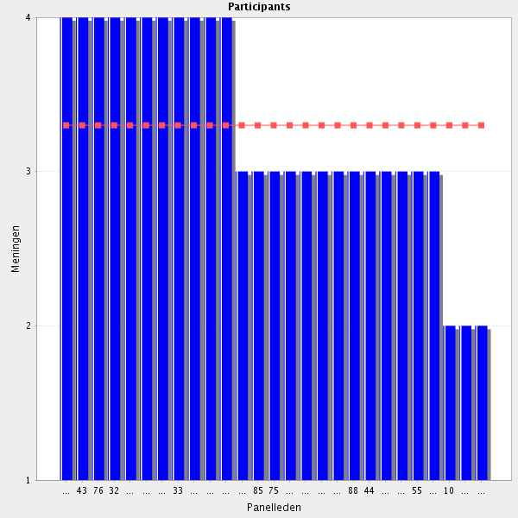
Average score: 3.3
Summary: minor ammendment and link into other communication slills elements.
Proposal: amend to:-
Considers the patient’s ethnic, cultural, linguistic and social background when assessing personal health needs.

Comments:
Very important for pharmacists dealing with outpatients
But very difficult
I agree that personal health needs should be adapted to the patient in question. But, I believe that assessing those needs is not up to the pharmacist, but to the doctor or ideally to a team of healthcare professionals which include the pharmacist, as well.
Expertise on communication skills and collaboration with other health professionals is a prerequisite, so that a pharmacist may include that in practice
As in previous comment
Expertise on communication skills and collaboration with other health professionals is a prerequisite, so that a pharmacist may include that in practice
we can not reach
"personal health needs" is essentially estimated by physicians and nurses
Should be reworded to "Able to take into account....."

3.3 Medicines information - Is aware of an individual patient’s need for information and is able to source relevant and at an appropriate level.
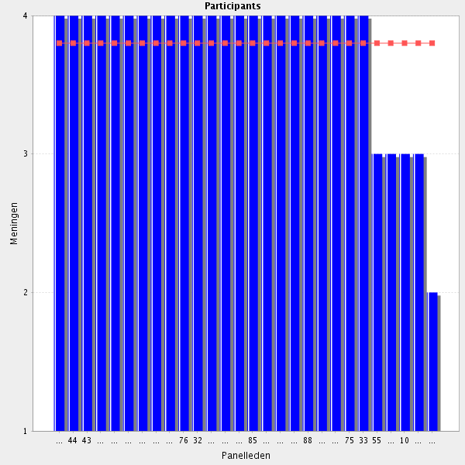
Average score: 3.8
Summary: rewording needed.
Propsal: Amend to:-
Can assess an individual patient’s need for information, and is able to provide relevant support appropriate for that patient.
Comments:-
To obtain adherence with treatment
Core part of role
The information given to patient should be adapted to the patient in question. Giving to one patient a lot of information is not a good idea, specially if she/he has just left the doctor's office. I believe that is up to the pharmacist to reinforce the key massages which have already been transmited by the doctor (e.g. how to take medicines - when, with or without food; what to do if one dose is missed; main side effects of the medicines that those medicines).
Typo - "Is aware of an individual patient’s need for information and is able to source relevant information at an appropriate level." Suggest addition of "in an appropriate form"
As a central and important purveior of information, pharmacists have to be able to determine what are the information needs and seak and give the appropriate one
Be aware of memory and cognition problems with elderly patients, not too much information, write down the instructions.
Provided that there is assistance from other personnel, infrastructure, cultural background and legislation
The information given to patient should be adapted to the patient in question.
Shoud be reworded into two separate competencies: a. Able to elicit an individual patient´s need for information. b. Able to source relevant information at an appropriate level.

3.4 Medicines information - Ensures the accuracy of medicines information, using appropriate resources and consulting colleagues as needed.
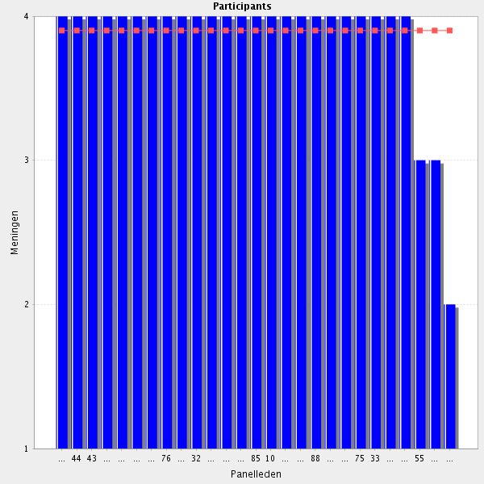
Average score: 3.9
Summary: duplication with Cluster 1.
Proposal: delete.
Comments:-
National and international data bases
Core part of role
redundancies with previous "cluster information"
The information given should always be accured. Otherwise, one might loose credibility. All information given should be supported by the appropriate resources. If neeeded, before giving information, one might ask for a colleague's opinion.
The information given has to be of high quality
Provided that there is assistance from other personnel, infrastructure and cultural status of the society
The information given should always be accured. Otherwise, one might loose credibility. All information given should be supported by the appropriate resources (e.g. summary of drugs product, Micromedex). If neeeded, before releasing that information, one might ask for a colleague's opinion.
Should be reworded to "Able to ensure the accuracy of......"

3.5 Medicines information - Provides accurate counselling to empower patients with knowledge about the medicines and what they do for the pathology associated.
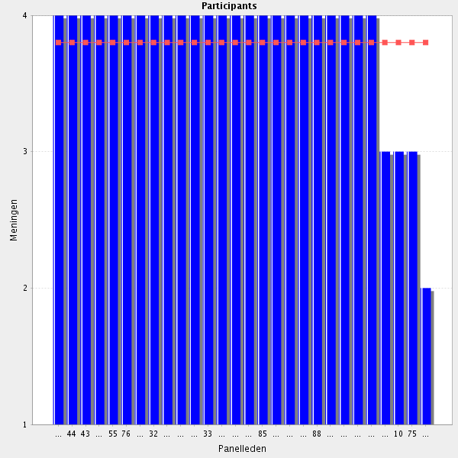
Average score: 3.8
Summary: duplication of Cluster 1 .
Proposal: delete.
Comments:-
Essential for adherence to medications
empowering patients should be considered, essential for a good adherence
This is particulary important to our outpatients with chronic diseases, since they must learn how make the best of their diseases. For instance, a patient that is taken an interferon should be advised o take paracetamol 20 minutes before injection and for at least 24h in order to prevent flu syndrome. With the exception of those patients who work at the weekends, pharmacists should also advise patients to take injections on Friday or Saturday, so that they could have some time to recover from treatment.
Core part of role
Is important to give useful information to the patient. The information has to be adapted to the characteristics of the patients in order that she/he understands it and made a good use of it, improving their health outcomes.
essential If the time permits, few minutes individual talk with the patient about the medicines, feeling to be seen by an expert can have stronger effect than placebo.
Should be reworded to "Able to provide accurate counselling....."
I am not sure whether you "empower" or "equip" with knowledge.for good adherence
3.6 Medicines information - Provides printed information when this would be helpful or is required by national regulation.
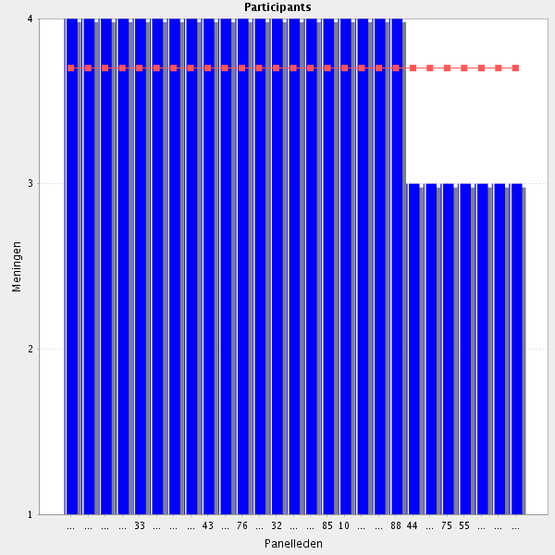
Average score: 3.7
Summary: duplication.
Proposal: delete.
Comments:-
Core part of role
the information delivery should be documented in most of the cases
Pharmacist has to determine what is the better way to informe, and this include to prepare and provide printed information adapted to the patient.
I agree with giving written information to a patient whenever he/she starts a medication or changes a therapeutic scheme. Still, if a patient does not know how to read, giving writing/printed information won't do him/she any good. In that case it would be better to have some drawings that would explain how to take medicines (e.g. a plate, with a fork a knife and the moon for those medcines to take at dinner; a bed and the moon for those to take at bedtime). Those drawings should be standardized. I agree with providing printed information to national authorities (e.g. patients taking biological drugs). That would help to know how many patients suffer from, for instance, Crohn's disease, which medicines are they taking and how much is spent in those medicines.
Provided that there is assistance from other personnel, infrastructure and budget
Provided that there is assistance from other personnel, infrastructure and budget

3.7 Before going to the next group: do you have a remark, suggestion and or question on this group of competencies?

this section should be merged with the cluster information
Pharmacists are involved in educational therapy
Repetition of questions already in cluster 1
Giving information is a important role of hospital pharmacists. it is well known that pharmacists can give a hight quality and effective information.
Medicines information is in my opinion and f.e. in the UK a broader term, related not only to patient information as you use it in this Chapter, but also to all other Groups of gathering information, practising drug information in Hospital pharmacies or producing different kinds of information handouts or information for digital use for carers or patients. Some countries have a medicines information strategy (UK, Finland) which structures all "medicines-information"-activities in these countries.
Why is this subsection in cluster 2? It is a repetition of many things from cluster 1. It will make this framework unnecessarily big.
Group: 4 Monitoring medicines therapy and medical devices (Group 10 of 26)
4.1 Medicines management problems - Identifies patients for which ongoing monitoring is required together with the responsible physicians.
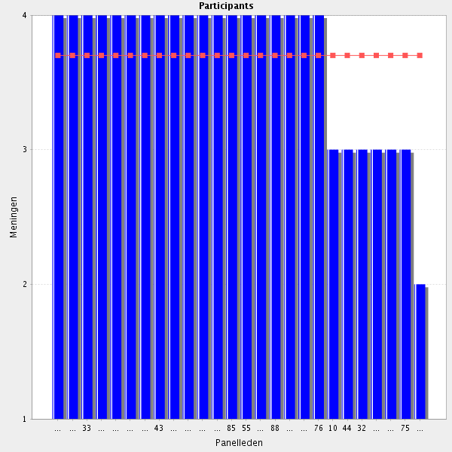
Average score: 3.7
Summary: duplication.
Proposal: delete.
Comments:-
As part of a multiprofessional team.
Stratification?
Core part of role
needs a strong inter-disciplinary involvement with physicians and other HC professionals
Pharmacists, as well as nurses, are the best healthcare professionals to identify those chronic patients that need a closer monitoring, Usually, a patient sees more frequently a pharmacist/nurse than a doctor. Patients tend also to speak more freely with the pharmacist/nurse. It is my strong believe that when a pharmacist identify a patient that needs a stronger monitoring, he/she should inform that patient's doctor. They should work together in order to find strategies to improve patient's compliance.
When a pharmacist identify a patient that needs a stronger monitoring, he/she should inform that patient's doctor. They should work together in order to find strategies to improve patient's compliance
Pharmacists can identify through different sources patients that needs a more close monitoring and help nurses and physicians in this control
Provided that there is interdisciplinary teams culture and infrastructure in place
If a pharmacist identifies a patient who needs ongoing monitoring, he/she should inform the responsible physician but also the patient him/herself, if the patient is not aware of the monitoring need.
Should be reworded to "Able to identify patients....."

4.2 Medicines management problems - Identifies monitoring parameters and potential adverse effects together with the responsible physicians.
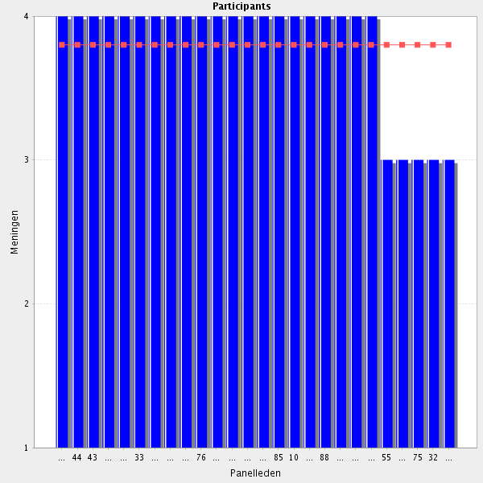
Average score: 3.8
Summary: duplication
Proposal: delete.
Also reports adverse effects within the hospital or to the national/competent authority
The part of the Statement "together with the physician" is important and should be highlighted in most Statements. It is important for the pharmacist to act as a teamplayer.
Core part of role
the pharmacist might play a key role in identifying potential adverse effects in those medicines that just arrived at marked.
The pharmacist should be able to identify such parameters and potential adverse effects and cooperate with the physician. It would also be good if the pharmacist/physician informed the patient to be on the lookout for potential (severe) adverse effects.
Due to their knowledge on drug effects, etc. pharmacists are in a special position in order to determine what parameters have to be monitored as well as to predict adverse reactions
Provided that there is interdisciplinary teams culture and infrastructure in place
It is my strong belief that pharmacists should always work together with the responsible physician of a patient. Doctors identify many adverse effects and use monitor parameters whenever necessary, Still, I believe that the pharmacist might play a key role in identifying potential adverse effects in those medicines that just arrived at marked. At my hospital we have a program called "active pharmacovigilance". It applies to those medicines that just arrived to the hospital and that at the same time are given to our outpatients (e.g. dimethyl fumarate, teriflunamide). For each of those medicines a sheet is done with the most frequent adverse reactions discrebed in the drug's summary. Whenever a patient comes to hospital the pharmacist asks him/she questions regarding those adverse reactions, as well as what other medicines/natural products she/he is taking. All reactions described to the patient that are not mention on de drug's summary or that have a frequency different from that descried at the drug's summary are reported to our National Pharmacovigilance System.

4.3 Medicines management problems - Establishes a plan for review of objectives and treatment outcomes together with the responsible physicians.
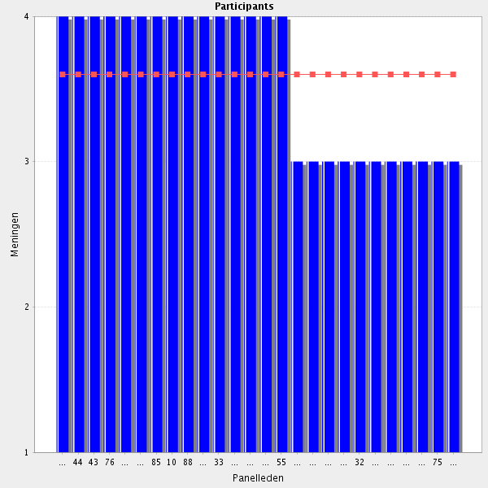
Average score: 3.6
Summary: duplication
Proposal delete.
This should be a team effort of all health care professionals who take care of the patient plus the patient him/herself.
Tratment review is one of the main contributions that hospital pharmacists can do in improving the health care outcomes of patients. Pharmacists have to establish a comprehensive methodology to do the revisions, as well as document the recommendations that their give, derived from these revisions.
Core part of role
Essential for adherence to medication and patience safety but should be assisted by infrastructure, culture and legislation
Ideally, it should be like that. More, the plan should be establish not only with the doctor, but also with the other heathcare professionals that take care of that patient. The only problem that I see is that, at least in my hospital, we do not have enough human resources to do so, eventhough all pharmacists assist to the clinical visit of those wards that they are responsible for.
Problem of personal ressources and time to be implemented
Ideally, it should be like that. More, the plan should be establish not only with the doctor, but also with the other heathcare professionals that take care of that patient

4.4 Medicines management problems - Ensures medicines are appropriately monitored when required together with the responsible physicians.
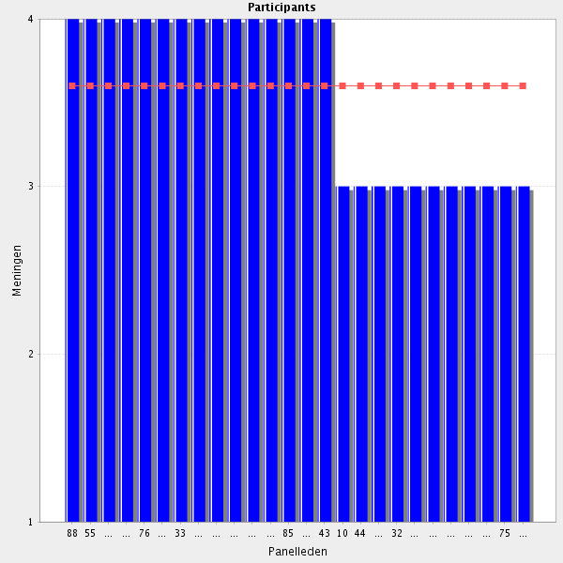
Average score: 3.6
Summary: duplication
Proposal: delete.
Comments:- Provided that there is interdisciplinary teams culture and infrastructure in place
Core part of role
They have to know what drugs should be monitored and inform the physician
to do that a close collaboration (and confidence) with physicians is essential
It is extremelly difficult to monitor all medicines. So, pharmacist should establish criteria for that monitoring (e.g. high alert medicines, medicines that just arrived at the market). Whenever an adverse effect is detected, pharmacists should inform the doctor reponsible for that patient. Furthermore, she/he should encourage that heathcare professional to report that event to National Autorithies. In those cases that doctors don't report adverse events detected, pharmacists should be free to report themselves.
It is not feasible to constantly monitor all medicines for all of the patients. Pharmacists should develop and maintain a criteria set to identify high risk patients, medications and the combination thereof.

4.5 Medicines management problems - Ensure appropriate action is taken promptly when medicines management issues area identified and ensures that the required actions are implemented, to ensure that patient harm is avoided or minimised.
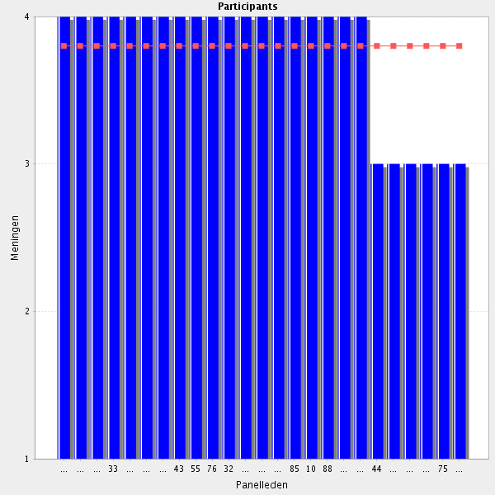
Average score: 3.8
Summary: duplication
Proposal: delete.
Comments:-
Reports, analyses and improve
As part of a multiprofessional team.
Core part of role
Provided that there is interdisciplinary teams culture and infrastructure in place, assisted by relative legislation
Should be a team effort with the physician and the pharmacist cooperating.
Pharmacists have to ensure to set circuits to inform, recommend and implement
this has to be made by the physician and the pharmacist may collaborate

4.6 Prioritisation - Interacts with the therapeutic team to prioritise medicines management issues of individuals and patient groups that one works with.
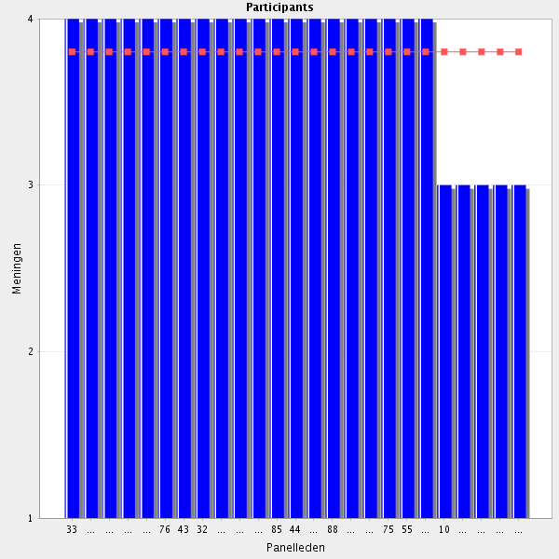
Average score: 3.8
Summary: duplication
Proposal: delete.
PART of role
Essential for patient safety
Pharmacists should be aware of typical medicines management issues and interact with other professionals and patient groups in order to tackle them.
Due that there are a great amonut of drug related problems and that usually the staff is short, it is necessary to priorize issues with more impact on the patient
Provided that there is interdisciplinary teams culture and infrastructure in place

4.7 Use of evidence based guidelines or protocols - Is aware of the current clinical guidelines and protocols, local and national, applicable to the field one is working in and understands how they ought to be applied.
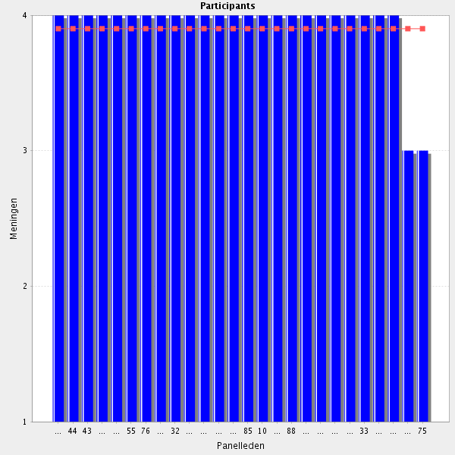
Average score: 3.9
Summary: duplication
Proposal: delete.
Add, applied to a specific patient
Provided that there is interdisciplinary teams culture and infrastructure in place
of course, and be sure they can be applied to the patient
core part of role
It is essential that pharmacists be aware of the current clinical guidelines and protocols appliable to their field of working. Only with that knowledge can pharmacist contribute to the rational use of medicines and, in some cases, prevent medical errors. Hospital protocols, as well as current clinical guidelines should be on-line. All healthcare professionals should have free access to them.
Absolutely.
It is basic to work using protocols and guidelines

4.8 Use of evidence based guidelines or protocols - Applies current clinical guidelines, recognising their limitations.
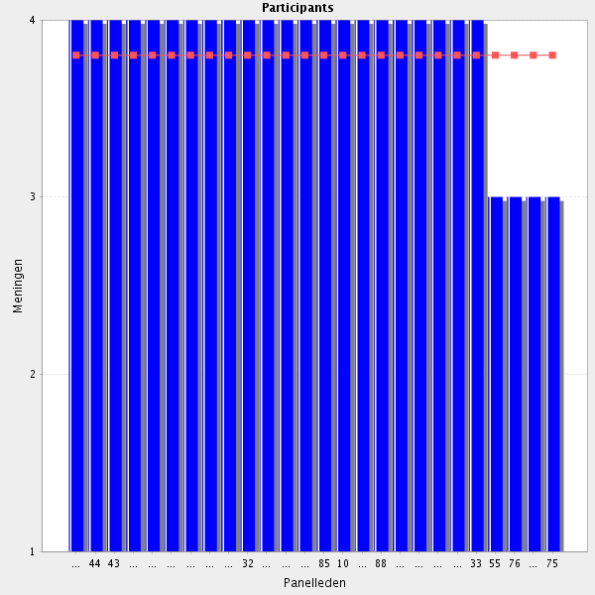
Average score: 3.8
Summary: duplication
Proposal: delete.
Comments:-
Core part of role
No matter how current a clinical guideline/protocol is, has always limitations. It is important that pharmacists identify them, so that he/she might validade those prescriptions that don't comply with guidelines/protocols, but are the best alternative to the patient in question.
Obviously, the guidelines have to be known used and applied in a correct way
Applies current clinical guidelines taking the current situation (clinical, infrastructure, finances, etc.) into account.
In collaboration with other health professionals and provided that there is interdisciplinary teams culture and infrastructure in place
No matter how current a clinical guideline/protocol is, has always limitations. It is important that pharmacists identify them, so that he/she might validade those prescriptions that don't comply with guidelines/protocols, but are the best alternative to the patient in question.

4.9 Prevention - Develops a plan to avoid medicines management issues and medication errors.
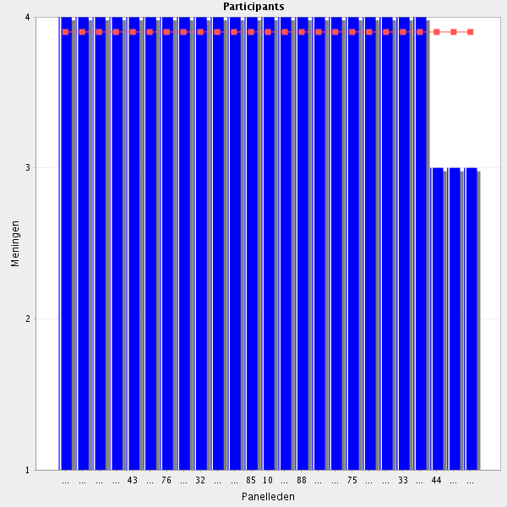
Average score: 3.9
Summary: duplication
Proposal: delete.
Comments:-
Core part of role
Given the potential adverse events related to pharmacokinetic drug-drug interactions, an in-depth knowledge of their origin should be considered and their prevention of should be prospectively organized (detection and proposal for drug substitution). Plans to minimize medication errors should be set up (at the institutional level)
Plans to minimize medication errors should be set up (at the institutional level)
As the medicines expert, the pharmacist should be the one that is aware of potential medicines management issues and how to deal with them.
One of the principal objectives of the work of hospital pharmacist's has to be the prevention of medication errors.
Integrating this plan into the institutional quality management system.
In order to avoid administration errors, LASA names should be written in all labels of the medicines. That information should be reinforced with signs in those medicines with similar packages and in medicines with more than one concentration. For those medicines given intravenously, the possible administration routes should be also included in the label, as well as concentration by vial (concentration by mL is not enough and sometimes is misleading). Audits should be frequenty perfomed to assure that everything is correctly labelled.

4.10 Record of contributions (if applicable) - Documents information to support contributions to patient care, e.g., maintains pharmaceutical care plans or updates information systems to ensure that relevant information is available to colleagues.

Average score: 3.9
Support: duplication
Proposal: delete.
Core part of role
Preferably supported by appropriate IT/eHealth/mHealth infrastructure.
It is important to document all pharmaceutical interventions. In my hospital we have an Excel that is filled at the end of each month by all pharmacists with their activities (e.g. number of questions answered, number of prescriptions validated, number of oupatients attended). We also have another Excel with all the questions (and answers) done by other healthcares professionals, as well as patients. All pharmacists have access to that Excel. Should a question be asked a second time, it would not be necessary to search for the answer again.
It is very important to document all pharmaceutical interventions.
Yes. Cooperation with other professionals is the key.
All activities done by the pharmacist have to be propertly recorded in order that other professionals could see what has been done and also to know what activities performed and their possible impact in the patient

4.11 Pharmacovigilance, medicines and medical devices safety - Record, monitor and report adverse drug reaction (ADR), and quality defects to the appropriate authorities.

Average score: 4.0
Summary: duplication
Proposal: delete.
Comments:-
Core part of role
pharmacists should participate to the vigilance of the medicines and med devices under their responsibility
It is extremelly important to report to national authoriries all ADR, as well as quality defects. In most of the cases that task is up to the pharmacist. All ADR should be recorded in the patient's file. Hospitals should also have active pharmacovigilance programs for those medicines that just arrived at the market.
Very important!
Pharmacists are the best positioned to do this work
Mission critical competency.

4.12 Pharmacovigilance, medicines and medical devices safety - Is able to recall the stock when necessary and maintain appropriate records.
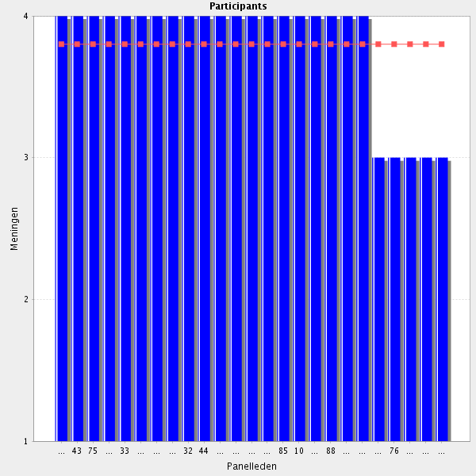
Average score: 3.8
Summary: rewording.
Proposal: Amend to:-
Can recall stock when necessary and maintain appropriate records.

Comment:-
Ok but requires some information technology and advanced logistics
Core part of role
Hospital pharmacies should be equipped with computers programs that allow a proper stock management. In order to keep tracebility, all batch numbers of medicines/medical medices that enter or leave the pharmacy should be registered in the stock manegement application.
Traceability is extremely important.
Has to establish ways and guidelines of how to do it, fast and efficiently, and recording all the steps
Only when it us possible

4.13 Pharmacovigilance, medicines and medical devices safety - Is able to plan, implement and supervise execution of actions to improve medication use process based on reported information to avoid similar errors in the future.
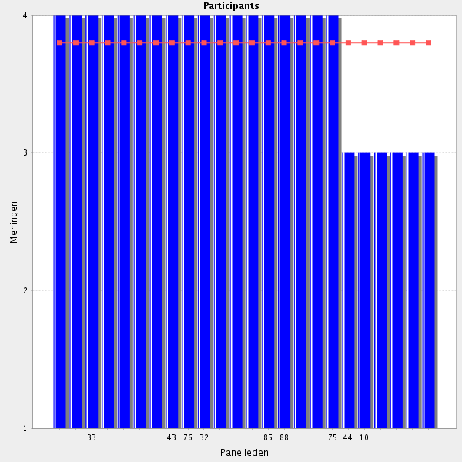
Average score: 3.8
Summary: largley duplication
Proposal: Merge with element from Cluster 1.
Comments:-
Core part of role
As I referred before, it is important to label all medicines/medical devices in a way to prevent administration errors. Using LASA names and signs when labelling would prevent some mistakes, but it won't be enough. I believe a label should also have the total concentration/volume. For instance, frequently we had problems with morphine 2%. The reason is very simple: if the total concentration of a vial of morphine1% is 10 mg, the same vial with morphine 2% should be 20 mg. Wrong: our vials of morphine 2% (B Braun) have 40 mg (20 mg x 2 mL). Useless to say that whenever I send morphine 2% (B Braun) to the wards, I always put an extra label with total concentration.
Pharmacists have to be part and leaders in the professional team charged to evaluate these problems and find improving measures.

4.14 Therapeutic Drug Monitoring (TDM) / pharmacokinetic - Is able to design, validate and implement bio-analytical analyses to support regular pharmacotherapy and toxicology and supervise their execution.
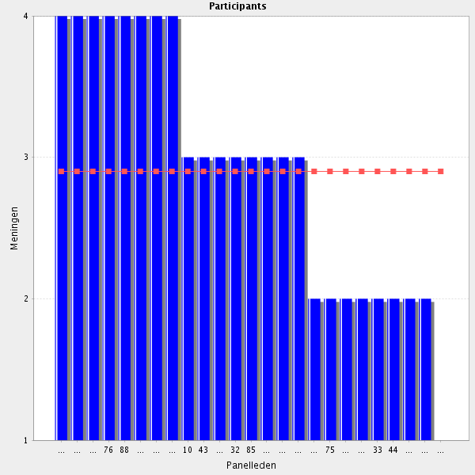
Average score: 2.9
Summary: not wonderful agreement but seems valid and relevant. Reword and test in Delphi 2.
Proposal:- amend to:-
Can design, validate, implement and quality assure bio-analytical testing to support therapeutic dose monitoring.
Comments:-
It is important that all pharmacists know how to make pharmacotherapeutic drug monitoring for those medicines with narrow therapeutic margin.Of course that implies having appropriate programs that help in the development of pharmacokinetic protocols, as well as, rapid results from the hospital's analysis laboratory and that these results can be accessed by all health professionals. In the hospital where I work, it is up to the pharmacists to propose the doses and intervals of administration of the aminoglycosides prescribed, provided that the doctor when prescribing requests for protocol. Each pharmacist do the protocols of the services that he provide support. It is also the pharmacist who requests ("on-line") the necessary blood tests (e.g. creatinine, vancomicynemia) necessary for the elaboration of the protocol.
This task requires additional training
requires a specialized knowledge so that all pharmacists may not be able to design, validate and implement such services
full kwnowledge needs addional training or differentiation especially desing and validation. Interpretation of TDM/pharmacokinetics is a basic skill but needs additional training in case of complex care or patient populations.
In many hospitals also task of the pharmacologist.
I think this is only necessary in hospitals with specialized departments
Pharmacist should know about TDM, but other member of interdisciplinar team should be responsible for desinging and validation
This is the field of biologists
I think to understand TDM is a big job!!! It is a job only for several HPs. It is not suitable for a general skill for every HPs.
I doubt that this should be a universal HP skill. Doing TDM properly is a task calling for a specialist.
Outside the remit of hospital pharmacy in, I think, most countries. This is mostly done by the clinical pharmacologists.
What about pharmacogenomics?
Not so much a pharmacist's job - but I think a pharmacist should have the basic understanding of such analyses.
Not a pharmacist's job to perform analyses in all countries
Not a hospital pharmacist role - more suited to a biochemist.

4.15 Therapeutic Drug Monitoring (TDM) / pharmacokinetic - Is able to give advice, whether or not on request, to medical specialists and other care providers on qualitative and quantitative analyses of xenobiotics in body fluids regarding individuals or groups of people.
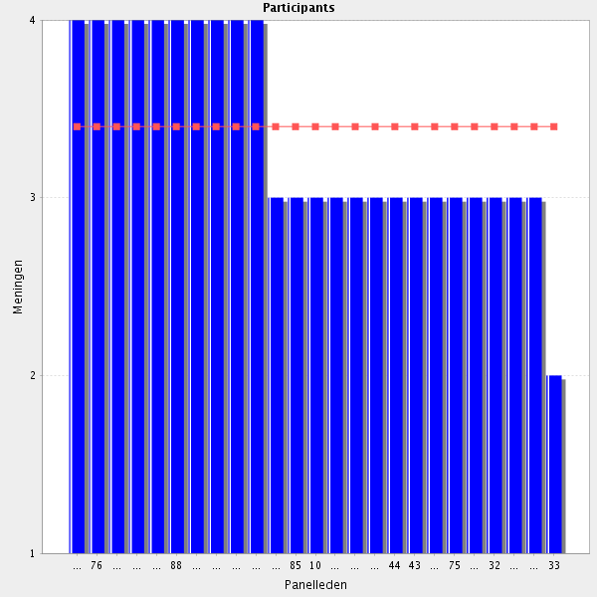
Average score: 3.4
Summary Amend as per participant suggestion
Proposal: Amend to:-
Able to give advice to other healthcare providers on qualitative and quantitative analyses of medications in body fluids
Comments:-
needs specific knowledge
All pharmacists should know that the behaviour of medicines and xenobiotics might be different in certain group of people (e. g. children, older people and pregnat women), not to mention certain patients (kidney and hepatic insuficcient patients, burned patients). In my opinion, pharmacists should advice other healthcare professionals whenever something is not right or might be improved. Of course that it is up to the other healthcare professional to accept or not the advice given. Pharmacists should always advice other healthcare professionals
All pharmacists should know that the behaviour of medicines and xenobiotics might be different in certain group of people (e. g. children, older people and pregnat women), not to mention certain patients (kidney and hepatic insuficcient patients, burned patients).
Core part of role
see comment 4.14
Only in hospitals with specialized departments
Agree but poorly worded. Suggest "Able to give advice to other healthcare providers on qualitative and quantitative analyses of medications in body fluids."
Agree with suggestion
What about pharmacogenomics?
4.16 Therapeutic Drug Monitoring (TDM) / pharmacokinetic - Is able to determine kinetic parameters to generate patient’s specific dosage on the basis of results of bio-analysis, also in complex situations such as dialysis.
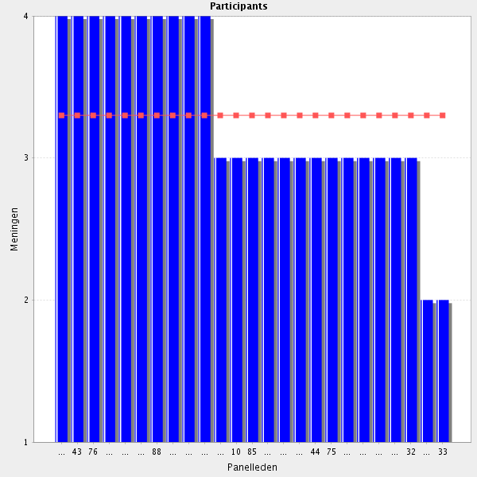
Average score: 3.3
Summary: duplication.
Proposal: remove.
Pharmcists should be trained for it
may be a quite complex area, needs specialization
As I said before, all pharmacists should be able to do so for those medicines with a narrow therapeutic margin. But for doing so, it would be necessary to install the appropriate programs and to establish protocols for the medicines that the pharmacy propose to monitor. It would be also essential the support from the clinical laboratory and that the clinicians delegated to pharmacists that function.
All pharmacists should be able to do so for those medicines with a narrow therapeutic margin. But for doing so, it would be necessary to install the appropriate programs and to establish protocols for the medicines that the pharmacy propose to monitor. It would be also essential the support from the clinical laboratory and that the clinicians delegated to pharmacists that function.
Core part of role
Not a pharmacist's job I think, but they should have an understanding of this
Only in hospitals with specialized departments
special skill after training
Amend "also in" to "including in".
All HPs should have an overall awareness of TDM basics, and the ability to recognize when to refer patients, but in my opinion TDM is a skill of a qualified specialist (who can, and should be a pharmacist).

4.17 Before going to the next group: do you have a remark, suggestion and or question on this group of competencies?

such a chapter is highly essential for patient safety and pharmacists should be involved as much as possible
TDM section should include pharmacogenomics.
I think that the knowledge about pharmacokinetics monitoring depens on the kind of institution. Is not the same a subacute care hospital than a huge acute hospital with departments as transplantation, oncology, etc
Some of these competencies would be difficult to demonstrate in hospitals where there is poor recognition of the hospital pharmacist or the value that he/she brings. It may not be feasible for pharmacists to demonstrate some of these behaviours Does the framework recognise the need for personal skills - assertiveness, negotiation, influencing, stakeholder engagement - these are crucial competencies that are required before hospital pharmacists can realise their potential
For the competencies lacking the verb "able to" or "knows" I think this should be added. Otherwise the sentences are more like job descriptions than competencies to be achieved/fulfilled,
There are many statements in this sub section that totally or partly overlap with cluster 1. Why? And why is the "collaboration with physician" only highlighted here? The document needs to be more homogeneous in its wording throughout the document.
I agree, too much overlapping statements. In many areas one conclusive statement would be more clear and informative.
Agree. Use of "as part of a multidisciplinary team" throughout might be useful.
see comments on the level of the individual competencies
Group: 5 Interface management (Group 11 of 26)
5.1 Seamless care - Is able to identify and manage the problems related to all interface management care including hospital and community.
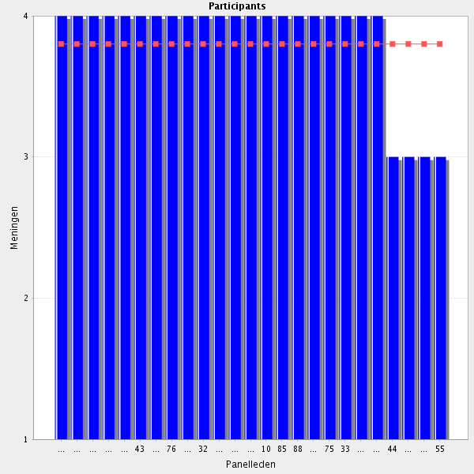
Average score: 3.8
Summary: rewording
Proposal: Amend to:-
Identifies and manages the problems related to interface management
Comments:-
Core part of role i
nterface management should also refer to the "transition of care" for patients leaving the hospitals to the ambulatory setting. Such a transition should be considered as a role for the hospital pharmacist to coordinate the patient discharge (discharge medication counseling at least for high-risks patients) to that to improve the patient return to its personnal environment.
Important for patient safety.
Pharmacists have a priviliged position that makes them very important to ensure that problems arising from transicions in healthcare could be approached and solved
It depends on infrastructure, cultural background and legislation . Initiative are not enough if they are not supported
Yes, crucially important point!

5.2 Seamless care - Is able to reconcile medication on the basis of the patients' acute state and specifics needs.
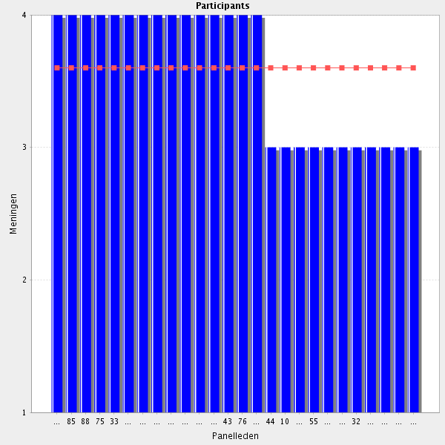
Average score: 3.6
Summary: duplication
Proposal: delete.
think that is a basic work for hospital pharmacists and that all should be able to do it
Might overlap with previous MedRec points, but still important.
Overlap with questions already answered.
Core part of role
Agree, but overlap with previous section
It depends on infrastructure, cultural background and training to acquire this expertise and to maintain it
has been discussed in a previous section (overlap)
agree. Since it is very difficult to do this for all patients, a protocol should be created to define which patients would benefit the most with therapeutic reconciliation (e.g. patients over 65 years of age, taking more than 5 medicines and with cardiac/renal disease).

5.3 Seamless care - Identifies and manages the problems related to switching patients' medication to formulary medicines, especially in specific groups such as the elderly and paediatric patients.
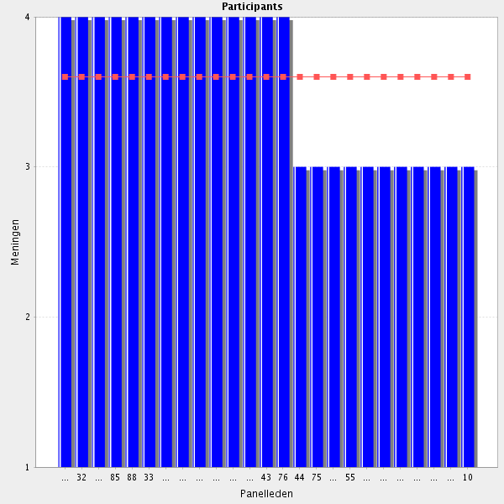
Average score: 3.6
Summary: no change
Proposal: no change. Link with clinical practice elements.
Comment: Pharmacists have to know how to interchange medications, in what cases it is possible and in what it is not. They have to be the leaders in the establishment of drugs interchange quidelines, apply them or help physicians in their application
Core part of role
It depends on infrastructure, cultural background and legislation support. Also collaboration with all involved stakeholders
Don't think switching problems are necessarily more likely in "specific groups" - they may be related to specific medications or to the patient's mental state at the time in relation to their health e.g. anxiety and difficulty retaining information when acutely unwell or worried about their health. I would suggest removing "especially in..." and replacing with "including awareness of the patient's individual needs".
In cooperation with physicians

5.4 Before going to the next group: do you have a remark, suggestion and or question on this group of competencies?

Seamless care, in my opinion, is one of the main (future?) competency areas of the hopsital pharmacy profession. I would highly recommend to emphasize this chapter's importance in the upcoming framework.
I totally agree with x . According to workshop discussions at the EAHP Conference in Hamburg seamless care is a challenge throughout Europe.
Medication reconciliation is an important achievement of hospital pharmacists. I think that we have to mantain this privilege and also to improve our perfomance in it and include pharmacists that have not alrealdy started to be involved in it. We have also to show the benefits to doctors. (Nb another said after this, “I def agree.”)
medication reconciliation is essential between hospital and home. Pharmacists have a main role
I think there should be something about communication of patient needs with other healthcare professionals with interface management/transition of care.
I think a point saying that reconciliation of medication should be made at every admission and discharche by a HP or under its responsability should be included.
"transition of care" for patients leaving the hospitals to the ambulatory setting should be considered as a role for the hospital pharmacist to coordinate the patient discharge (discharge medication counseling at least for high-risks patients)
Group: 6 Evaluation of outcomes (Group 12 of 26)
6.1 Assessing outcomes - Monitors or follow up interventions as well as medicines advice.

Average score: 3.5
Summary: duplication.
Proposal: delete.
Comments:-
Together with phycisians.
Chapter with insufficient details. Outcomes should be defined in the different arenas where the hospital pharmacy is involved in (outcome related to the patients, medications errors, production, prescription validation ...) The analysis of the proper (or responsible) use of drugs and medical devices within an institution should be coordinated by hospital pharmacists and constitutes an "outcome" to be evaluated.
Outcomes should be defined in the different arenas where the hospital pharmacy is involved in
i think that is obvious, but is an area that needs a lot of development. First of all, i think that pharmacists have to be able to determine and consensuate what indicators are useful in order to do this monitoring
Is it meant "pharmacist interventions" or all interventions during hospitalization of patients?

6.2 Assessing outcomes - Records contributions and where possible, continues to learn from the outcomes of one’s own contribution.
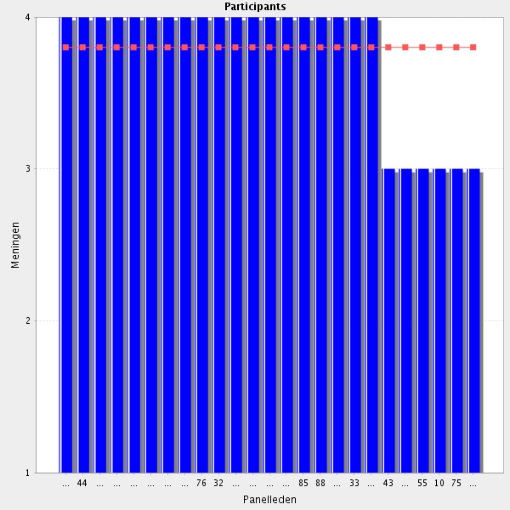
Average score: 3.8
Summary: add records to previous element from Cluster 1.
Proposa: merge.
Comments:-
Core part of role
Key issue
It is important to record the contributions made in order to improve the patient's health status and to learn from that contributions. For example, if a patient tells the pharmacist that a particular medication causes nausea, the pharmacist should advise taking this medicine with food. That pharmaceutical intervention should be recorded on the patient's file. Thus, when the patient returns to the pharmacy, the pharmacist will not forget to ask if the advice given improved his quality of life. If so, the same advice may be given to other patients who take the same medication.
Professionals should always continue to learn from outcomes
It is basic to have a good and structured recording permeting to drawn results and find areas that need improvement
It depends on infrastructure, cultural background and legislation

6.3 Before going to the next Cluster: do you have a remark, suggestion and or question on this group of competencies?

it is a team work
Chapter that deserve a more in-depth analysis.
The verb "Is able to" or "knows how to" should be added to the text of the competencies. This will make them look more like competencies to be fulfilled/achieved than job descriptions.
as per previous cluster, pharmacists may not always be in a position to demonstrate these competencies, given that they are reliant on the involvement and co-operation of colleagues within hospital Also, should there be some reference to transition of care to community? Or is that considered elsewhere in the framework?
I think that in this area hospital pharmacist still have a long way to do. First, because not all are involved. Second there is a need of metrics for evaluation of the impact of the actions done by the pharmacists, and third there is an even longer way to make in order to expand the collaboration between hospial and comunity pharmacists.
Chapter that deserve a more in-depth analysis

