

EAHP
CTF - Cluster 1. Patient care and clinical pharmacy skills competencies
Delphi Round 1

Synmind BV / FB
Haarlem, 21 March 2017

Group 1: Patient consultation 3
Group 2: Medicine, medication safety and medical devices issues 49
Group 3: Gathering information 134
Group 4: Analysing and applying information 158
Group 5: Providing information 192
Group 6: Information expertise 223

Group: 1 Patient consultation (Group 1 of 26)
1.1 Patient Assessment - Is able to take a health status and medication history by using appropriate questioning where possible, or medical records to obtain relevant information from the patient, recognising conditions, symptoms and special needs of individual patients.
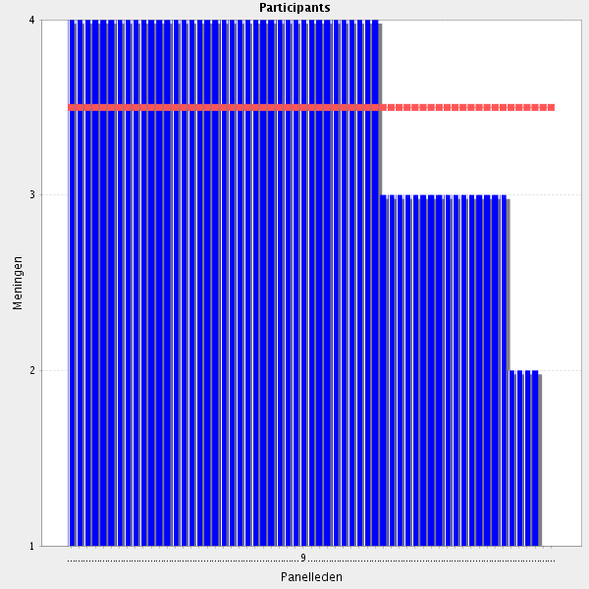
Average score: 3.5
Summary: High level of agreement. Where disagreement reasons were stated these related to roles and responsibilities specificall relating to arrangements and legislation in different countries. These issues are well known.
Proposals: (i) Amend to:-
Can take a health status and medication history about the patient directly from the patient where this is possible, using medical records or other relevant information sources when this is appropriate, to identify conditions, symptoms and special needs of individual patients.
(ii) there should be increased emphahsis in pre-publicity for Delphi 2 and on Synmind platform that some aspects of the CTF may seem aspirational or even inappropraite in some countries (at least currently), but that in other countries such statements would appropraitely reflect the role of at least some hospital pharmacists in that country. Particapnts in Delphi 2 should bear in mind that the CTF applies to all EU countries, and therefore should include elements approriate in some countries even though they are not currently applicable in all.

All comments on this statement: impactful statements in red
Fundamental clinical pharmacy skill.
It is important, so that the appropriate consultation is offered, the perscription of medication is reviewed and possible side effects and adverse reactions are prevented or addressed.
during different step of the patient pathway the HP can support the MDs giving them information on possible DDI, DFI , ADRs or possibille controindications.
pharmacist education allows this competency
I'm apprehensive to the statement concerning health status, but strongly agree that pharmacists should be able to take a medication history and know what health status issues will be important to know in order to be able to evaluate if the medication is sufficient or appropriate.
I agree
Proper patient assessment is one of the key factors for the ability of a pharmacist to recognize wrong therapeutic approach or wrong choice of a medicinal product. Ability to check patient status is also the basis for minimising the risk for a medication error.
An essential role at the core of clinical pharmacy practice.
that's seem the first degree of starting an assesment of patient also one Group of it.there must be a few way of assesment besides obtainings patients itself.
Core skill requirement
very important competence in the field of hospital pharmacy
A combination of medical records and questions directly to the patient will be of value.
Moving towards individualized medicine means you have to know the condition of the patient
very important skills
A complete medication history is mandatory to perform any ither clinical pharmacy task in a good way.
Routine practice by hospital pharmacists
patient assessment is needed for a pharmacotherapy assessment
Necessary qualification
Core skill for clinical pharmacy.
It is necessary to make clinical recomendations.
Pharmacist has to be incorporate in the daily work to know and assess all the information related with the patient. Therefore, has to check all the information available, from the clinical record and questioning other professionals, the patient and caregivers. Related to this point is very important, that pharmacists have access to all this information.
If appropriate and reasonable answers were given to the questions asked then an a professional assessment can be made.
Essential
The basic of true history is good communication between doctor and patient. Often the history alone does reveal a diagnosis. Sometimes it is all that is required to make the diagnosis. A good example is with the complaint of headache where the diagnosis can be made from the description of the headache and perhaps some further questions. Communication skills is more imoprtant. Open questations, listen what the patient says very carefully, open mind and always ask....
Need of shared medical records between primary care and secondary care for best medicine reconciliation
In my opinion every action of recognising conditions, symptoms and special needs of patients by pharmacists should be related to the patient's pharmacotherapy (i.e. posiible side effects) and medical devices use. I think that pharmacists shoud not involve into patient diagnosis as this is a role of medical doctor. Also I would be very careful with performing any type of physical examination by pharmacists, especially in the hospital setting.
Hospital pharmacists validate prescriptions. Parameters such as weight, body surface, and creatinine clearance are needed to calculate the right dose. Medication history is crucial for allergies and reconciliation of therapy.
This statement is the basis for clinical pharmacy. With the shift to more personalised medicine individual history taking will become increasingly important. Medical records should also include medical information in the personal health file/record of the patient, e.g. genetic screening, adherence and outcome measures of therapy.
Sometimes doctors miss important drug interactions. Patients not always tell their doctors how they really feel. Sometimes, patients feel more confortable telling that to the pharmacist. Even when patients tell their doctors how they really feel, sometimes the doctor only cares with the benefit of treatment, dismissing important side effects. Othertimes, doctors prescribe withou respecting maximum drug dosage.
I can see patient's medication history butıt ıs only limited withmy hospital. ı can not see a patients medication history when he/she was notin my hospital.
This question should be extended to "using relevent information sources" like relatives, GP, nursing home etc
This is closely associated with the law concerning medical records in particular countries, therefore it depends not only on the hospital regulations.
Hesitates when it says "Basic physical examination (e.g. - Blood pressure, weight)". I do not believe the pharmacist needs to be able to DO the physical exam, but to be able to INTERPRET the result.
I agree - it is useful but not essential to be able to take blood pressure however it is essential to be able to interpret it.
Special needs refer to secondary levels. Achievable/affordable main health objectives or wishes should be primary levels to be considered.
...medical records and other health care professionals.... This should be done systematically, continously and planed to be valuable.
Reconciliation in a basic skill of any hospital pharmacist
Medication history yes, but I presume that health status assessment might be carried out by other health care professionals.
This is a very basic competence
history taking is essential i would say appropriate questioning of the patient where possible or the caregiver if necessary AND medical records
Since other Health care personal already has recorded the information needed, maybe more focus on obtain relevant information from Medical records. But important to get the information correct.
It is the part for psycial examination I disagree with.
In my view, this is a more ambiguous summary of the next 3 items.
Basic physical examination (e.g.-blood pressure, weight)- Pharmacist is not allowed to perform these tasks in Sweden.
Pharmacists in some countries legally do not have access to patient's medical record

1.2 Patient Assessment - Retrieves all relevant and available information about patients’ health, social status and ethnic background from different sources.
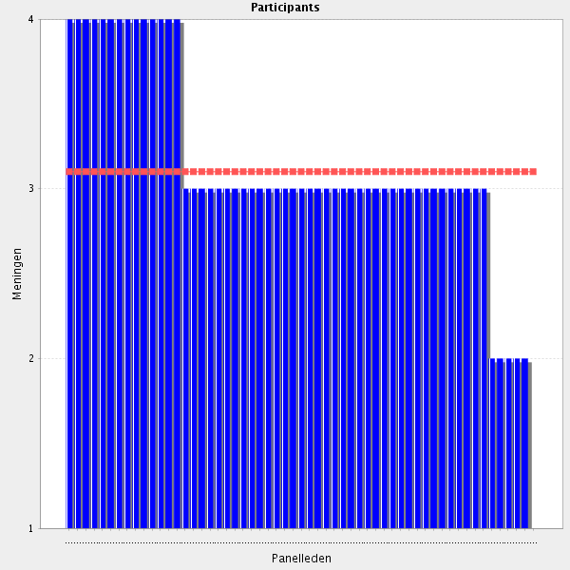
Average score: 3.1
Summary: high level of agreeement. Suggestions for further improvement relate to whether such information is always required or appropriate. Consideration is required about amalgamating this element with 1.1 Consent is an issue but is covered in 1.5.
Proposal: Amalagamation would conflate the technical information in 1.1 with the socially orientation of information referred to in 1.2. Adding “appropriateness of information” would potentially be advantageous and could increase consensus.
Amend to:-
Retrieves all appropriate, relevant and available information about patients’ health, social status and ethnic background from different sources.

All comments on this statement: impactful statements in red
especially medication/pharmacothetapy related. Checks if information is complete because a lot of information is gathered by other professionals
Necessary
Capacity to synthetase
Very important especially with elderly patients.
Since different Health care personal focus on different topics it is important to garther information from different sources.
Strongly agree
It is important, so that the appropriate consultation is offered, the perscription of medication is reviewed and possible side effects and adverse reactions are prevented or addressed. Technolody Enabled Care may be a useful ally
routine practice for pharmacists working in hospital
See comments in 1.1 This will become more relevant with eHealth and mHealth technology
all the informations mentioned are not useful for the pharmacist
The information about patients' health, etc. is related to the legislation in particular countries.
it would be useful.
Social status and ethnic background may not be relevant and may be sensitive subjects in some cases where patients are reluctant to share that information. I suggest adding "as appropriate" to the end of the statement.
Since different Health care personal focus on different topics it is important to garther information from different sources to get the relevant one.
I don't know if it's important to use different sources, but some knowledge of these factors is important. For instance can ethnic background be important in pain tolerance.
To assess effective impact/result of patient's treatments should be explicited in patient assessment by pharmacists
A robust IT / eHealth background is a must for this competency.
Do we really need to know social status?
Not always possible to get information - especially in hospitals where data is not kept electronically.
Better phrasing than first Statement. Probably include not only "retrieves" but also "comprehends" or "recognizes".
If this is relevant in relation to the medication problem or history of the patient.
environmental factors genetics factors
With patient's consent.
I don't think explicit consent should be required to obtain information relevant to taking a history/patient assessment. With the pharmacist as a part of the patient's care team this consent should be implicit as part of their care.
Should be done in particular situations, for instance, when the pathology could have been caused/influenced by health, social status and ethnic background.
Agree, social status and ethnic background are not always relevant.
it can be use old governmental health records and social media,
In my opinion, it should also take into account patients' needs and expectations.
I agree. This may be covered somewhat in the first statement "recognising...special needs of individual patients" but I think it should explicitly be stated also as part of the patient assessment.
If a patient has a lower social status, probably it would be more difficult to understand how to take medicines after releasing from hospital. Some ethnics might refuse to take some treatments (e.g. blood transfusions).
Normally, these information are recorded during the first visit or during the admission in the hopital as standard information to be recorded in the CPOE by other health care providers
only if the information is needed for a healtcare purpose
This is the work of the doctor, ref. comment on the next item
we have limited sources for retrieving informations. but we cansome backrounds too
its a bit vague and already sort of covered in 1.1, i wonder if these should be mergerd?
I agree it appears similar. Perhaps they should both be more clearly defined i.e. 1.1 is about taking a history of presenting complaint whilst 1.2 is more about information retrieval and contextual information
This is the basic informatin to evaluate patients' drug therapy

1.3 Patient Assessment - Basic physical examination (e.g. - Blood pressure, weight).
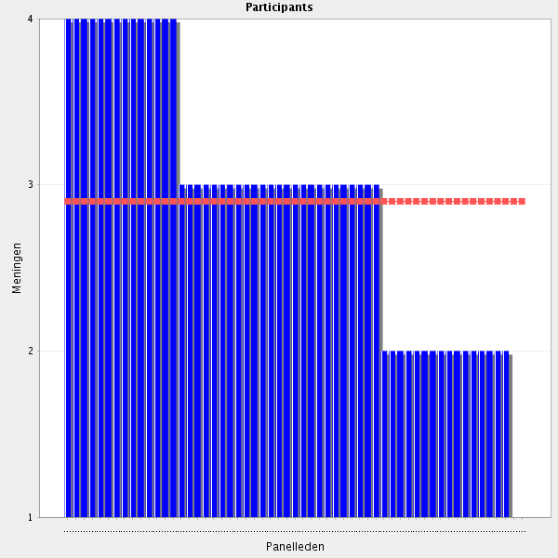
Average score: 2.9
Summary: a strong dissenting voice was obtained re carrying out basic physical measurements hospital pharmacists not being part of the professional remit. Others agreed with the element. However, current wording is not clear whether the intention is being able to personally perform the examinations, or interpret them, or something else.
Proposal: reword to reflect sentiments expressed in comments to arrive at a clarification which can be tested in Delphi 2.
Amend to:-
Knows how basic physical health examinations (e.g. BP, weight) are performed, can interpret and respond appropriately to such findings, and when required can carry out relevant elements of a basic physical examination.

All comments on this statement: impactful statements in red
This are baseline values which are not neccessary taken by the pharmacist, but pharmacist should be able to perform this task and to be aware of diffidulties when using data from other health care professionals.
These basic physical examinations will ensure that the pharmacist has the necessary information - they add status to the pharmacist role.
That's what pharmacists usualy do in pharmacies (non-hospital), so I would expect hospital pharmacists to do the same job.
I disagree, because at non-hospital pharmacies there are not doctors, nor nurses.
I agree with R192 - a hospital pharmacist should not be involved into taking any physical exams, since this is a role of nurses and MDs. Hospital pharmacist should however be able to draw conclusions and make decisions based on the outcome of physical examination and diagnosis.
Useful role in community pharmacy but also at the hospital
For the correct decision (or help) we need it
will give more precise information about the patient and can help limit the risks the patient might face due to an abnormal measurement whether it's high blood pressure or extra weight.
Respiratory rate, heart rate and being able to interpret patient's bloods results and basic imaging studies
Basic clinical skill.
Important to have somo basic knowledge in order to be able to work in an interdisciplinary team
As long as it is assisted by user-friendly apparatus and does not include physical examination that medical doctors are trained to do. So we need to define what basic physical examination a pharmacist might perform
we can see a patients basic physical exam from our hospital patient information systems. the doctors are taking from patients and they save in to patients charts.
Blood test the fastest route to the discovery of the disease
I do not see as very interesting the implication of the pharmacist in making basic physical examination Sometimes, in order to feel surer it is easier to refer the problem to another than making decisions.
investigate any lack of organs or histologic pathology,and hormanes and blood dynamics affected by them
Not sure if I understood the question in the right way. Pharmacist should be able to perform a basic physical examination? In my country, this is done by the physician and the nurses and not by the pharmacist
not yet performed by pharmacists
I agree to the extent, but it should be in addition to, and in agreement with, the other health professions in the clinical team.
These information are important to better understand the patient clinical profile, but normally are measured by MDs or RNs
Hospital pharmacists should be totally aware how these procedures should be properly performed so that they can detect any errors during measurement which can jeopardize patient status but these measurements should be performed by nurses or any other assisting medical staff.
I agree. Does the pharmacist need to be able to perform a bp check, to have this knowledge? Can theory be enough (I initially Think so)?
I agree with the idea of assessing Basic Parameters, but I'm not sure if I would call this "physical examination". Probably use "health Status assessment"?
If the data is important and does not exist the pharmacist must get it.
Physical examination is not a pharmaceutical field in Austria but to be informed about the findings of physical examination by the physicans is mandatory for the medication assessment.
Pharmacists in hospital, unless more specialised, would not be involved in carrying out physical examination. Although weight and BP are simple parameters. I would expect a pharmacist to be routinely considering physical parameters when reviewing a patient
This is the work of the doctor. Hospital pharmacists are meant to add competencies to the health care team which are not already in place. This is our "raison d´etre"!!!
Not on the pharmacist in my country, maybe this can not be mandatory everywhere.
In my opinion it's more relevant that someone else performs this.
It's not up to the pharmacist to do a physical examination. That should be left to the doctors. Still, sometimes it's important to know how much a patient weights and if she/he has a normal blood pressure or not.
Done by other health care professions for the most part.
this is not in the scope of pharmacists activities
Basic physical examination in hospitals should be performed by trained nurses, or medical doctors. Pharmacist's area of expertise is pharmacotherapy, and not diagnosis. This may be different in community parmacies, where these basic tests might be a part of pharmaceutical care and if results were alarming - pharmacist shoud send the patient to medical doctor. In hospital setting where other medical professionals are part of patient-care team, pharmacists should focus on the safety and efficacy of pharmacotherapy.
I agree.
Usually doctors and nurses do it and write it down in patient's file. It's a waste of time.
In the hospital there are more competent health care workers to perform these tasks. Access to all measured data should be available.
Physician's work.
These data should be collected by other Health care Professionals such as doctors and nurses, not by clinical pharmacists.
Basic physical examination (e.g.-blood pressure, weight)- Pharmacist is not allowed to perform these tasks in Sweden.
Taking of such physical health observations is not a hospital pharmacist role in my opinion (though might be for community pharmacists running e.g. weight loss clinics) but I would suggest that the pharmacist must be: "able to interpret and respond to relevant physical heath observations e.g. BP, weight, QTc interval changes etc. according to their area of expertise."
Knowledge about, not skill
This should already been taken care of. Not what I include in the tasks of a pharmacist.
i do think that pharmacists should be trained to do this, but my experience in a hospital shows that the nurse ALWAYs does this. so yes it should be in training as in community this is necessary but im not sure about in hospital

1.4 Patient Assessment - Documents an accurate and comprehensive medication history when required.
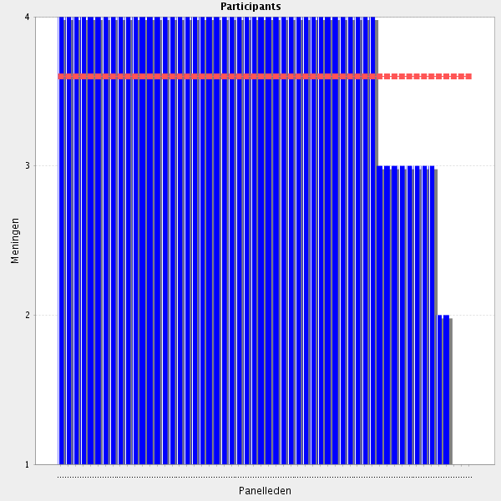
Average score: 3.6
Summary: strong agreement, which would probably have had a higher numberical value but for a loading error which recorded some early entries for 1.4 with reveresed scores - strongly agree as 1, agree as 2 etc. These were corrected and all participants received notification and a request to revisit and correct their score. Many did this, but it does appear that a small number did not. Two key suggestions would appear to clarify this element and this can be tested in Delphi 2.
Proposal: Amend to:-
Documents an accurate and comprehensive medication history including adherence to medication, adverse effects, and outcomes.

All comments on this statement: impactful statements in red
It is important, so that the perscription of medication is reviewed and feedback is provided to other health professionals that the patient contacts
This should be done for all patients - but not the system in all hospitals.
An accurate medication history is mandatory to all drug related activities.
Routine practice. Has been assessed as part of Foundation Training framework for many years.
Reconciliation done by a pharmacist, when needed, has the best level
Necessary qualification
Important skill. A task where pharmacists excel and should continue to do so.
An important task to gather information what works or not works for the patient
Phamacists have to be able to document all the information related to the medication of the patient as well as their recommendations.
Pharmacist should document their findings in the Medical record. Available to all other health care workers and the patient him/herself (or their caretaker)
Very optimistic - I mean, we would need more pharmacists. But a pharmacist should do a medication history, because of the knowledge.
Sometimes, in order to explain/prevent an adverse effect it is necessary to know patient's history. For that, pharmacists must have access to patients' medical records
Sometimes, in order to explain/prevent an adverse effect it is necessary to know patient's history.
Many times patients do not remember the name of their medicines or believe that herbal medicines are not so important. HPs can provide a complete and accurate medication history
mandatory especially for DDI's
This is important both in the Group of being able to communicate with other health professions and in the Group of patient safety.
Essential for following therapeutic decisions.
Very important, both for the medication use in the hospital but also for the further treatment of the patient in other levels of the health system.
Core requirement
reconsillation reasons that documents routinly checked,and ıdentifes how biologicaly, chemicaly situations the patients in
This medication history should include: adherence to medication, adverse effects, outcomes.
if the medication history was not accurate and precise medication errors can occur. In addition to that, some patients might lose their trust and feel uncomfortable when they ask about a previous medicine that was not placed in the documents.
Ideally, we would have e-tools where all the data would be continuously collected. If not, this would mean too much work for hospital pharmacists and it is not realistic
It is importanten to document the relevant information.
Medical documentation has multiple purposes. In the first place, medical documentation provides the correct treatment of the patient and scientific research.
Maybe use the term "medication reconciliation" and state to use at least two sources (e.g., Patient interview and central medication database) What is the difference to "medication reconciliation" (Groups 2.10-2.15)?
I Think they mean the history, ie former medications. "What blood pressure medicines has the patient tried and why did he stop?"
In psychiatry for example, it can be very useful to summarise a life-long medication history of all drug therapy options tried. Clinical pharmacists are well suited to undertake this often time consuming task.
This is not an original task of a clinical pharmacist but the pharmcist should be able to perform the task and identify parts where information is missing.
i would just move the when required, i think in a ideal world this would be done for all patients
For drug-drug interactions and to decide right medication for patient is necessary
this is very important for patients health.

1.5 Patient consent (if applicable) - Ensures that the consent of a patient is obtained when required (procedures/treatment/research).
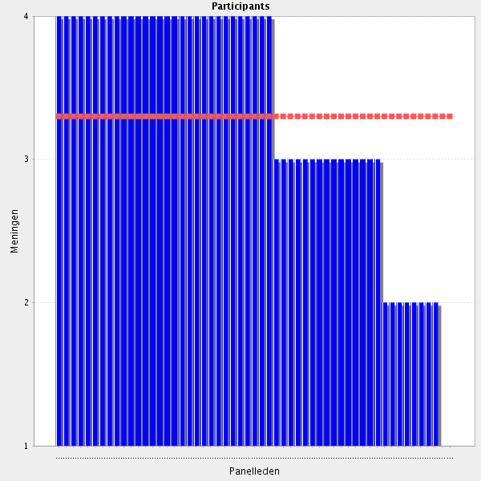
Average score: 3.3
Summary: reasonable agreement, which would probably have had a higher numberical value but for a loading error which recorded some early entries for 1.4 with reveresed scores - strongly agree as 1, agree as 2 etc. These were corrected and all participants received notification and a request to revisit and correct their score. Many did this, but it does appear that a small number did not. Off-label and unlicensed use was inferred by a small number of participants, and some participants were concerned about thier responsibilities as opposed to those of other health care professionals. A rewording should help to clarify and can be tested in Delphi 2.
Proposal: Amend to:-
Ensures that patients receive appropriate and sufficient information to obtain informed consent when this is required for procedures, treatment or research.

All comments on this statement: impactful statements in red
Obtaining patient's consent is very important especially when starting an off-label therapy, and of course mandatory when conducting a clinical trial.
Patients need to give consent to everything that might compromise their rights as citizens and patients. A pharmacist plays a key role in that.
An indispensable question of ethics.
The patient should be fully aware and, if necessary or possible, in charge of their health data and treatment plan
...obtained and recorded....
I fully agree.
Everytime medicines/treatments are used beyond their approved indications, a patient consent should be written and signed by the patient. Pharmacists should be aware of the situations that require a patient consent and should inforce its use. Whenever a procedure/treatment requires patient's consent, only after the local Ethic Comission approval, should the treatment/procedure be started..
Everytime medicines/treatments are used beyond their approved indications, a patient consent should be written and signed by the patient.
HPs can inforce its use , everytime a drug is used outside of the approved indications ( according with the Ethic Commission approval). HPs are responsible to obtain a copy of the patient consent before to dispense a drug prescribed outside of the approved indications or when is required ( compassionate use. specific law requirements and so on).
patients rights includes "patient consent"
I really agree
If the clinical pharmacist is responsible for the patient and the patient consent is important for safe medical practice then the pharmacist has to be sure that the consent was obtained.
Necessary
Research without patient consent is not an option in my world.
It iI would change the word 'consent' to 'informed consent' - pt needs to be informed well before asked for consent.
Patient consent is important from a legal point of view, but it is just as important to assure that the patient trus us as clinical pharmacists and Health care profeesionals.
Essential. Routine practice. Has been assessed as part of Foundation Training framework for many years in Great Britain
Patient agrement is required with written tracability
Know the difference between "experimetal off-label" and "evidence based off-label" in pediatric practice. Mithani Z. Informed consent for off-label use of prescription medications. American Medical Association Journal of Ethics 2012;14:576–81.
Patient consent is one of the most famous international laws used all around the world.
Don't agree for medical procedures which, in my opinion, should be the physicians responsability
giving information about the cure plan to patient and bounding to this to a document is always be helfull not just for legall things also for the cognitive reasons and awarnes of the patient himself,
Only if related to pharmaceutical procedures/Treatments/Research
Assess whether the information given to the patient is valid/accurate, understandable and understood
It is important when any action to be taken by the pharmacist needs a consentment
Would rephrase to include adequate Information of patient prior to obtaining consent ("informed consent"). E.g., "Ensures that the Patient receives adequate Information to obtain informed consent for procedures/Treatment/Research."
I agree but I'd rather say: Ensures that adequate advise is avalible for the patient AND informed consent is obtained (since the act of obtaining a consent is not usually a pharmacist' task).
i think more detail could be added here.
applicable only in cases of clinical research projects. It would be better of consent procedures are assigned to nurses or any other responsible members of medical team.
This seems to imply that it is the pharmacists role to ensure consent is obtained e.g. for unlicensed medications where I would see it as the prescribers role. It may open pharmacists to legal liability where a patient was not adequately informed and was harmed by a medication even if the pharmacist was only dispensing the medication and not clinically involved.
Only in case of studies performed by the pharmacy; otherwise it's a physician's task
this may be (but should not be) a part of the pharmacists activities
Should not imply that pharmacists themselves are responsible for obtaining the consent.
This is necessary to work confidently in a health care team.
this is so important. because Some medicines can be used out of their indications. In this case it is legally important for the pharmacist to obtain the approval of the patient.

1.6 Consultation or referral - Refers complex pharmaceutical and/or complex acute healthcare issues to a senior colleague, other healthcare professional or other service when appropriate.
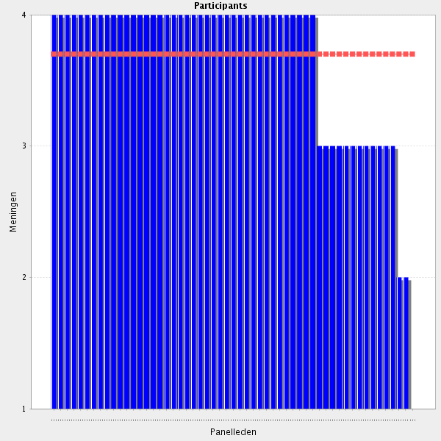
Average score: 3.7
Summary: High level of agreement. Minor rewording to reflect hierarchy concerns raised in some responses.
Proposal: Amend to:-
Is aware of his / her own limits and, when appropriate, seeks advice from a specialist colleague, other healthcare professional or other service, especially when dealing with complex pharmaceutical and/or complex acute healthcare issues.

All comments on this statement: impactful statements in red
No one knows everything. A referral is a great service.
Collective discussion should be preferred to referring to one single professional
Yes, this is how multiprofessional patient care should look like.
This ensures a multi-disciplinary approach.
Important to know and admit one's own limitation and refer to colleagues - both pharmacists and other health care professionals.
Essential to develop these skills throughout Foundation Training years. Routine practice. Has been assessed as part of Foundation Training framework for many
Knowing the limits of your competence is equally important to being competent. A fundamental part of professionalism.
It is alwys necessary to see one's own limitations.
Important to realize the limitations of the role and individual pharmacists
t is an important point, the decision taken by the pharmacists, if it is a problem that she or he can solve o if there is any need of referral, to whom. Is a very complex decision, in order to give the best option for the patient. To know the border line between to do something or to refer the patient to another professional. I do not see as very interesting the implication of the pharmacist in making basic physical examination Sometimes, in order to feel surer it is easier to refer the problem to another than making decisions.
Any alarming symptoms discovered by pharmacists should be discussed with patient's physician.
Senior colleagues have a wider knowledge and multidisciplinary teams get better results.
multidiciplanary work is always been brougtht the nearest cure chance to the patients,
Whenever a healthcare professional has doubts regarding a treatment or medicine, should ask for a second opinion to another colleague, healthcare professional or service.
It is very important to support other health care providers according our expertise
referral in most important for juniors
Recognizing our own limits and referring the patient to another hcp with more expertise in the area can only be of benefit for the patient.
very important, especially in cases of a complicated clinical case
It is the righ thing to do when the pharmacist knows that the consultation or referal is the better for the patient.
Necessary part of collaborative practice, which represents best clinical practice
i think if a pharmacist and its a pharmaceutiocal issue im not sure its referral but it does warrent discussion, regarding other health idssues it needs referral
I agree with the importance of consultation or referral, but I would omit the term "complex" as it implies an inability to handle complex situations, which is not true in my opinion. We as pharmacists are able to handle complex pharmaceutical issues in collaboration with other HCP. Maybe write as "handles complex pharmaceutical [...] with a Senior colleague [...] when appropriate."
I would suggest adding "Identifies and ...." to the beginning of this statement and replace senior with specialist.
Important. Make demands not only on the individual but also on the environment of the working Place.
Usage of proper sources to gain best evidence base information. Need to train new pharmacist to how to use proper sources of information like: - Renal Handbook - National formulaires - Microbiology Guidelines – etc
I do not like the hierarchy in this statement (senior). Referral to a more specialised colleague, not senior could be an option too. Yet knowing ones skills ánd limitations is an essential part of being a professional (authorised vs competent). In case one does not have the necessary skills a proper solution or referral should be part of standard care.
Alternative: Solves the issue together with the senior colleague (learning effect)

1.7 Consultation or referral - Ensures that the standard operating procedures and guidelines are met for complex situations.
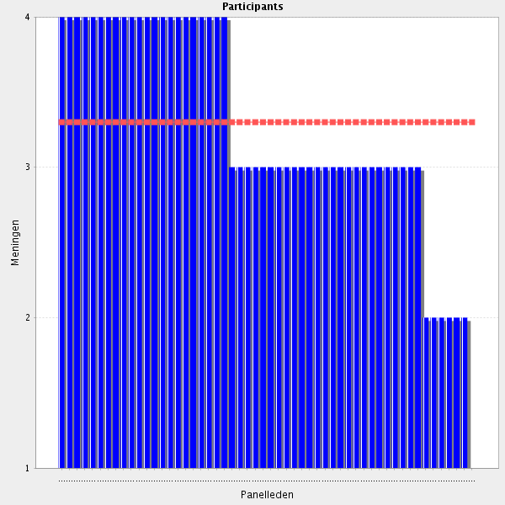
Average score: 3.3
Summary: despite reasonable agreement a number of comments expose that guidelines are there to guide and are not rules to be applied rigidly in the care of individuals, and may not apply to many patients with complexity or multimorbidity. In addition any prinicples relating to SOPs and guidelines apply to all cases and not only complex cases. In addition patients may not wish to have care recommended in guidelines.
Proposal: Amend to:-
Uses standard operating procedures where these are available and appropriate, and judiciously uses guidelines in the care of individual patients.

All comments on this statement: impactful statements in red
It is always better when you have standardized algorithm to follow.
Should also be clear that patient care does not always fit easily into guidelines and that interpretation and application of guidelines is a more accurate skill/competence
totally applicable, it is always better when you have standardized algorithm to follow.
It is important to standardize this process
SOP should be operational
Standard operating procedures and guidelines are not rules but provide guidance drawn up by experts and based on a number of similar cases.
Agreed, guidelines generally cover at least 80% of cases - not all cases will fit into algorithms or guidelines.
I agree, SOP and guidelines are just a frame
Pharmacist must have an important role in the promotion and use of guidelines. I think that their are in a position and have a knowledge that makes them a central figure in the promotion of guidelines in front of other health care practitioners
What is usually done right can become difficult to accomplish in stressful/complex situations (introduction of new software for instance, treating refugees without social security number, language problems etc.).
Necessary part of practice
The phrasing of this statement differs in the web survey here and the published pdf-version. The pdf-version reads: ...guidelines are always met, especially for complex situations. Be mindful of this discrepancy going forward to the next round of delphi consultation.
Only limited to the SOP's concerning medication.
Pharmacist have an important role in the promotion of guidelines use. However, many of them do not fit in complex situations.
SOP's and guidelines should not only be followed in complex situations but always (within clinical reason)
But complex situations may need to compromise with standard guidelines or procedures, considering global benefit/risk ratio
Standard operating procedures and guidelines should be met always, not only in complex situations
erase "complex situations"
do not fully understand this
Understands the interpretetion of the others, and I agree, if "complex situations" is taken out of the sentence.
SOP and guidelines should be the basis of action. Yet in complex situations they might not apply. In that case documentation of the arguments for deviation should be included in the health record.
Nevetheless expecially in complex situations it might be usefull to do a bit more.
In a broad sense? Of course. But specially for complex situations?
As long as these procedure are simple and comprehensive.
Ensure (and manage) that SOP are constantly updated to be fit to handle complex situations.
Can not always meet guidelines in complex situations. Must be able to act withing the professional licence and take own responisibility.
Why only for complex situations?
Agree - complex situations are often complex because they fall outside clinical guidelines.
I think this should be rephrased. SOPs are operational not clinical - is this talking about e.g. supply of medicines? SOPs and guidelines should be referred to and utilised for all situations not just complex ones otherwise why have them. And complex situations are often complex because they fall outside the guidelines therefore you cannot "ensure" they are met.
actually secondary opinions and consulations ensures the integrity of the cure
ı mean it would be better if there is a secondary person(dr,pharm,) he could check the order, prescription,we do so allways
In my opinion, SOPs and guidelines should govern most (if not all) situations. It is the complex situation area where things start to fall out of the scope of SOPs. I am not sure if this argument is phrased right.
What are the Standard operating procedures and Guidelines for complex situations? I assume there are no universal Guidelines or SOP's, so the Statement should probably recommend the Elaboration of such douments and ist core Contents (e.g., the appropriate documentation of the reasons and adressees for consultation/referrals).

1.8 Before going to the next group: do you have a remark, suggestion and or question on this group of competencies?
ın our country we are very at the begining of clinical pharmacy in many hospitals. there ıs no clinical pharmacists ın our hospitals. but our hospital pharmacists can work like a clinical pharmacist in some hospitals
I have commented on another response i.e. that there should be something about interpretation of lab results (LFTs Renal function etc.) cant see it referred to elsewhere and usually done as part of intimal assessment/reconciliation.
This section included tasks, mainly done by physicians and nurses in several countries. Sometimes difficult to answer.
I think that pharmacists have to be completely incorporated in the health care team, have access and share all the relevant information of the patient
Maybe is too focused on health records and less in direct patient interview and evaluation. Needs to be more patient-centered.
are there competencies around communication? with patients / carers / other health care professionals?
Important to highligt the need to understand what the information in the medical records, including interpreting lab results etc.
Agree - there should be something about interpretation of lab results (LFTs Renal function etc.) cant see it referred to elsewhere and usually done as part of intimal assessment/reconciliation.
All those outlined here seem sensible and necessary - irrespective of the state of current practice in each country
The pharmacist must be able to cooperate effectively as a member of a health care team IN THE CLINICAL UNIT
We miss the core competence of pharmacists preparation for patients with special needs (alternative pharmaceutical forms) e.g. newborns, children, patients with special need of application, eldery people etc. Hospital pharmacists should be able to find decide what they can prepare in the current situation to get the best outcome of a therapy. In Austria pharmaceutical preperations is a part of the university curriculum.
Maybe some points can be added regarding patient communication skills and ways of direct patient interview performance.
competencies seen in relation with direct patient contact!
The phrase "is able to" or likewise should be included in the text of the competencies where this is lacking. This will make them look more like competencies to be fulfilled/achieved than job descriptions.
Other key (clinical) competencies might include the whole MedRec/MedReview process in a more pronounced way. Lab test interpretation (and the consequential dose adjustement) seems missing. Also, in our current clinical practice, nutritional therapy is also a shared/multiprofessional competency that includes pharmacists as well. Might be worth looking into that.
This section discribes skill which are lacking in many parts by pharmcists in my county.

Group: 2 Medicine, medication safety and medical devices (Group 2 of 26)
2.1 Ensure appropriate selection of dosing regime: formulation and concentration, route and timing - Ensure dose is appropriate using point of care technologies for diagnostics and relevant information.
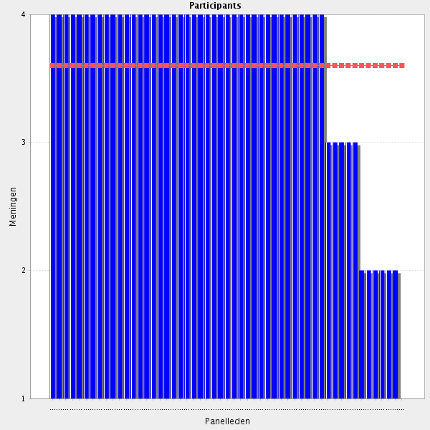
Average score: 3.6
Summary: good agreement. Comments relate to simplifing the language and removing ambiguity.
Proposal: amend to the following. Additional text re point of care diagnostic issues can be added back in in Delphi 2 if this is an important point.
Note: Suggest “issues” is removed from group title; title now reads as above.
In collaboration with other relevant health care professionals, ensures the right medicine, is given for the right reason, in the right dose, using the right route of administration, at the right time, with the right documentation, to the right person.

All comments on this statement: impactful statements in red
Extremely important in multidisciplinary teams
dosing regime is very important for all healthcare areas
this is what we should be doing and yes training is essential
Must be a distinction between prescribing and prescribing review/clinical screening of prescriptions
Core pharmacist role.
That should be our job!
Please add "In collaboration with doctors and other health care professionals and the patients."
In order to maximize the benefits of a drug it is paramount to respect its dosing regime. In some cases, timing is essential, particulary for those medicines that interact with food. Maximum doses should be respected, as well as the route of administration. Maximum doses and route of administration should be adapted to patient's diagnosis.
I agree that pharmacists have to ensure the appropriate dosage. However I do not see to what technologies for diagnostics the question refers. But oviously pharmacist has to use all the relevant information available.
Agree. Techologies for diagnostics?
The pharmacists should be responsible for the correct dose, formulation, concentration, etc, the physician for the choosing the correct active substance (after the diagnosis) and the nurse for the correct administration.
I Believe the pharmacist also has a role in choosing the correct Active substance, together with the physician. And I Think we need to be able to support the nurse in administration issues (in theory, not administer).
Pharmacists may help physicians in choosing the correct active substance, however I believe the group of the drugs should be suggested by the physician (e.g. patient with hypertension - physician has decided the ACEIs are the most suitable and the pharmacist has choosen one of the ACEIs)
pharmacist is one of the health professionals that has the best knowledge on dosing regimen; and should promote the development of technologies to check for that subject
It is very important to ensure the appropriate selection of dose regime.
In order to maximize the benefits of a drug it is paramount to respect its dosing regime. In some cases, timing is essential, particulary for those medicines that interact with food. Maximum doses should be respected, as well as the route of administration. Maximum doses and route of administration should be adapted to patient's diagnosis.
Necessary part of practice
Basic for clinical pharmacy services
Important task for clinical pharmacists and one of the competencies where we as pharmacists have better knowledge than any other health care professionals
extremely vital for proper treatment
officiallly explain these type of standarts to the public ,personally also ensures relailbility on the patients side to the systems
Make sure the diagnostics is being used when applicable
What is included in "point of care testing?"
example?
I think the first step should be selection of the appropriate drug rather than dose - the 5 R's Right Drug, Right Dose, Right Route, Right Time, (Right Person) could be used to structure this section. I'm not sure what point of care technologies refers to - is it lab results and diagnostic tests?
I don't agree that pharmacists should be responsible for diagnostics. Appropriateness of dose should predominantely be determined based on diagnoses and documented Information. If missing, pharmacists should encourage physicians or nurses to do further testing.
The role of hospital pharmacist is not diagnose diseases. The hospital pharmacist may advise on the use of some point of care technologies for diagnostics, or suggest alternatives to the doctor.
Selecting actual need for drug treatment and, if needed, getting appropriate evidence based choice of treatment, should be a prerequisite step in this chapter
It forgets about drug indication, appropriateness and cost efficacy evaluation of the treatment. Pharmacogenomics should also be mentioned in this section.
being sure we allways use rxmediapharma (digital vademecum(more than vademecum))

2.2 Ensure appropriate selection of dosing regime: formulation and concentration, route and timing - Understands the consequences of all different formulations and routes of administration
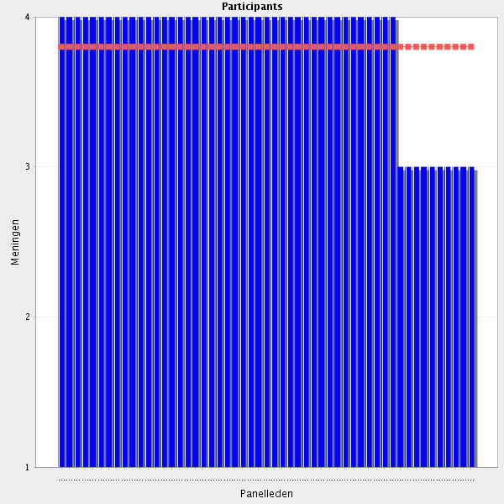
Average score: 3.8
Summary: strong agreement, but a number of comments signifying that this element can be amanlgamated into a revised 2.1.
Proposal: Amalgamate into 2.1.

All comments on this statement: impactful statements in red
A must. (Not sure though if 2.1 and 2.3 cover this as well...)
necessary qualification
The statement in this question and the next can be merged into one statement, thus reducing the total number of behaviour competencies descriptions of the CTF.
Maximum doses varies in accordance to the formulation and route of administration.
A key parameter in medicines optimisation
yes very ımportant
To ensure safe medication
Hospital pharmacists are medicines' specialists and should therefore understand the related pharmacokinetic and pharmacodynamic issues.
Pharmacist is the expert in drugs and medicines, therefore is the healthcare professional that has to be more prepared and know all that is related with formulations and administration routes. He or she has to be the expert in this issues and give guidance to the other health care professionals
one of the core competences of a pharmacist
the pain and pdyn (as well as clinical) consequences of dosing regimen should be known by all pharmacists
Essential. Needs to be able and willing to explain to the patient the possible consequences of each formulation and in such a manner include the patient in the decision-making process.
Sometimes MDs are not aware about the consequences of all different formulations available
One of the core competences of a pharmacist.
Necessary parts of practice
This is knowledge the pharmacist has to bring into the clinic.
Core competency for clinical pharmacists.
not only an essential skill for a clinical pharmacist, but it may be useful in cases of comparative effectiveness evaluation
routine practice
"Understands the consequences of all different formulations and routes of administration. " should be amended to "Understands the clinical consequences of all different formulations and routes of administration."
not sure this is needed as you cant do 2.1 without 2.2 i think this statement is redundant
This almost similar writing as for question 2.1 demonstrates that this former one should be rewritten to address treatment decision or stategy, not dosing regime .
Seven rights?
I think the next statement (2.3) covers this more thoroughly.
so precipitations and adverse reactions can be stopped, before hand exesive liquid loading be seen also
Why the use of "understands"? for some competences. I think the wording should be more focused on application of knowledge in this section

2.3 Ensure appropriate selection of dosing regime: formulation and concentration, route and timing - Understands the full range of formulations available, and ensures that the appropriate formulation and concentration is used.
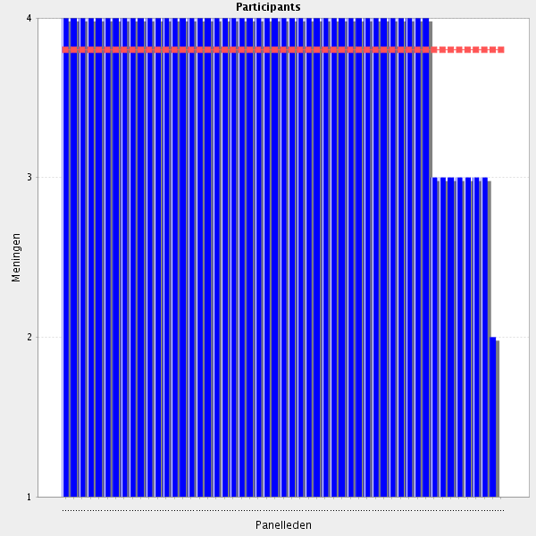
Average score: 3.8
Summary: strong agreement, but a number of comments signifying that this element can be amanlgamated into a revised 2.1.
Proposal: Amalgamate into 2.1.

All comments on this statement: impactful statements in red
Drug use must be adapted to the diagnosis and status of the patient. If a patient is conscious and eats normally, he should receive medicines by the mouth, unless he would need something with a very rapid effect (e.g. morphine i.v.). Depending on wether the drug is given orally or intravenously, concentration would be different.
Provide the choice for children, old people pregnant women, nursing mother, patients with renal impairment
The statement in this question and the previous one can be merged into one statement, thus reducing the total number of behaviour competencies descriptions of the CTF.
if it doesn't suit the case it will cause some unwanted adverse effects.
Essential for medication safety
Right medication at the right time
There might be a conflict between the formlation avaiable in relationship to the hospitals' formulary and patients' needs.
Hospital pharmacists are medicines' specialists and should therefore understand the related pharmacokinetic and pharmacodynamic issues.
Here I would say the same that in the previous question. Pharmacist is the professional that has to be the referent in all these issues
Continuous training needs to be available in order to be aware of the full range of formulations.
Necessary part of practice
Very important
It is obligatory for a clinical pharmacist to be aware with the full range of formulations available
Cannot agree more, though points 2.1, 2.2, 2.3 might be summarized in one overall statement.
Why the use of "understands"? for some competences. I think the wording should be more focused on application of knowledge in this section
again i think this has overlap with 2.1 bus of course it is essential
I think 2.2 and 2.3 should be merged.
according to concentrations of active subtances which adverse reacts to each others,there could be changed even sequences,and liquid load,
all this casacde of details should be summed up in one single question that covers all Groups of dosing regime

2.4 Ensure appropriate selection of dosing regime: formulation and concentration, route and timing - Considers whether medical devices for administration are required to ensure safe and effective administrations.
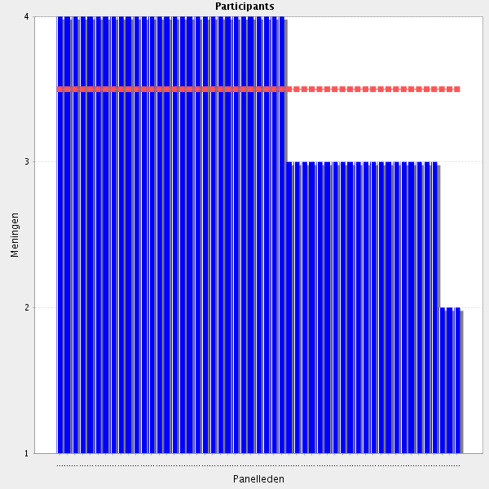
Average score: 3.5
Summary: reasonable agreement. Some indications that amalgamation with 2.1 is possible but on balance a seperate element relating to the use of medical devices seems tob e the sentiments expressed in comments.
Proposal: Amend to:
In collaboration with other relevant health care professionals ensures medical devices are used appropriately to enable safe and effective administration of medicines.

All comments on this statement: impactful statements in red
necessary part of practice
the very important part of health care for a lot of patients
admınıstratıon of medıcal devıces ıs so ımportant ın hospıtals
Role of the pharmacist
Make sure the medication reaches the target.
routine practice
Good use = good dose It's critical to educate patients
In a team with a medical doctor and nurse, of course
this is a newer concept but needs to be incorporated into training and practice
medical devices are to be considered with the same importance as medicines
I have commented elsewhere on change of wording
Continuous training related to medical devices needs to be available.
Always in collaboration with a medical doctor and a nurse. Skills of communication are required
Change wording, e.g. "encourages medical devices to ensure safe and effective administration if required."
It is not allways easy to do so because you might not allways know relevant fact and because there is a difference between the hospital and comunity setting.
Administration of medication is a nurses' task but it can be guided, in some cases, by the pharmacist.
Pharmacists have to have knowledge about administration devices, however I think that it is an area that has to be shared with nurses, because they are the ultimate responsable of drug administration in hospitals and in parenteral administration.
Also a nurse may be responsible for this activity
that's already a JCI minutes must be followed while checking and controlling an order of a patient and have to be choosen way of appliying wheather device or watched by nurses individually or togeather
proper way of administration is vital for therapy effectiveness and patient safety, but administration itself should be obligation of nurses or performing personnel
Medicxal devices are not the outmost priority in every hospital pharmacy
I agree, but sometimes it might be difficult for the pharmacist to assess that need.
same comment as before
some cases where the patient can be a child or an elderly(especially those with mental impairment) might not be able to use these devices safely and it can lead to more damage than benefit.

2.5 Ensure appropriate selection of dosing regime: formulation and concentration, route and timing - Ensures appropriate time of dose has been requested and works towards reducing instances of missed, delayed and duplicate doses.
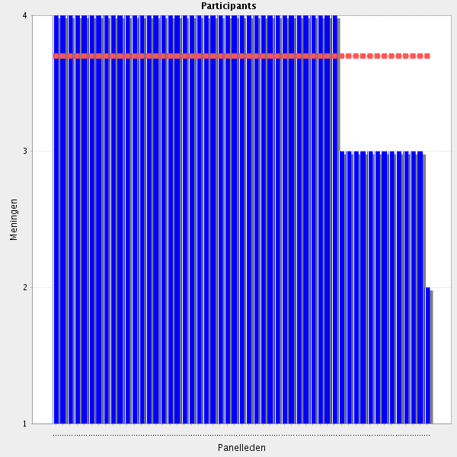
Average score: 3.7
Summary: good agreement. Some comments about duplication and the potential for amalgamation but the overall sentiment seems to be to have a separate element covering this topic, although involvement of other health care professionals and patients is required.
Proposal: Amend to:
In collaboration with other relevant health care professionals and the patient, ensures appropriate time of dose has been determined and works to prevent instances of missed, delayed and duplicate doses.

All comments on this statement: impactful statements in red
In order to maximize the action of a drug, it essential to choose the right dosing regime: formulation, concentration, route and administration. It's up to the pharmacist to assure that patients receives the right dose in the right moment, without delays or duplications.
routine practice
I guess, for time saving, we would need a good IT support
Essential for medication safety
Is the English correct "works towards"?
Pharmacists are drugs' specialists and should therefore alert for the consequences of missed, delayed and duplicate doses.
Pharmacists are drugs' specialists and should therefore alert for the consequences of missed, delayed and duplicate doses.
I totally agree. Pharmacists are in a privileged position to do this work, working with pharmacy technitiants and nurses. Pharmacists have a lidering position in the organizations to develop measures to minimize medication errors.
Essential for medication safety.
Necessary for optimal therapeutic care
it is important, but adherence to the prescribed regimen should also be considered by doctors, nurses and all the medical staff (shared responsibility)
using and electronig prescription software is sufficient while checking order and also retrospective analysis for all the things you questionnig about,route,adm.way,duplicty,delaying,missed dose etc,we use med soarian
this is often more difficult but i agree the monitoring of doses given is an important function
use "determined" instead of "requested"
reminders or timers on smart devices can be used in such cases.
Important, but is not only a work of a pharmacist. Is also part of compliance. Maybe needs more explaining?
This topic is often not in the responsibility of the pharmacist.
Probably a word missing here. ...and works towards preventing missed, delayed and duplicate doses.
It should also include documentation of the adminsitration (where possible, electronic administration record).
far too many detailed steps under the scope of core competencies and learning

2.6 Medication therapy management - Is able to evaluate patient-specific drug therapy and therapeutic problems.
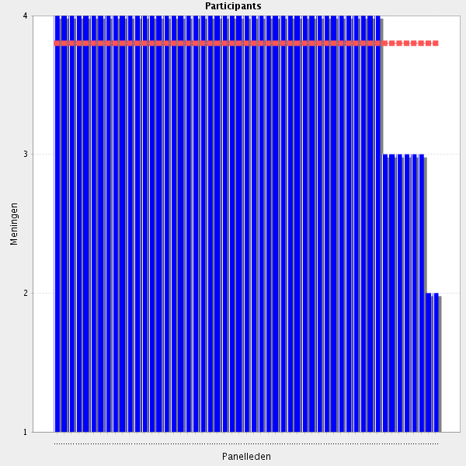
Average score: 3.8
Summary: strong agreement but one telling comment idicates that with some minor wording changes this elleemnt is a repetition of 2.7.
Proposal: amalgamate with 2.7.

All comments on this statement: impactful statements in red
Core feature of pharmaceutical care.
This behavioural competence is listed twice in the published pdf-version of the CTF.
Sometimes, therapeutic problems are missed by doctors.
Important for medication efficiency, effectiveness and safety, always in collaboration with other health professionals and definitely the patient.
this is key
This one of basic task of a clinical pharmacist.
Also able to identify problems, needs to be added.
Hospital pharmacists are experts in medicines, evaluate patient-specific drug therapy and therapeutic problems is a part of their function.
This is one of the principal step in the process of Pharmaceutical Care. Pharmacists have to be able to evaluate the patient treatment, in order to determine if there are medication related problems. After to take measures and to revaluate the effectivity of them.
Very important for a clinical pharmacist. To be discussed, if every hospital pharmacists needs very detailed clinical skills.
key component for clinical pharmacists
It is a key behaviour competencie for clinical pharmacists.
Necessary part of practice
Basic for hospital pharmacy
essential competency for a clinical pharmacist
routine practice
This is a must for orthodox clinical pharmacy services.
at the hematology clinics that gets you informed much about how human beings a thing ,(they are also using cure time spesific drugs like at the oncology let alone patient specific)
AND actual needs, objective. See before
What kind of therapeutic problems?
same as next item
Assess? Drug-related problem or therapeutic problems?

2.7 Medication therapy management - Is able to monitor patients in the health care setting with ongoing evaluation of progression of disease, development of disease related complications, efficacy of drug therapy, and development of drug-related adverse effects.
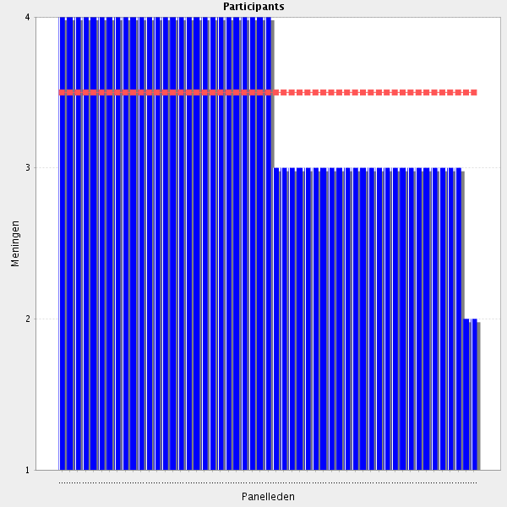
Average score: 3.5
Summary: reasonable agreement but many comments relating to the need for multidisciplinary teamwork and some comments about including the patient.
Proposal: Amend to:-
In collaboration with other relevant health care professionals and the patient and carers, contributes to the ongoing assessment of health status, monitors for disease related complications, monitors the efficacy of drug therapy, prevents and identifies drug adverse events, considers alternative treatment options, recognises the risks and benefits of each option, selects and takes actions which are appropriate for individual patients, takes responsibility for those actions, and is able to justify them.

All comments on this statement: impactful statements in red
"Drug related adverse effects". Important to use common terminology that both includes patient safety and adverse reactions eg "Drug Adverse Events
As I said in the previous question, the Pharmaceutical Care process implies this step also. However, this evaluation has to be done in collaboration with other professionals
necessary part of practice
This is the global main task
Although I agree in principle - it is not feasible for all hospitals
core competency for a clinical pharmacist
routine practice
Core clinical pharmacy competency.
It's the medical follow up in collaboration with the treating physician
Important to know the complex human. With effect of disease and effect of drugs
This is a task difficult to perform because it is not easy to retrieve all relevant information when changing between differtent settings.
As a valuable meber of the multidisciplinary team
we watch all the records of patients disease and the drugs used,with collaboration by the professionals at the visits and the computer sessions as a supportive power not as desicion makers,
remove "in the health care Setting". Write "drug-related Problems" instead of "drug-related adverse effects"
I agree strongly in the latter, drug related issues, but the first, relating to the disease might lean towards medical diagnosis. Pharmacist responsibility at this level?
Focus on efficacy of drug therapy, and development of drug-related adverse effects. Do not focus so much on evaluation of progression of disease, and development of disease related complications because that is doctors' job.
I disagree. The pharmacist should monitor, evaluate and assess e.g. worsening renal function or diabetes to be able to recommend appropriate pharmacotherapy
Agree with the drug-related adverse Events. The monitoring of disease progression in our country is mostly done by the physician.
monitoring patients is mainly the responsibility of the physician and pharmacists have most of the time a partial view of the follow -up of the disease thus inter-disciplinary is necessary
As a part of the multidisciplinary team (that mutually communicates and collaborates for the benefit of the patient) the pharmacist should manage questions of efficacy of drug therapy and adverse effects of drugs while the physician should monitor and evaluate the progression of the disease.
I agree, provided that clinical reports be available "on-line" for consultation.
This evaluation has to be done in collaboration with other professionals.
In cooperation with other health care professionals.
To accomplish this ponit, ther is a need of clinical understanding, not alwayes present in the standard HP-curriculum
Should be stressed that follow up of drug therapy is a multi professional responsibility where the the pharmacist is one contributor.
Only together in a team.
Pleas add "together with the doctor and other Health care Professionals and the patient"
It is important when it comes to drug therapy, and development of drug-related adverse effects. Evaluation of progression of disease, and development of disease related complications is other health care professionals job.
does not belong to the 5 core elements of MTM.

2.8 Medication therapy management - Is able to design a comprehensive drug therapy plan for patient specific problems.
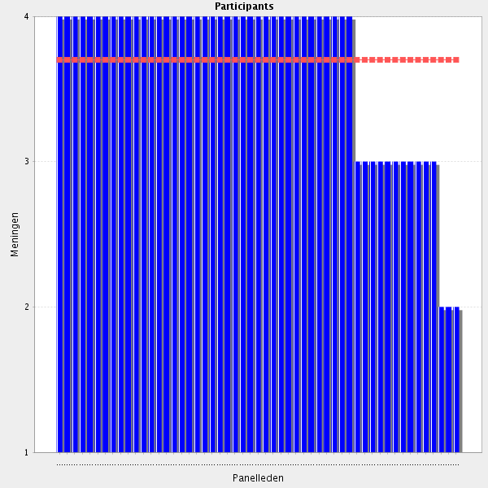
Average score: 3.7
Summary: strong agreement in scores, but many comments reflecting this needs to be a team approach, involve the patient and reflect their needs (and preferences) and not just be based on the patient’s problems.
Proposal: Amend to:-
In collaboration with other relevant health care professionals and the patient, contributes to the design of a comprehensive treatment plan which addresses the patient’s needs and preferences.

All comments on this statement: impactful statements in red
routine practice.
To obtain compliance with treatment, take into account her lifestyle specificity
Clinical pharmacist
This task is not routinely performed by pharmacists in my county.
Pharmacists should have skills in the development and preparation of a drug therapy plan adapted to the needs of the patient. For example their knowledge on formulations and administration routes, can help in finding the more suitable for the patient, thus increasing the adherence. As well as selecting the more appropriate drug in function of the possible adverse effects and the appropriate dosage.
one of the most significant task for a clinical pharmacist
In collaboratin with other healthcare professionals and the patient
nowadays by early access programme ,patient find have the chance to meet with comphrensive cure methods and drugs
If the pharmacist doesn't do this, who can?
Should be the way forward
i wonder if it needs to have the word problems, as sometimes plans can include prevention, so re word is able to design comp drug therapy plan based on patient specific needs
write "for patients individual therapy". A drug therapy plan is not just for Problems.
Individually or in a team
Change patient specific problems to patient specific needs.
In collaboratin with other healthcare professionals and the patient.
it is very important skill, but proper design of effective patient specific therapy plan should be accomplished as a result of fruitful collaboration with the responsible physician.
In agreement with physicians.
It's not up to the pharmacist to design a drug plan. That task belongs to doctors.
Still, pharmacists as members of the healthcare team can and should participate in the drawing of a drug plan together with doctors, nurses and other healthcare professionals.
In my country doctors design drug plans but I agree that pharmacists should actively participate
This kind of authority belongs only to doctors in our country.

2.9 Medication therapy management - Is fully competent in providing complex, in-depth clinical services and direct patient care.
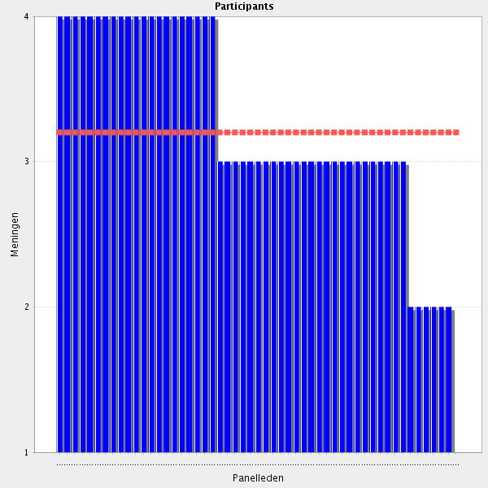
Average score: 3.2
Summary: a lower level of agreement compared to previous elements. A significant number of comments concerned either that “fully competent” is unachieveable, and especially that this elemnt is not specific enough for a training tramework.
Proposal: Remove this element. Other elements adequately describe the components of a high quality clinical pharmacy service.

All comments on this statement: impactful statements in red
great adaptability
As the experct in medicines, pharmacist can aproach any problem and recommendation in relation with drugs. Even the more complex.
Provided that the pharmacist collaborates with healthcare professionals and social care individuals and institutions
With sufficient (and adequate) training (and licensing), as part of a multiprofessional patient care team.
In the context of a multidisciplinary team.
Strongly agree, but more and more surprised with this Delphi hierarchy of items : major/innovative Groups and added values for pharmacy teaching/learning/practicing are lacking attention/description/detailes, compared to simple technical ''minor'' Groups
In the context of a multidisciplinary team.
A key competence
Broad description, but maybe neccessary.
fully competent by the end of foundation training
Not all pharmacist in my county will be able to do so.
it needs to be clarified what is the scope of '' in-depth clinical services and direct patient care"
not very specific compared to other items
this is an overarching motherhood statement that i think is alreday covered in the others
But this can also be on a more specialized level (as an example: oncology ward). To provide in-depth therapy management in every area of care is hardly manageable.
This requires very good training and education in clinical pharmacy.
for such a competency as specialised formation would be necessary
Very broad statement. Remove the word fully - this is about Training - and consider revision of overall statement to include examples.
This is the routine in my hospital but it is not common in all the regions in my country
pharmacist only aren't being educated complete physiology, pathology and teh mentalty of algortim in spesific clinic situations,but clinical pharmacist are,and then no need to doctor; is the only matter of med are in,
In the context of a multidisciplinary team.
it depends on the position of clinical pharmacist on ward
Pharmacists should be able to advice doctors, as well as patients. Still, direct patient care should be shared with other healthcare professionals, namely nurses.
Need of a curriculum/spercialisation in clinical pharmacy
Don't understand completely
with the multiprofessional team
Too broadly phrased to be meaningful. It's like saying "be a skilled clinical pharmacist". The phrasing does not usefully contribute to defining the competencies that characterizes a skilled clinical pharmacist.
if meant for a "Training Framework", this is much to complex.
This is a very high level requirement. Is this framework ment to be useful for training? This is not a level that can be reached unless you have extensive work experience. Maybe these competencies should be somehow graded into different levels.
I'm not sure "fully competent" is achievable for pharmacists who are working in areas that do not provide complex, in-depth clinical services. It may be wise to reword this to, capable of, or capable of becoming fully competent to
This kind of authority belongs only to doctors in our country.
Patient care should be provided by nurses.

2.10 Medication reconciliation - Gather and interpret all the information about the patient medication and medical devices use.
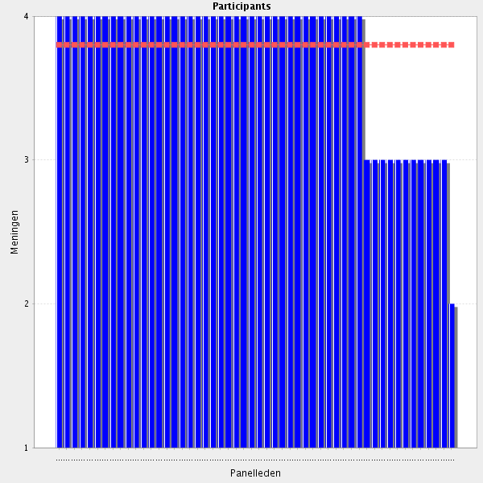
Average score: 3.8
Summary: high level of agreement. As a comment suggests, this can still be strengthened by making the link with history taking in 1.3. 2.11 and 2.12 can readily be incorporated into 2.10.
Proposal: Amend to:-
Uses an accurate and comprehensive medication history, including the use of medical devices, to identify any discrepancies and reconcile medicines, in collaboration with patients, carers and other relevant health care professionals.

All comments on this statement: impactful statements in red
it is a key factor for proper maintenance of a therapeutic database and forming relevant conclusions/evaluations for prescribed therapy. One of the main responsibilities of the clinical pharmacist.
routine practice
New main task
Core skill
Medication reconciliation is often missed by the doctor.
Key Group of medication safety
Relevant task at the point of hospitalisation.
Pharmacists are the only qualified specialists in a hospital who can interpret all the information about the patient medication.
Pharmacists should have a dept and wide knwoledge on medication and medical device usem in order that they can interpret and deduce all the important issues in the drug treatmente and in the use of medical devices.
THe HP is the appropriate person for making MR.... but we need more staff
there was a quite gap for the patient mediation safety issues
work to be done in collaboration with other health professionals, and to find the right place for the pharmacist in this activity (most important for patients living the hospital)
Work to be done in collaboration with other health professionals, and to find the right place for the pharmacist in this activity.
add "from at least two sources"
this was already covered in history taking
The three points are ok but I think it should be stated somewhere that hospital pharmacists have to be able to reconcile medication at every admission, discharge and transition of care. They should be able to do it themselves or under their supervision.

2.11 Medication reconciliation - Identify discrepancies
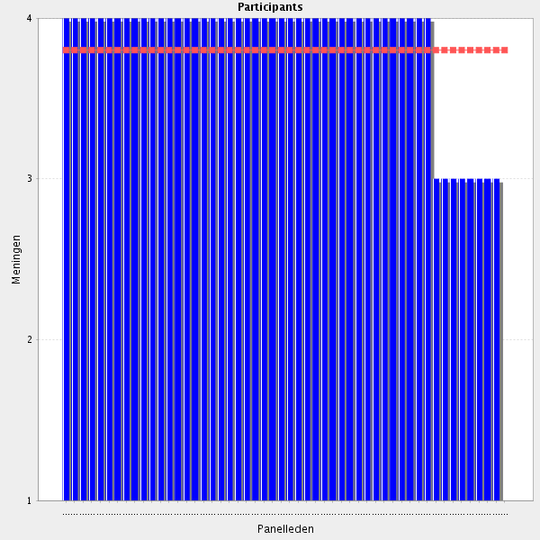
Average score: 3.8
Summary: scores indicate good agreement, but a number of comments indicate the need for merging current stand alone elements.
Proposal: this element has been merged with 2.10 and can be deleted.

All comments on this statement: impactful statements in red
essential
As long as the methods and tools for that identification are available
Pharmacist is the most qualified healthcare professional concerning the identification of discrepancies (e.g. concentrations limits, drug interactions).
necessary to draw conclusions
As an expert in drugs and treatments, pharmacist is the best positioned to identify discrepancies. The degree of knowledge has to be very high in order to do detect discrepancies very efficiently.
Pharmacists' job.
as soon as all the informations are available (development of technologies "electronic patient dossier" is necessary)
Agree, IT is of great importance
newly prescribed drug may have get into adverse reaction if you don't check the drug that has possiblly opposite effect of last dose of the patient has taken,there are several examples of this situation especially in high alert medication,
I fully agree.Is it possible to join 2.10 an 2.11?
routine practice
ı agree but itis very early for us
This point can be fused with the next one.
add "between regimens"
The behavioural competencies pertaining to medicines reconciliation can probably be merged into fewer item in order to reduce the total number of competencies, thus making the CTF more manageable.
same comment again : this is part of the medication reconciliation process by itself. Why is this topic divided in so many questions, while some others gather very different procédures in one single question ? very strange

2.12 Medication reconciliation - Resolve appropriate discrepancies with patients, or GP, or community pharmacist, or nurse, or patient carer.
Average score: 3.8
Summary: high level of agreement but again the potential for merging with 2.10.
Proposal: merged with 2.10. This element can be deleted.

All comments on this statement: impactful statements in red
very important competency for a clinical pharmacist
Providing a sufficient level of seamless care systems.
Always in a collaborative and friendly manner
or the medical doctor in the hospital too
Sometimes maybe and/or the different sources. Important that everyone has the whole Picture of the patients drugs.
otherwise the pharamcist is part of the problem but not solving it
Pharmacists' job.
As I said in the previous question, the degree of knowledge and management of discrepancies has to be effecently, and phamacists has to be able to argument and discusse their recommendations with the other professionals and patients
the old therapy needs to be investigated all the time may be can catched a clue about it
I agree. Is it possible to join 2.10, 2.11 and 2.12?
It is important to know exactly what the patient is really taking and how. For that is essential to speak with those who take care of them.
routine practice. core skill for pharmacists
ıt ıs a multı dısıplınary team work ı agree
rephrase "Resolve discrepancies appropriately..." write "physician" instead of "GP"
Sometimes maybe and/or the different sources. Important that everyone has the whole Picture of the patients drugs.
The results shoud be avalible for other healhcare professionals via the medical records.
see before (amalgamation)

2.13 Medication reconciliation - Communicate with the physician or relevant healthcare practitioner to resolve significant issues (if applicable).
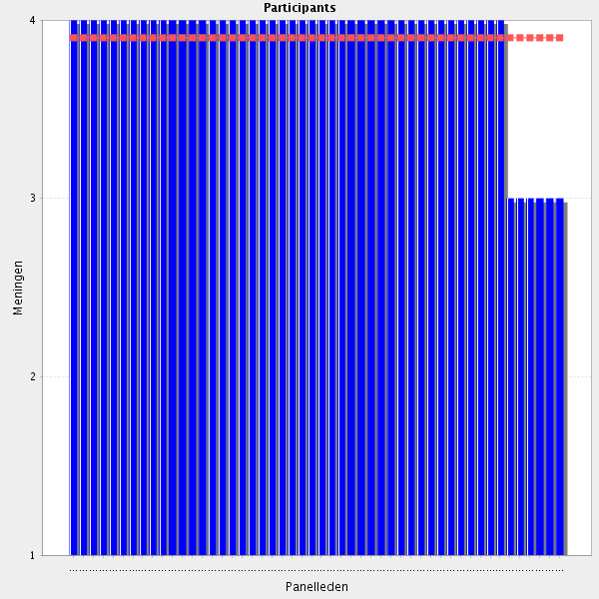
Average score: 3.9
Summary: high level of agreement. Comments may have suffered from reconcilation fatigue but one does identify this can be merged into the revised 2.10.
Proposal: this is merged into the revised 2.10 and can be deleted for Delphi 2.

All comments on this statement: impactful statements in red
If something is not right with a patient, it is important to inform his doctor, namely if a adverse event happened or if a major drug interaction was detected.
Essential to the point of an absolute. A key factor in medication safety.
Emphasis on spoken information not only written.
effectivly working in a health care team
ı strogly agree
Should also be applied in the medication management section
Pharmacists' job.
This is obvious. I want to say that this requieres some competencies by the pharmacists. First, to have a high preparation in drug therapy and also comunication skills. It is very important that physicians see that the pharmacist is an expert in this area. Morevoer, the way of comunication is of paramout importance in order to establish a good collaboration with physicians.
I agree, eventhough that might be not so obvious...
Please, to what exactly are you refering that is not so obvious?
interdisciplinarity is essential for this task
interdisciplinarity is essential for this task
And include the patient in the process.
when you see a new patient's order at the hospital information programme at the order control section you firstly check the patient medication history at the programme,if that is left blank let the dr ask why,wheather taken prognoses from the patient or not about the drug history, by mail or verbally,go further till find the drugs
basic competency
routine practice core skill for pharmacists
Ability to communicate
even ifd issue not significant it needs to be resolved, i think this is covered in the one before
I understand that pharmacist prescription is uncommon but we shouldn't close the door to it. Some experiences are being carried out in US an UK with pharmacis prescription/medication adjustment using shared protocols with other healthcare professionals (ex.: statins prescription or antihypertensive drugs dose adjustment, antibiotic prophylaxis in surgery). It could be called "treatment indication" or "adjustment" to make it less controversial.
And include the patient in the process.

2.14 Medication reconciliation - Communicate reconciled medication and medical devices list to the patient.
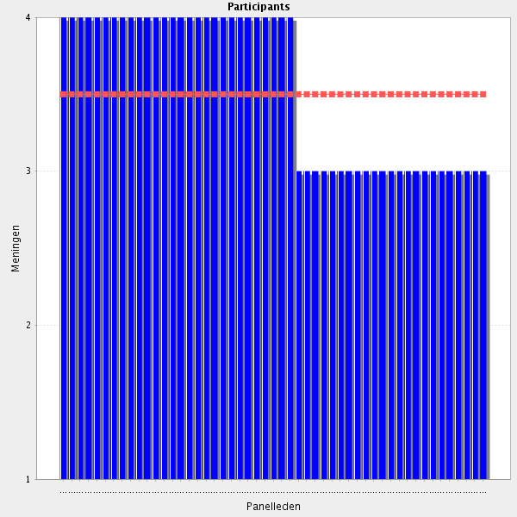
Average score: 3.5
Summary: lower level of numerical agreement but the sentiment of comments indicates that communication of an agreed, reconciled medicines plan is important and a stand alone element is jsutifiable. Issues about wider communication that just to the patient and need addressing in ammendments.
Propsal: Amend to:-
Communicates an agreed, reconciled medicines plan with patients, carers and other relevant health care professionals.

All comments on this statement: impactful statements in red
we do so by mail to all health care team written and verbally
An important part of patient-centred care
it is usefull to focuse the using explenation on patients
Patient involvement is paramount
As long as communication with the patient or the carer is feasible and the reconciles medication is not imposed on the patient, against his/her will. The patient needs to understand the changes. The pharmacist may be one of the healthcare professionals that should have developed the skills to do that. But other health professionals could do the communication of the reconciled medication, as long as a pharmacist is included in the group that "brainstorms" regarding this reconcilliation.
routine practice. core skill for pharmacists
Not medical devices
Would it be appropriate to include a medical device if it were involved in the administration of a particular medicine?
I agree with you. I have changed my mind since I have thought about a different thing. I would like to say that it is not always aplicable.
Very important for patient engagement and shared decision making.
The patient needs to be includd in the decision-making process and not just notified about the decision.
that's realy a good idea
Medical devices if possible.
also communicate to all professionals
The pbest plan does not help when it is not communicated with the patient
with the need for special training or joint communication with other helath care personnel, if children.
add "and other caregivers"
If applicable. Or communicate to the one that administrers drug to the patient.
Pharmacists can make an important collaboration in the comunication of the reconciled medication to the patient, however in the hospital, we have also to take in account that nursing staff is strongly involved in the patient care. Therefore, I think that this should be a collaborative issue.
Or their carer as appropriate. Also would not necessarily communicate errors of omission, incorrect doses etc. to the patient if they are corrected before they reach the patient to avoid undermining the therapeutic relationship with their prescriber.
Also communicate to all professionals.
it is not always applicable, in most of the cases (when there is no integrity of databases) clinical pharmacist does not have access to the full panel of information for medical devices, medicines used for a specific patient.
Sometimes the communication to physician/nurse is enough
It is important to inform the patient how he should take his medicines in order to prevent drug events. In my opinion, before that we should inform his doctor, as well.

2.15 Medication reconciliation - Update all changes made in the appropriate records.
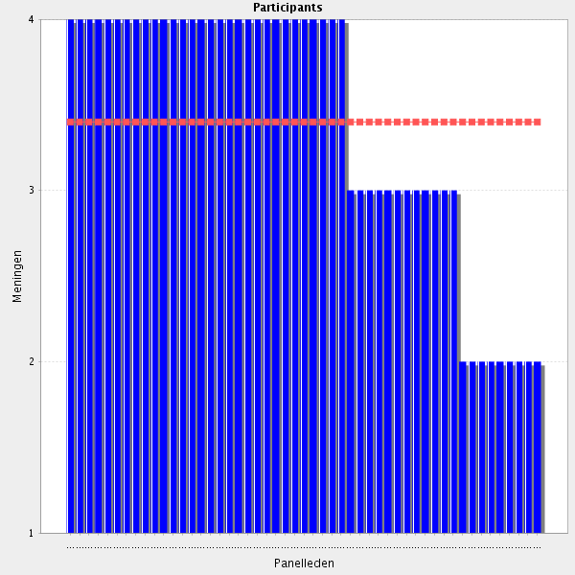
Average score: 3.4
Summary: average agreement. A number of comments indicate that responsibility for recording the results of the medicines reconcilation process may rest with other health care professionals in some situations and in some countries. A rewording can be tested in Delphi 2.
Proposal: Amend to:-
In collaboration with other relevant health care professionals, ensures that the results of the medicines reconciliation process are clearly, accurately, and comprehensively documented in the appropriate records.

All comments on this statement: impactful statements in red
Pharmacist are responsible to update any change done during the reconciliation process. Therefore, they have to have access to the clinical record of the patient.
requires ad hoc technology
Important that pharmacists take responsibility for this
Agree but not possible so far in my country
Routine practice. Core skill for pharmacists
Again, we need a good IT support
In my county we will have an electonic health insurance card containing "all" relevant information but presently pharmacist are not the key persons to take card of the comprhensive drug list because of political reasons.
Important for a next intervention.
This records should be clear, accurate, comprehensive and accessible so any other health care professionals can use them.
This task is very time-consuming and requires additional working hours of the pharmacists
I agree, despite being my belief that it's up to the doctor to change the prescription. Medication reconciliation is very important, but pharmacists should not prescribe. All that is prescribed should be validated by a pharmacist. He/she should feel free to advise/propose therapeutic alternatives whenever is necessary.
update and check for effectiveness scale.
Important for a next intervention.
Important to know how and to do the update. However, Technology Enabled Care may be a useful ally.
depending on local regulations
Provided the pharmacist have access to medical case notes.
write "document" instead of "update"
update only changes made by the pharmacist himself
Appropriate records might not be accessable.
The pharmacist is not Always able to update in apprioriate record. So instead: Make sure Updates of all Changes is made in appropriate records. If accessable to the pharmacists they can do it. Otherwise make sure the presribers do so.
This is not part of my profession - the prescriber needs to do this.
Only prescriber can do that, not HP. Or a clinical pharmacist when he´s established in the hospital.
we do not so way
In pour country this is a nurses'taslk
it should be performed by the medical specialist, who had administer the medication/medical devise. Clinical pharmacist should be responsible for reconciliation, but not for entering the data for application itself.
Pharmacists don´t have the formal competence to change medication records and other documents in our country.

2.16 Pharmacoeconomics - Is able to identify the most cost effective medicines and medical devices based on interpretation of relevant data.
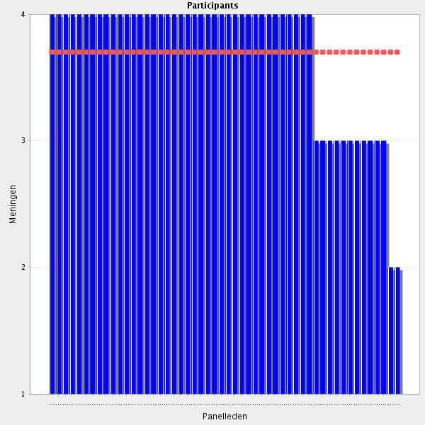
Average score: 3.7
Summary: reasonable agreement. No clear steer from comments on 2.16 to indicate areas for further improvement, but perhaps removing “the most” should be tested in Delphi 2 since a number of medicines with similar effectiveness, safety and cost effectivess data are likely to be required to be included in a formulary within a therapeutic class becasue of the charactericis and different responses of individual patients. However, there is a clear steer from 2.17 that the CTF should focus on an understanding of pharmacoeconomic studies and data and not necessarily on being able to perform such studies personally. Indeed, as some particiapnts point out, some pharmacoeconomic approaches require considerable specialist expertise; such studies should not be attempted without the requisite training and supervision.
Proposal: Amend to:-
Can identify cost effective medicines and medical devices using valid and relevant pharmacoeconomic data.

All comments on this statement: impactful statements in red
very very essential for clinical practice
Resources ar limited. So, it is extremelly important that pharmacists know how to select the most cost effective medicines and medical devices.
Routine practice. Core skill for pharmacists
Absolutly
There is a public procurement law in the related state hospitals. And all the hospitals are taking medicines and supplies with these rules
Very important! Resources are limited.
Pharmacists are the healthcare professionals better informed about the cost of medicines and medical devices. They have to be the central professional giving advice about this issue to other professionals and managers.
such an analysis should be done and shared with physicians
Pharmacists are the healthcare professionals better informed about the cost of medicines and medical devices. They have to be the central professional giving advice about this issue to other professionals and managers.
Important for pharmacists to do this
Important to lower costs
mrp (management resources programme) programes of purchasing department of the pharmacy detects the most advanced priced drugs all the time in diffent ways
Using developed tools and procedures and always assisted by the appropriate professionals.
I agree, but we are more focused on cost minimalisation rather than cost effectivness. We would need more training.
Good that it is able to
But despite this fact other key players in health care will make the decision in ways which are sometimes not the best for the patient.
maybe? im not sure, i would hope that only cost effective items are on the formulary??
To a point basic knowledge, yes, but fully interpret pharmacoeconomic Groups does not need to be done by every hospital pharmacist.
Maybe use Another Word for "identify"? "Work towards"? "goal for"?

2.17 Pharmacoeconomics - To perform pharmeconomics evaluation.
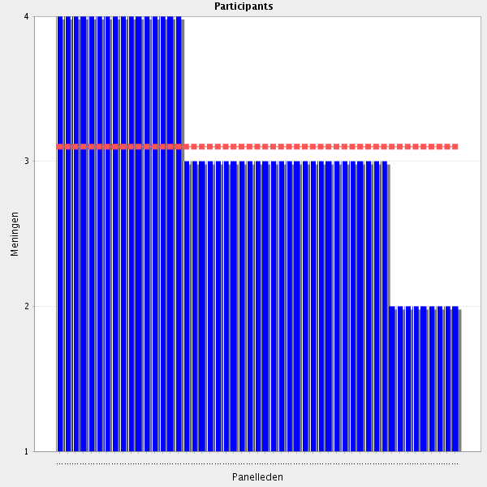
Average score: 3.1
Summary: a lower level of agreement and a large number of responses indicating that performing pharmacoeconomic analyses, especially the more advanced approaches, should not form part of the CTF.
Proposal: 2.16 has been clarified and strengthened to reflect the comments on 2.17. 2.17 can be deleted. For Delphi 2

All comments on this statement: impactful statements in red
searching biosimilar medicine
Together with economists
Pharmacists should have a in depht formation and information on how to perform pharmacoeconomic evaluations.
pharmacists should understand (at least ) the basics of pharmacoeconomics (concepts of ICER, QALY and different types an analyses).
Pharmacists should have a in depht formation and information on how to perform pharmacoeconomic evaluations.
Necessary part of pharmacists' role
essential
It's essential that a pharmacist knows how to perform pharmacoeconomics evaluation.
How to perform? Or how to interpret? In my Point of view, for phamacoeconomic evalutations you also have to know a lot about the specific therapeutic area, for exampel cancer treatments and phamacoeconomic evalutations of new treatments. Not something I would Think all of us are able to do, or have to do.
Basic knowledge of pharmacoeconomics should be sufficient
needs fuller explanation. Should be able to perform evaluation of cost / benefit, however may not conduct routinely
it's part of a pharmacist knowledge. However, in a clinical setting it is only necessary a basis on pharmacoeconomics evaluation.
They should have basic knowledge about it and at the same time they should always bear in mind the importance of patients' safety
Not all the HPs are able to conduct a pharmacoeconimcs evaluation.
"To be able to perform a pharmacoeconomic evaluation" Same as the previous point - suggest removing this one.
Some basic evaluations are easy; more structured pharmacoeconomic evaluations need specific training
Knows the principles of pharmaco-economics. Knows how to interpert results. To perform an evaluation is not necessary a generic competence but could be part of a specialisation/differentiation program within the curriculum
Basic ones, not in an enhanced level
Should form part of the CTF module
thıs must be a duty for a hospıtal pharmacıst
Not every hospital pharmacists need to be deeply specialized in pharmacoeconomics
I agree. The skill level of this competency should be set at being able to understand and interpret pharmacoeconomic analyses rather than being able to fully perform them yourself.
We need more training to this (the certificate).
Maybe a pharmacist, specialised in pharmacoeconomic area
To understand - I fully agree. To perform - it is very complicated. I think HP can do only cost minimalization study. Cost-effectivness or other types of pharmacoeconomic analysis are very complicated.
The level of skill must be specified. To be able to perform a full in depth pharmacoeconomic evaluation requires expert skills that are beyond what should be required of hospital pharmacists in general. A basic understanding of pharmacoeconomics is one thing, being able to perform a HTA-style pharmacoeconomic analysis is something completely different.
Not applicable. Pharmacoeconomic evaluations are performed by other agencies in Sweden
this explanation is very limited in my opinion
Requires a lot of specialist competence. Is this done at hospital pharmacies? I'm thinking NICE-work...
same as previous but less specific
not 100% convinced it is a skill that all pharmacist need to be trained in. i do think that some should specialise in this and all should have some appreciation of the elements but these evaluations are complex and usually require a health economist to do it properly
And drug utilisation evaluation
This is a v eray difficult task. In my oppinion we should be aware of pitfalls when interpreting studies.? Don't know if this should also be included here.
Not a basic knowledge.

2.18 Pharmacoeconomics - Is able to conduct a health technology assessment, which refers to the systematic evaluation of clinical data, properties, effects, and/or impacts of health technology to inform/influence a policy decision making (if applicable).
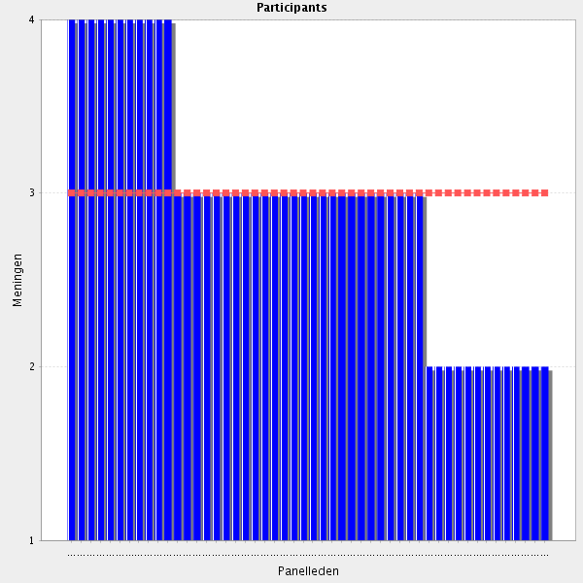
Average score: 3.0
Summary: the lowest agreement score so far, and a clear message from comments that conducting HTAs should not form part of the CTF.
Proposal: remove this element of the CTF.

All comments on this statement: impactful statements in red
Important
Before introducing any drug/health technology in an hospital, it is paramount to perform the assessment of that drug/health technology. Pharmacist should be able to do so.
In a group that does this, not individually. A pharmacist should know how an HTA is conducted
Not all the HPs are able to conduct a HTA evaluations.
Important to report to Drug and Therapeutics committees etc. Not something most pharmacists will do regularly but an awareness and knowledge of what is required to conduct one is important.
Not sure if this statement if need in new guidelines as a prerequisite for every hospital pharmacist
Pharmacists should have some knowledge in the area of health technology even though I think it is not their main area of work
this should be done in cooperation with physicians
ı'm a purchaser same time got bored that kind of buisness,lol
This is important, but to what extent should this be expected of all pharmacists? Is this starting to get into advanced/specialist competencies?
We need clinical pharmacists that are being able to conduct such assessments, but it is not mandatory that all clinical pharmacists can do this.
if applicable. may not be core to all pharmacist roles
pharmacists should be able to do it.
Nice to have, but not of primary importance
In a group that does this, not individually. A pharmacist should know how an HTA is conducted
Too spesialised to be a part of the general specialisation. Some understanding of the principles can be included.
Is this something a hospital pharmacist does?
In order to improve the Common Training Framework, please can you tell us why you disagree with this statement. Can you suggest different wording that would gain your agreement with this statement?
it would be very nice if every clinical pharmacist is able to perform HTA, but a proper HTA performance can be done by multidiciplinary team of physicians, biostatistic professionals, economists, etc.
Too ambitious skill requirement. Performing a scientifically sound HTA requires specialised skills that general hospital pharmacist do not and need not possess. It is important to be able to understand, interpret and assess HTA-reports, but being able to a HTA-report yourself is a competence bonus.
not sure its the role of all pharmacists
Disagree not about the objective/competencies, but about the very disorganized conception/structure of this Delphi survey
Needs to be done by a few specialist pharmacists, in cooperation with other Health care professions, but not something every hospital pharmacist needs to know fully.
if only basic pharmacoeconomic knowledge is sufficient, this is far to complex for a training framework
This is a very special task and should be performed by specialists.
conducting a full, formal HTA is not the Task of the General Hospital pharmacists

2.19 Medical devices - Understands and applies knowledge of medical devices for drug delivery, administration and reconstitution.
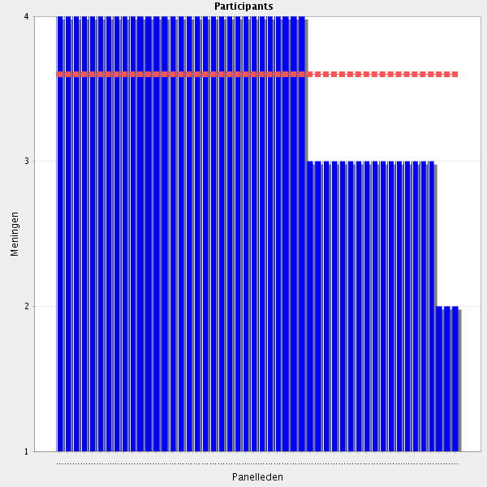
Average score: 3.6
Summary: reasonable agreement, and comments do not indicate areas for improvement. However, can be better placed with the new 2.2.
Proposal: merge this with 2.2

All comments on this statement: impactful statements in red
It depends, medical devices might be out of the pharmacist's reach, depending on the country.
Pharmacist should know how medical devices work (mechanism of action and drug delivery) and how to use it (administration, reconstution and dilution).
Essential
Important
essential for clinical practice
Routine practice. Core skill for pharmacists
Pharmacist should know how medical devices work (mechanism of action and drug delivery) and how to use it (administration, reconstution and dilution).
To every patient will use medical devices applies knowledge from a pharmacist.
Pharmacists' job.
All medical devices? Maybe only these, closely related to the drug application.
As experts in medication, pharmacists should have a wide knowlege about the different devices for drug delivery, in order to assure the correct administration of medication, even they are not the ones performing administration. As in many hospitals phamacists are responsible of the preparation of IV admixtures and citostatics, is clear that they have to have a high level of knowledge about reconstitution.
thought this has been covered but i agree
In discussion with patients
Necessary to educate paitients on use of devices
Changes fast. Pharmacist needs to know the basic Technologies and be able to apply this on new devices.
Only for medical devices that are indispensible for effective and safe drug delivery, administration and reconstitution. All the other medical devices should be included in another healthcare professionals' expertise
Duplication (merge with Group 2.4)
Don't understand "reconstitution" in this context

2.20 Before going to the next group: do you have a remark, suggestion and or question on this group of competencies?
Medication reconcilliation: a very important area for the involvement of pharmacists Other Statements concerning pharmacoeconomics etc. might be to specific for every single hospital pharmacist to learn. It might make more sense to have some specialized pharmacists in the team
Maybe explicate pharmacoeconomic evaluation.
All Groups mentioned in this group should be included in the CTF modules
I don't see much of medication safety in this section. Should pharmacovigilance be included here?
HTA competencies may be separated in a single chapter
further clarity required with regards to 'devices' and pharmacoeconomics
The competence in this group are not regular competencies of a hospital pharmacist in my county but are necessary for a clinical pharmacist.
Even though pharmacists have to have a high knowledge on all the related with medicines, in reference to medical devices or technology it depends on the degree of relation of these with the every day work of the pharmacist.
advanced level formation should be necessary for some of the competencies described
I believe pharmacoeconomic is very important but not include in the scoop of medication safety
Here is a general remark relevant to CTF as a whole. It would be most useful to have a consistent defined taxonomy scale of words used in the CTF to define skill level from rudimentary to outstanding. What is the ordinal order of understands, is able to, demonstrates, is aware of, fully competent etc?
These all seem necessary, but some of the areas, such as HTA and pharmacoeconomics, are very broad and perhaps we need to be more explicit about the standard of competency/familiarisation that is required - we don't expect pharmacists to operate at expert level, unless they have direct responsibility for development of policy/processes in these areas. But I'm assuming we do expect pharmacists to be conversant with the concepts
The section on medication reconciliation includes a section of communication and collaboration with others. It should also be included in medication therapy management (or removed to the communications part).
Competencies in perspective of direct patient contact if necessary. Not all competencies have to be at highest level.
Some competencies that require a more comprehensive and experienced vision (such as those of pharmacoeconomics) could be at an advanced level of learning. The remaining competencies could be at an initial level of learning. Level learning is a recommended type of learning.
Unclear questions, disorganized structure for this chapter, too.
I see other participants already made some good remarks

Group: 3 Gathering information (Group 3 of 26)
3.1 Accesses information - Is able to use databases including specific expert databases of hospital pharmacy, information services, evidence-based literature and all relevant local sources.
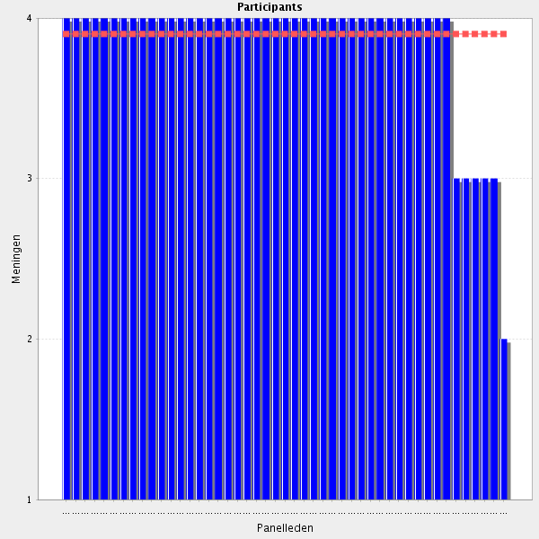
Average score: 3.9
Summary: high level of agreement and no direction from particiapnts on futher improvements. However, amalgamation from 3.2 and 3.3 is possible.
Proposal: Amend to:-
Can efficiently find relevant and valid information using specific hospital pharmacy expert databases, information services, evidence-based literature and relevant local summaries of evidence to promote rational and safe use of medicines.

All comments on this statement: impactful statements in red
Important skill
Important tool
Quite often pharmacists are asked to solve doubts, some of them quite specific. It is important that they know how to use expert databases of hospital pharmacy/information services/evidence-based literature and all relevant local sources, For that, hospitals should garantee that healthcare professionals have access to those sources.
It would be nice if all hospitals would have access to as many databases as possible.
What counts is to make the best of the resources, namely databases, one hospital have. It is unrealistic to have a lot of databases if you don't have the time to search them.
should be a competency of all pharmacists
Is obvious that these competences are paramount in the work of the hospital phamacist
This kind of competencies are needed to be able to give EvidenceBasedMedicine-advise
Routine practice. Core skill for pharmacists
these skills would be useful for a clinical pharmacist in case he/she wants to be well informed and prepared
Important tool
As long as they are user friendly
It is not possible to reach every data source.

3.2 Accesses information - Accesses this information in the most time efficient manner in order to undertake a review of the appropriateness, safety and efficiency and to promote rational and safe use of medicines.
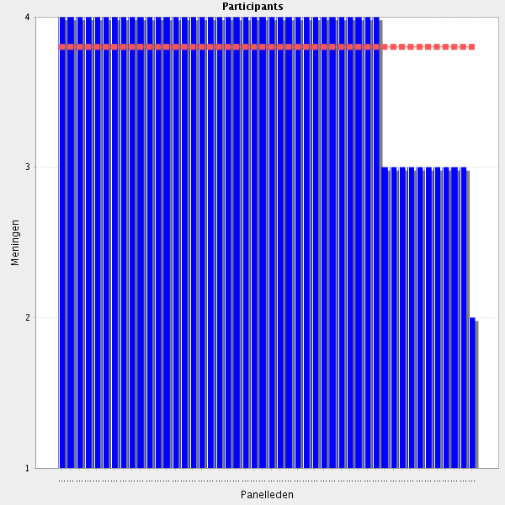
Average score: 3.8
Summary: good agreement but amalgamation with 3.1 possible.
Proposal: delete this element form the CTF.

All comments on this statement: impactful statements in red
Routine practice. Core skill for pharmacists
Quite often pharmacists are asked to evaluate medicines (new and old ones). Only by accessing the information concerning that drug it is possible to promote the safe and rational use of that drug. Most of the times a patient is waiting for that evaluation, so it is important that pharmacist access that information in the most time efficient manner.
Hmm, if you want to be efficient, you need a comp and some peace...
Phamacists should have high level skills in knowing where to find the information that is the more appropriate depending of what they are serching and also in a efficient way.
Quite often pharmacists are asked to evaluate medicines (new and old ones). Only by accessing the information concerning that drug it is possible to promote the safe and rational use of that drug. Most of the times a patient is waiting for that evaluation, so it is important that pharmacist access that information in the most time efficient manner.
Necessary Skill
One of the main roles of pharmacists is to access the most relevant information on drugs
essential for one of the main responsibilities of a clinical pharmacist- being a medical adviser
undertake a review .....needs time
This is depending on the working envionment.
Provided that the access is not time consuming and needs advanced knowledge of hospital informational systems
ı agree we are giving education to all hospital workers about dryg safety and etc.
Lacks how this work can be included in the Learning of the rest of the staff.
incorporate "time efficiency" in the previous Group, e.g. "Is able to use databases including specific expert databases of hospital pharmacy, information services, evidence-based literature and all relevant local sources in the most time efficient manner." The part "...in order to undertake a review" does not belong to the access of information.

3.3 Accesses information - Able to assess information, including scientific resources, for reliability of the source, potential bias and relevance to patient care.
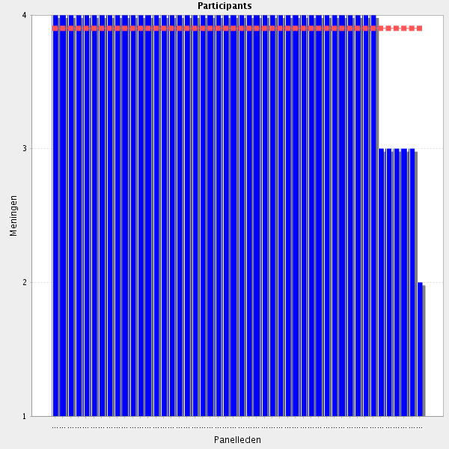
Average score: 3.9
Summary: good agreement but amalgamation with 3.1 possible.
Proposal: delete this element form the CTF.

All comments on this statement: impactful statements in red
To make it evidence based
More and more of interst in using internet sources
good but sort of implied in last one
Pharmacists should be able to assess information. Not all that is published is reliable. Sometimes, data form clinical trials have bias. Not all that is published could be directly applied to the patient (clinical trials mean a controlled environment, with very selected patients).
Especially valid and accurate info
Phamacists have to be critic when searching information. They have to know what are the better sources, they reliability and what is important for the their work. How to compare information from diverse sources.
a good knowledge of the scientific sources (their relevance) is necessary
Pharmacists should be able to assess information. Not all that is published is reliable. Sometimes, data form clinical trials have bias. Not all that is published could be directly applied to the patient
Any therapeutic plan should be backed by evidence
Routine practice. Core skill for pharmacists
does not belong to the access of information, but to the evaluation of information

3.4 Summarises information - Is able to evaluate/critically appraise evidence-based data for medicine and medical devices use, applicable to the certain patient.
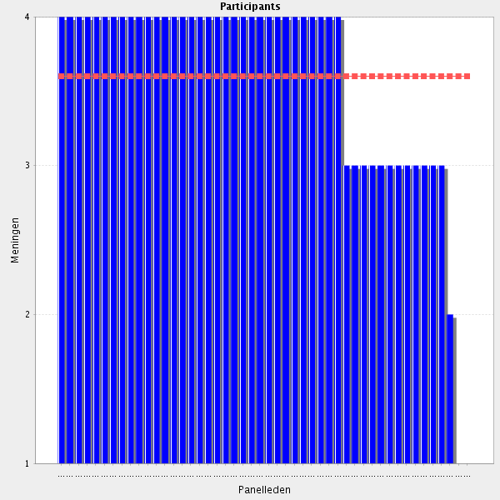
Average score: 3.6
Summary: reasonable agreement. Needs a separate elelemnt in the CTF – this skill is often not mentioned in simialr frameworks and is incrreasingly recognised as being important. Some rephrasing needed to gain consistency with 3.1 required.

Proposal: Amend to:-
Can apply relevant and valid evidence-based data for medicine and medical devices use to the care of individual patients.

All comments on this statement: impactful statements in red
How it affects the patient in front of you
it is vital for a clinical pharmacist to be able not only to find/access proper information needed, but to be trained/competent to perform a critical appraisal and reject non-reliable sources or recognize articles with high rate of biases.
"Mission critical" ability and a unique pharmacist's competency for the multiprofessional therapy management team.
Routine practice. Core skill for pharmacists
It is important that a pharmacist know how to critically evaluate evidence-based data for medicine and medical devices use. Pharmacists should be able to identify if what they are reading could be used in a certain patient. Again, clinical trials are very controlled environments with patients with litlle comorbilities. Real life, most of the times, is quite different: patients with a lot of comorbilites and taking quite a few drugs.
Sadly some Faculties of Pharmacy don't teach that kind of topics or they only do it theoretically. It would be great to have practical knowledge.
Informetion found, has to be evaluated in a critical way and summarize depending on the use: information for the patient, for health care professionals, cargivers or a report for the Pharmacy Commettee
Pharmacists should be able to identify if what they are reading could be used in a certain patient
Thi skill is of particular importance in order to be able to discuss with physicians (who then take the decision)
ok but should be merged with previous item
nevertheless the desicion is made by others
some patıents use very expensıve medıcal devıces ıt ıs ımportant for a hospıtal for farmaeconomics.
With the assistance of other health professionals
The evaluation part of this statement is not a part of "summarises information". Should be in "evaluates information"
does not belong to "summarise information". Merge with previous Group to "Able to critically appraise information, including scientific resources, for reliability of the source, potential bias and relevance to patient care." and move to "evaluates information" section.
is to do with accessing and assessing information not summarising information.

3.5 Summarises information - Demonstrates the ability to summarize the information, extract key points that influence medicines use and communicate this information to another colleague and professionals.
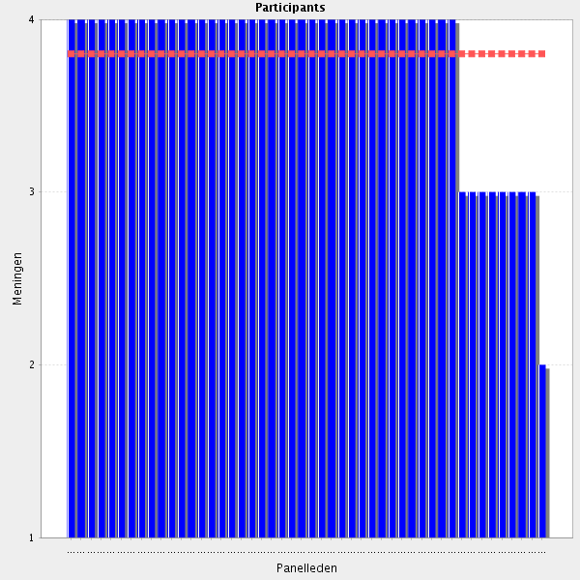
Average score: 3.8
Summary. Good agreement. May need moving to another section. Some rephrasing needed to gain consistency with other related elements of the CTF. May need to have two elements – summarising and extracting key findings for other health care professionals, and risk / benefirt communication.
Proposal: Amend to:-
Can summarise and extract key findings from relevant and valid evidence-based data, communicating these accurately and succinctly to other health care professionals.

All comments on this statement: impactful statements in red
The wording of this competence overlaps with the competencies regarding providing information.
Quite often, pharmacists are asked to evaluate a medicine/medicine device. It is essential that they kow how to do it in a speedy way. The answer given should be short, focused on key points that support a certain use/not use of that medicine. That information should be communicated to other healthcare professionals (e.g. colleagues, doctors, nurses, etc.).
I have already talked about this in the precedent question. Pharmacists have to produce high quality reports for other professionals. In fact the reports of the pharmacists are those of higher value for the Pharmacy Commettee and for the inclusion of drugs in the Hospital Formulary
Pharmacists have to produce high quality reports for other professionals
usually clinical pharmacist is the first choice for therapeutic adviser, so it is essential to be able to present medical information in a brief and understandable way.
Routine practice. Core skill for pharmacists
...and provide patient information?
Important only if interdisciplinary teams are in place
Move to next section after "evaluates information". Write "communicate this information to colleagues and other professionals"
A HOSPITAL PHARMACIST MUST GIVE EDUCATIONS TO ALL HOSPITAL WORKERS ABOUT DRUGS
OK but should be emerges with previous items
I s this meant in relatin to teaching sessions? Are all pharmacist in hospital considered to participate in teaching sessions?

3.6 Before going to the next group: do you have a remark, suggestion and or question on this group of competencies?
Are we missing the concept of gathering information that is relevant to the patient - either in terms of medicine-related behaviours or attitudes etc? Perhaps it comes in elsewhere - but the focus here seems to be specifically on meds info. Where are we considering patient info? Perhaps this comes in under another group of competencies?
I think that the management of drug information is one of the most important competencies of hospital pharmacists. No other professionals have the understanding on drugs and the skills in searching and evaluation information to perform this work.
Important to keep a Learning perspective. To learn from each others gathering of information and where we found the answers. Beacause new ways of finding the answers exists.
Pharmacists are often the main driver of informations
The management of drug information is one of the most important competencies of hospital pharmacists
merging of items are necessary (too much detailed and some redundancies)
Some of the cometencys are strongly related to specialists in drug information.
I believe the competencies regarding gathering information, analysing and applying information and providing information can be merged into fewer behavioural competencies without losing the intention.

Group: 4 Analysing and applying information (Group 4 of 26)
4.1 Evaluates information - Is able to evaluate and apply effectively the obtained information.
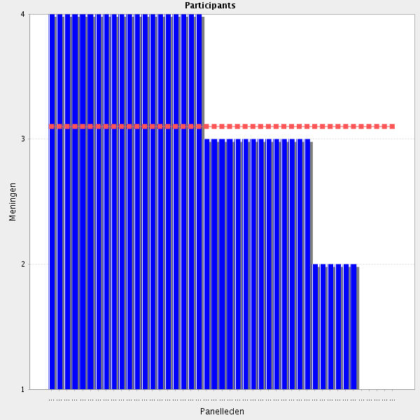
Average score: 3.1
Summary: lower level of agreement. Several comments about duplication of this statement and the prospect of merging groups 3 and 4 emerges.
Proposal: delelte this element of the CTF.

All comments on this statement: impactful statements in red
After searching information pharmacists have to evaluate what they have found. To drown clear and useful conclusions is basic.
Routine practice. Core skill for pharmacists
After searching information pharmacists have to evaluate what they have found. To drown clear and useful conclusions is basic.
Agree, but this pretty much covered by the competencies about gathering information.
I agree, but it should be included that the evaluation should be done to a certain patient.
I interpret the sentence as evalutating information from a literature search and maybe information from drug Companies.
Use wording from previous section: " "Is able to critically appraise information, including scientific resources, for reliability of the source, potential bias and relevance to patient care."
Very vague statement.
There is also some specific information for physicians
Agree, but in my opinion this is covered in the previous section
In collaboration with other healthcare professionals
The descripiton is all right but evaluating and applying informatin are two different task!
agree but assume this has already been covered
ok but merging of items in the information section is necessary
this statament is not clear about which information or which actions have to be applied.

4.2 Problem identification - Is able to identify, to solve and to prevent medicines and medication use related problems in clinical practice.
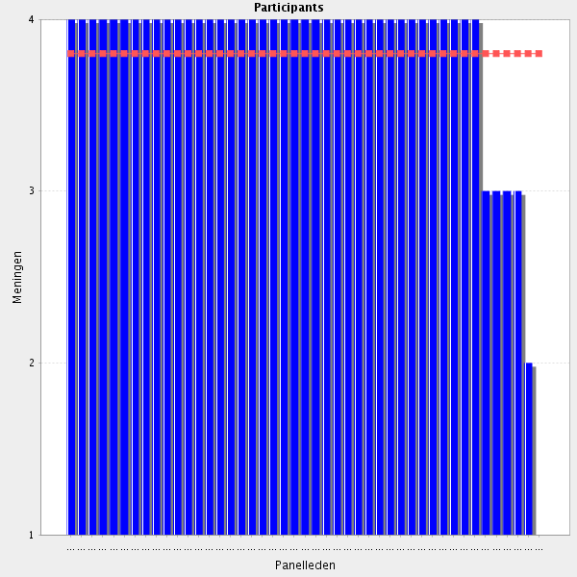
Average score: 3.8
Summary: strong agreement but as some comments identify this is covered in section 2, and specifically in the new 2.7.
Proposal: delete this element of the CTF.

All comments on this statement: impactful statements in red
Core competence for clinical pharmacists.
What we can offer
I agree, but think this section should be incorporated in medication therapy management
It is one of the main tasks in the wide range of responsibilities of clinical pharmacists but it is mainly associated with availability of multidisciplinary approach in hospital practice and good hospital/clinical management,
which ensures communication between different medical professionals.
core business!!
Medicine problem identification is essential for the wellbeing of our patients. By identifying, solving and preventing medicine problems pharmacists can contribute to rational use of medicines, as well as reducing of hospital stayings.
This is one of the most important task in clinical pharmacist work!
Pharmacists are those with wider knowledge about medicines, therefore in front of any pharmacologic treatment should always be prepared to detect any problem and then to solve or offer a possible solution
Solving the pro lem is the most important part.Otherwise you wil be rdcognized as part of the promlem instead of solving it.
Medicine problem identification is essential for the wellbeing of our patients. By identifying, solving and preventing medicine problems pharmacists can contribute to rational use of medicines, as well as reducing of hospital stayings and cost.
Routine practice. Core skill for pharmacists
wording isnt great, and again i think this was covered in the clinical part
there ıs no clınıcal pharmacısts yet ın our country they wıll be ın sector in 2023
1st identify achievable objective rather than problems per se
remove "to solve and to prevent": "Problem identification - Is able to identify medicines and medication use related problems in clinical practice."
ok but merging of items in the information section is necessary or included in a previous section (med therapy management)

4.3 Appraises options - Assesses various options available for problem solving.
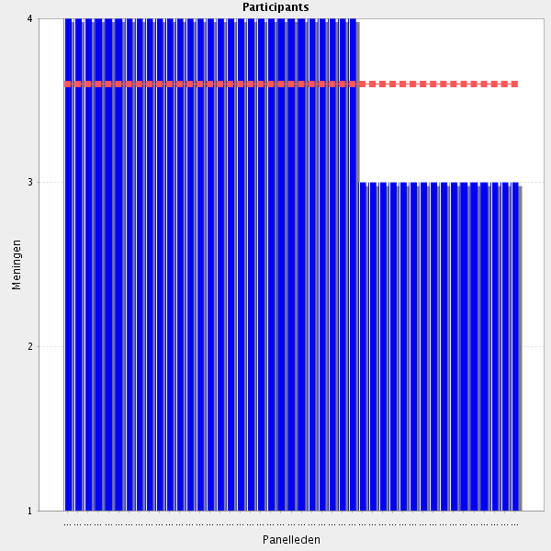
Average score: 3.6
Summary: reasonable agreeemnt. However, as identified this can be merged into 2.7.
Proposal: remove this elemnt form the CTF.

All comments on this statement: impactful statements in red
Sometimes, a problem do not have only one solution. It is important that pharmacists know how to identify different solutions. Still, more important: the best solution found should be applied to the patient assessed.
To make the best decision
In the context of a multidisciplinary team. Missing problem soliving competence by pharmacy preparation.
Key competence
Routine practice. Core skill for pharmacists
As sometimes the solution of the problem does not depen solely on the pharmacist, it is important, if possible to think of different solutions to offer to the nurse or the physician or the patient
agin think this is covered or should be mergered earlier
use "different" instead of "various"
To make the best decision.
Assisted by tools and ICT applications
Can be difficult for one person, this is a task for teamwork.
Applicable only in cases of problems with therapy and applicated medicines.
This is not always feasible because there are time constraints.

4.4 Appraises options - Considers possible outcomes of any action and recognises the pros and cons of these various options.
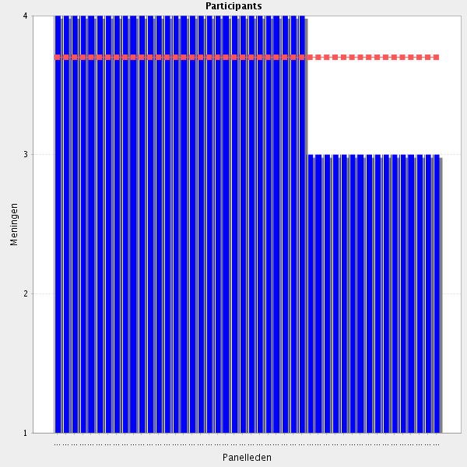
Average score: 3.7
Summary: reasonable agreement but again issues about collaborative practice are raised and can be dealt with by merger with 2.7.
Proposal: Delete this as a stand alone element of the CTF.

All comments on this statement: impactful statements in red
Showing a solution is not enough. Before changing anything, is paramount to evaluate positive and negative effects of a certain action, so that doctor could decide wether or not to change a certain prescription.
Essential
Be aware of pros and cons, but be careful to make personal decisions without consultation.
Routine practice. Core skill for pharmacists
Again, a very vague and nondescript statement. This should be a general human approach towards life itself.
Obviously, whe determining possible solutions, the pharmacist has to have in mind the advantages and disadvantages of any one of them. What is more is that if it has to be consulted with another professional or the patient, these pro en cons should also be explained
ok but should be done in collaboration with physicians
Change pros and cons to risks and benefits
Showing a solution is not enough. Before changing anything, is paramount to evaluate positive and negative effects of a certain action, so that other professional could decide wether or not to change a certain action.
Hard to determine if this is done each time. Not documented Just in ones head.
very academic, best practice must be more pragmatic
agree but i wonder if it should says uses evidence to support recommendations and takes responsibility for recommendation options
write "different" instead of "various"
In collaborations with the rest of the team
Risks and benefits rather than pros and cons
Useful skill, but again it could not be restricted only to the competence of the clinical pharmacist, as clinical pharmacists are usually advisers, but physicians are the responsible decision makers. And again the internal organisation of the hospital/clinic should be designed so that it provides the clinical pharmacist access to the full panel of necessary information regarding patient and disease history.
This should be done before offering a solution and should be included in the answer if the partner is willing to hear/read it.

4.5 Decision making and logical approach - Demonstrates clear decision-making. Identifies the most appropriate solutions and justifies the decision taken.
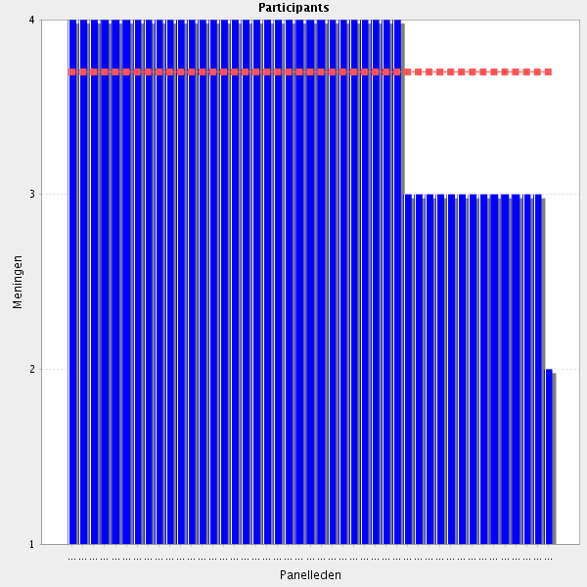
Average score: 3.7
Summary: reasonable agreement scores, but again comments indicate a preference for merging statements.
Proposal: merge into 2.7. This elemnt can be deleted from the CTF.

All comments on this statement: impactful statements in red
Routine practice. Core skill for pharmacists
Is very important to feel sure and clear when offering a solution. No solution should be offered if the pharmacist is not sure of the outcome or any other particularity.
ok but merge with previous items
Objective criteria for the decision should be used
Before proposing any changes and after havin identified the most appropriate solutions, pharmacists should be able to justify, rationally, their choices.
This item partially covers the two previous competencies. Should be possible to merge them into fewer competence items.
Of course, not just random
agree but merge with previous one
add "decision-making abilities"
This is directy related to questin 4.4.
Most appropriate solution for whom? This statement should be more patient-centered.
What is more, good presenting and negotiating skills are needed so that the clinical pharmacist can summaries and stress the pros and cons of an approach he/she offers.
is this a Survey for practical hospital pharmacy competencies or an outline for a Philosophy tract ?

4.6 Decision making and logical approach - Is aware of one’s own limits and seeks advice when necessary.
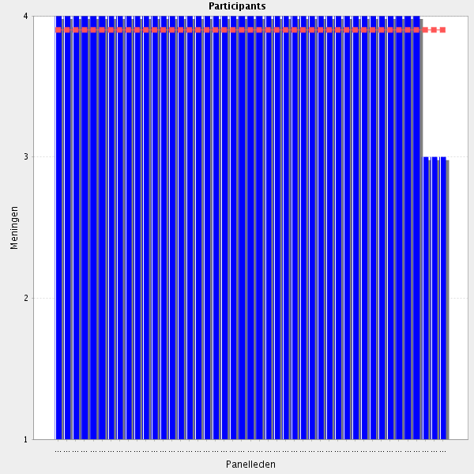
Average score: 3.9
Summary: reasonable agreement but as comments point out, can be merged into 1.6.
Proposal: merge into 1.6. Delete this as a stand alone element of the CTF.

All comments on this statement: impactful statements in red
Fundamentalt important
Important with senior collegues or a system with Exchange between existing collegues
I agree, but seeking advise is already included in a previous section
Nobody knows everything. Sometimes it is important to seek help with other colleagues/healthcare professionals. The patient should be the focus of the healthcare system. All healthcare professionals should work together for the wellbeing of our patients.
Addition: And knows where to find help and advice when necessary
As important as to be able to find solutions is to be aware of yours limitations. Pharmacists have to know the limit of their knowledge and abilities and seek help to another professional if necessary.
A major skill
ok but redundancy with previous items
The world soes not revolve around pharmacists.
Nobody knows everything. Sometimes it is important to seek help with other colleagues/healthcare professionals
Routine practice. Core skill for pharmacists - to be developed over foundation training years
It's difficult not to agree with such statements. Very nonspecific though.
absolutely obligatory. In some clinics and in cases of some specific conditions it is even advisable some therapeutic decisions to be made by a group of several professionals. ( it may be even written in a SOP when and how a consultation should be performed)
already covered but i agree

4.7 Decision making and logical approach - Demonstrates the ability to apply a logical approach to work and problem solving.
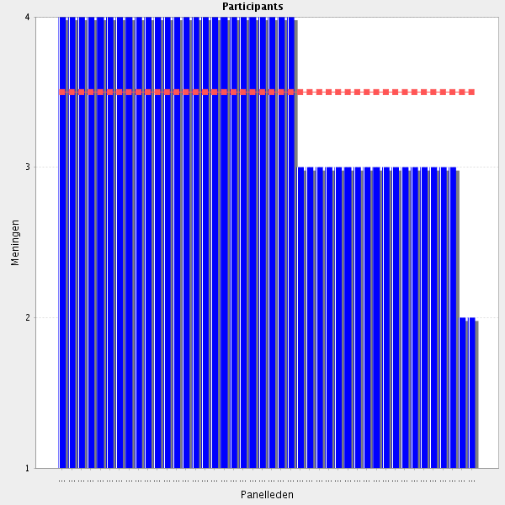
Average score: 3.5
Summary: again reasonable agreement but some perceptive comments about the importance of human dimensions of decision making. Pure logic is rarely the basis for any decision, even if those making the decision think it is. The facilitators propose an amendment to reflect some comments, and their own expertise in this area for testing in Delphi 2.
Proposal: (i) Amend to:-
When making decisions can demonstrate self awareness, understands their own, their colleagues and their patients’ decision making processes, and uses that knowledge and self-awareness in decision making with and for patients.
(ii) the heading should be simply “Decision Making” – delete logic.

All comments on this statement: impactful statements in red
Any solution has to be explained in a logical and estrategic way, to show that it derives from a knowlelge and reflection
This is a basic task a person working in an natural science environment.
Routine practice. Core skill for pharmacists
Eventhoug we are human beings, it is important that pharmacist uses a logical approach to solve problems.
this skill should apply to all competencies of a pharmacist thus should not be included in "information section"
I agree, but is this statement needed?
needs to mergered with earlier skills but i agree
similar to previous Groups
Important but not essential
Any solution has to be explained in a logical and estrategic way, to show that it derives from a knowlelge and reflection.
Patients are people not a collection of data. I am in favor of a holistic approach as oppose to a pure logical approach.
It is not clear what these statement mean. Nobody wants to apply wrong or not a logical approach to work...
Already in previous statements, where also the RESULT of the logical thinking is in focus (and not in this statement).

4.8 Before going to the next group: do you have a remark, suggestion and or question on this group of competencies?
One of the most important things for pharmacists is to demostrate its ability in solving medication problems. A basic Group is the process of how they do this process, its logic and in what is based.
This section should be condenced because there are too many details and overlapping topics
I'm not sure that there is adequate attention given to patient factors being considered here. Very drug/medicine focus - not entirely congruent with global move to patient-centred care
I would recommend rethinking this whole section as it contains some rather general and nonspecific statements, even clichés.
there are a lop of overlapping in tis section and there are too much detail for questions related to informations Information competencies should be integrated under 1 competency "Information" with a merging and /or simplification of the different "attitudes" currently reported. The Knowledge and corresponding Behavioural Competencies are too much detailed and should be summarized in 5-6 items. Indeed, the number of items currently proposed (n = 17) outweight the role of information in the daily hospital pharmacy practice and tend to offset the importance of the other activities.
Some merging with the previous section could be useful in order to reduse the number of points (in my world collecting, analysing and applying information is closely linked).
Some of the competences are overlapping with previous sections. It is unnecessary to make a document with duplicate and similar competencies in different sections.
Note the numbers for the opinions (agree, Disagree etc) are the wrong way around for 4.1
some of the statements are too formal/general and the idea of the skill/ability is not very clear
Sections 3 and 4 can be put together
I can't disagree with this section, but I don't feel I have understood it. I don't know if we're talking about drug information, evidence-based medicine, pharmacist interventions or writing clinical guidelines. ??
still frustated
Group: 5 Providing information (Group 5 of 26)
5.1 Provides accurate information - Ensures information provided is accurate, validated and understandable to other professionals, patients and carers.
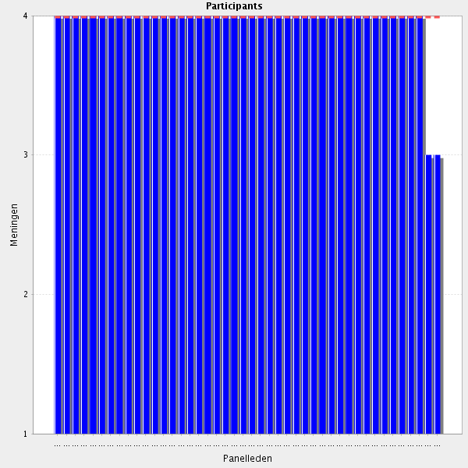
Average score: 4.0
Summary: excellent agreeement but can be merged with new 3.3.
Proposal: merge with 3.3

All comments on this statement: impactful statements in red
Important regarding information
Pharmacists should always provide accurate information. The answer given must always be adapted to whom has asked (e.g. doctor, nurse, patient, carer).
Imperative
of course
Information delivered by pharmacists has to be allways of high quality
This should allways be done.
OK with this Group, but really very rambling survey
Basic work ethics.
Pharmacists should always provide accurate information. The answer given must always be adapted to whom has asked (e.g. doctor, nurse, patient, carer).

5.2 Provides accurate information - Accesses relevant sources.
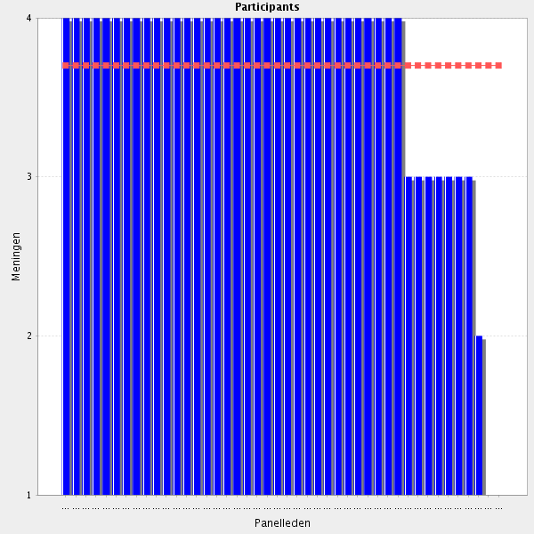
Average score: 3.7
Summary: comments identify that this is duplication of 3.1
Proposal: Delete this as a stand alone element of the CTF.

All comments on this statement: impactful statements in red
The right information
Accesses and is able to identify relevant sources.
Yes, but this I think is covered in one of the other sections.
obligatory
Important to avoid misinformation or/and circumstantial evidence
In order to deliver this high quality information, pharmacists have to access relevant sources. The problem is that for budged problems not they are not allways available to pharmacists. Pharmacists have to be able to work with the sources available and between them select what are realy serious and useful.
already covered
x bis repetita
the sources that are available in the Hospital pharmacy
we can not access to some sources whıch are very expensive.
Pharmacists should know how to access relevant sources of information in order to provide always accurate data.
Previously covered in Gathering Information.
covered under Group 3
How can we decide what sources a pharamcist should access? Also, there is a previous subsection on information access. Duplicate.

5.3 Provides accurate information - Makes references to appropriate literature or to colleagues as appropriate, applying the right information in the situation.
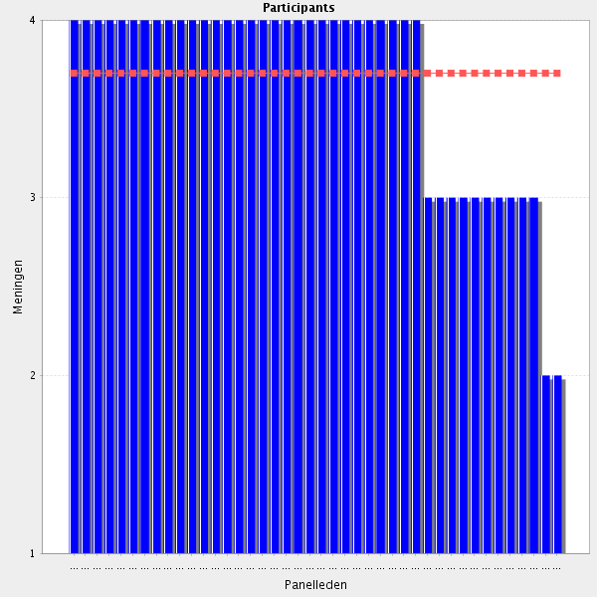
Average score: 3.7
Summary: comments identify that this is duplication of 3.3, and 3.4.
Proposal: Delete this as a stand alone element of the CTF.

All comments on this statement: impactful statements in red
Important
Although it is more subjective rather than objective referral mostly. That demands expertise and not just relative skills
All the sources used have to be referd, it gives quality and soundness to the information given
Evidence based
All the sources used have to be referd, it gives quality and soundness to the information given
It is important to know how to choose the right sources of literature and to identify them to solve the present situation.
Clinical/Hospital pharmacist should take the role of a reliable adviser and useful source of information, but he/she cannot be used as a search engine.. if any member of the medical team needs information then a consultation with clinical pharmacist should be requested and it is clinical pharmacist` business what kind of sources he/she will use.
"Refers to appropriate literature..." As per no 4 Analysing and applying information - duplication.
rephrase, e.g. "provides references to appropriate literature or other sources"

5.4 Provides accurate information - Uses effective verbal, non-verbal, listening and written communication skills to communicate clearly, precisely and appropriately.
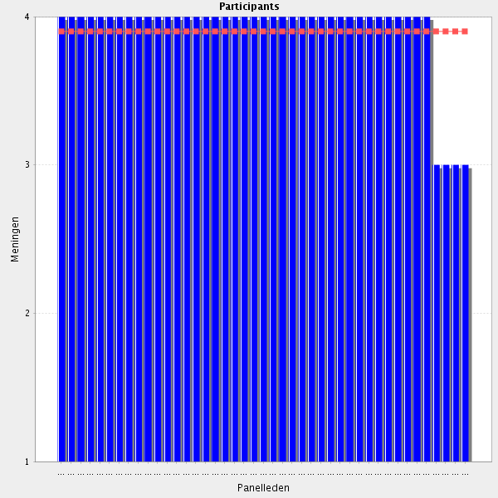
Average score: 3.9
Summary: high level of agreement
Proposal: some overlap with Group 3 especially, but probably important to have communication skills separely identified in the CTF. However, a clearer definition of communication skills would be advantageous.
Amend as below for Delphi 2:-
When both gathering information from the patient and when exchanging information and planning treatment, he /she uses effective verbal, non-verbal, listening and written communication skills to communicate relevant, timely information clearly, precisely and appropriately.

All comments on this statement: impactful statements in red
Again important regarding information
definately but should be one of the first things
Communication between pharmacists and other healthcare professionals/patients should be clear, precise and appropriate. If an outpatient dos not know how to read, an alternative to writing might be using signs or drawings to explain how to take medicines. It is important that pharmacists learn how to listen to their patients. Gestual language might be important when pharmacists deal with deaf patients.
It is very important to choose the most suitable way of comunication, depending on the kind of information and to whom is addressed
Communication between pharmacists and other healthcare professionals/patients should be clear, precise and appropriate.
very important, as mentioned in previous questions
A mast in communicating
Important for every health professional

5.5 Provides relevant and timely information - Provides information, which is appropriate to the patient’s or other professional’s needs.
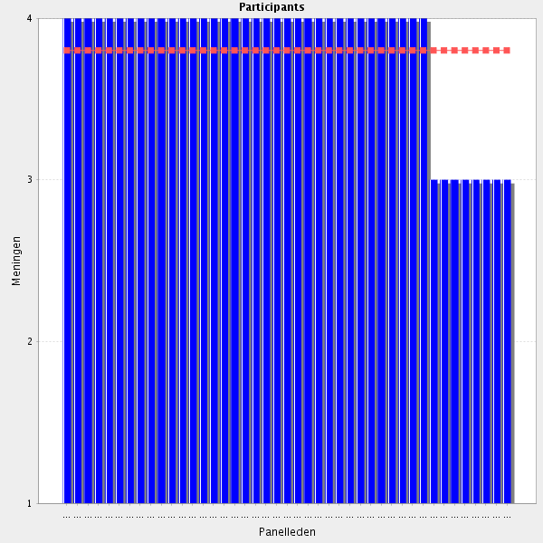
Average score: 3.8
Summary: hogh level of agreement but as identified is already covered by 3.3 and 5.1
Proposal: Delete this as a stand alone element of the CTF.

All comments on this statement: impactful statements in red
differentiate information to the patient to that for the health care professionals
Pharmacists have to decide what is important and useful depending of the person to which is addressed.
Otherwise you are boring
Repetition in this statement
The information given should be adapted to needs of the person who asked the question.Time between posing the question and receiving an answer should be as short as possible.
Enough information when it is needed
Provided that there is access to the pharmacist and the others are willing to attend
The information given should be adapted to needs of the person who asked the question.
Agree, but it has already been stated in another chapter.

5.6 Provides relevant and timely information - Provides information in a timely manner and prioritizing information provision when it is needed.
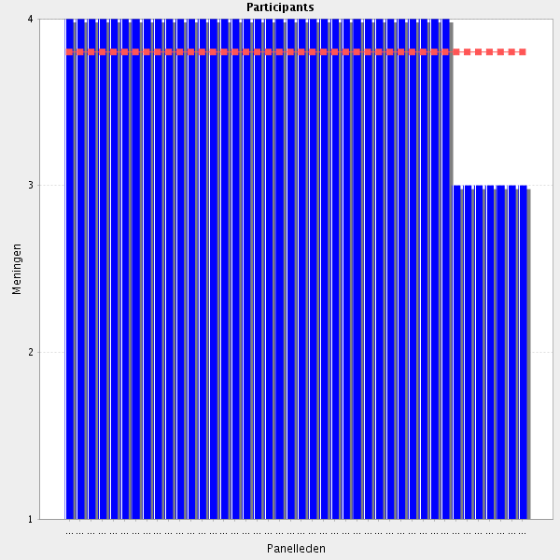
Average score: 3.8
Summary: reasonable agreement but this is covered in 2.4.
Proposal: Delete this as a stand alone element of the CTF.

All comments on this statement: impactful statements in red
Should it be the case, pharmacist should kow how to prioritize information provision. For instance, if they receive at the same time a question form an outpatient and from a doctor concerning an alergic reaction of an inpatient, they should first try to answer the second question.
Priorization is important as in other issues, specially due to the workload.
Should it be the case, pharmacist should kow how to prioritize information provision.
Neccessary information when it is needed.
There are some overlap, but is this intended as nearly the same competencies are linked to different parts of the CTF?

5.7 Follow up – ensures resolution of problems - Resolves problems promptly and undertakes the appropriate follow up to ensure patient safety.
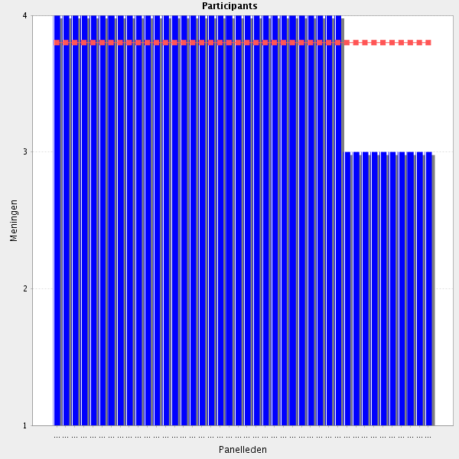
Average score: 3.8
Summary: reasonable agreement but this is covered in 2.4. Duplication fatigue in participants? See comments at end of this Group.
Proposal: Delete this as a stand alone element of the CTF.

All comments on this statement: impactful statements in red
Important
I agree, but as it often is the physician who has the final word the advise from the pharmacist is not always taken into account.
The most important is a follow-up.
As a member of the interdisciplinary team
Everyday work in the hospital, needs that professionals find and aply solution to problems fastly but also in a safe way
we must do ıt but sometımes there ıs no tıme for ıt
Xhy always (only) safety ? Not wellbeing or health
This is not allways in the hand of the pharmcist.
Good, but sometimes lack of system to ensure this.
...or at least tries to do so.
Only patient safety? It could be added: efficacy, adherence...?
Everyday work in the hospital, needs that professionals find and aply solution to problems fastly but also in a safe way.
agree, but as far as follow up process is concerned this obligation should be shared between responsible pharmacist and responsible physician and what is more in many cases it is not technically possible to perform this follow up activities.

5.8 Before going to the next group: do you have a remark, suggestion and or question on this group of competencies?
too much details and should be merged
To say that this group of competences are very important in the pharmacy work but that they require a very high level learning and training
Be aware of overlapping competencies
to document researched valued information (answers to enquiries) to save time in not researching the same subject twice besides for sure actualizing documented information. i.e. to practice quality-assured drug information
more and more disconnected.
Be aware of overlapping competencies
some of the statements have already been discussed in above sections.
It's repetitive. A lot of statements have been answered in section 3 and 4
The sectin has too much details.
There is some repetition n this group of comments - can be made more compact to avoid having such a long Delphi process!!!
statements of this section should be merged in fewer.
Agree

Group: 6 Information expertise (Group 6 of 26)
6.1 Pathophysiology and anatomy - Understands normal organ function and the effect of disease states and if it affects medicines use.
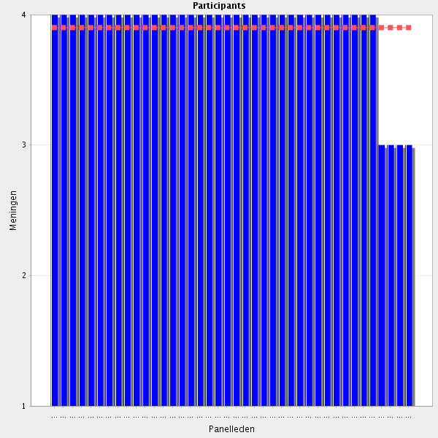
Average score: 3.9
Summary: excellent agreement. Some refinement of phrasing possible.
Proposal: Amend to:-
Understands normal organ structure and function, the effects of disease states on those organs, and if and how those disease states affect medicines use.

All comments on this statement: impactful statements in red
To understand effects of drugs
It is essential for the pharmacist to understand how the human body works and how medicines can affect that function, either positively or negatively.
basic knowledge- obligatory for understanding pharmacology mechanism of action of medicines
The basic knowledge is needed also from internal medicine!
basins in patio-physiology is mandatory
To have a total knowlegde of the different Groups of drugs and drug therapy i basic a in deph understanding of physiology and disesases
Unfortunately pharmacist do not have the relevant knowledge finishing studies in my country.
It is essential for the pharmacist to understand how the human body works and how medicines can affect that function, either positively or negatively.
Also include interpretation of lab results.
Agree, but this is taught on undergraduate level, at least in my country.

6.2 Pathophysiology and anatomy - Is able to apply knowledge of pathophysiology relevant to the therapeutic areas one is involved in including acute and rare diseases as well as special populations (e.g. paediatric, geriatric, etc).
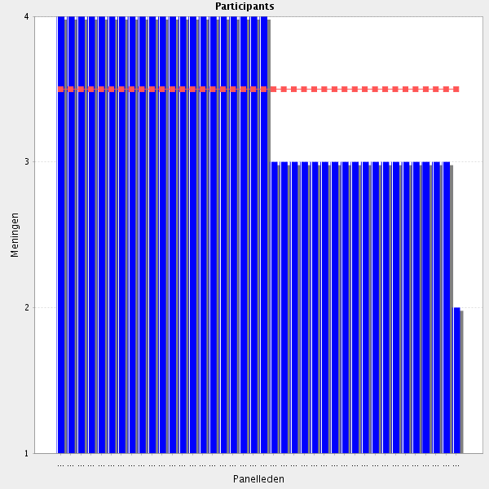
Average score: 3.5
Summary: reasonable agreement but som rewording required.
Proposal: Amend to:-
Can apply knowledge of pathophysiology of different diseases to a specific therapeutic area and to particular populations (e.g. paediatric, care of the elderly, etc).

All comments on this statement: impactful statements in red
It is essential that pharmacists understand how the human body works, not only in the general population, but also in special populations (e.g. eldery and children). Pharmacists should also know how the human body behaves in acute, chronic and rare diseases.
may need rewording but yes
It is difficult to guarantee it in all fields
This knowledge can be aquired on job.
It is essential that pharmacists understand how the human body works, not only in the general population, but also in special populations (e.g. eldery and children). Pharmacists should also know how the human body behaves in acute, chronic and rare diseases.
Important for specialty areas
Yes, it is necessary but it is directly reflected from the scope of the clinic itself.
This is the ideal case: global in depth-knowedge in any illness and any population
Applied at job. Or if we put this practice also when learning on Faculty of pharmacy
This shoud be a matter of further pharmacit's specialisation (f.e. oncology pharmacist).
Does this mean specialisation?
OK but sub-specialities should be created to avais a too general knowledge
Pharmacists have to know all that is stated in the question, but is impossible to have a total knowledge. Therefore, in some cases, there has to be a specialization.
Suggest removing "including acute and rare...." and leaving it as relevant to the therapeutic are one is involved in.
To some extent depending on topic
Does no need to be a specialist in all patient groups if not working in that field.
basic knowledge for all hospital pharmacists. In deth via differentiation in the curriculum or further differentiation after the basic specialisation curriculum.

6.3 Pharmacology and Pharmacotherapy - Is able to discuss pharmacology of medicines that are routinely reviewed in the course of daily practice.
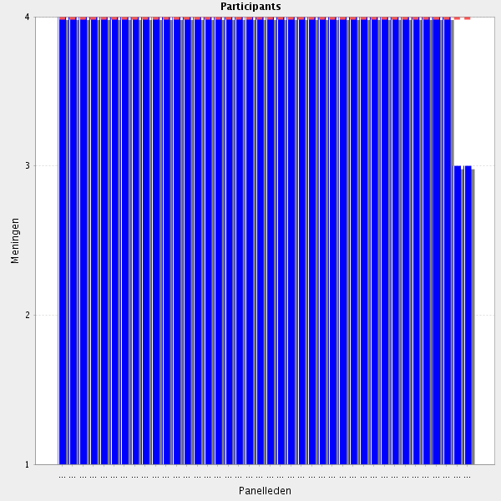
Average score: 4.0
Summary: Excellent agreement. Facilitators would advocate a rewording to clarify meaning.
Proposal: Amend to:-
Can describe and discuss the pharmacology and pharmacotherapy of medicines that are routinely used in their daily practice.

All comments on this statement: impactful statements in red
It is essential that the pharmacist be able to discuss the pharmacological Groups of the medicines that he reviews everyday with other healthcare professionals.. By doing so, he is contributing for the rational use of medicines.
And need to learn if change of speciality
This is very impormant issue! This should become the core of pharmacists' work.
Its one of the most important capacities and skills of pharmacists
Typo in Pharmacotherapy.
It is essential that the pharmacist be able to discuss the pharmacological Groups of the medicines that he reviews everyday with other healthcare professionals. By doing so, he is contributing for the rational use of medicines.
This differentiates the pharmacist from the other healthcare professionals
I'd use pharmacotherapy rather tan pharmacology since is focused on the daily practice.

6.4 Pharmacology and Pharmacotherapy - Able to apply this knowledge to rare diseases and also to specific chronic disease such as cancer, infectious or auto-immune.
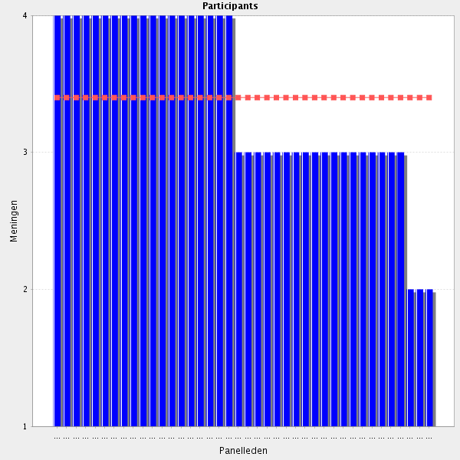
Average score: 3.4
Summary: only fair agreement. Comments identify that this is covered in previous element.
Proposal: Delete this as a stand alone element of the CTF.

All comments on this statement: impactful statements in red
I don´t understand why is this question separately (because of rare diseases?) from previous question
Imp for specialisation
Where is the difference to the question before?
I agree, but is this question needed?
Pharmacists have to cover all kind of pathologies
It depends of the specilisation of the hospital
Necessary
Advance in medicine and new drugs development makes it impossible to be an expert in all of specific dieases. Basic knowledge should be required, but further specialisation is needed.
In order to revise prescriptions and also advise patients how to take medicines for rare or specific chronic diseases, pharmacists must understand the pharmacology and pharmacotherapy of the medicines used to treat those diseases.
Through some courses of specialisation, maybe.
application to all fields of medicine would require a pharmacist to the a very wide knowledge of diseases (quite impossible to obtain...),
Maybe not neccessary for all.
Is it possible to join with previous?
Only if there is a specialization the field
I agree when the pharmacist is specialised on certain area (similar as doctors)
differentiation/further specialisation
A requirement only when working in these specialised fields.
In my point of view it should be a matter of additional specilisation depending from the scope of the clinic
Only if you specialize and together with other health professionals.

6.5 Pharmacology and Pharmacoterapy - Understands the importance of pharmacogenomics in pharmacotherapy.
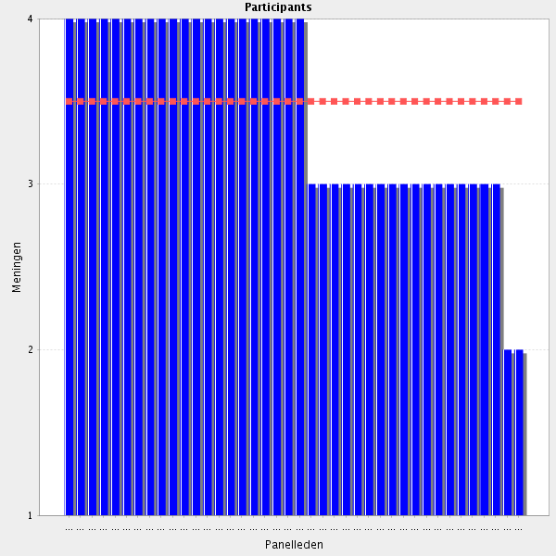
Average score: 3.5
Summary: fair agreement only. Comments advocating a more general appraoch to new and emerging science.
Propsal: revise to reflect more general appraoch to emerging science and test in Delphi 2.
Amend to:-
Can describe and discuss the importance of emerging topics in pharmacology and pharmacotherapy (e.g. pharmacogenomics).

All comments on this statement: impactful statements in red
OK will be most significant in a close future
It is important that pharmacists kow that in some diseases pharmacogenomics is very important in terms of pharmacotherapy, namely in some cancers, hepatite C and VHI.
Yes, but why only this Group of pharmacotherapy? I miss one criteria on for instance relevant evidence and recommendations
Strongly agree, but again, would like to gain that knowledge within graduation.
Pharmacists are the health care professionals in an unique position and with the knowledge necessary for this purpose
Understands target therapy
newer concept that is not covered alot in training but needs to be
Agree, but not one of the most important statements of this survey
In a basic kevel, for the everyday practice
I think that this taks may be fulfilled together with geneticists and other proffesionals involved in this field of science.
This is a new field but of what help is just understanding a topic?
Pharmacogenomics is likely to be increasingly important but perhaps not the only new field of importance? Perhaps amend to "Understands the importance of new developments in pharmacology e.g. pharmacogenomics in pharmacotherapy"?
better. Too much focus on a small area of knowledge, will instead be included in e.g phamacokinetics or other basic subject in grad edu.
Somewhat important
worth paying attention , especially if the clinical pharmacist is working in the field of oncology or rare disease management, but I am not sure whether it should be stated as a general competency
I'd reformulate this to make a reference to precision medicine (including pharmacogenomics, biomarkers etc). I think an specific section of pharmacogenomics should be included. It is a trend that in EU and US, large hospitals have pharmacogenomic laboratories that depend on hospital pharmacy departments. Therefore, pharmacists can lead the implementation of pharmacogenomics in the hospital as it happened with the pharmacokinetics units.
But not Always applicable
Way too specific. The importance of pharmacogenomics might increase in the future, but might also prove a false hope on the long run. Evidence is still somewhat lacking. I would reformulate the statement to reflect the pharmacist's ability to assess the potential importance of emerging technologies and treatment modalities.

6.6 Pharmaceutical technology & biopharmacy - Understands the importance of different dosage forms, how they are designed and how may influenced the clinical efficacy of medicines preparations.
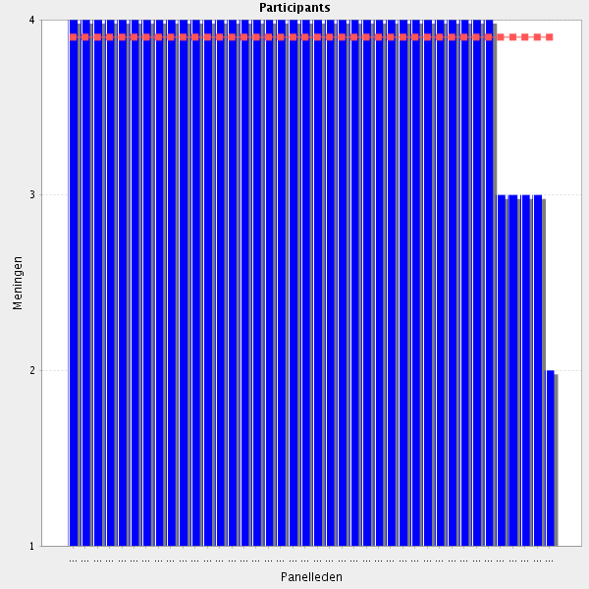
Average score: 3.9
Summary: high level of agreement. This does seem more specific that 2.1 et seq. Rewording required to clarify.
Proposal: Amend to:-
Can describe, discuss and provide accurate advice to other health care professionals about the importance of different dosage forms, how they are designed, and how they may influence the clinical efficacy of medicines.

All comments on this statement: impactful statements in red
In our profession
Pharmacists must kow that coated pills should not be broken. Otherwise, its protective effect would be lost. Pharmacists must kow the difference between slow release forms and forms with immediate action. Acute pain should be treat with immediate action forms. On the contrary, in chronic pain should be preferred slow release forms.
totally obligatory skill
Necessary
Field of expertise uniquely attributed to pharmacists
The pharmacist is the only person with knowledge in this field. All other fields have experts on their own.
AS the previous question. Pharmacists have to be the central professional knowing all these issues
Typo - "how they may influence the clinical..."
Pharmacists are the central professional knowing all these issues.
thıs ıs the main definition of a pharmacist job
Not sure if this is anything more than 2.1-2.3 combined.
I agree, but the grammar is not correct. What does ",,and how may influenced the clinical efficacy of medicines preparations."?

6.7 Pharmaceutical technology & biopharmacy - Understands how the active pharmaceutical ingredient, dosage, form, design and the administration site influences the medicine action (pharmacokinects, biopharmacy).
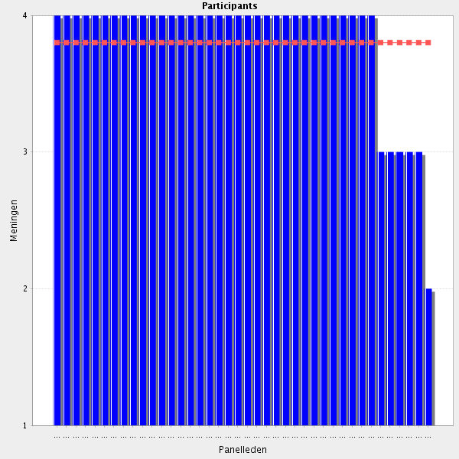
Average score: 3.8
Summary: very good agreement. Some sentiments expressed that these more specific elleemnts should be combined with and precede the higher level applied skills; this may indeed be worthy of active consideration.
Proposal:-
Amend to:-
Can describe, discuss and provide accurate advice to other health care professionals on how the active pharmaceutical ingredient, the auxiliary materials needed for formulations, the dosage form, design and the administration site influence the medicine’s action.

All comments on this statement: impactful statements in red
very very important
In our profession
necessary qualification
an in depth knowledge of biopharmaceutics and pharmacokinetics is mandatory because the knowledge of other health professionals on theses topics is sometimes insufficient
It is essencial that pharmacists understand the pharmacokinetics of the medicines that they revises every day. He/she must kow how much time a medicine takes to be absorbed, if it connects with proteins, how long it stays in the body and how is eliminated. For instance, the frequency of administration depends on how fast that medicine is eliminated from the body. Medicines dosages migh vary depending on the form and administration site (e.g. orally, intravenously).
Pharmacokinetics and biopharmacy are directly related to the efficay of medicines.
Pharmacists have to be the professionals with more knowledge about pharmacokinetics, it is basic to understand all the process of drugs in the body
Typo – Pharmacokinetics
An in depth knowledge of biopharmaceutics and pharmacokinetics is mandatory because the knowledge of other health professionals on theses topics is insuficiente.
I feel a definite overlap with chapter 2 here.
merge with others but yes, i think some of theese underlying knowledge statements should be first prior to the skills based statements as these underpin??
For this kind of task pharmacists should be extra trained.
I agree, but this I think is taught on undergraduate level. The same comment also applies for the previous competence.
I of course agree that kinetics and biopharmaceutics should be included, but it needs a sub section of its own! For example include understanding of PK principles and apply them to dosing strategies in individuals and patient groups based on for example organ function, and manage drug interactions in a specific patient, and understanding the concepts for TDM (that is later lifted as a competence to perform TDM)

6.8 Pharmaceutical technology & biopharmacy - Is able to understand the advantages and risks of the new formulas (nanotechnology, Advanced Therapy Medicinal Product (ATMPs).
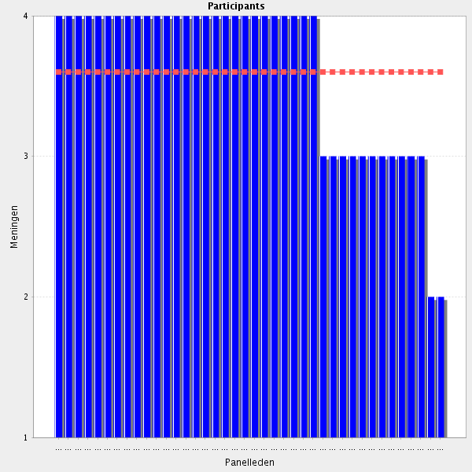
Average score: 3.6
Summary: average agreeemnt; can be merged into the more general statement about emerging topics (6.4).
Proposal: Delete this as a stand alone element of the CTF

All comments on this statement: impactful statements in red
Knowledge instead of guessin
Keeping up with evolution
Same problem as with the statement about pharmacogenomics. Pharmacists should be in general able to assess and evaluate new/emerging technologies. One statement point should sufficiently cover that
an in depth knowledge on nanoT and ATMP's may not be necessary to all pharmacists (ad hoc specialization)
Necessary
basic knowledge of new formulas
If the pharmacist does not understand how new formulations are working he/she is not able to give an advise on them.
and he / she is able to communicate it to patients
Obviously, all novelties have to be known, understood and aplied for the every day work
It is important that pharmacist know the advantages and risks of the new formulas so that the could advise other healthcare professionals, as well as patients in how to take/prescribe them and how to store those new generation medicines.
It is important that pharmacist know the advantages and risks of the new formulas so that the could advise other healthcare professionals, as well as patients in how to take/prescribe them and how to store those new generation medicines.
but is it specific for CLINICAL pharmacist education, or should it be a basic knowledge from grad education?
after concideration I can understand this, although a detail in the big Picture.
That should be basic knowledge, at least for those who want to work at hospital pharmacy. More and more biologicals appear in the marked to treat diseases. It is also important to decide which patients should keep on taking the biological molecule and whose should take the biossimilar. For now at my hospital only those patients who start therapeuthics are offered the biossimilar (naive patients)..
In our country it is also a big problem concerning biossimilars. Some authorities say that their activity and ADS are not proved and some of them have opposite opinion. The pharmacists may become experts in this discussion, however but I believe that we still (physicians, pharmacists and other professionals) do not have enough knowledge about this medicines.
we are the specialists!
again new but needs to be in the training
I agree that pharmacists need to be familiar with new technologies, especially when it comes to new formulations and solutions like nanotechnology. When it comes to ATMPs, I think that pharmacists should know what ATMPs are about, but I have some serious concerns if - as for today - pharmacists should get strongly involved into ATMPs. ATMPs require skills and knowledge which are in my opinion more associated with biotechnologists. In other hand - this might be the future of therapy, but if so - we need to change pharmacist's university programmes as soon as possible.
I understand what you say but we have to keep in mind that the CFT is also about the future. I think it's clear that we don't have the education and the resources to compound ATMPs in most hospital pharmacies yet, but I believe we can't let biologist or biotechnologist take the lead of this field outside the research setting.
Dear R33, that is why I wrote that if ATMPs are to be the future of therapy, then we need to include ATMPS also in our university education. I also think that we need to keep up to the progress in therapeutic methods. My point is that ATMPS present a whole different field, which is still unknown to pharmacists, and which also intuitively is very different from so far known drug compounding. This is a very important discussion of where does the pharmacy end - very similar to radiopharmaceutical compounding. In my country pharmacists are formally dedicated to manage radiopharmaceuticals, but in the reality - biologists and physicists are doing the job, while pharmacists up to last month could not even start a postgraduate education in this field. Anyway - thank you for your opinion - it is very mind opening. Best regards :)
Needs advanced skills, especially for "the older generation" of pharmacists
as these are new formluas they should be part of an educational program
I believe that the pharmacists may become experts in this new field of pharmacotherapy, however we still do not have enough knowledge about this kind of medicines (similar to other professionals, as eg physicians). This statement may be applicable in several years.
yes it is important, but maybe it should be a focus of additional training or specialization
Compared to biopharmacy and PK, this is a very detailed requirement. Is it necessary to be this specific?

6.9 Pharmaceutical technology & biopharmacy - Has knowledge on the purposes and risks of the auxiliary materials needed for formulations.
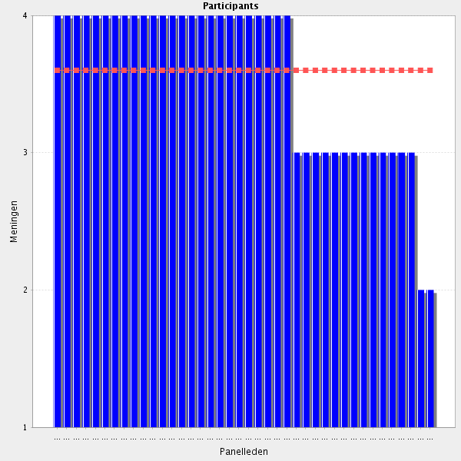
Average score: 3.6
Summary: fair agreement but can be merged into 6.3.
Proposal: Delete this as a stand alone element of the CTF

All comments on this statement: impactful statements in red
Included in Biopharmacy competency (please merge)
very important as usually physicians don't have knowledge on that issue
totally obligatory, pharmacist are the key opinion leaders who are the best experts in this field
Necessary - If pharmacists don't know this, who does?
It is important that pharmacists be informed of the risks and porpuses of auxiliary materials needed for formulations, so that he could alert other healthcare professionals, as well as patients. Sometimes, the problem is not the medicine itself, but the auxiliary material (e.g. a bad injection or a bad reconstitution)
To prepare medications pharmacists have to know all related to the drugs and anyother material needed
Agree - knowledge of excipients and possible interactions with substances which may be used to reconstitute etc is essential for those working with e.g. chemotherapy, IV medications etc.
Unique area of expertise for pharmacists.
Directly related to the questions before.
Again, I think this is part of the undergraduate curriculum.
in our profession
The pharmacist (if have appropriate knowledge may help), but it should not become a pharamcists' responsibility.
unclear i dont know what this means

6.10 Pharmaceutical technology & biopharmacy - Is able to make a patient oriented choice for the best individual pharmaceutical formula to obtain the desired effect.
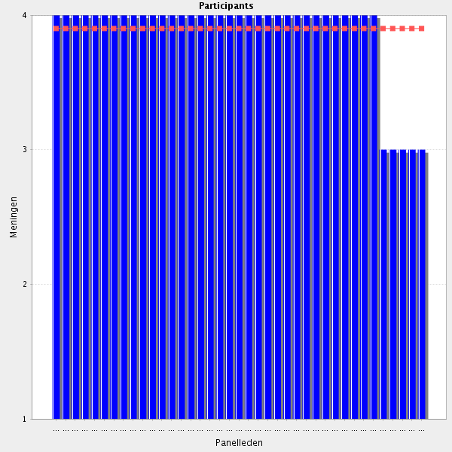
Average score: 3.9
Summary: very good agreement but this is exactly the same as 2.1. Duplication fatigue again?
Proposal: Delete this as a stand alone element of the CTF

All comments on this statement: impactful statements in red
Eventhoug it is not up to the pharmacist to prescribe, this healthcare professional should be able to advice patients so that they could choose the best individual pharmaceutical formula for them, whenever possible.
yes, but again good collaboration with other member of the medical team is needed.
It is the task of the phramacist to ensure makind best use of medicines.
One of the most appretiated contributions of pharmacists are the recommendation that they made to nurses and physicians in this area
In collaboration with the others in the team of health professionals
Recommendation to prescriber
in a multidisciplinary manner

6.11 Adverse effects and toxicology - Knows or is able to understand major side effects profiles of medicines and recommend alternative medicines therapies.
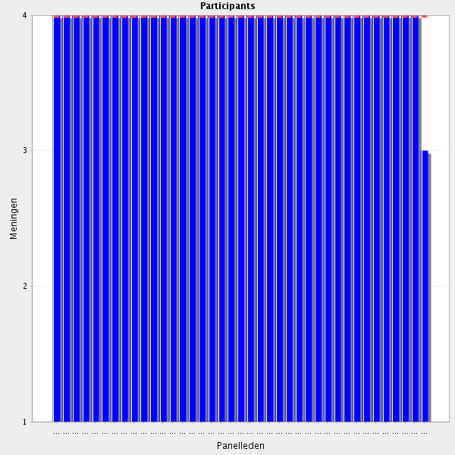
Average score: 4.0
Summary: excellent agreement but can fit better into Group 2, and be improved with a little repharasing to incorporate multidisciplinary working as identified in comments.
Proposal: Place the below as am element in Group 2:-
Can recognise side effects of medicines and, in discussion with other health care professionals, patients and carers, can recommend alternative treatment strategies.

All comments on this statement: impactful statements in red
If a patient is taking an interferon for multiple sclerosis and suffers a lot with flu syndrome, the pharmacist might suggest a medicine different from interferon (associated with flu syndrome), namely glatirame acetate.
Essential as the pharmacist is the expert on medicines
knowledge of side effects is necessary but recommendation of AMT should be done with caution
Selecting the best product for an individuel patient
It is basic that pharmacists know all related to adverse reactions and offer alternatives if available.
Some typos - "Knows or is able to understand major side effect profiles of medicines and recommend alternative medication therapies."
Essential as the pharmacist is the expert on medicines
it is one of the main tasks of the advising pharmacist as ADRs are one of the most common reason for unsuccessful therapy.
See better choices

6.12 Adverse effects and toxicology - Is able to take action, when required.
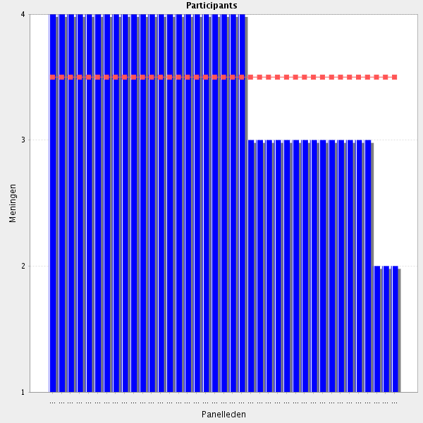
Average score: 3.5
Summary: Modest agreement. Comments indicate a need for clarification and a move to Group 2.
Proposal: Move the revision below to Group 2:-
When a drug adverse event is suspected, takes personal responsibility to ensure the patient is safeguarded, and takes the appropriate action to support pharmacovigilance procedures.

All comments on this statement: impactful statements in red
very ımportant for farmakovigilance
Yes, a very general virtue in life. Largely nondescript for a pharmacy competency.
If a patient or a healthcare professional report an adverse effect, pharmacists should report that adverse effect to National Autorities, in Portugal Infarmed. When the adverse effect is reported by the patient, the pharmacist must immediatly inform the doctor's patient. If a pharmacist encounter a description of an adverse effect in the "on-line" clinical process of a patient, he should immedialy contact the doctor of that patient
Need to be able to support the management of such situations
About what actions are we talking? Of course a phamacists if is aware that a patient is experimenting a toxic effect or a ADR has to do something. But in general the most she/he can do is to advert the physician, because we cannot discontinue a drug or prescribe a new one.
In collaboration with the other health professionals
Too general. Suggest merging this with the next two points i.e. "Is able to take action, when required - to recommend side effect management strategies...."
Specify "take action": alert national pharmacovigilance authoroties? Alert doctor? Both in my opinion
what does it mean - take action - non-specific?
An effective communication with the physician is even more important
maybe not to take action, but to consult what actions to be taken when an ADR is detected or suspected.
What action? Need more explaining
do not belong to information section and is a bit confusing for a reader of such document (a re-organization of the information section is mandatory)
This is a competence that does not belong tn this section about information expertise

6.13 Adverse effects and toxicology - Is able to recommend side effects management strategies (such as dose reductions or supportive medication).
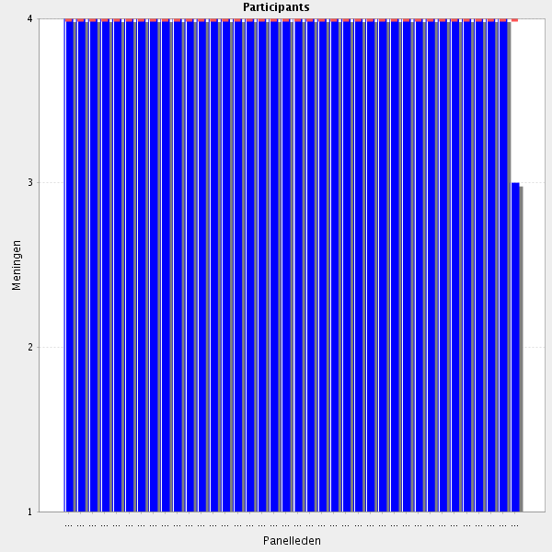
Average score: 4.0
Summary: Strong agreement, but duplicates new adverse effect elements now in Group2.
Proposal: Delete this as a stand alone element of the CTF

All comments on this statement: impactful statements in red
Yes, but what is the difference between this competence and the one concerning the ability to take action?
For instance, in order to reduce flu syndromes when patients take interferon, one might recommed taking paracetamol twenty minutes before injection. Those medicines that might cause nausea and vomits should be taken with food.
After discussion with patients and HCP
Taking action mentioned in the question before means the same to me. This one here is more specific.
This is ovbious
Typo - "side effect management strategies"
Important to make a suggestion as to solve a problem
Very important for the patient
one of the main skills needed for a clinical pharmacist- totally agree
Important to make a suggestion as to solve a problem

6.14 Adverse effects and toxicology - Is able to support the management of acute overdosing situations and antidotes.
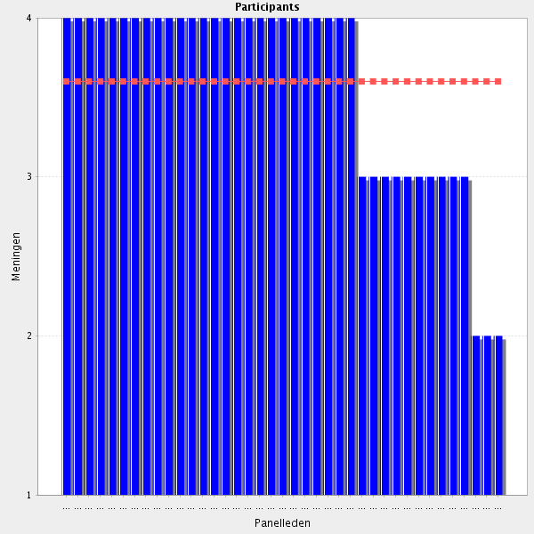
Average score: 3.6
Summary: reasonable agreement. A useful improvement in pharasing in these comments.
Proposal: Amend to:-
Can support the management of acute overdose and advise on appropriate antidotes.

All comments on this statement: impactful statements in red
Important role
core skills
In my institution that job is done by a department of toxicology... They have a clinical pharmacist, but usualy doctors are doing that job.
I believe adverse effects will be in a special section
Consultation but not administration, unless certified to do so.
Pharmacist must kow which antidote to give in accordance with the medicine that was exceeded (e.g. naloxone for morphine). It is important that he knows the antidots of the medicines that he validates everyday and which measures are necessary to be taken (e.g. ventilation, hydratation).
Suggest rephrasing to: "Is able to support the management of acute overdose and advise on appropriate antidotes."
This must be done in collaboration with the physician
Pharmacist must kow which antidote to give in accordance with the medicine that was exceeded
Together with toxicologists
Certainly a pharmacist should be able to assist in this task but in my county there specialized centres of this (poison centres).
Someone must know
management of overdosing means "action" ...performed by physician
Agree but I think "support the management" means to support the team in managing overdose.
Specialized knowledge, few of us need to be able to handle situations like this.
Only together with other health professionals. Basic knowledge of antidotes OK.

6.15 Microbiology and hygiene - Is able to describe the interaction between bacteria, viruses, fungi, parasite, anti-infectives and the human body including resistance mechanisms and hygiene.
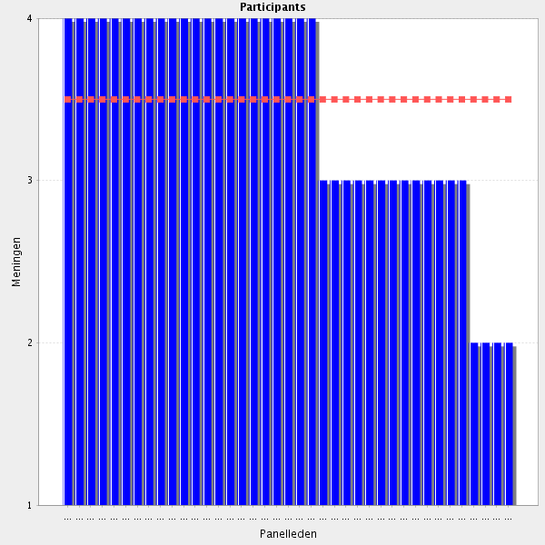
Average score: 3.5
Summary: moderate agreement. Comments indicate the need for some clarification. Revision can be tested in Delphi 2
Proposal: amend to:-
Can describe and discuss with patients and carers the interaction between bacteria, viruses, fungi, parasite, anti-infectives and the human body, including resistance mechanisms and the benefits of basic hygiene actions such hand washing.

All comments on this statement: impactful statements in red
Part of patient safety
In the framework of consultation and engagement in Health Promotion Campaigns
I believe that is basic knowledge and all professional should have it.
Very important with the infection controle committee
Even though this is an area that can also be assumed by nurses or doctors, I think that pharmacist should have a lider position due to they knowledge and interet.
It is important that pharmacists know that quite frequently those patients with a bad immunitary system are frequently in high risk of getting an infeccion. In many cases that infection might be caused by bacteria, fungi or even virus, all at the same time. For instance, if a HIV patient has a lower CD4+ load, he is more prone to respiratoty infections, as well as fungi attacks. On the other hand, a fungical infection might be one of first signs of HIV infection. Whenever possible, it is important to know which agent/agents is/are responsible for a certain infection, in order to prevent resistances to antibacterials/antivirals. For the same reason, it is important to use the right dose in the right period of time.
Very helpful but not a specific task of a pharmacist.
Agree but too broad - suggest amending to "Has an understanding of the interaction between...."
The pharmacists has a special undestanding of the resistance mechanisms of antibiotics and can explain them to the other health profissionals.
very hard
Describe on what level? To whom? In what settings?
if the scope of this statement is anti-viral therapy and relevant use of antibiotics- yes, but stated like this it does not seem to be addressed to reasonable antiviral therapy decision making
question too large and the knowledge of a pharmacist will not reach that of a microbiologist .... thus question to be reformulated
only on a basic level
Describe. For who? In what way and why?

6.16 Microbiology and hygiene - Is able to support staff training activities regarding infection control and infection control strategies (e.g. anti-microbial stewardship).
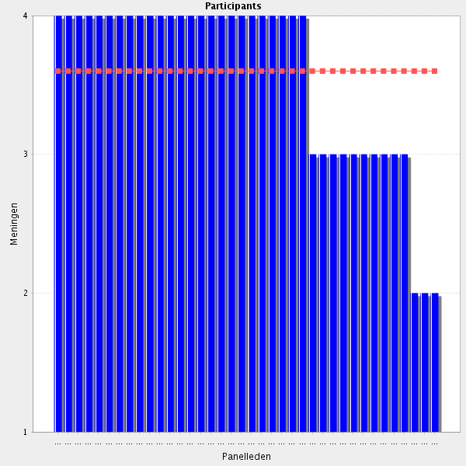
Average score: 3.6
Summary: modest agreement; comments indicate the antimicrobial stewardship and the role of the pharmacist is a challenge for some participants.
Proposal: Minor amendment as below:-
Can support staff training activities regarding infection control and infection control strategies (e.g. anti-microbial stewardship).

All comments on this statement: impactful statements in red
Maybe a specialised pharmacist
Necessary
The role of pharmacists in the choice of antibiotics, antiseptics and desinfectants is essential
As a member of the team
As I said in the previous question, the pharmacist can have a central position in the group of professionals managing infection control, and be one of the major responsible of anti-microbial stewardship-
I agree but you need to have specilized knowleg (i.e.antibiotic stewardship).
The pharmacist is a part of the team
ok , should be a member of such team (and leader in some cases)
the pharmacist can have a central position in the group of professionals managing infection control, and be one of the major responsible of anti-microbial stewardship programs
1. This statement does not refer to the pharmacists' basic education which concerns mainly medicines and everything surrounding them. 2. This will be better fulfilled by other hospital staff (eg microbiologists) 3. If the pharmacists feel that they are prepared for performing such activities they, of course, may take part in it.
It is important for your own work , but other professionals are doing staff training activities in this area.
not our profession.

6.17 High-alert medications - Is able to identify high-alert medications and high-risk administration routes of a particular hospital setting/route.
Average score: 3.9
Summary: very good agreement, but this is a patient safety topic and should be collated in group 2.
Proposal: Place in Group 2; minor rewording as below:-
Can identify high-alert medications, and high-risk administration routes according to the setting.

All comments on this statement: impactful statements in red
If not the pharmacist, then who?
To be preventive. But need ways to handle data.
It is important that the pharmacist know which medicines are regarded as high alert medicines and that those medicines be cleary signed in all ward, emergency services and operating rooms, so that when healthcare professionals use those medicines be aware of the risks associated with their use. In my opinion, medicines labels should identify which routes a medicine might be use.That should be written in a different colour.
In drug safety issues is the best positioned to do it
yes we do ıt
It is our routine job.
Important Group of patient safety
very important
"High alert medication" is allways related to the kwnoledge of all professionals in a specific setting!
After adequate training and specialisation

6.18 High-alert medications - Is able to plan and implement risk management actions to minimize the risk of errors related to these medications.
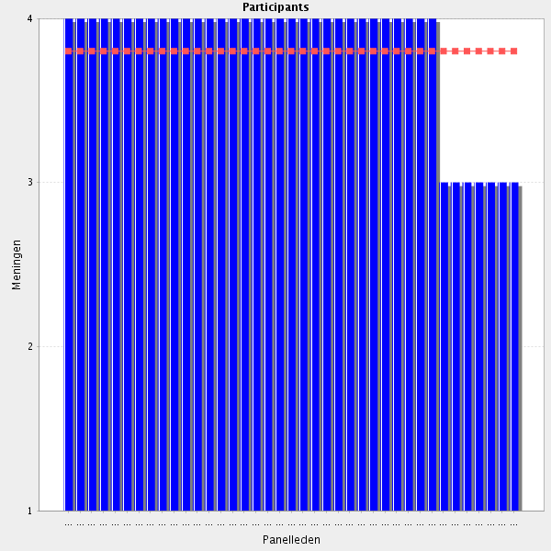
Average score: 3.8
Summary: good agreeemnt but needs to be collated with other patient safety elements of the CTF.
Proposal: Move to Group 2, minor change to wording.
Can plan and implement risk management actions to minimize the risk of errors related to these medications.

All comments on this statement: impactful statements in red
Necessary
In my opinion, all high-alert medications should be identified with a dangerous sign in the pharnacy, emergency rooms, operating rooms and wards, as well. Labels of all medicines, and particulary those for high-alert medication, should mention which routes of administration might be used.
definition of plans to minimize such problems could be coordinated by pharmacists
Pharmacists have to desing strategies and guidelines of how to manage the use of risk medication and how to minimize errors
Patient safety
clinical pharmacist should be able to propose most of the measures from the risk management plan but it is really important his management plan to be considered, discussed and decided in a wider format- multidisciplinary team and also all stakeholders to be responsible for implementing these measures in their everyday tasks and sticking to the applied rules and SOPs.
In the interdisciplinary team
To focus on drugs that can do most damage

6.19 Medical devices - Understands and applies knowledge of medical devices for drug delivery, administration and reconstitution.
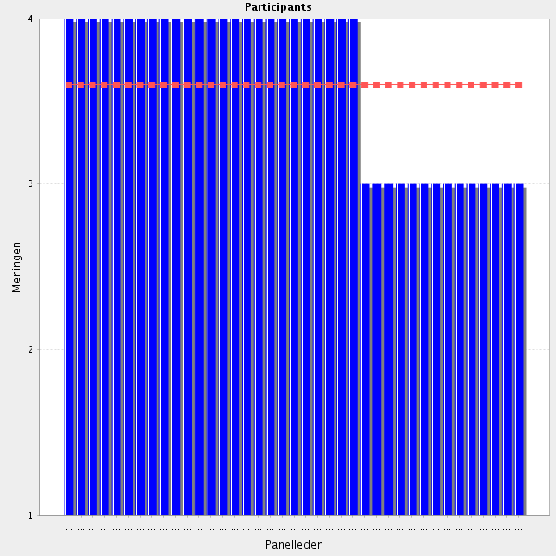
Average score: 3.6
Summary: moderate agreement but several participants corretly identified that this is a duplication and can be removed.
Proposal: duplicated, therefore remove.

All comments on this statement: impactful statements in red
Exactly the same as 2.19!!!
Necessary
It is important that the pharmacist know which medicines are necessary to be filtred and how (e.g. dantrolene). This healthcare professional must also know how to reconstitute a medicine (usually with water), and how to dilute it (usually saline solution or glucose 5%), should it be the case. Eventhoug it is not up to the pharmacist to recontitute and dilute medicines, he/she must know how to do it in order to help nurses whenver any doubs appear. In my opinion, pharmacists should verify if the other healthcare professionals know how to do it in the proper manner.
medical devices are critical for the good use of some medicines and a high level knowledge in Med-Dev should be made available
This knowledge is needed to make the best use of medicines in a certain situation.
But this statement has been used before. In what section does it belong?
Is this already covered in 2.5 Medical Devices?
Fundamentals only. Specialised issues should be a matter of extra certification
This statement has been repeated in 2.19
To help make sure the drug reaches the target
Important
Pharmcists can have a central role but I do not think it exclusive or that the should devot much of their time to this

6.20 Research - Understands and applies knowledge in pharmacy practice research and clinical research.
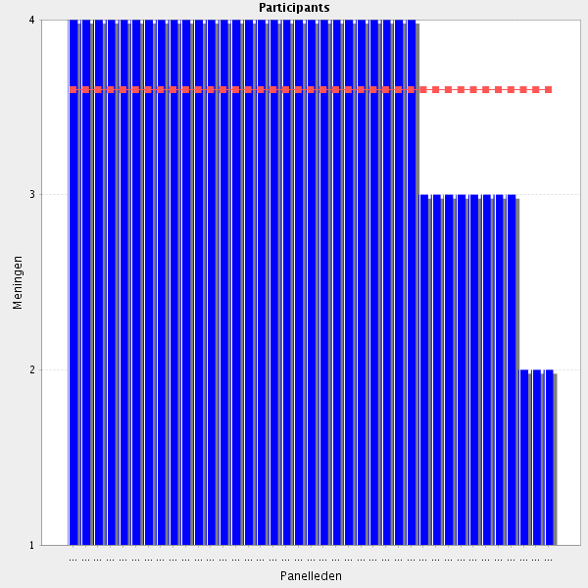
Average score: 3.6
Summary: moderate agreement; current pharasing needs further definition in order to actively contribute to the CTF. Needs linking with the consent element in the CTF.
Proposal: Amend to the following, and place next to the Consent elment in the CTF.
Can describe, explain and discuss commonly used research methodologies in order to be able to participate, when appropriate, in pharmacy practice research and clinical research.

All comments on this statement: impactful statements in red
I strongly agree, but discover every day, that me and my team are not so good at doing it. We would like opportunities for training or periodic renewal of knowledge in this field, as well as all the others.
Necessary - needs to be able to interpret research findings and apply
extremely important, especially in cases when the clinical pharmacist is a member of the clinical research team, participating in the process of a clinical trial performance.
also able to perform research!!!
It is the only way to evolve scientifically
Many experimental medicines turn out to be approved and introduced in the clinical practice. Those pharmacists who take part in clinical trials learn before hand how those medicines work and which adverse reactions are associated with their use. When those medicines are approved and reach their pharmacies, they should be alert for the side effects that were described in the clinical trials.
I have conducted a questionnaire research and a small nomber of hospital pharmacists are keen to participate in this kind of research.
research in pharmacy practice should be promoted and rewarded (as physicians do in clinical research)
Obviously, the knowledge adquired has to be applied to do research
Not every pharmacist will conduct research (unfortunately) but all should understand it to interpret the evidence and be able to apply it in case they do have involvement in e.g. hospital research.
This is not a taks of all pharmacists.
To make sure we do the right thing in the best way
Not needed for every hospital phamacist.
Not needed for everybody. Everybody must understand and have basic knowledge of clinical research, but not everybody needs to practice it.

6.21 Research - Understands the assessment of benefit risk in relation to clinical issues.
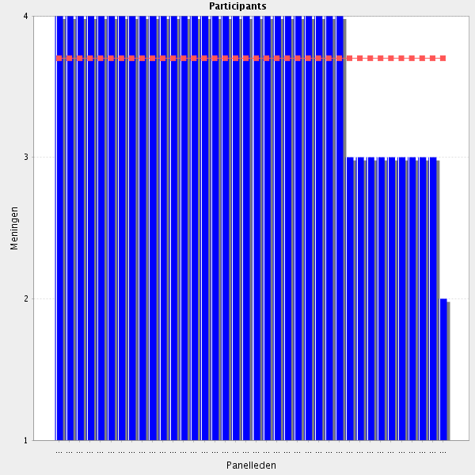
Average score: 3.7
Summary: despite the score this element is not clear. Does it refer to the risk:benefit ratio of taking part in research, or does it refer to an explicit assessment of risk:benefit of different management options in routine clinical practice.
Proposal: ask for clarification. For now, assume this refers to clinical practice. Reword to:-
Uses the benefit: risk ratio when assessing alternative treatment strategies in relation to clinical issues.

All comments on this statement: impactful statements in red
All medicines have side effects. Taking a medicine is only acceptable when the benefit is superior to the side effects.
Necessary
Essential
In order to recommend and do pharmaceutical interventions phamacists have always to evaluate the risks in front of benefits of whatever of their decisions.
More common phrase is "risk/benefit"
In order to recommend and do pharmaceutical interventions phamacists have always to evaluate the risks in front of benefits of whatever of their decisions.
it is very useful, but it is not so simple and maybe often it is a matter of an additional specialization. however it is very important skill.
This is not only a researc question! Risk - benefit relations is a normal consideration in the selection process of a specific medication.

6.22 Research - Applies appropriate research methodologies to scientific and practice.
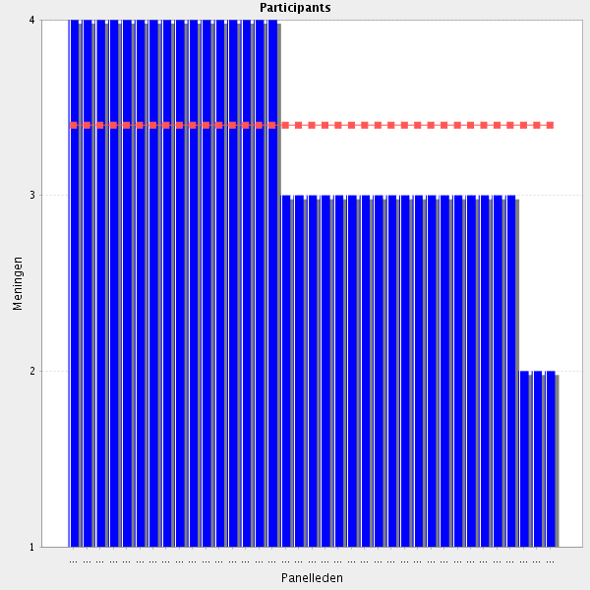
Average score: 3.4
Summary: Modest agreement, but this is now covered in the updated 6.20 element of the CTF.
Proposal: can be therefore removed as a stand-alone element of the CTF.

All comments on this statement: impactful statements in red
relevant methodologies should be applied to pharmacy practice research to strengenth our profession
In order that all the actions taken be sound, phamacists have to known the appropriate methodology
In order that all the actions taken be sound, phamacists have to known the appropriate methodology
Do you mean ALL Clinical pharmacists need to have this knowledge such as a ph.d.? I Believe knowledge to interpret and explain research is important, but not to perform och choose methodology all of Clinical phamacists. What do you Think?
I think that pharmacists, even those that do not do research, need this knowledge. They have to be up to date in all related to medicines, therefore, they should read articles about clinical trials, etc. and interpret them adequately.
Typo - remove "and" to read: "Applies appropriate research methodologies to scientific practice."
I agree, but this doesn't sound proper English to me.
if this means applying good practices from research publications into practice- YES, it is a necessary skill.
Incorrect English
Supported my academia
Important
Don't understand completely
a Research Project should be part ot the training programm
In case you are providing this task you should do so.
Again, there is something wrong with the grammar. The Word "Scientific" does not fit in. What should it be?
Only if you are involved in research. Basic knowledge is of course important.

6.23 Research - Is able to plan, lead and carry out research/practice development projects to promote safe and rational medication use of the hospital.
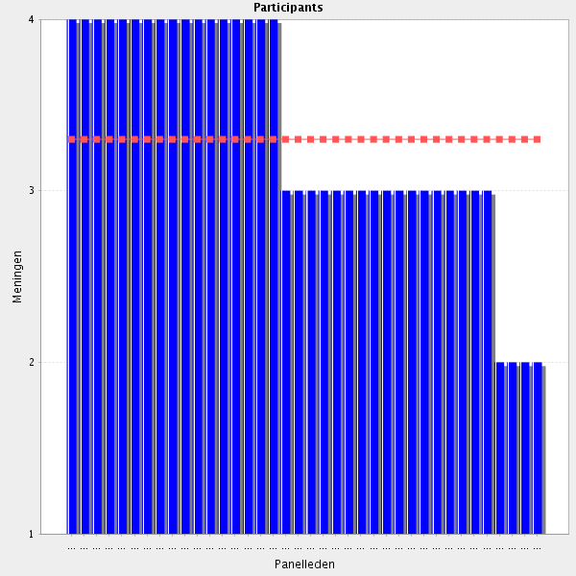
Average score: 3.3
Summary: some dissenters but also some realisation that this is not high level-research but audit or project-based data collection and simple analysis. A useful ammendment from a participant can be used in Deliphi 2.
Proposal: Amend to:-
Can plan, lead, carry out and support other colleagues in research/practice development projects to promote safe and rational use of medicines in the hospital setting.
Collate this withother resaerch / consent/ audit topics

All comments on this statement: impactful statements in red
In collaboration with other HCP
It is important that pharmacists develop projects in order to promote safe and rational use of medicines within the hospital. For instance, all medicines should be labelled with the following itens: name, dose and possible administration routes. High-alert medicines should be identified with a dangerous sign. Medicines with similar packaging should be identified with a stop sign. Those medicines with different concentrations should also be identified with a traffic light sign. LASA names sould be used for those medicines that look alike or have a similar image.
all pharmacists may not be able to "plan, lead and carry" but in a team at least one individual should be able to do that and to involve her-his colleagues
Is it something for everybody to learn in this depth in education for Clinical pharmacist?
Pharmacists have to be liders in research and development projects of these areas.
Does not have to be high level - could be e.g. a prescribing audit on your own ward to identify specific problems to be addressed at ward level. Essential learning for all trainees.
Pharmacists have to be liders in research and development projects of these areas
maybe a specialised pharmacist for that area
yes, and it is important not noly in cases when there are ongoing clinical trial on the territory of the hospital, but it can be associated with post-marketing studies or research projects, used to evaluated best prescribing options or better therapeutic alternative.
"Is able to plan, lead and carry out research/practice development projects to promote safe and rational medication use of the hospital." should be amended to "Is able to plan, lead and carry out research/practice development projects to promote safe and rational use of medicines in the hospital setting"
The cooperation with physicians is necessary. HP is a colleague - not leader. I think - it is not routine job.
Agree, but does not need to be a core competence of every hospital pharmacist.
Research should be an important part of the hospital pharmacist's job
Pharmacists from hospitals are rather practitioners and they should cooperate with universities.
May not have to plan, lead and carry out simultaneously. Being able to support in research development projects may be sufficient?
This is a very high level requirement that all should be able to do this at a research level. Development projects OK, but not all need to be true researchers.
As part of a multiprofessional team.
A pharmacist will not be able to do so on his own.
Not needed for everybody.

6.24 Before going to the next Cluster: do you have a remark, suggestion and or question on this group of competencies?
Research is not always possible, due different reasons: lack of time, lack of resources. I want to point out that in smal or not acute care hospitals is very difficult to ondergo research. Moreover, I think also that for pharmacists working in these posts it is very difficult for them to publish their work. Maybe journals should take all this in account before rejecting a manuscript, because somethims the results even though not being espectacular can be very useful for other pharmacist working in similar situations
I agree but research does not have to be high level / published to be of value. Researching local problems like medication errors, omission of medications etc. and implementing strategies to effect change can improve working practises and patient care within small hospitals/wards. However, published research is very important to further our profession and to improve our reputation with other healthcare professionals.
Then I would like to know how we can improve or solve this issue
as mentioned in a previous response the chapter dedicated to "information" is much more detailed with a lot of overlaps and some items in this section are mis-placed and do not refer per se to information. This Cluster should be reconsidered and re-formated (17 Information is a key component of our profession and Information competencies should be integrated under 1 competency "Information" with a merging and/or simplification of the different "attitudes" currently reported. The Knowledge and corresponding Behavioural Competencies should be summarized in 5-6 items (as in most of the Chapters) Indeed, the number of items currently proposed (n = 17) tends to outweight the role of information in the daily hospital pharmacy practice and hence tend to offset the importance of the other activities.
Some very general statements need reviewing (see my previous comments). Also, some statements could be merged or omitted completely.
I appreciate pharmacy practise research but it will never be in the portfolio of all pharmacists.

