Procurement Position Paper

Ideas

The EAHP Statement on Sustainable and Equitable Access to Medicines as well as the EAHP Statement on public spending austerity and its impact upon access to medicines and patient safety should be considered. Conflicts between these statements and the Procurement Positon Paper should be avoided.

The Procurement Position Paper must be in line with Sections 2.1, 2.4 and 5.6 of the European Statements of Hospital Pharmacy.

No European Healthcare Professional Organisation has a statement on procurement. The European Public Health Alliance (EPHA) published a position on the modernisation of EU public procurement policy in 2011.

Health care costs are rising considerably. The cost of medicines contributes to these rising costs. Specialised medicines are an increasing part of total medicines expenditure (*)
The immediate concern of any hospital pharmacist is to ensure that every patient within the hospital receives the medications they need in order to improve or stabilize their health status and relieve pain and suffering. For this reason, hospital pharmacists have a direct stake in the efficient functioning of the medicines supply chain.

Procurement of medicines is an important part of ensuring an efficient supply of medicines in hospitals. The responsible use of medicines in hospitals strongly depends on the availability, safety, quality and efficacy of medicines in the hospital. Procurement of medicines should therefor take into account not only the volume and price yet should incorporate medical policy, risk and safety management as well as operational choices for the hospital and the larger health ecosystem. Procurement should be part of the hospital quality system in which the process is evaluated regularly and actions are taken to improve the outcomes at therapeutic, patient safety and efficiency level. Additional tendering options to improve patient safety (e.g. primary package barcoding) or efficiency (e.g. aggregated barcoding for compliance with the Falsified Medication Directive) can be incorporated in the procurement process.

Hospital pharmacists have the knowledge, the skills, and the tools for all these aspects and should therefore be involved in all procurement phases involving medicines to be used in or under responsibility of hospitals as outlined in Section 2.1 of the European Statements of Hospital Pharmacy.

- European Legal Framework for Public Procurement

An overarching European framework based on the

EU’s public procurement legislation ensures transparency, equal treatment and non-discrimination throughout the Union. These rules were further simplified in 2014 with the adoption of Directive 2014/24/EU. Rather than only award a contract on the basis of the best price, authorities are encouraged to integrate qualitative criteria, demand innovative, energy saving solutions or insisting on sustainable and socially inclusive approaches. The EU legal framework sets out procedures which all public sector authorities must follow when conducting procurement above a certain threshold. This also applies to the tendering of pharmaceuticals in the public hospital sector. Pharmaceutical tendering is a complex process that involved different stakeholder and steps that are regulated at national level leading to diverse solutions in the different European countries. In addition, these processes are guided by publications of other international actors such as the World Health Organisation (WHO) and the Organisation for Economic Co-operation Development (OECD).

- Types of procurement

Several procurement methods can be distinguished. National choices lead to either one method or a mixture of methods comprised out of the following choices:
- 1. Central price negotiations by government;
- Central price negotiations by field parties within government frameworks;
- National purchasing by field parties;
- Purchasing through regional purchasing contracts;
- 5. Purchasing through strategic purchasing relationships; and,
- Purchasing by individual hospitals.

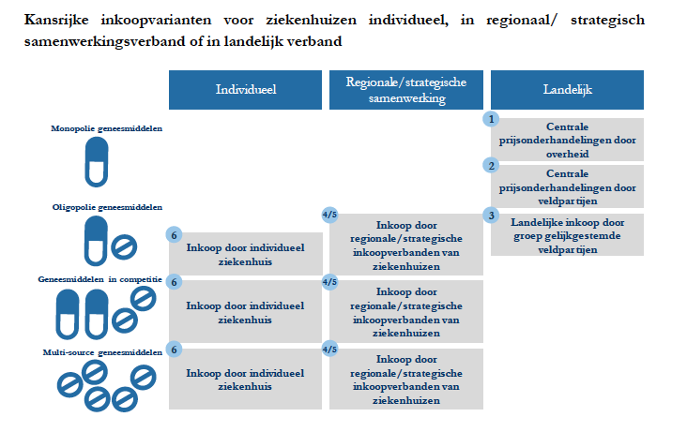

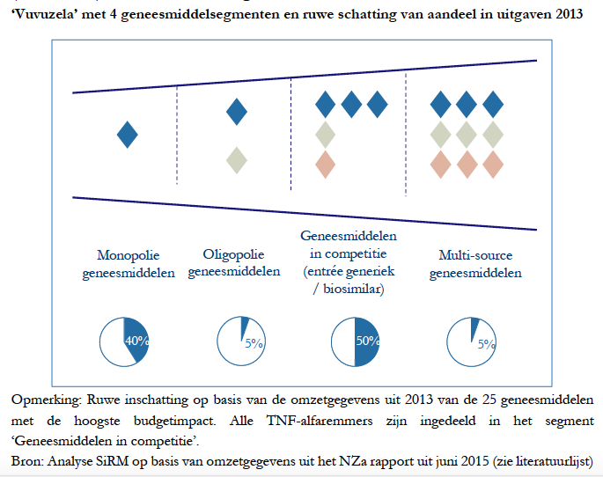

- Procurement processes

Section 2.4 of the European Statements of Hospital Pharmacy outlines that procurement should be according to the medicine formulary and informed by the formulary selection process. A robust process should also be in place to appropriately procure medicines not included in the formulary where their use is indicated for the safe and effective care of individual patients. In the hospital sector, procurement follows a 6-step process which includes
- Choosing aChoice of medical policy and volume;
- GetGetting a mandate for negotiation;.
- Tendering; (not in picture)
- Negotiating;ions.
- ImplementationImplementing the of result of the tender; and,.
- Monitoring prescribing.

For high risk medicines, the hospital pharmacist should ensure – in accordance with Section 5.6 of the European Statements of Hospital Pharmacy – that procedures are implemented in procurement to minimise risk.

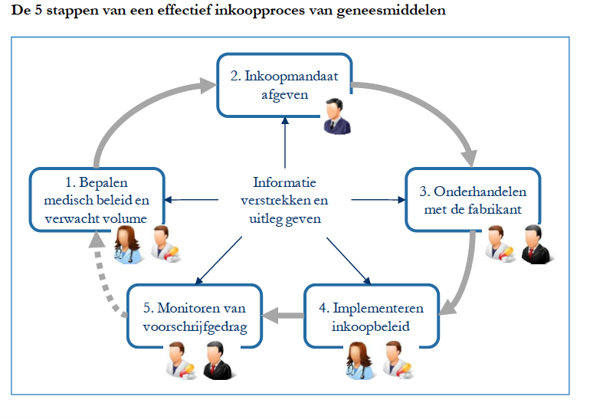

- Role of the hospital pharmacist in procurement

Different possible roles in procurement:
Procurement variants:
National level

1. Central price negotiations by government. HP: National Association
2. Central price negotiations by field parties within government frameworks. HP: National Association/specialists, negotiation

3. National purchasing by field parties. HP: National Association/specialists, negatiation

4. Purchasing through regional purchasing contracts: HP: collaboration, formulary and negotiation

Hospital level
5. Purchasing through strategic purchasing relationships. HP: collaboration, formulary and negotiation
6. Purchasing by individual hospitals. HP: formulary and negotiation

Procurement at hospital level or with regional or strategic hospital partners reduces the scale of procurement yet it offers more flexibility in adjusting the medicines to local medical practice. Most value is obtained in medicines that are available from multiple sources or for which there are various comparable products.

Procurement should be according to the medicine formulary and informed by the formulary selection process. Involving medicines use data and evaluation, including risk and safety management can optimise the formulary selection process.

Hospital pharmacists are part of the Therapeutics committee in hospitals. Hospital pharmacists can combine data of drug use to evaluate formulary compliance and recommend changes to the formulary based on use data and scientific data. Best practices include the evaluation of use of medicines and outcomes of care (van de Garde EMW, Plouvier BC, Fleuren HWHA, et al Pharmacotherapy within a learning healthcare system: rationale for the Dutch Santeon Farmadatabase, Eur J Hosp Pharm Published Online First: 18 September 2017. doi: 10.1136/ejhpharm-2017-001329).
Including Risk and safety management in the formulary decisions will reduce medication errors. Hospital pharmacists should identify high-risk medicines and ensure appropriate procedures are implemented in procurement. Procurement based on these principles can thus enhance patient safety (L. V. Groudins et al, J. Pharmacy Practice and Research, 2016 vol 46, p 145-151).

A robust process should also be in place to appropriately procure medicines not included in the formulary where their use is indicated for the safe and effective care of individual patients. The hospital pharmacist

Scale versus versatility:

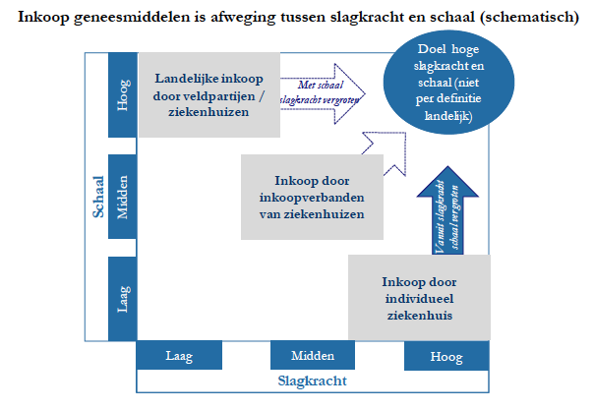

In relation to the role of the hospital pharmacist, the position paper could touch upon good contracting practices (example of NL) – i.e. what kind of steps does a hospital pharmacist need to take in relation to the procurement/ purchase of medicines.

7S model of McKinsey: Strategy, Structure, Systems, Style, Staff, Skills en Shared values.
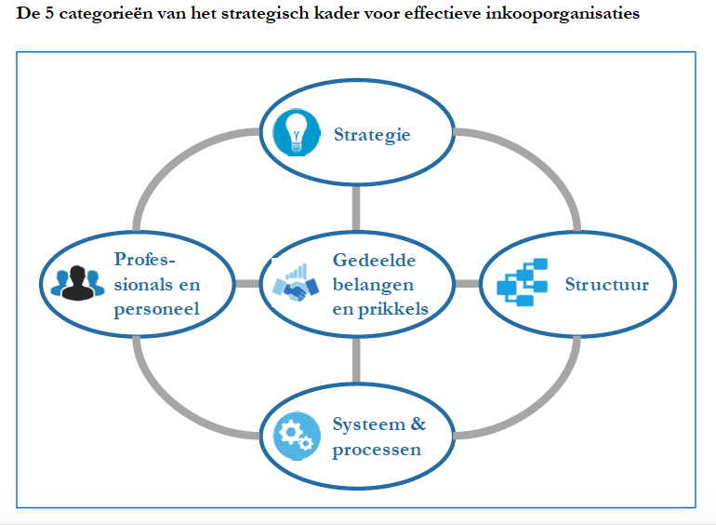

- Medication ecosystem

Without careful use tendering can, in certain circumstances, negatively impact the sustainability of the medicines supply chain. Manufacturers do not always have the manufacturing capacity to meet the potential need and vulnerability to the supply chain is added if alternative suppliers drop out of the market due to loss of tender. Impact assessment tools when conducting tendering should include considerations of the impacts on medicine supply chain vulnerability and sustainability.

For the conclusion, we need to decide whether we want to include calls for action or not. This depends very much on the scope of our paper – i.e. is it just an informative position that sheds light on the views of hospital pharmacists or do we aim at achieving anything with the paper.

Section 2.2. European Statements of Hospital Pharmacy: Hospital pharmacists should be involved in the complex process of procurement of medicines. They should ensure transparent procurement processes are in place in line with best practice and national legislation, and based on the principles of safety, quality and efficacy of medicines.
Directive 2014/24/EU of the European Parliament and of the Council of 26 February 2014 on public procurement and repealing Directive 2004/18/EC.
WHO, Practical Guidelines on Pharmaceutical Procurement for Countries with Small Procurement Agencies (http://apps.who.int/medicinedocs/en/d/Jh2999e/).
OECD, Public Procurement Recommendations (http://www.oecd.org/gov/public-procurement/recommendation/).
Section 5.6 European Statements of Hospital Pharmacy: Hospital pharmacists should identify high-risk medicines and ensure appropriate procedures are implemented in procurement, prescribing, preparing, dispensing, administration and monitoring processes to minimise risk.

