From: Maarten Van Baelen - Medicines for Europe <mvanbaelen@medicinesforeurope.com>
Date: Friday, 8 February 2019 at 16:23
To: Stephanie Kohl <Stephanie.Kohl@eahp.eu>
Cc: Kate O'Regan - Medicines for Europe <koregan@medicinesforeurope.com>
Subject: EAHP - Medicines for Europe get-together on mutual interests

Hi Stéphanie,

I hope you are doing well.

Would you be interested to organise a get-together with the EAHP team (+ 1 or 2 board members) to present and discuss topics that might be of mutual interest for both organisations in order to see as well how this could grow into a collaboration / support of common interests?

Would it interest you to schedule such a meeting in the upcoming months? February, March and April seem to be already packed, but would you have some time in May?

Kind Regards,
Maarten

Maarten Van Baelen
Market Access Director
Rue d'Arlon 50 - 1000 Brussels - Belgium
email: mvanbaelen@medicinesforeurope.com
D: +32 (0)2 239 20 10
www.medicinesforeurope.com





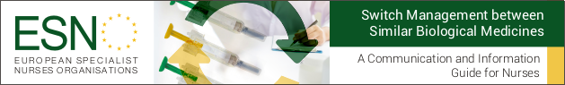
Disclaimer - E-mail
The information contained in this E-mail is intended for the named recipient(s). It may contain certain privileged and confidential information or information which is otherwise protected from disclosure. If you are not the intended recipient of this message, please immediately send it back tomvanbaelen@medicinesforeurope.com and delete it from your computer. You must not copy, distribute or take any action in reference to this information. Because of the nature of the Internet the sender is not in a position to ensure the integrity of this message, therefore the sender disclaims any liability whatsoever in the event of this message having been intercepted and/or altered.

