

EAHP
CTF - Cluster 4. Professional competencies

Delphi Round 1

Synmind BV / FB
Haarlem, 21 March 2017

Group 1: Professionalism 3
Group 2: Effective communication skills 47
Group 3: Team work 71
Group 4: Organisation 88
Group 5: Service Provision 107
Group 6: Costs systems 122
Group 7: Training other healthcare professionals 130
Group 8: Leadership development 146
Group: 1 Professionalism (Group 19 of 26)
1.1 Confidentiality - Respects and maintains the individual’s right to confidentiality and understands when information about the patient’s condition can be shared with colleagues.


Average score: 4.0
Summary: no change required.

Comments:
Each patient has the right to keep his/her clinical situation confidential. So, when medication is given to a third person pharmacists should not disclose that information. Instead, they should tell that person to ask the patient in question. Between healthcare professionals confidentiality should be respected, as long as that do not put in danger the health of patients and healthcare professionals (e.g. HIV patients and possible blood contamination in the operating room of a surgeon/nurse).
Agree.Moreover, the information which gets students (medica, pharmaceutical) schould be also confidental.
Very important. Patients have a right to privacy
According objective and precisely set criteria

1.2 Confidence - Interacts in a way with patients, health professionals, colleagues and carers that will inspire confidence and generate professional respect.

Average score: 4.0
Summary: minor rewording to:-
Interacts in ways with patients, other health care professionals, colleagues and carers that will inspire confidence and generate professional respect.
Comment:
If we want to be respected as hospital pharmacists, we must earn the respect of our patients, colleagues and other healthcare professionals.For that it is important to know how to approach our patients. colleagues and other elements of the healthcare hospital team. The right approach (be polite, but firm whenever necessary) is essential. If we do not earn professional respect , our advices would not be taken into consideration by anyone

1.3 Responsibility of own action - Takes responsibility for one’s own action. Is prepared to give an account of professional judgments, acts and omissions in relation to own professional roles.

Average score: 3.9
Summary: minor rewording:-
Takes responsibility for one’s own action. Is prepared to give an account of professional judgments, acts and omissions in relation to own professional roles.

Comments:
Professionalism
Absolutely, as we do In UK clinically screening a prescription makes the pharmacist liable of his own actions
Pharmacists, as well as all the other healthcare professionals, should be responsible for their actions. All pharmacists should exactly know their duties. Omissions and wrong doings should be penalized.
"Responsibility for own actions"
depending on the cultural background an legislation

1.4 Responsibility for patient care - Takes responsibility for patient care, and recognising their needs as individuals.
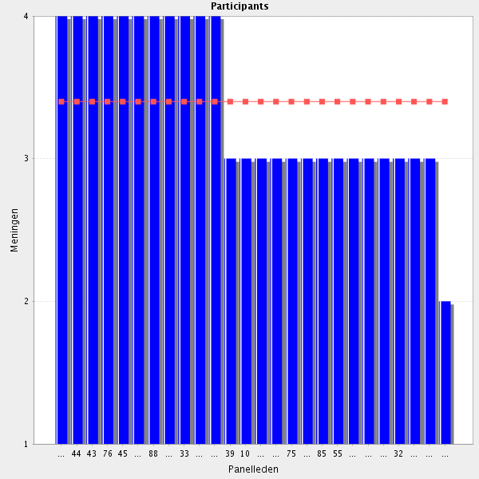
Average score: 3.4
Summary: rewording indicated in line with comments.
Proposal: Amend to:-
In collaboration with other health care professionals, recognises individual patient needs and preferences and takes responsibility for approriate aspects of patient care.

Comments: impactful statements in red
"Takes responsibility for patient care, recognising individual patient needs, as part of a multidisciplinary team."
Agree with suggestion
More specifically: takes responsibility for the tasks delegated to the pharmacist as the physician is the one responsible for the total care of the patient. The second half of the sentence is OK.
To some degree
Basically yes. But individual needs must be in good balance with economic thoughts.
It depends on cultural background and legislation
Shared with other professionals
The patient's care is not really the pharmacist's responsibility but for sure the pharmacist is responsible for his/her role in the patient care.
It is not up to the pharmacist to take that responsability. Still, pharmacists as an element of the healthcare team might play a major role in patient care, together with doctors, nurses and other healthcare professionals.
I would prefer the following: the pharmacist, along with the other members of the health team, is responsible for the care to be given to the a certain patient, contributing to the recognition of the individual needs of each patient.
1.5 Responsibilty for patient care - Knows when to ask for advice and act upon it as appropriate.
Average score: 4.0
Summary: this is a duplication of
Is aware of his / her own limitations and, when appropriate, seeks advice from a specialist colleague, other healthcare professional or other service, especially when dealing with complex pharmaceutical and/or complex acute healthcare issues.
From Cluster 1.
Proposal: delete as duplication.

Comments:
Important to know your own limitations
Whenever a pharmacist has doubts, should ask for assistance from colleagues, as well as other healthcare professionals.
one of the most important skill for pharmacists too
It depends on cultural background and legislation

1.6 Recognition of limitation - Is aware of one’s own and other’s professional and personal limitation and seeks advice or refers when necessary.

Average score: 3.9
Summary: this is more eleegant phrasing and can replace
Is aware of his / her own limitations and, when appropriate, seeks advice from a specialist colleague, other healthcare professional or other service, especially when dealing with complex pharmaceutical and/or complex acute healthcare issues.
from Cluster 1.
Proposal: this wording to replace previous 1.5.

Comments: impactful comments in red
Rather this than 1.5
To ensure patient safety
If a pharmacist feels that something is not right, but do not feel at ease to immediatly suggest an alteration, he/should seeks advice whenever necessary before suggesting any modifications.
Repetition of previous point but this version is better phrased.
Isn't this the previous question paraphrased...?
It depends on cultural background and legislation
Quite nonspecific statement. As a general virtue, it is hard not to agree with it, but this is not necessarily something that comes out of pharmacy education.

1.7 Quality and accuracy of documentation - Ensures that legally required information is documented in a timely and accurate manner.
Average score: 4.0
Summary: no change required.

Comments:
If applicable. Only legally required?
All legally required information (e.g. batchs numbers from blood medicines given to patients) should be documented. That information should be kept at pharmacies, as well as in the patients files. Audits should be done to verify if that is being respected.
I think that one of the merits of the pharmacists in general is that their do this job very accurately
It depends on cultural background and legislation

1.8 Legislation - Is aware of and appropriately implements legislation that is directly linked to the delivery of a service to an individual patient and all any other activity.
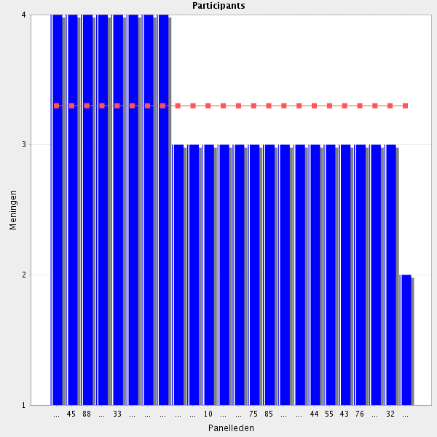
Average score: 3.3
Summary: Requires ammendment to participant’s suggestion.
Proposal: Amend to:-
Is aware of and appropriately implements legislation related to pharmacy activity.
and amalgmate with previous element.

Comments: impactful comments in red
In his/her area
This statement must be changed to only involve the pharmacists tasks. Too general as it is now.
Provided there is assistance from infrastructur and relative personnel
Very vague statement. It should be noted somewhere that this sentence is about pharmacy related legislation and services.

1.9 Ethics - Exercises transparency and probity in the relationship with pharmaceutical industry.
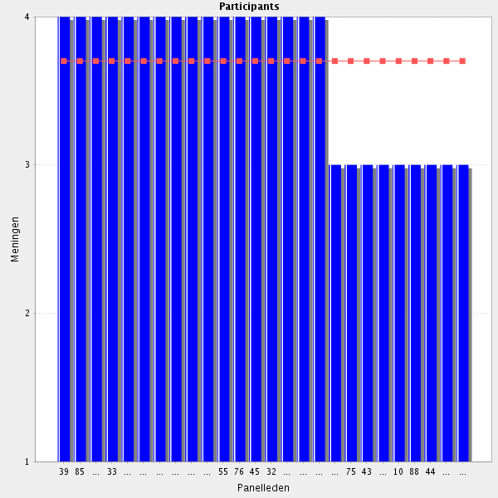
Average score: 3.7
Summary: minor rewording to:-
Has a relationship with the pharmaceutical industry based on transparency and probity.

Comments:
Important to be objective
Important for both parties. It is probably not very fortunate though to demonize pharma industry.
extremely important
The pharmaceutical industry should be recognized as a partner, not an enemy. The pharmacist should seek to maintain an honest and cordial relationship with pharmaceutical industry, bearing in mind the well-being of patients. .
Only agree if the pharmaceutical industry does the same. And unfortunately, they often don't.

1.10 Ethics - Respects the rights of patients in therapeutic decisions (e.g. informing about the risk associated with off label use and unlicensed medicines).
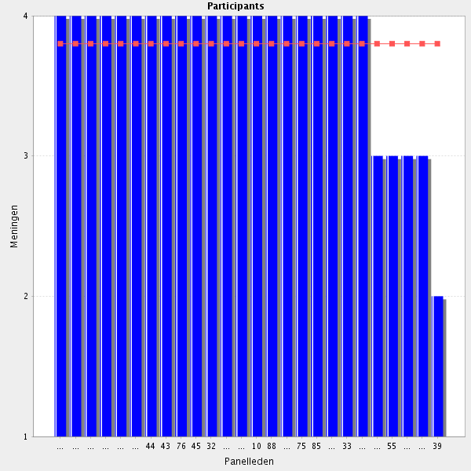
Average score: 3.8
Summary: accept participant’s rewording. Fits better in the decision making section.
Proposal: Amend to:-
Respects the rights of patients in therapeutic decisions and assists in providing information to facilitate their decision (e.g. informing patients about the risks associated with off label use and unlicensed medicines).
Comments: impactful comments in red
By all means so.
Agree. Even if in my country, this is mostly done by the physician and not the pharmacist.
in collaboration with other health professionals
Agree however the legal responsibility rests with the prescriber. The pharmacist may not always be able to contact the patient directly to inform of risks. Suggest: "Respects the rights of patients in therapeutic decisions and assists in providing information to facilitate their decision (e.g. informing patients about the risks associated with off label use and unlicensed medicines)."
Although it is up to the physician to inform the patient of the advantages and disadvantages of a particular medicine/therapy, the pharmacist should ensure that the patient has understood what the doctor has explained before releasing the drug. In the case of off-label medicines, it is also the responsibility of the pharmacist to ensure that the patient has signed an informed consent and that such off-label use was authorized by the hospital's ethics committee.
Of course respect the rights of patients, but do the pharmacist need to inform about the risks?
I agree with 129Suggest: "Respects the rights of patients in therapeutic decisions and may assists in providing information to facilitate their decision (e.g. informing patients about the risks associated with off label use and unlicensed medicines).
1.11 Ethics - Recognises ethical dilemmas in practice and engages with the team and patient/carers in working through these in a structured manner.
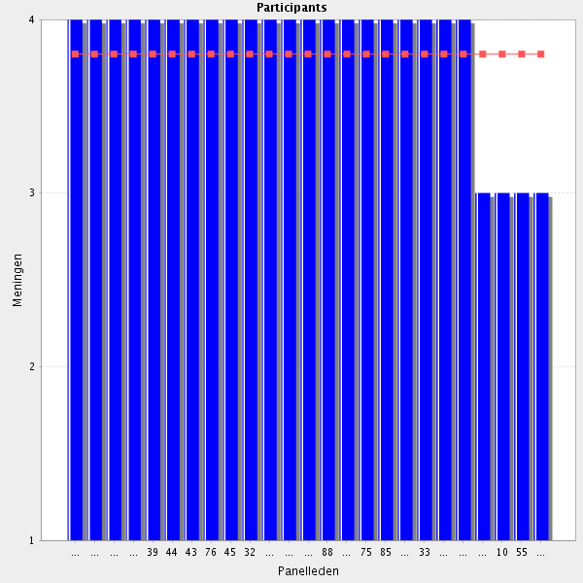
Average score: 3.8
Summary: no change required.

Comments:
Important. Sometimes hard to do in real Life because of lack of structure.
Agree, even if in my Hospital, pharmacists are not very much involved in ethical discussions
It depends on cultural background and legislation

1.12 Responsibility for CPD - Understands the need for continuing professional development and taking responsibility for it.
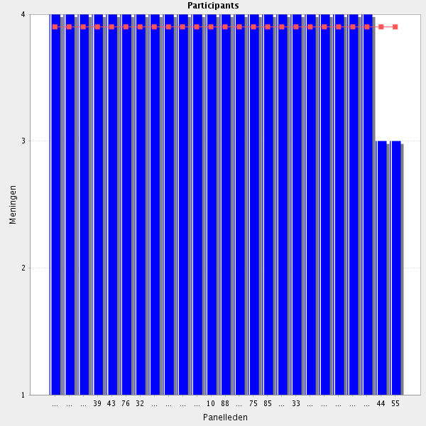
Average score: 3.9
Summary: minor rewording to aid the further development of educational aims and objectives. .
Proposal: Amend to:-
Understands the need for continuing professional development, takes a personal responsibility for it, and demonstrates that commitment.

Comments:
Since old knowledge can end up be untrue
Each pharmacist should be concerned about keeping up-to-date in their field of interest (e.g. outpatient care). Only by doing so pharmacists would be able to know the new medicines that are emerging and contribute to its rational use.
I think CPD needs to be explained - can't be confused with Continuing Education
It depends on infrastructure, cultural background and legislation

1.13 Responsibility for CPD - Complies with local CPD requirements, reflecting on performance and is able to self/assess competence and performance.
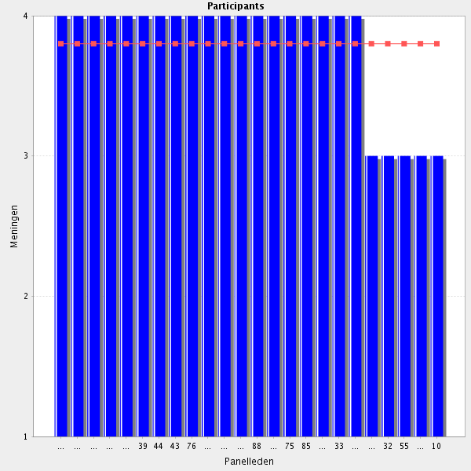
Average score: 3.8
Summary: suggest accept ammendment from participant.
Proposal: Amend to:-
Complies with local CPD requirements; can self-assess competence and reflect on performance.

Comments: impactful comments in red
To be able to require new knowledge one has to be able to selfassess competence
Suggest: "Complies with local CPD requirements. Is able to self-assess competence and reflect on performance."
This can be improved in many hospital pharmacies for sure
It depends on infrastructure, cultural background and legislation . In addition, objective criteria should be set

1.14 Responsibility for CPD - Engages with life-long learning.

Average score: 4.0
Summary: duplication (see comment)
Proposal: delete as stand alone element of the CTF.

Comments: impactful comments in red
Knowledge is not static
Any pharmacist should be aware that the need for life-long learning will always be constant while he/she is working in a hospital pharmacy. Without life-long learning we will not be able to adequately advise our patients, nor the other members of the health team.
But already covered by 1.12 and 1.13.
Is one of the main things that an hospital pharmacist has to do
It depends on cultural background and legislation . However, personal initiative is important

1.15 Responsibility for CPD - Identifies one’s own learning needs.
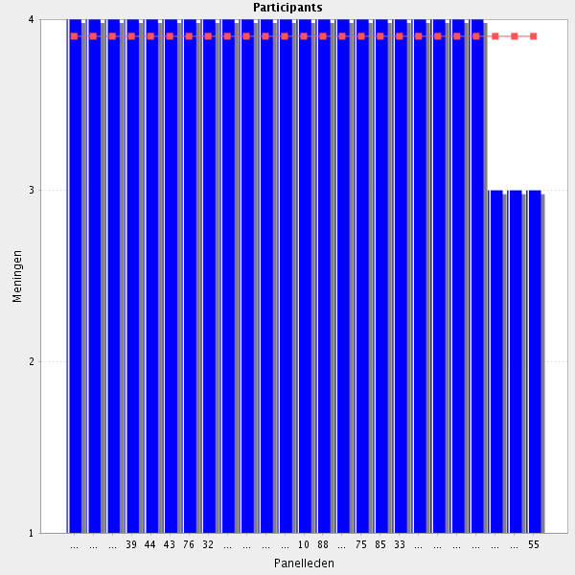
Average score: 3.9
Summary: can be merged into previous statements.
Proposal: merge with preceding elements.

Comments: impactful comments in red
If you can selfasses you identify your own Learning needs.
Since it is impossible to cover all the information, it is important that the pharmacist be able to identify the areas in which he needs training.
But covered already by 1.13
Of course, even if nobody have the skills to be able to do this identification
Very important part of CPD which is often overlooked. Good to see this in here
It depends on infrastrycture, cultural background and legislation . this cn never be an one way street. Sometimes it is not enough to identify needs, especially if there are priorities of needs

1.16 Responsibility for CPD - Evaluates one’s own learning.
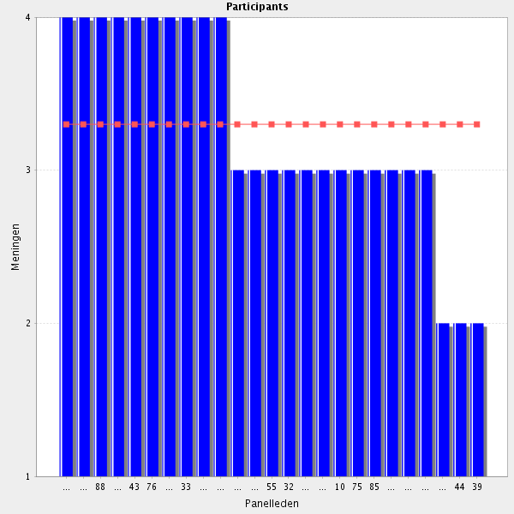
Average score: 3.3
Summary: can be merged into a single element, as particiapnts identify.
Proposal: merge.

Comments: impactful statements in red
But covered already by 1.13
criteria for evaluation?
f the pharmacist is honest with himself, he will be perfectly capable of evaluating the knowledge gained. However, this does not prevent that at the end of each formation there migjt be an evaluation for consolidation of what has been learned.
I think that it has to be shared with an exterior evaluation
Maybe in combination with external evaluation? It should be guaranteed that learning effect and level of knowledge is of a national/regional standard.
Sounds nice in theory. Practical implementation is another question.
Unnecessary
In what purpose?

1.17 Before going to the next group: do you have a remark, suggestion and or question on this group of competencies?

Hospital Pharmacy cannot contiue to improve and develop if pharmacists do not mantain a hight DPD
some of the cpd statements should be merged
I agree with splitting up the parts of CPD. There is general lack of awareness of the need to address the different parts of CPD - self-assessment, identifying appropriate learning, evaluating impact on practice. If you merge these you will lose on the depth of what is required for developmental CPD
1.5 and 1.6 = the same thing from different views.
Group: 2 Effective communication skills (Group 20 of 26)
2.1 Patient/Carer - Communicates in a clear, accurate and concise way whether verbally, electronically or in writing, at a level appropriate to each patient/carer.

Average score: 4.0
Summary: strong agreement. No changes from participants.
Proposal: Move section on communication skills closer to clinical and decision making elements. This elelemnt then largely duplicates an element from Cluster 1 and can be merged with it.

All comments:
but what is electronical Communication??
To avoid any misunderstandings
If we want a patient to adhere/comply with the prescribed therapy, it is necessary to reinforce what has probably been previously told by the doctor. In doing so, we must use a language appropriate to our patient/carer. The message to be transmitted should be clear, concise and accurate.The first time a therapy is instituted and, or whenever there is a change in the therapeutic regimen, together with the medicines, written information should be provided concerning the most correct way to take them. We should not let the patient/caregiver to leave the pharmacy without first making sure he/she understands how to take the medication and how to keep them.
Very important from the patient's point of view
It depends on infrastructure, cultural background and legislation

2.2 Patient/Carer - Involves patient/carer in treatment.
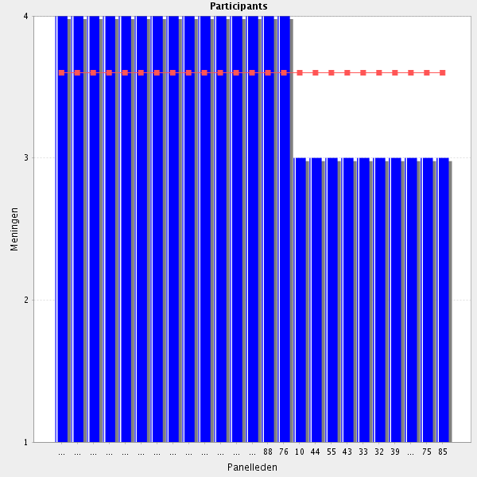
Average score: 3.6
Summary: some concerns from participants which may be addressed by a revision.
Proposal: Amend to:-
In collaboration with other health care professionals and when appropriate, assesses the preference of patient/carer to be involved in decisions about treatment options.

All comments, impactful comments in red
Whenever possible, it is important to ask the patient/care when he/she prefer to take the medication. In doing so, the pharmacist will contribute to greater adherence to the prescribed therapy.
HCPs should recognize this much more widely.
Where applicable"
Particularly important in management of chronic conditions.
The patient is the center of the treatment and absolutely has to be involved.
Could be improved --> Especially the clinical pharmacists might profit of more direct patient contact. And the patients would profit thereof
but ıf u re not a clınıcal pharmacıst ıf you are a hospıtal pharmacıst sometımes you can not ınvolve to patıent ın treatment
depends on the pharmacist's role, it might be the prescriber's responsibility.
It depends on infrastructure, cultural background and legislation
A team task. Not only the pharmacists responsibility.
Not always, depens on the institution
2.3 Other healthcare professionals and staff - Communicates with other healthcare professionals and colleagues in a clear, precise and appropriate way.

Average score: 3.9
Summary: high level of agreement. No change.

All comments, impactful comments in red
Communication with colleagues and other professionals should always be clear, precise and appropriate. Only be doing so is the pharmacist able to guarantee that the message would be understood without doubts.
mostly wıth doctors and nurses
In order to be a part of the healthcare team is basic to have a good communication
It depends on infrastructure, cultural background and legislation
Proffesionalism

2.4 Other healthcare professionals and staff - Possesses good inter-professional skills.
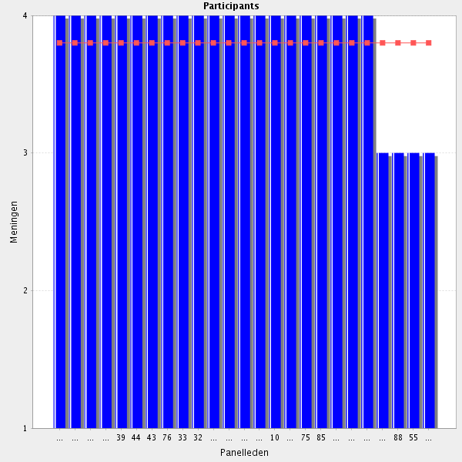
Average score: 3.8
Summary: comments signify the need for greater definition, and indeed it would be difficult to define educational aims and objectives and then learning materials given the indefinite nature of this element as it stands.
Proposal: Amend to:-
Is self aware when communicating with other healthcare professionals and staff and is able to use a range of communications skills and styles, selecting the most appropriate one for a specific situation.
All comments, impactful comments in red
Working in team and see the whole team and each team members contribution
It is extremelly important that pharmacists know how to work with the other members of the heathcare team. if we all work as a team, the greatest beneficiary will be the patient.
Very important, but not always present
I'm not sure that this goes far enough. Need to be able to be aware of the range of communication skills required for different stakeholders. EG presenting a business case to the senior management team requires very different skills to liaising with the nursing staff
It depends on infrastructure, cultural background and legislation
Important? Yes. Can this be taught? Maybe.
2.5 Immediate team - Communicates with other members of the team in a clear, precise and accurate way.

Average score: 4.0
Summary: good agreement but duplicates other elements.
Proposal: already covered so remove this as a serarate elelent from the CTF.

All comments, impactful comments in red
Professionalism
The information to be transmitted to other members of the team should always be clear, concise and accurate. Only in this way will it be possible to avoid misinterpretation.
Always important

2.6 Mentor/tutor - Ensures time is allocated for discussion of progress, including strengths and weaknesses.
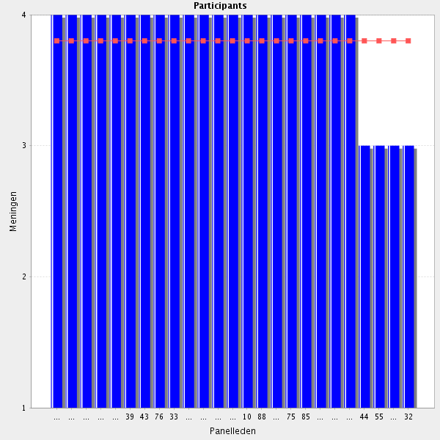
Average score: 3.8
Summary; Good scores. “Strenghts and weaknesses” generally replaced as a term. Revision as below. Needs a new section.
Proposal: amend to:-
In 1:1 meetings with trainees, ensures appropriate time is allocated for discussion of trainee’s doubts, feedback on areas of progress and those areas requiring further development, and for the review and updating of an educational plan.

All comments, impactful comments in red
Discuss to reach understanding
Whenever we act as a tutor, it is important not only to teach what we know, but also to take time to listen to our trainees' doubts and to check for their progress
Not easy to do with the every day workload, but should be done
if one is a mentor/tutor, thas is. Not for everyone.
It depends on infrastructure, cultural background and legislation

2.7 Transfer of care - Communicates with other organisations that affect the delivery of patient care, especially involving the transfer of care, and including information on reconciliation of medication on the basis of the patient’s acute state and specific needs.
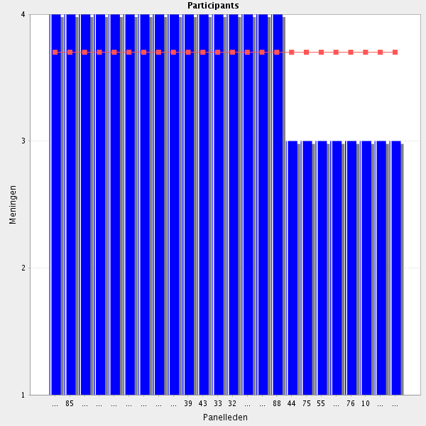
Average score: 3.7
Summary: limited comments. Appears should be linked with other reconcilliation elements.
Proposal: reword and move to link with other reconciliation items. Amend as below:-
Communicates with key individuals and organisations involved in the transfer of care, and on the basis of the patient’s individual needs includes accurate and relevant information on reconciliation of medicines.
Comments:
This is very important, but is not always possible due to different problems, as shortage of staff or difficulties in communication. However, it has to be a main field to improve for hospital phamacists, that can do an excellent job in this area.
Important. But it depends on systems.
depends on ones responsibilities, not Always a pharmacist task.
It depends on infrastructure, cultural background and legislation

2.8 Communications - Is able to communicate scientific and practical work to colleagues and other healthcare professionals.

Average score: 3.9
Summary: duplicates other elements elsewhere in CTF.
Proposal: delete as a separate element in the CTF.
Comments:-
It is important that the pharmacist knows how to present a scientific or practical work to others (e.g. colleagues, other healthcare professionals).
Professionalism.
It depends on infrastructure, cultural background and legislation

2.9 Communications - Is able to write a scientific article and explain in a clear and precise manner.
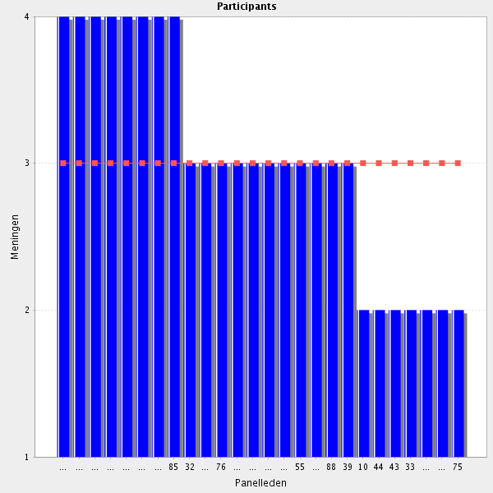
Average score: 3.0
Summary: one of lowest agreement scores, based on a relatively small number of responses.
Proposal: move to associate this with outher elelemnts relating to research and audit and reword as below to reflect understanding being a common requirement rather than actually doing.
Can describe, explain and discuss commonly used approaches to the reporting of audit and research.

Comments: impactful comments in red
It is important that the pharmacist knows how to write an article using clear and concise language. The following sections should be included: summary, introduction, objectives, methods, description of work done, conclusions and bibliography. At the moment, I believe it is difficult for a hospital pharmacist to have time for scientific activities, unless they are done outside working hours
Overlap with previous point - suggest merging the two as "Is able to communicate scientific and practical work to colleagues and other healthcare professionals in written and verbal formats."
Even though there are hospital pharmacists that are not involved in this area, I think that all should be, taking in account the level of their institution. I think that more pharmacists would try to improve these skills if they could feel confident that their work can be considered for publication. As I stated in another section, journals tend to refuse the publication of some works because they think they are not novelty. In rural, small hospitals for instance, some work and resarch could be done and I think is of value but face important barriers for publication.
Should be a competence for all
It should be not compulsory
It depends on infrastructure, cultural background and legislation . Also assistance from academia is a key factor
But not for al work places and all pharmacists.\
some collagues can not wrıte
When pharmacy services in hospitals will expand, and many pharmacists are employed, it is not realistic to demand scientific interest or ability from everyone. Leave out "write a scientific paper". "Explain in a clear and precise manner" is a bit difuse, is it meant just in writing? Everybody needs to communicate "in a clear and precise manner", but that might have been covered in another section?
I am not convinced that every hospital pharmacist should be able to write an article. Every pharmacist shoud know and understand the importance of finding relevant information which is of high quality and meets scientific requirements, but not every one has to be an author of scientific articles. I think that beeing able to write an article should not be a general statement to all pharmacists. Different wording suggestion: "Knows the basics of writing a scientific article, communicates in a clear and precise manner".
I'd say is a scientific communication (abstract, paper, short communication...). We also have to keep in mind that the CFT should be an inspirational and reference tool with focus on the future.
Is this a competence required by all hospital pharmacists? Or can this be a competence at a later stage of the career?
It is not a commonly used skill.

2.10 Before going to the next group: do you have a remark, suggestion and or question on this group of competencies?

A mixture of achieved competence through education and achieved skills/abilities through experience. Is there a purpose for somehow draw a line between the two?
Sometimes the excess of work and short staff makes difficult for pharmacists to face the activities described in this section.
Some Lots of overlap with patient care and clinical pharmacy skills section (e.g. information provision, interface issues etc.). Suggest reviewing to use the same language in both.questions repeated in other clusters (nb 2 others have also agreed with this response)

Group: 3 Team work (Group 21 of 26)
3.1 Pharmacy team - Recognises the value of team members and uses appropriate channels for referral.
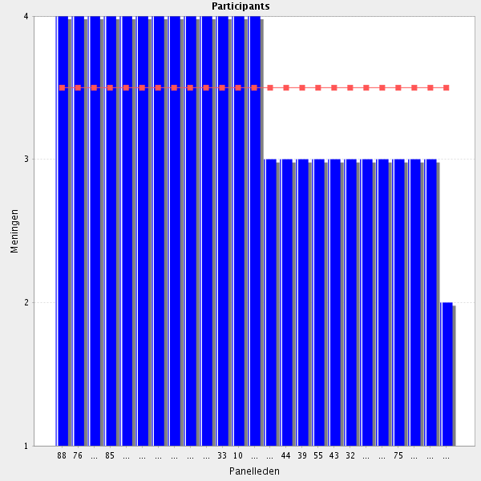
Average score: 3.5
Summary: in the light of comments from participants, minor revision requiredfor testing in Delphi 2.
Proposal: amend to:-
Recognises the value of pharmacy team members and uses appropriate channels for referral within the team.
Comments: impactful comments in red
It is important that the pharmacist knows how to work as a team. As in all teams, there will be elements more prone to certain areas. You should take advantage of that. Ideally, a pharmacist who is more willing to outpatient care should spend more hours in this activity than one who is more apt for the inpatient pharmaceutical care.
It depends on infrastructure, cultural background and legislation
I would like more details concerning the referral-part - is it meant referral within the pharmacy team or referral to other helthcare professionals?
If this is the pharmacy team is referral necessary? I would suggest this comment is more related to the multidisciplinary team.

3.2 Pharmacy team - Understands the roles and responsibilities of team members, knowing how the team works, respecting skills and contributions of others as well as recognising own limitations within the team.
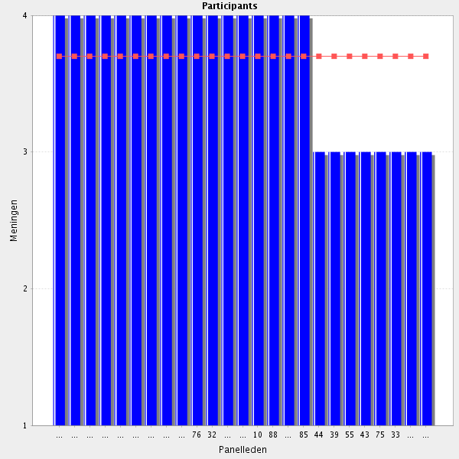
Average score: 3.7
Summary: minor rewording changes only required.
Proposal: Amend to:-
Understands the roles and responsibilities of pharmacy team members, knows how the team works, respects the skills and contributions of others, and recognises one’s own limitations.
It is important that pharmacists knows how to work as a team. Each member of the pharmaceutical team must know which are his/her tasks and which belong to colleagues .Each pharmacist should take responsibility for what he/she does and should know what his/her tasks are. This does not prevent the pharmacist from asking for help/clarification to colleagues and vice versa.
To be a good practitioner, you have to know and even have done the work undergo by your team
Professionalism
It depends on infrastructure, cultural background and legislation
Important in any team work

3.3 Multi-disciplinary team - Recognises the value of other healthcare professionals and seeks to establish co-operative working relationships with colleagues, based on the understanding and respect of each other’s roles.
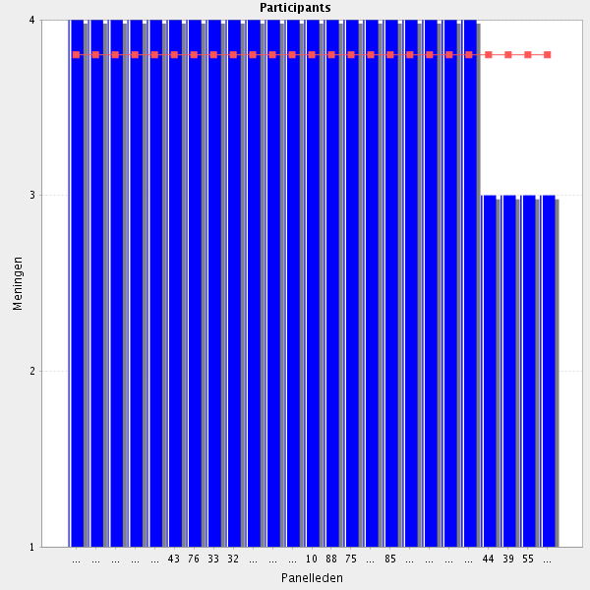
Average score: 3.8
Summary: minor rephrasing only required.
Proposal: Amend to:-
Recognises the value of other healthcare professionals working in the inter-professsional team and seeks to establish co-operative working relationships with colleagues, based on a mutual understanding of and respect for each other’s roles.

Comments:
Very important !
"understanding of and respect for each other's roles"
No one can know everything. The pharmacist should be able to seek for help from colleagues/other health professionals whenhe/she has doubts. By doing so, the pharmacist is contributing for the improvement of health care system. The center of the healthcare system should always be the patient. Healthcare professionals should work as a team in order to provide the best possible care to patients.
It is very important to detect the abilities of the different persons in order to make them work in what they have more skills and prefer, if is it possible.
I strongly agree with the proactive nature of statement
Professionalism
It depends on infrastructure, cultural background and legislation

3.4 Multi-disciplinary team - Understands own role as a medication treatment expert in an inter-professional patient care team.
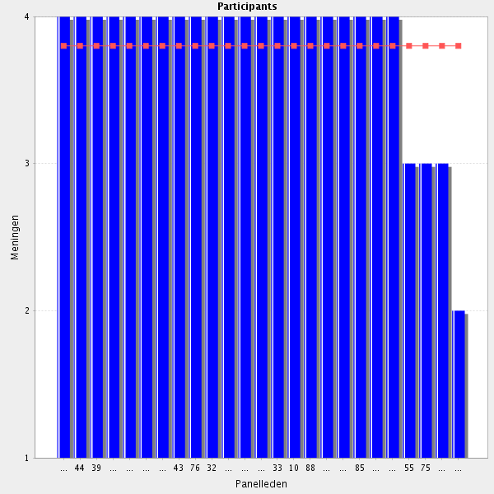
Average score: 3.8
Summary: Minor ammendment to reflect participant comment.
Proposal: Amend to:-
Understands own role as a medicines expert in an inter-professional patient care team.
Comments: impactful comments in red
Important to know the role one plays.
Of course you need to know your own role in the system
t is up to the pharmacist to validate medical prescriptions. In doing so, the pharmacist should make sure that the prescribed medicines are appropriate for the patient for whom they are intended. For example, if the patient is renal insufficient it is necessary to check the doses and/or intervals of administration of some drugs, namely antibiotics. The pharmacist should also be careful to check if there are any serious interactions in the prescription that he/she is validating. Whenever possible, the doctor should be asked to put everything that the patient does on the prescription, namely the medicines that the patient brought from home and is taken at the hospital. If the pharmacist finds something in the prescription that he considers less correct, he/she must inform the prescriber and leave written information on the patient's file. In the case of outpatients, in addition to validating prescriptions that appear in the pharmacy, the pharmacist should also monitor patient compliance. Any doubts should be reported to the prescribing physician. All patients who have difficulties in giving to themselves their injectable drugs should be referred to the nursing team that supports the Consultation where the patient is followed.
Pharmacists have to be confident with their knowledge and abilities in order to aply them to their work and know the limits of it and when to consult to other professionals
It depends on infrastructure, cultural background and legislation
Change "treatment" to "management". Reason: "Management" includes both treatment and handling of medicines.
3.5 Organisational team - Recognises the roles and skills of other non-clinical staff within the team and works in collaboration with them.

Average score: 4.0
Summary: minor rewording required.
Propsal: Amend to:-
Recognises the roles and skills of non-clinical staff and works in collaboration with them.
Comments:
In a hospital pharmacy we do not only have pharmacists. We have other professionals who, together with the pharmacist, seek to ensure that patients (inpatient and outpatient) receive the correct medication without ruptures. Pharmacy technicians are responsible for preparing the medication to be sent to the services, after that medication was validated by the pharmacist. The auxiliaries are the ones that take the medication for the services and who repackage the drugs supplied in unit dose. Administrative staff is essential for the reception of medicinal products.
Some times we talk a lot about other professionals, thinking in doctors and nurses basicaly. But non.clinical staff has also an important role and phamacists have to interact with them. For example management staff, cleaners, informatics
It depends on infrastructure, cultural background and legislation

3.6 Before going to the next group: do you have a remark, suggestion and or question on this group of competencies?

instead of multidisciplinary team I would use the term interprofessional team
I agree with respondent R129 and with interprofessional team
To be able to interact with all the other people working in the hospital improves the performance of the phamacists.
The last question: For example?
I would assume this refers to administration staff, cleaners, porters and other hospital support staff. (nb one other agreed with this response)
I think the patient should be included as a partner in the multidisciplinary team. Reason: The patient is more and more expected to actively engage himself/herself in decisions concerning his/her own treatment. b. Agree with the respondent thinking that "multidisciplinary" should be changed to "interprofessional". Reason: "Interprofessional" connotates colloboration while "multidisciplinary" means that the professions give input while not necessarily discuss etc with one another.
Team work is one of the most valuable and important competencies of a hospital pharmacist and should be improved and promoted.

Group: 4 Organisation (Group 22 of 26)
4.1 Prioritisation - Prioritises work, managing one’s time efficiently including prioritising tasks to changing circumstances.
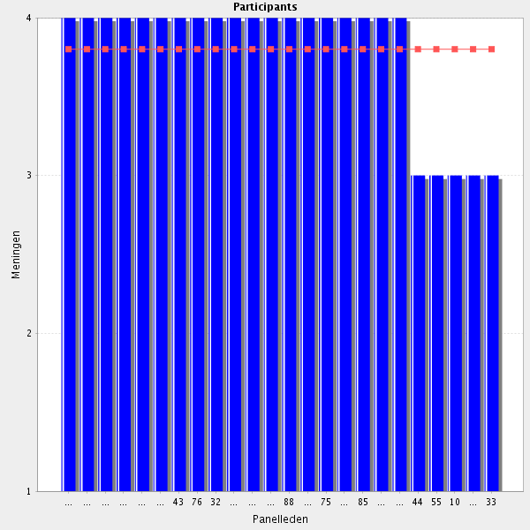
Average score: 3.8
Summary: minor rewording only.
Proposal: Amend to:-
Prioritises tasks appropriately, manages time efficiently and responds flexibly to changing circumstances.

Comments:
It is important that a pharmacist knows how to manage time and change routines whenever necessary. For example, if a pharmacist is dispensing narcotic drugs and in the meantime, he/she receives a phone call from a doctor asking for a gentamicin protocol, priority should be given to the protocol.
Basic, with the workload that usually we have.
It depends on infrastructure, cultural background and legislation . Assistance is very important.
Important, but not the most important issue of this survey
That is, developing a strategic plan.

4.2 Punctuality - Ensures satisfactory completion of tasks with appropriate handover, recognizing the importance of punctuality and attention to detail.
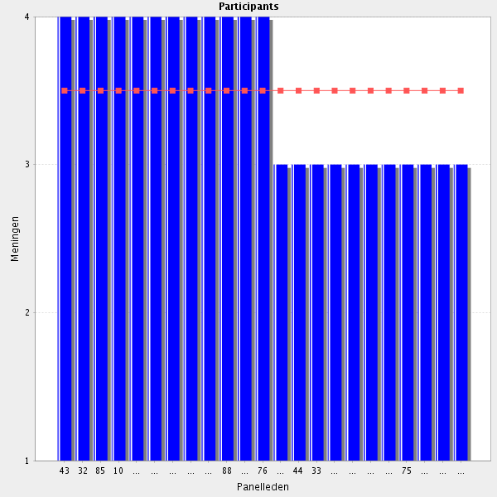
Average score: 3.5
Summary: minor ammendment required.
Proposal: Amend to:-
Ensures satisfactory completion of tasks with appropriate handover; recognises the importance of timeliness and attention to detail.
Comments:
But is difficult in the every day work.
we are robots :)
Agree but attention to detail is a separate issue to punctuality.
I agree. However, in order for the pharmacist to be able to perform the tasks delegated to him/she in a timely manner, it is necessary that there be sufficient human resources, so that do not systematically require him/she to replace other colleagues (and their work, as well). I agree that it is not enough to do. What you do should be well done and right on the first try. But for this to be feasible, it is essential that the pharmacist have sufficient time to allow him/she to review what he/she produces.
Quite general description of a general human virtue. Not very specific to hospital pharmacy, but very difficult not to agree with.

4.3 Initiative - Demonstrates initiative in problem solving and taking new tasks.
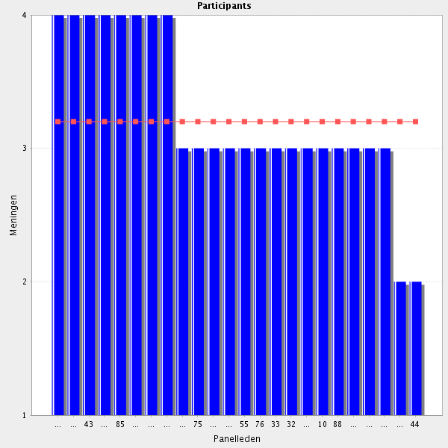
Average score: 3.2
Summary: particiapnt identifies that this is a personality trait rather than a professional attribute appropraite to development through training.
Proposal delete.
Comments:
Some problems are solved only by the pharmacist so if he/she does not take the iniciative is bad for the patient.
Typo: "Demonstrates initiative in problem solving and taking on new tasks"
I agree that it is important that the pharmacist has initiative. But before putting them into practice I think it would be better to talk first to the people in charge of the services who will be involved in this initiative. For example, if a pharmacist wants to do a training course for nurses responsible for reconstituting and diluting medications, the pharmacist should first talk to the pharmacy coordinator and then to the Head Nurse of the Service where he/she intends to train.
It depends on infrastructure, cultural background and legislation
I really don't think that this has anything to do with pharmacy education / specialization. As a personality trait, this is wonderful. But is it truly a professional competency/skill? As mentioned by others, this is part of employability, and not specific for a hospital pharmacist. This framework is about our profession and not our personality.

4.4 Initiative - Demonstrating ability to work independently with one’s own limitations.
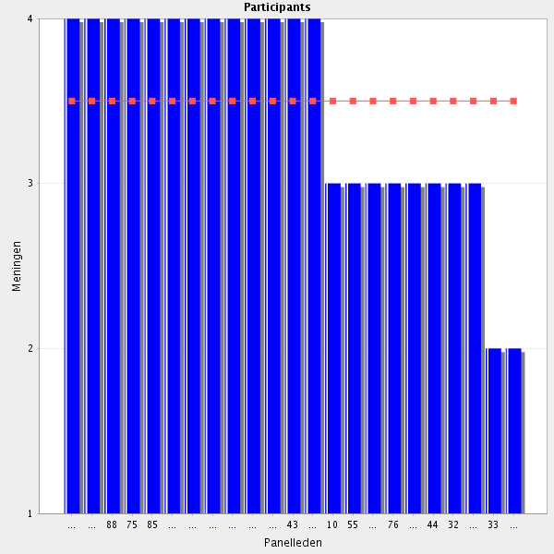
Average score: 3.5
Summary: on balance this is a professional attribute rather than a personality trait. Reword.
Proposal: amend to:-
Demonstrates the ability to work independently with one’s own limitations.
Comments: impactful comments in red
"Demonstrates ability to work independently within one’s own limitations." (nb a second responder agrees with this)
It depends on infrastructure, cultural background and legislation
I'd reformulate it in a more positive way: being able to identify one's own strengths and areas of improvement and creating a personal development plan.
I'm not so sure if we're talking about the ideal person (personality) for the profession, or the ideal skill set offered by pharmacy education/specialization.

4.5 Efficiency - Demonstrates a process of care using the time productively with minimum waste of effort.
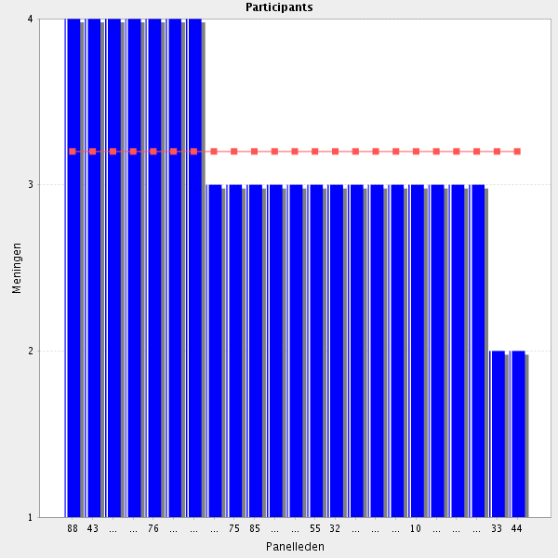
Average score: 3.2
Summary: see comments.
Proposal: remove.

Comments: impactful comments in red
Yes, but very difficult
It depends on infrastructure, cultural background and legislation
Poorly worded. Suggest: "Demonstrates productive use of time with minimum waste of effort."
of course, but is this within hospital pharmacy education??
I would suggest it to be remove completely.
This also, in my opinion, is part of employability and personality, and not part of our profession.

4.6 Safety - Is able to work and make decisions without compromising patient safety.
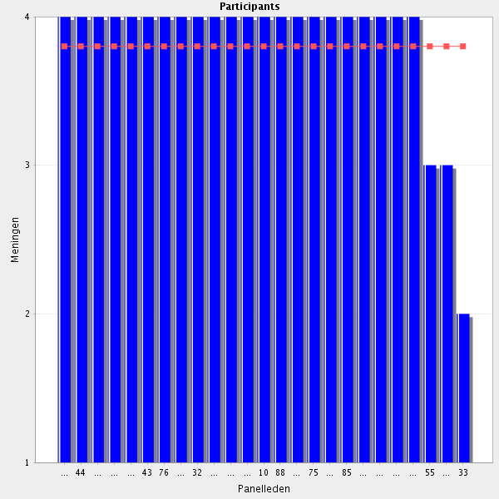
Average score: 3.8
Summary: with a wording ammendment fits better with the decision making elements.
Propsal: move to sit with decision making elements adn amend to:-
Puts patient safety first when making decisions with or for patients.
Comments:
ensure that the legislation and different rules applied to medicines and medical devices, as well as those applied to the organiszation of the profession of hospital pharmacists, are applied
That suits better, I agree.
It should be clear that patient safety can not be compromised!
The pharmacist should always put patient safety first. If in doubt, he/she should not be afraid to consult with colleagues/other health professionals.
provided that there is support from a team and adequate legislation to permit this
I don't think is necessary to mention this... Isn't it implied in every pharmacist's intervention?

4.7 Before going to the next group: do you have a remark, suggestion and or question on this group of competencies?

Many times I had a feeling of confusing personality with professional skills.
Is true in all work places. Not specific for pharmacists. (4 more agrees with this )
Group: 5 Service Provision (Group 23 of 26)
5.1 Quality of service - Reviews services provided to ensure they meet local and national standards and specifications.
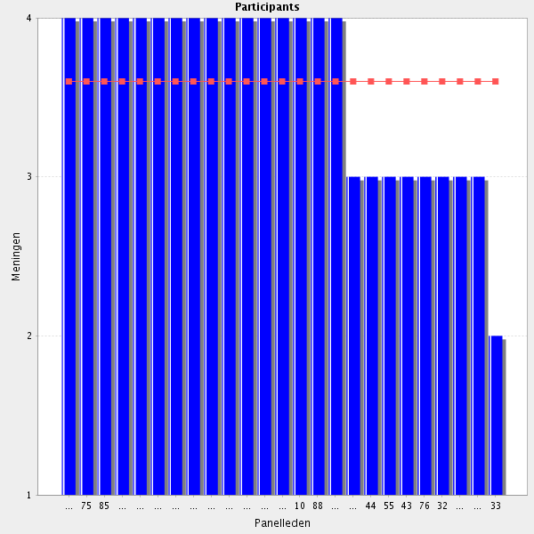
Average score: 3.6
Summary: no change required.

Comments:
Is our responsability
I am surprised this did not get higher agreement. I would see it as part of CPD to ensure practice is up to date with current evidence/guidelines.
I think that in each institution there should be someone in charge to keep up with the legislation that goes out on hospital pharmacy. Whenever appropriate, pharmacy processes should be reviewed in order to comply with legislation. For example, if the maximum dispensing time for ambulatory surgery changes from 5 to 7 days, the distribution process should be adjusted to comply with current legislation.
It depends on infrastructure, cultural background and legislation
Shouldn't it include somethin about choosing or setting the appropiate quality indicators?

5.2 Quality of service - Understands and applies the knowledge related to the analysis and quality control of pharmaceutical products in the service.
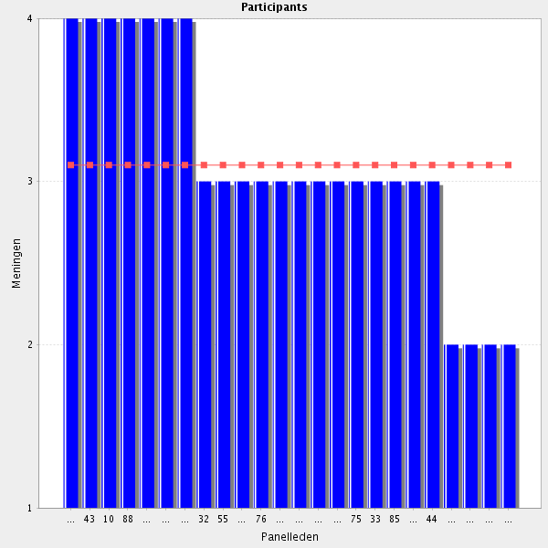
Average score: 3.1
Summary: low level of agreement; unclear wording; belongs with manufacturing elements probably.
Proposal: Amend as below and place with manufacturing elements:-
Applies the analysis and quality control of pharmaceutical products in order to support quality patient care.
Comments:
It depends on infrastructure, cultural background and legislation . The role of academia is also important
This is not necessary in all hospitals
Basically yes, but can be a core topic of specialized pharmacists in the team. not every pharmacist needs to be an expert in every Group of quality control
Not necessary for clinical practice e.g. to carry out QC of formulated medicines such as Aspirin or Paracetamol tablets but would be necessary for Chemotherapy or TPN production. Perhaps amend to "...analysis and quality control of pharmaceutical products formulated within the service."
Not so sure if this is applicable as such a general statement. Maybe for compounding and aseptic preparations, but definitely not in general.
The statement is too general. Analysis and quality control of drugs formulated in the pharmacy, yes, but not as a general statement as written above.
5.3 Quality of service - Implements service or quality improvement projects.
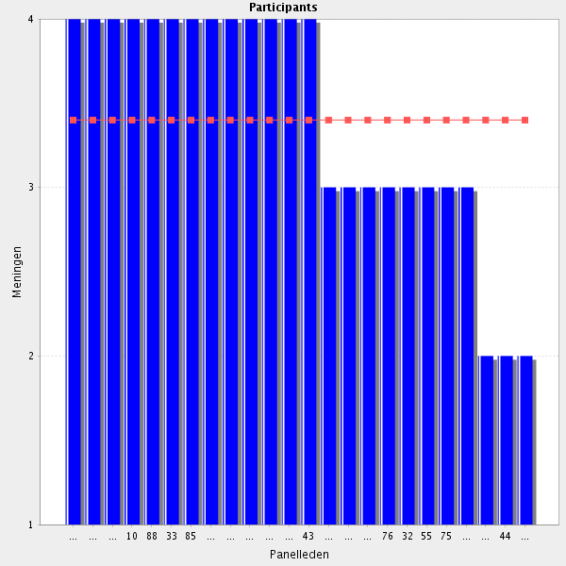
Average score: 3.4
Summary: not great agreement and some comments expressing uncertainty with the vagueness.
Proposal: amend as below:-
Particiaptes actively in local or national quality improvement projects involving pharmacy services.
Comments: impactful comments in red
Phamacists have to be responsible of the quality control of their area of work or the pharmacy service in the case of the Director.
Is this repeating from a previous competence?
It depends on infrastructure, cultural background and legislation
Does this mean anything in particular? I really dislike vague statements like this.
For everyone? Or for the manager?
Quality improvement projects is OK, but I don't get the "implements service"-part. It's too vague.

5.4 Service development - Identifies key drivers and new services or innovations or ways of working in relation to local plans (projects) and needs of local populations.
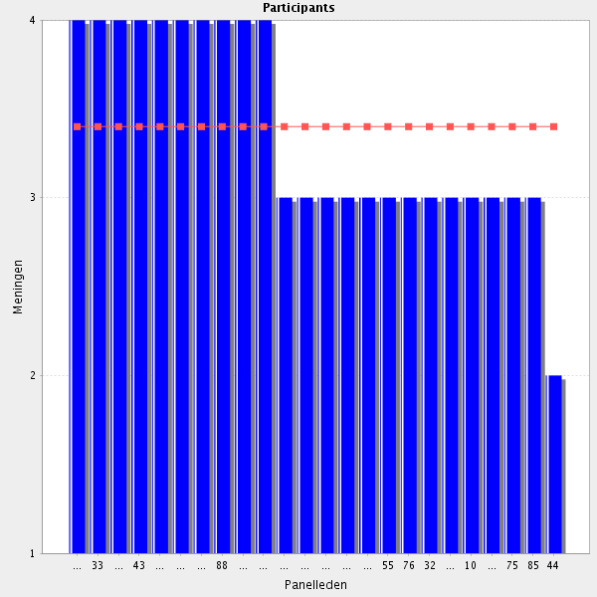
Average score: 3.4
Summary: unclear wording, no clear steer from participants, only modest agreement.
Proposal: amed to the version below and test in Delphi 2.
Identifies new services or ways of working to support local plans or projects which address local health needs.
Comments:-
It depends on infrastructure, cultural background and legislation
Only some institutions are involved in this area
Again, in my opinion this is not something we can demand from everyone in say 10-20 years from now, when our services are expanded. In a great team there are different abilities and personalities.

5.5 Service development - Ensures sustainability and availability of the service.
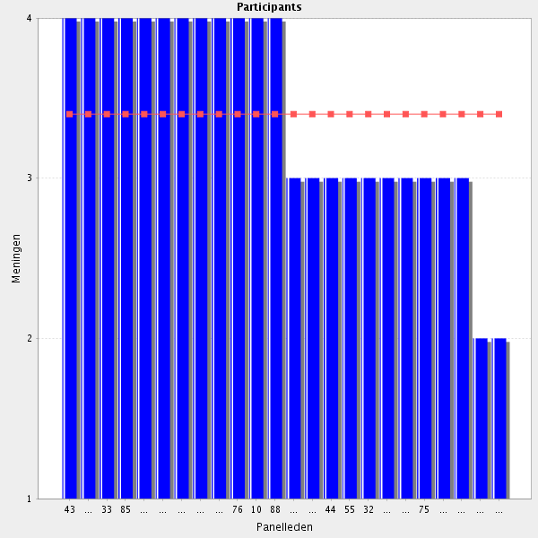
Average score: 3.4
Summary: modest agreement, helpful suggestion from participant.
Proposal: amend to reflect input from participant.
Contributes to the sustainability and works to maintain the availability of the service.

Comments: impactful comments in red
It depends on infrastructure, cultural background and legislation
Ensures? Perhaps the term "Contributes to" is more accurate?

5.6 Before going to the next group: do you have a remark, suggestion and or question on this group of competencies?

In my opinion, the CTF should really try to refrain from general/vague/nondescript statements about personality traits and otherwise admirable human virtues...
I miss a point about quality systems certificactions like EFQM.
I struggled with some of these statements, because I didn't feel that they were specific to pharmacists, but were generally desireable traits and competencies. If we are going to start being specific about time-keeping/puctuality etc, should we not be similarly specific about appearance, hygiene, manners etc? Where do we draw the line? I'm not sure that it's correct to include non-pharmacy specific attributes here. That said, many of the competencies such as management skills etc are generic. It's difficult to know where to draw the line. In the end I considered each statement in terms of it's desireability - but that is not to say that I'm completely in favour of them being included in the framework. I think it's a wider discussion that's probably already been had by the core framework development team, and I defer to that.
This section is not specific for the pharmacists
Group: 6 Cost systems (Group 24 of 26)
6.1 Service reimbursement (if applicable) - Uses relevant reference sources to ensure appropriate and accurate reimbursement.
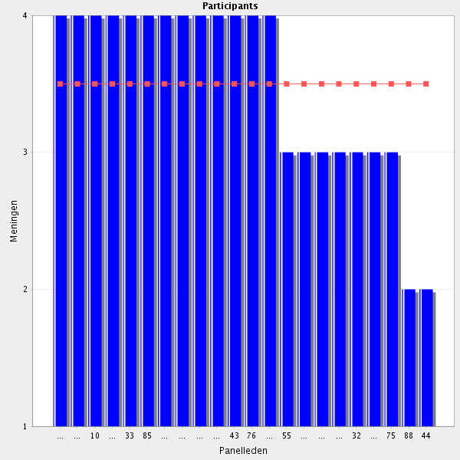
Average score: 3.5

itis very ımportant for prıvate hospıtals
In general the pharmacist is involved in all related the costs and reimbursement of drugs, and I agree because he or she has the enough knowledge about medications in order to work this area
It depends on infrastructure, cultural background and legislation
In my country it is difficult to get reimbursement for all the pharmacy services.
if applicable. Maybe so different throughout contries to include in this.

6.2 Service reimbursement (if applicable) - Claims reimbursements appropriately for services that are provided.
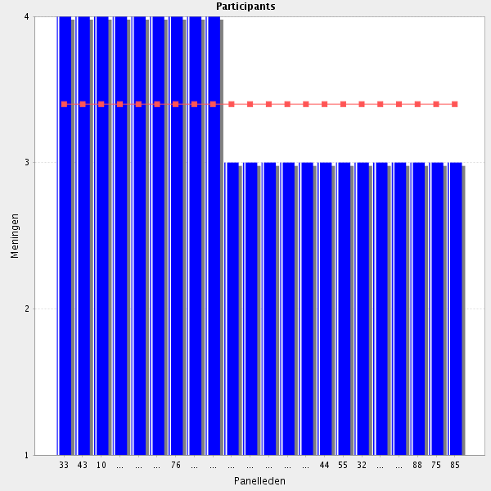
Average score: 3.4
Summary: not great agreement, perhaps becasue it comes first in the section.
Proposal: reorder section and test in Delphi 2.
Comments:-
Not applicable. No clear reimbursement for pharmacy services in hospital
It depends on infrastructure, cultural background and legislation
Can be shared with other departments

6.3 Prescribing budgets (if applicable) - Considers the budgetary effects of prescribing and uses generic substitutions, and considers the budgetary effects in medicines use reviews and medicines pathways, where possible.
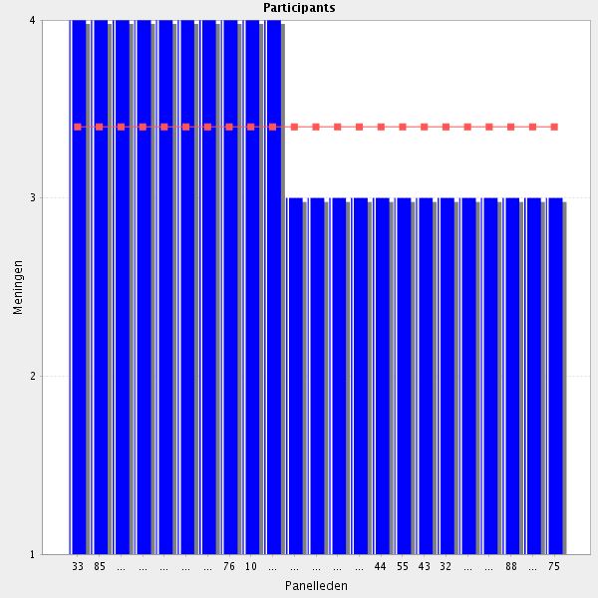
Average score: 3.4
Summary: as participants comment, this seems better as two separate elements.
Proposal: Amend to:-
Considers cost-minimisation when appropriate as part of medication reviews and medicines use reviews.
Claims reimbursements appropriately for services that are provided.

Comments: impactful comments in red
Pharmacists are the best positioned to do this. Many considerations about the quality and properties of a medicine should be taken in account when doing substitutions.
Agree but suggest separating into two points.
I agree, but maybe split into two statements.
It depends on infrastructure, cultural background and legislation

6.4 Before going to the next group: do you have a remark, suggestion and or question on this group of competencies?
No comments made.
Group: 7 Training others healthcare professionals (Group 25 of 26)
7.1 Pharmacy staff - Ensures that staff, under one's responsibility are competent to undertake the tasks allocated to them.
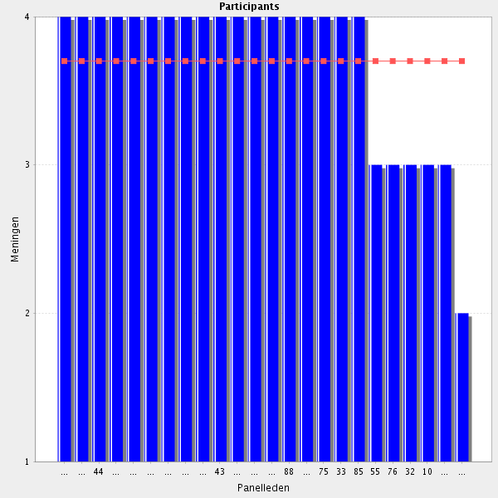
Average score: 3.7
Summary: no substantive comments indicating a need for changes. Can best sit with other mentoring, tutoring and teaching elements.
Proposal: no change in wording; link with similar tutoring statements.
Comments: impactful comments in red
It is very important to ensure that staff under one´s responsability are competent to undertake the tasks allocated to them but that depends not only on us but also on legislation. In my country we are having a big problem on public hospitals because experiential training is not being done as it should . To define the control training framework will help to to resolve this big problem.
It is very important to ensure that staff under one´s responsability are competent to undertake the tasks allocated to them but that depends not only on us but also on legislation. In my country we are having a big problem on public hospitals because experiential training is not being done as it should . To define the Common Training Framework for for Hospital Pharmacy will help to to resolve this problem. 13-03-2017
I agree. And sometimes they are under your responsability but you can't choouse your own personel. I'd add somewhere "Is able to establish a periodical competence assessement to ensure that stuff under one's responsability can fullfill the organisations objetives in terms of safety and quality".
It depends on infrastructure, cultural background and legislation
This is task of the pharmacy manager or director
If you have that posission.
Should not be a requirement for all hospital pharmacists.
This is not really a question of skill or ability, but mandate and authority
7.2 Pharmacy staff - Makes arrangements for training when necessary.
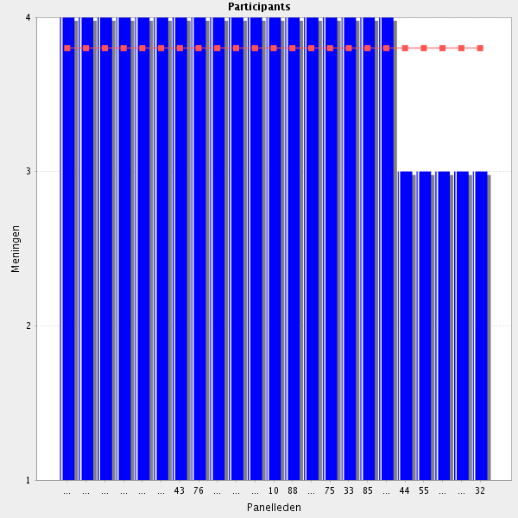
Average score: 3.8
Summary: good agreeement. Consistancy of wording with other elments would possibly improve the statement.
Proposal: Amend to:-
Ensures that staff, under one's responsibility, have access to appropriate education and training.

Comments:
It depends on infrastructure, cultural background and legislation

7.3 Other healthcare professionals - Participates actively in training other healthcare professionals and non clinical staff.
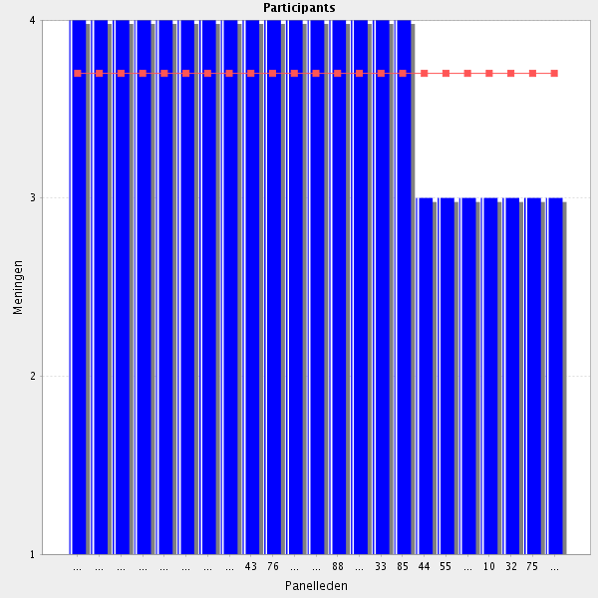
Average score: 3.7
Summary: no change needed.

Comments:
In the areas related to the pharmacy and medicines
It depends on infrastructure, cultural background and legislation and availability of pharmacist. there are always priorities!

7.4 Other healthcare professionals - Organises training events or uses an opportunistic conversation to facilitate training.
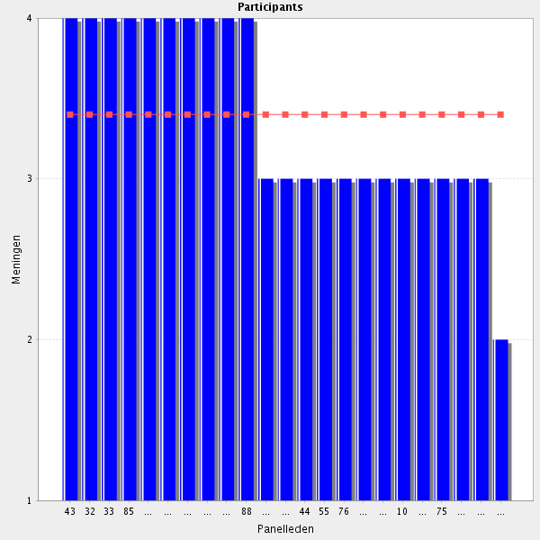
Average score: 3.4
Summary: not great agreement and no comments to direct revisions.
Proposal: test out the amended version below in Delphi 2:-
Uses both formal training events and opportunistic conversations to develop colleagues.

Comments:
It depends on infrastructure, cultural background and legislation
Not a requirement.

7.5 Other healthcare professionals - Ensures that the staff are competent to undertake the tasks allocated to them.
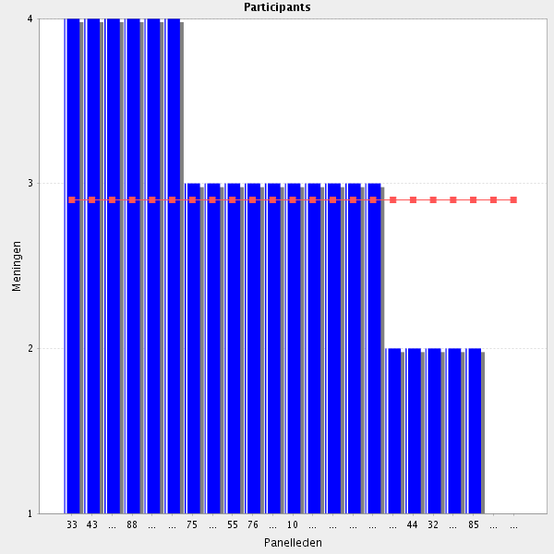
Average score: 2.9
Summary: as a participant identifies this is a duplication of a previous elelemnt’
Proposal: delete as a separate element within the CTF.
Comments:-
It depends on infrastructure, cultural background and legislation
I could imagine that pharmacist should ensure the competence of his/her colleague in the pharmacy, not in other departments of hospital
This is not the responsibility of the hospital pharmacist. An alternative could be "takes part in training of other healthcare professionals".
if that is your responsibility. maybe not on just the hospital pharmacist, but the manager of some kind.
Is it mandatory for a hospital pharmacist to be a manager? In my opinion, this is not in the hospital pharmacist profession (hence not in our education), but in a managers profession. I would suggest to leave out this statement completely.
Not the responsibility of the pharmacist where other healthcare professionals are involved. Suggest amending to e.g. "Reports concerns over competence to the appropriate line manager where they occur"
No if they do not depen of the pharmacy service
The responsibility to ensure that the staff are competent lies with the line manager of the staff in question. I therefore think this item should be deleted.
Essentially the same as 7.1. Should be merged.

7.6 Other healthcare professionals - Shows links between practice and education development.
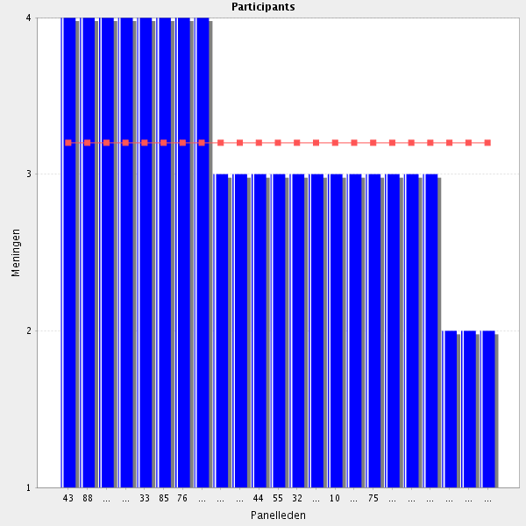
Average score: 3.2
Summary: neither the participants nor the facilitators understand this element.
Proposal: delete for now.
It depends on infrastructure, cultural background and legislation
I do not understand the question.
I don't understand the question.
I don't understand this statement.

7.7 Before going to the next group: do you have a remark, suggestion and or question on this group of competencies?

Professional competences do not rely solely on the wish of the professional when the cultural and professional setting is not supportive.
(nb 1 other agrees with this opinion)
Group: 8 Leadership development (Goup 26 of 26)
8.1 Role model - Acts as a role model.
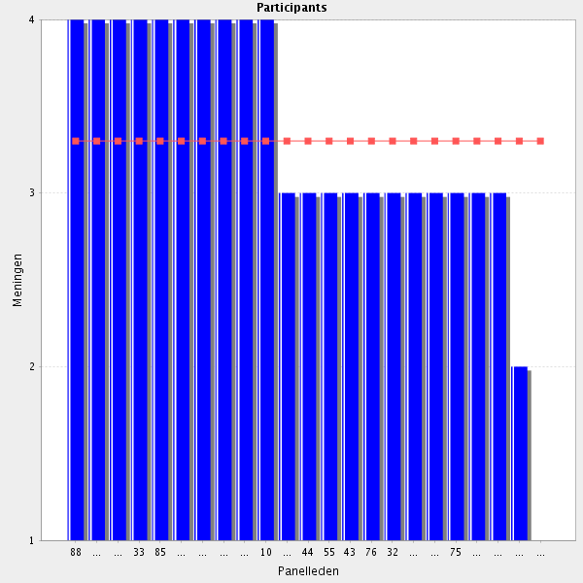
Average score: 3.3
Summary: not great scores, comments indicating concerns about this being included.
This exisiting statement may serve the purpose:-
Interacts in ways with patients, other health care professionals, colleagues and carers that will inspire confidence and generate professional respect.
Proposal: dleelte this as a stand alone element of the CTF.

Comments: impactful comments in red
to the best of everybody's ability, capacities and social status and setting
Role model to whom? For sure everyone should strive to act as a role model to colleagues and employees.
A role model to whom? Colleagues? Students?
A role model to whom? This isn't a competency
Come on... this is not a competency, neither an ability that can be taught.

8.2 Role model - Understands and demonstrates key attributes of a role model to members of the team.
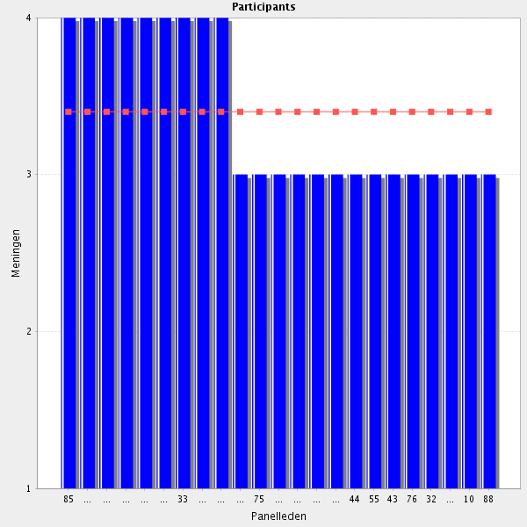
Average score: 3.4
Summary: not great scores.
This exisiting statement may serve the purpose:-
Interacts in ways with patients, other health care professionals, colleagues and carers that will inspire confidence and generate professional respect.
Proposal: dleelte this as a stand alone element of the CTF.

Comments: impactful comments in red
It depends on cultural background and personality
Could be together with the previous question

8.3 Mentorship - Demonstrates mentorship behaviour to others.
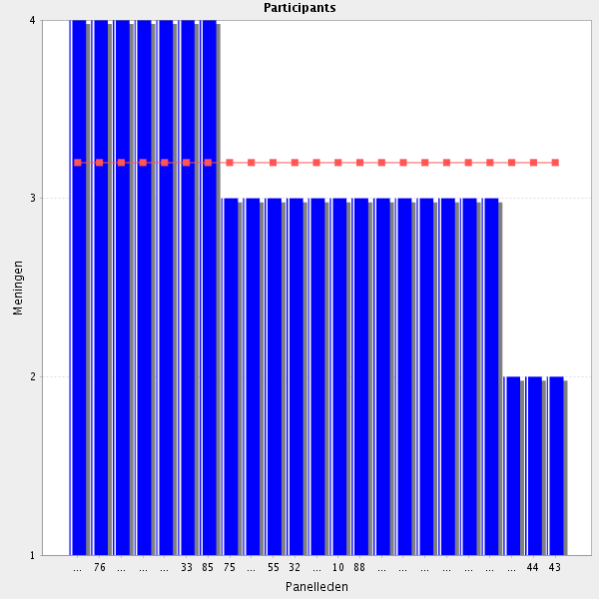
Average score: 3.2
Summary: not great scores and comments. Suggestion for rewording from participant.
Proposal: adopt suggestion from participant and test in Delphi 2. Amend to below and link with other similar statements:-
Able to demonstrate mentorship behaviour (on request).

Comments:
Yes, but depens on the person
it depends on cultural background
If he/she is in a higher position where such behavior is required
mentorship behaviour only to the person, who must be mentored, not other colleagues/stuff
OK, but maybe some rewording is needed? Of course one should participate in training of new staff and be available for questions and give advice to other healthcare professionals, but I read this statement as negatively loaded. Maybe: "Able to demonstrate mentorship behaviour (upon request)"?
This statment should demonstrate a much less condescending overtone I think. (nb 1 other agrees with this opinion)
Depends, not for everybody.
In my opinion not part of hospital pharmacist profession, I suggest it to be left out.
Mentor is a teacher, a guide, someone of great experience. In today's world more and more pharmacies rely on teamwork, which is a form of more "horizontal" workplace relations. Mentorship associates with very "vertical" setting, and I cannot imagine a team where every pharmacist demonstrates mentorship. I agree that a mentor is needed, but this is usually a chief of pharmacy, or a leader of workgroup (eg. oncology team, nutrition team). Maybe I misunderstood the statement, but I cannot find any way to solely fit a group of mentors into one workplace.
8.4 Mentorship - Provides effective feedback.
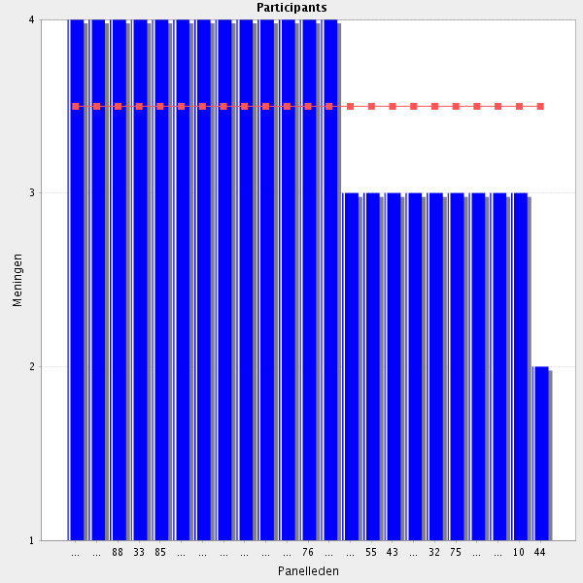
Average score: 3.5
Summary: not great scores and is covered in:-
In 1:1 meetings with staff under one’s responsibility, ensures appropriate time is allocated for discussion of staff member’s doubts, feedback on areas of progress and those areas requiring further development, and for the review and updating of an educational plan.
Proposal: delet as duplication.

Comments:
Very important if you whan that who you are mentoring follow an improving path
If you are a mentor you should be able to provide effective feedback
Yes - but there needs to be a wider appreciation of what constitutes effective feedback. Open to a wide range of interpretations!
It depends on infrastructure, cultural background and legislation
I believe there are excellent hospital pharmacists out there, doing no feedback at all. To be able to give effective feedback is to me not mandatory for everyone in our profession, or for everybody in a team. I suggest this statement is erased.

8.5 Mentorship - Helps others to identify training needs.
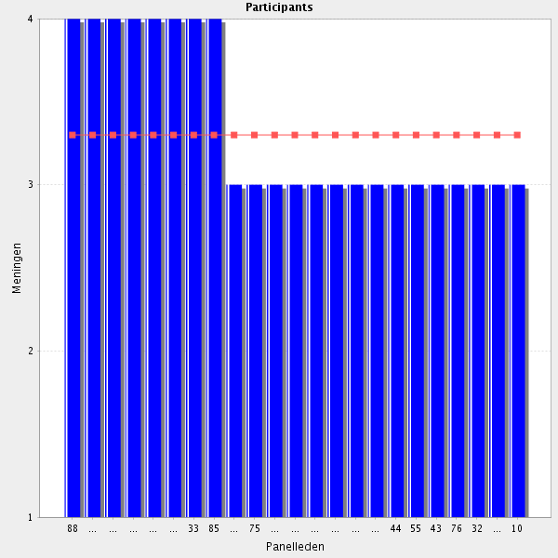
Average score: 3.3
Summary: not great scores and covered elsewhere.
Proposal: delete as duplicated.

Comments:
It depends on infrastructure, cultural background and legislation

8.6 Education and training - Communicates and facilitates innovative ideas to the team.
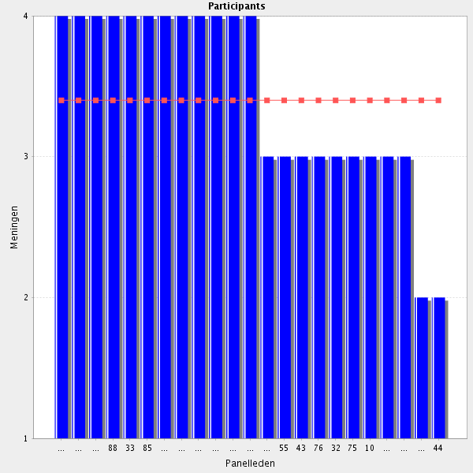
Average score: 3.4
Summary: not great scores and as identified is a duplication.
Proposal: delete as is duplication.

Comments:
It depends on infrastructure, cultural background and legislation
Same meaning as a former statement. I suggest it to be left out.

8.7 Education and training - Draws up and implements service improvement projects linked to local and national innovation projects.
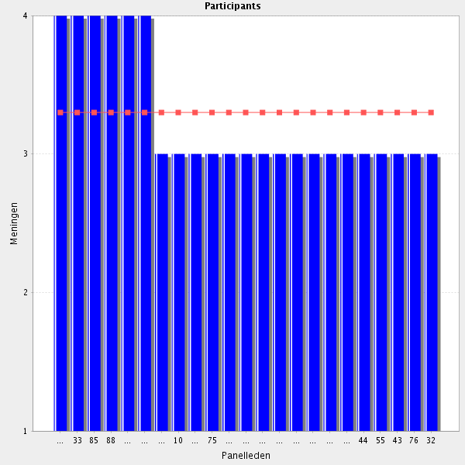
Average score: 3.3
Summary:not great scores and duplicates:
Identifies new services or ways of working to support local plans or projects which address local health needs.
Proposal: delete as duplication.

Comments:
Not sure that this should be part of a core competency framework. The reference to "drawing up" service improvement projects may exceed basic competence. Also, my experience is that we need to be careful not to push people to believe that they have to draw up new plans in order to demonstrate competence. You risk the "drawing up" of a plan without the right degree of critical thinking being applied
It depends on infrastructure, cultural background and legislation support

8.8 Education and training - Co-ordinates and reports on local, national or international innovations.
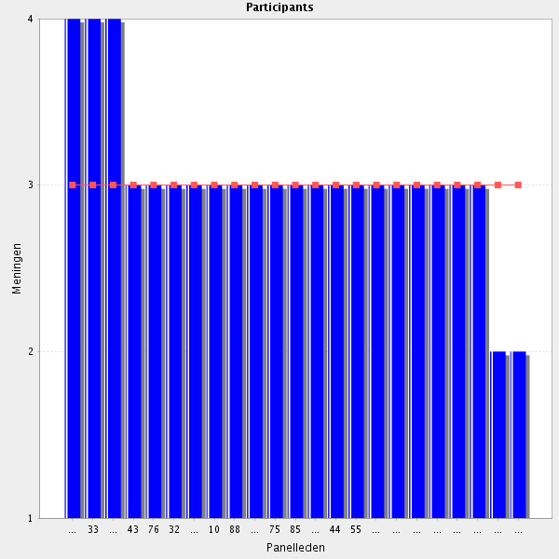
Average score: 3.0
Summary: one of the lowest scores and comments though limited are for removal.
Proposal: delete.
Depens on the country and in what institution he or she is working
It depends on infrastructure, cultural background and legislation
Not a general requirement in my opinion.
I don't believe every hospital pharmacists should be co-ordinating and reporting on innovations - this would cause chaos. pharmacists need to know when it's appropriate for them to do so and when it's not - and often there can only be one co-ordination role within a hospital pharmacy department and the mistaken belief that every pharmacist should be co-ordinating could have unintended consequences

8.9 Education and training - Participates actively in training of pharmacy students regarding the hospital pharmacy field.
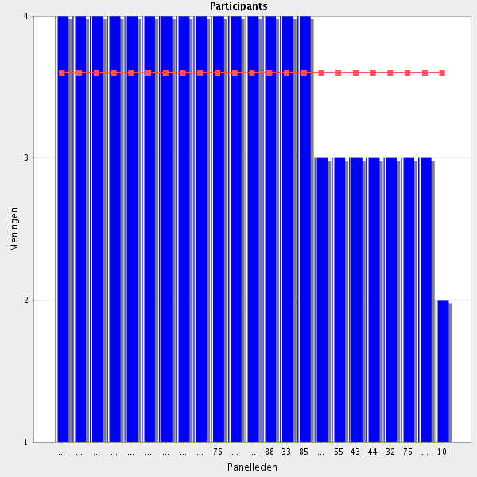
Average score: 3.6
Summary: better supported than others in this set. Link with other educational elements of the CTF. Limited rewording to clarify.
Proposal:Amend to:
Participates actively in the training of pharmacy students in hospital pharmacy.

Comments: impactful comments in red
This should've been the first statement in this chapter. (1 other agrees with this)
No all pharmacists must participate in this task.
It depends on infrastructure, cultural background and legislation and availability of pharmacist. Support from academia is essential
no we are not doıng thıs

8.10 Do you have a remark, suggestion and or question on this group of competencies?

if we want to create the list of skills for pharmaceutical superman/superwoman, we can use this. I agree with previous comments, it depends on the job position of the pharmacist which part of framework should be applicated
There are cultural settings where leadership development equals attack to the status quo. A professional needs facilitators from the society, institutions, authorities and colleagues instead of barriers to develop leadership capacity and too exhibit it.
I think that the most of skills are usefull mainly for the chief of HP.
Statements in this chapter should reflect a little bit more humility. (I other agrees with this and says "I have a dream.........." I agree with respondent x)
As described in previous comments, not everyone should be playing co-ordination roles - there needs to be a recognition of the local environment and whether or not it's appropriate to take action in local circumstances. I do think that there should be some reference to understanding the appropriateness of actions in all regard with respect to the local environment. If not, you could have junior hospital pharmacists asserting that they need to be given co-ordination roles in order to be able to meet the EAHF framework. I would urge the developers to read the entire framework through the eyes of a young, enthusiastic hospital pharmacist and consider how some of the statements in the framework could cause unintended headaches! (nb 1 other agrees with this comment)

