COMMON TRAINING FRAMEWORK LABOR MOBILITY SURVEY
Hospital pharmacist attitudes and perspectives on labour mobility

Results of the largest pan-European survey on labour mobility in the hospital sector.

September 2016

Table of contents
Table of Contents
Table of contents 2
Foreword by Mrs. Joan Peppard, President of the European Association of Hospital Pharmacists 2
EXECUTIVE SUMMARY 5
Background of the survey respondents 6
1) Distribution of professions answering the survey 6
2) Distribution of experience in the hospital pharmacy setting 7
Common Training Framework 8
3) Do you support the concept of creating a ‘common training framework’ for the hospital pharmacy specialisation? 8
4) If a common training framework for hospital pharmacy specialization in Europe was created, and the hospital pharmacy qualifications you have gained in your country were included in the framework, how likely do you think you would be to make use of this new opportunity to work in other countries? 11
Case studies 12
5) Do you have previous experience of trying to have your hospital pharmacy qualifications recognized in another country? 12
6) What was the main motivation for seeking qualification recognition in another country? 14
7) Was your experience of trying to have your hospital pharmacy qualification recognized in another country positive or negative? 15
8) Case studies 15
9) Please provide any further comments or perspectives you would like to share on the topic of hospital pharmacy labour mobility 23
Employment of foreign hospital pharmacists 25
10) Are you, or have you previously been in, a position of responsibility for the employment of pharmacists in a hospital? 25
11) Have you ever employed (or tried to employ) a pharmacist with hospital pharmacy qualifications gained in another country? 26

Foreword by Mrs. Joan Peppard, President of the European Association of Hospital Pharmacists
[Reflections and thoughts on key results – key messages and calls for action to national Governments and the Commission]
Background
[REFERENCES TO BE INSERTED]
Background to be written
The survey results are presented in several sections:

- Background of survey respondents
- Common Training Framework
- Case studies
- Employment of foreign hospital pharmacists
The survey was available online and distributed amongst EAHP’s 34 member countries. A total of 1039 responses were received from 33 European countries (including non EAHP members Andorra, Azerbaijan, Cyprus and Moldova). Response from one non-European country, Algeria, was also received and was not included in the analysis provided in the following pages. The survey opened on 16th September 2015 and closed on 7th April 2016.
Country | Responses | % of total | Country | Responses | % of total
Andorra | 1 | 0.1% | Ireland | 35 | 3.4%
Austria | 7 | 0.7% | Italy | 5 | 0.5%
Azerbaijan | 1 | 0.1% | Malta | 19 | 1.8%
Belgium | 27 | 2.6% | Moldova | 1 | 0.1%
Bosnia and Herzegovina | 1 | 0.1% | Netherlands | 5 | 0.5%
Bulgaria | 25 | 2.4% | Norway | 32 | 3.1%
Croatia | 8 | 0.8% | Portugal | 3 | 0.3%
Cyprus | 2 | 0.2% | Romania | 9 | 0.9%
Czech Republic | 121 | 11.6% | Serbia | 17 | 1.6%
Denmark | 25 | 2.4% | Slovakia | 16 | 1.5%
Estonia | 12 | 1.2% | Slovenia | 25 | 2.4%
Finland | 18 | 1.7% | Spain | 212 | 20.4%
France | 29 | 2.8% | Sweden | 14 | 1.3%
Germany | 230 | 22.1% | Switzerland | 28 | 2.7%
Greece | 5 | 0.5% | United Kingdom | 7 | 0.7%
Hungary | 93 | 9.0% | Non-European | 1 | 0.1%
Iceland | 5 | 0.5%
Table 1 – Table showing the number of responses and percentage (%). All countries included if at least 1 response was received. Number indicates responses received online (excluding non-European countries).
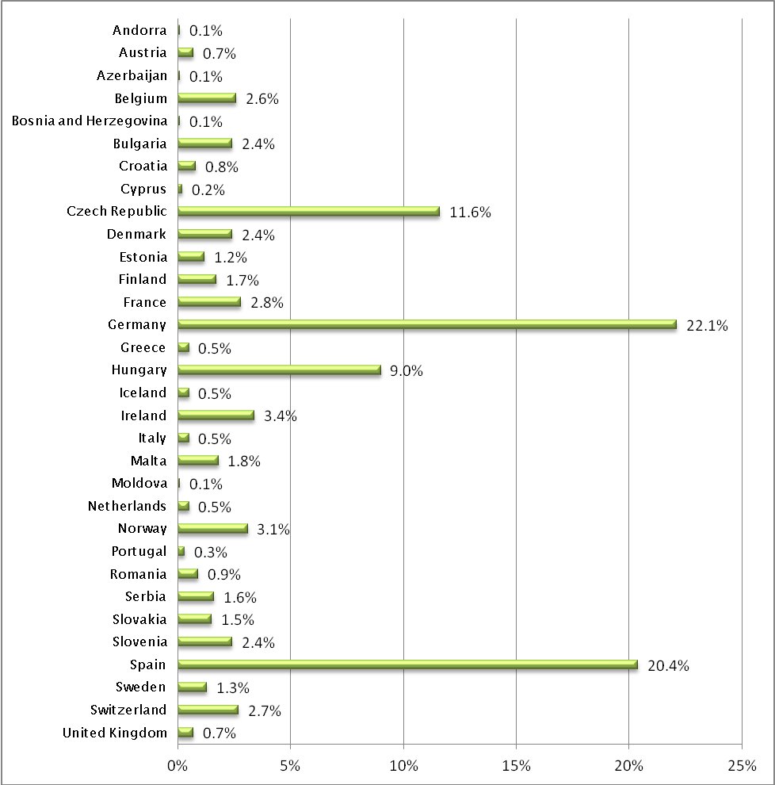
[Chart 1 – Number (%) of responses by Member States of the Council of Europe. Non- European countries (Algeria) responses were excluded. The highest numbers of responses were from Germany, Spain, Czech Republic and Hungary respectively. N=656 ]
EAHP thanks its members for the time given to distributing and responding to the 2016 survey on labor mobility.

EXECUTIVE SUMMARY
[Insert key illustrative results in visual infographic manner]

Results

Background of the survey respondents

1) Distribution of professions answering the survey
Possible answers were: Head of hospital pharmacy, Hospital pharmacist or Other. Additional comments could be provided.
There were 1038 respondents with 781 (75.24%) being hospital pharmacists, 244 (23.51%) being Heads of hospital pharmacies and 62 (5.97%) including other professions as described in the comments below.
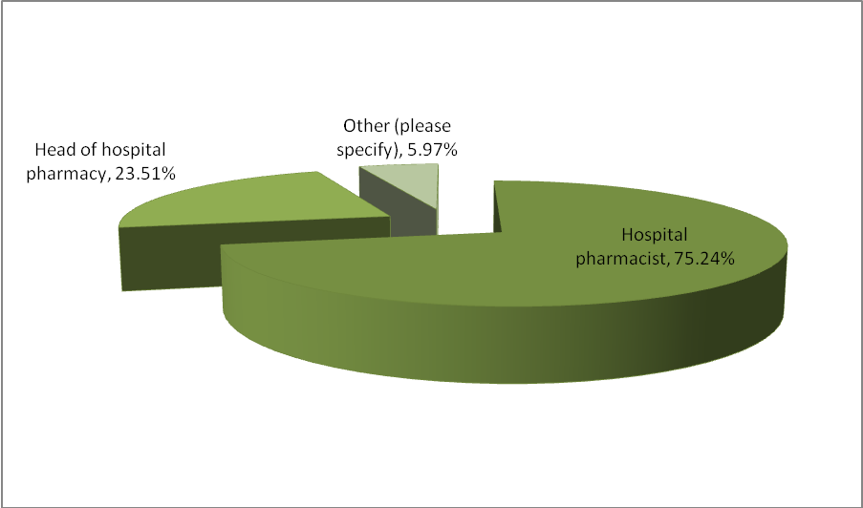
[Chart 2: Proportion of professions (%) answering the survey. N=1038]
In order to present valuable results the answers from respondents that selected ‘Other profession’ were excluded from the rest of these survey results.
Comments
Other professions (n=62) included:
- Residents (11)
- Clinical pharmacists (9)
- Heads of departments in the hospital pharmacy (4)
- Community pharmacists (4)
- Academia (4)
- University professors (3)
- Lecturers (3)
- Other not specific (3)
- Deputy chief pharmacists (3)
- Retired (2)
- Researchers (2)
- Assistant lecturers (2)
- Other single responses: Administrative position in the hospital pharmacy, Agent, Chief Oncology/Aseptic, Long term care pharmacist, Not working at the moment in hospital, Oncology Pharmacist, Representing Pharmaceutical Association, Pharmacist from the Institute of Rheumatology, Postgraduate course coordinator, Pre-registration pharmacist, Strategic manager pharmaceutical products, Volunteer.

2) Distribution of experience in the hospital pharmacy setting
Possible answers were: 1-2 years, 2-4 years, 4-8 years, 8-15 years, 15-30 years and over 30 years.
There were 995 respondents with 274 (27.54%) who have been working for 15-30 years, 236 (23.72%) working for 8-15 years, 202 (20.30%) working for 4-8 years, 142 (14.27%) working for 2-4 years, 90 (9.05%) working for 1-2 years and 51 (5.13%0 working for over 30 years in a hospital pharmacy. 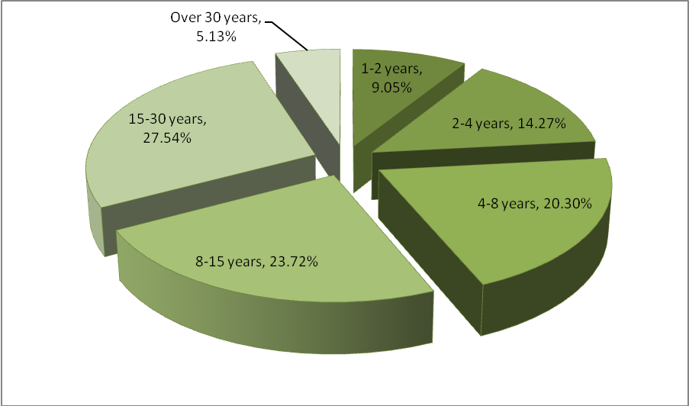
[Chart 3 – Proportion of hospital pharmacy experience among the respondents [n=995]

Common Training Framework

3) Do you support the concept of creating a ‘common training framework’ for the hospital pharmacy specialisation?
Possible answers were: Yes, No, Unsure
904 respondents answered this question of the survey (91 skipped this part).
764(84.51%) out of 904 respondents support the concept of creating a common training framework for the hospital pharmacy specialisation.
37 (4.09%) stated that the do not support this idea.
103 (11.39%) were unsure whether they support the creation of common training framework or not.
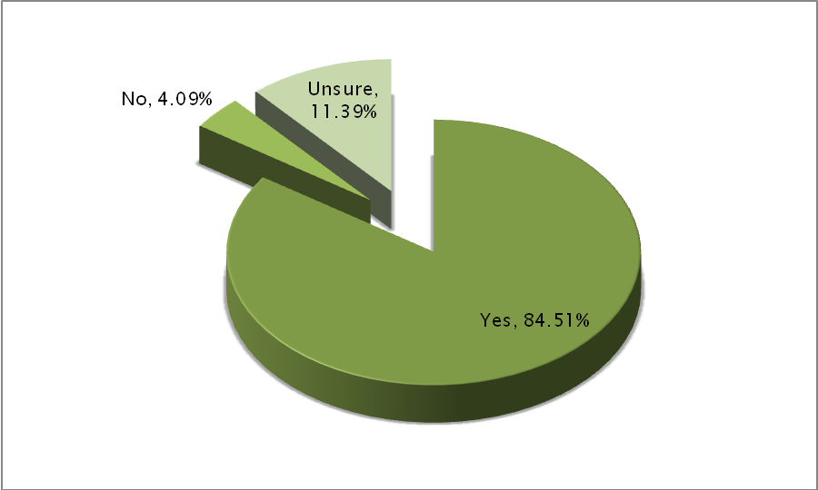
[Chart 4– Support for the creation of the common training framework [N=904]
The countries supporting the common training framework in 100% were Romania (n=9), Austria (n=7), Greece (n=5), United Kingdom (n=5), Iceland (n=5), Italy (n=4), Cyprus (n=2), Andorra (n=1) and Bosnia and Herzegovina (n=1).
Strong support (above the average 84.5%) has been present among respondents from Spain (86.02%, n=160), Hungary (94.87%, n=74), Ireland (91.18%,n=31), France (96%,n=24), Belgium (92.31%,n=24), Switzerland (91.67%,n=22), Slovenia (86.36%,n=19), Bulgaria (94.74%,n=18), Malta (93.75%,n=15), Finland (88.24%,n=15), Serbia (84.62%,n=11), Estonia (90.91%,n=10).
Support for the common training framework was the lowest in the following countries: Denmark (73.91% , n=17), Sweden (72.73%, n=8), and Portugal (66.67%, n=2)
The biggest uncertainty was observed among respondents from the following countries: Germany (20.74%, n=45), Czech Republic (13.79%, n=12), Norway (21.43%, n=6), Denmark (13.04%, n=3) Sweden (18.18%, n= 2), Finland(11.76%, n= 2), the Netherlands (20%, n=1), Portugal (33.33%, n=1) and Croatia (12.50%, n=1).
Comments
From UNSURE
“Seems to be a difficult task due to different systems and working environments” - Head of hospital pharmacy, Germany
“If I move to another country, I want to make new experiences. I do not expect or wish to do the same work as at home. However, if recognition of qualifications from abroad becomes a legal requirement for senior positions, this leaves no choice and there will be no way around a common training framework, although this sadly reduces the chance for really new exciting experiences and views.” – Hospital pharmacist, Switzerland
“In Spain the specialization in regulated, difficult to access and lasts four years. Our regularisation would be to the low” - Hospital pharmacist, Spain
“It depends on how my qualifications are considered. I think that in Spain we have a high level compared with other countries and I am not sure if this would be recognized “– Hospital pharmacist, Spain
“Specialization does not take place during our studies in Germany in contrast for example in France. I prefer studies without specialization as a broader basis to go into any chosen field, but I would greatly encourage mutual recognition between countries” – Hospital pharmacist, Germany

From YES
“This would ensure standardisation of training, and thus recognition of the quality of such training amongst countries, allowing sharing of expertise as well as job mobility.” – Hospital pharmacist, Malta
“If you are going to work with patients, it´s very important that you can speak the language in the country you visit.” Head of hospital pharmacy, Sweden
“I trained in Spain for 4 years and completed my 4 year specialty which was then not recognised when I moved to UK and I had to start all over again. It would be great if there was a way of getting our specialization recognised across the different European countries so we could make the specialty more dynamic and exchange of experiences possible”. – Hospital pharmacist, United Kingdom

From NO
“Too big difference in education and health system” – Hospital pharmacist, Denmark
“Practice requirements are too disparate. The health systems have differing requirements. Local training should reflect the need of each member state”. – Head of hospital pharmacy, Ireland

4) If a common training framework for hospital pharmacy specialization in Europe was created, and the hospital pharmacy qualifications you have gained in your country were included in the framework, how likely do you think you would be to make use of this new opportunity to work in other countries?
Possible answers were: Not at all likely, Slightly likely, Moderately likely, Very likely, Completely likely.
904 respondents answered this question of the survey (91 skipped this part).
143(15.82%) of the respondents would not consider to move and work in another country.
267(29.54%) and 262 (28.98%) would consider moving abroad in these circumstances slightly or moderately likely, respectively.
173 (19.14%) of the respondents it would be very likely to move abroad, whereas for 59 (6.53%) it would be almost certain.
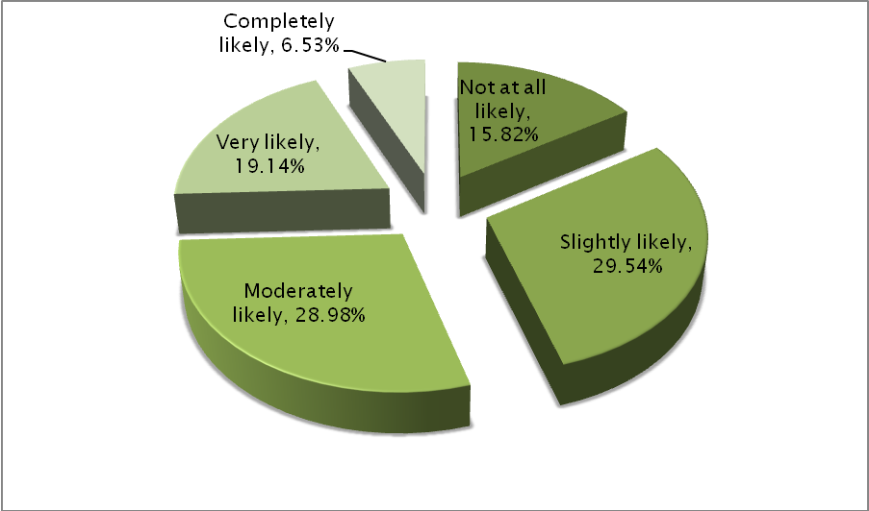
[Chart 5: Probability (%)of the respondents moving abroad if having qualifications recognised. N=904]
Most of the respondents that selected not at all likely or slightly likely were pointing out that they would not consider moving right now due to their age or family commitments but that it would have been more likely for them to move in the past if a common training framework existed.
Comments
“Less likely due to my age and family life commitments but as a younger pharmacist this would have been very attractive to me” – Hospital pharmacist, Ireland
“Country language must be spoken” – Head of hospital pharmacy, Switzerland
“Not for me, but for young pharmacists - that is good idea” – Hospital pharmacist, Czech Republic
“I would be interested in doing brief stays and learn techniques that I can apply back in my country” – Hospital pharmacist, Spain
“Because I am not far from retiring” – Hospital pharmacist, Germany
“In case my husband for example would have to go to another European Country for work, I surely would like to work as a HP in that country” – Hospital pharmacist, Belgium
“I would have taken up this opportunity readily when I was younger but with a young family and children at school I now have no wish to relocate”- Hospital pharmacist, Ireland

Case studies

5) Do you have previous experience of trying to have your hospital pharmacy qualifications recognized in another country?
Possible answers were: Yes, No
904 respondents answered this question of the survey (91 skipped this part).
111 (12.28%) of the respondents had previous experience of trying to find recognition for their qualifications, whereas 793 (87.72%) did not have such experience.
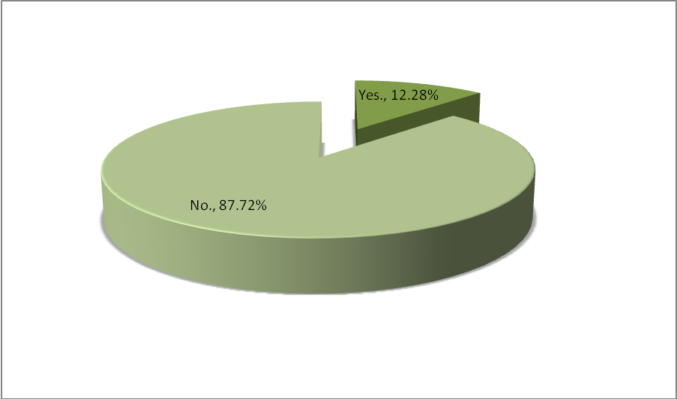
[Chart 6: Distribution (%)of the respondents having experience of seeking their qualifications recognised abroad. N=904]

Comments
“I have a postgraduate diploma in clinical pharmacy from the UK. Recognition in Switzerland does not seem easy, but will be a legal requirement for chief pharmacist positions”. – Hospital pharmacist, United Kingdom
“Completely difficult, I wanted to do for working in Italy” – Hospital pharmacist, Germany
“Qualifications in the UK are not recognized in Spain” – Hospital pharmacist, Spain
“I'm now working in Switzerland but got my hospital pharmacy qualification in France” – Hospital pharmacist, Switzerland
“This was not possible and I now have qualifications in both countries after studying for the Spanish specialty for a total of 5 years (which includes preparation of the state exam for a year + 4 year training in a hospital as resident. Then I started work at a UK hospital as a junior again, as my specialty was not recognised, and completed the 3 year Diploma in General Pharmaceutical Practice at University College of London which gives you options of working as a Senior Pharmacist in a Hospital Department in UK “– Hospital pharmacist, United Kingdom
“Germany, Austria-they do not recognize Slovenian Aprobierung Certificates” – Hospital pharmacist, Slovenia
“I have heard of many complications” – Hospital pharmacist, Germany
“I have not tried it due to information was given me it is impossible, only degree is recognized” – Hospital pharmacist, Hungary
“In France, not good experiences” – Hospital pharmacist, Czech Republic

6) What was the main motivation for seeking qualification recognition in another country?

Possible answers were: Travel reasons, To get experience of working in another country, Family reasons, Career development, Salary improvement, Other (please specify)
This question was answered by 94 respondents who have selected ‘Yes’ in question about experience of trying to get recognition for their qualifications in another country. 901 respondents therefore either skipped this question or did not have the chance to answer as the question was not applicable to them.
52 (55.32%) respondents have selected gaining experience of working in another country as their main motivation for seeking qualification recognition, 39 (41.49%) have selected career development as motivation, 32 (34.04%) have picked family reasons, 18 (19.15%) respondents have selected salary improvement, 16 (17.02%) travel reasons and 7 (7.45%) had other motivation that is described below.
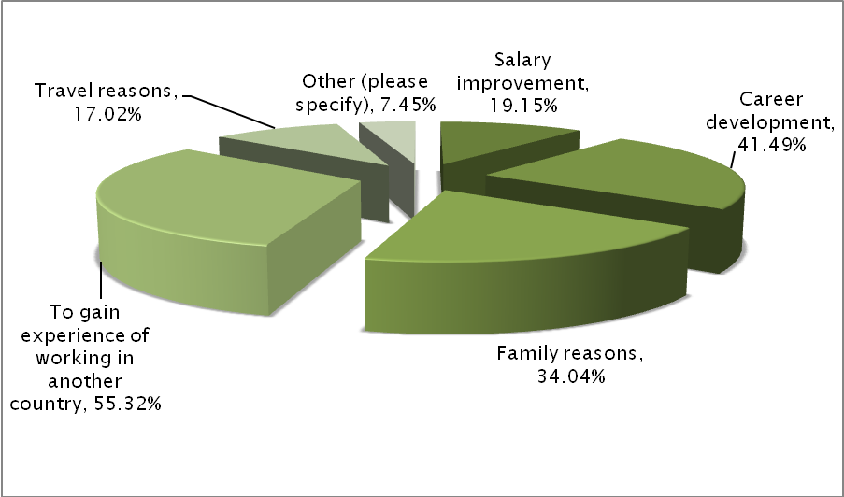
[Chart 7: Distribution (%)of the motivation for seeking qualifications recognised abroad. N=94]

Comments
“Recognition of the qualification from abroad is unfortunately a legal requirement for certain positions” – Hospital pharmacist, Switzerland
“Rate of unemployment in Spain” – Hospital pharmacist, United Kingdom
“Find a job while there were no hospital pharmacy opportunities in my country” – Head of hospital pharmacy, Spain
“No comparable to any job in my home country and city” – Hospital pharmacist, Switzerland

7) Was your experience of trying to have your hospital pharmacy qualification recognized in another country positive or negative?
Possible answers were: Positive, Negative, Neutral.
This question was answered by 92 respondents who have selected ‘Yes’ in question about experience of trying to get recognition for their qualifications in another country. 903 respondents therefore either skipped this question or did not have the chance to answer as the question was not applicable to them.
46 (50.00%) respondents stated that their experience was positive, 19 (20.65%) said that the experience was negative whereas 27(29.35%) stated that they the experience was neutral.
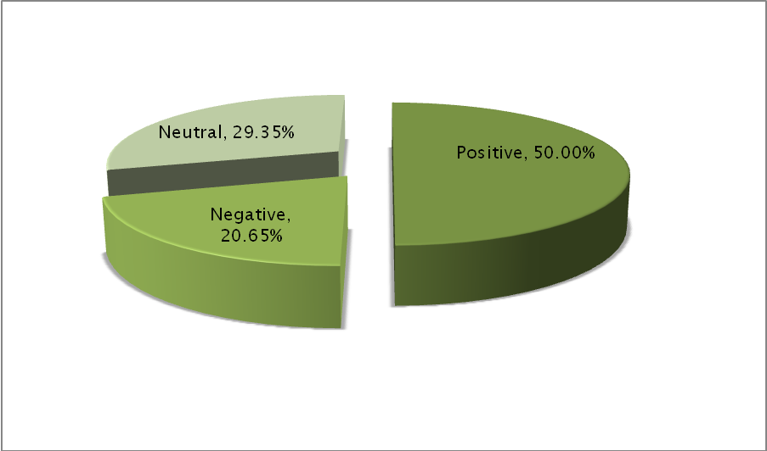
[Chart 8: Distribution (%)of the positive experience of seeking qualifications recognised abroad. N=94]

8) Case studies

Respondents that have confirmed their experience of seeking qualification recognition in another country have been asked the following questions:
Comments
- Please provide as much information about your experiences as you are willing to provide. 44 answers
- If you feel comfortable doing so, please mention the country you gained your qualifications in and the country/ies you sought recognition in. 54 answers
- If your attempts were unsuccessful please describe what the barriers to recognition were. 24 answers
- Please also describe your feelings about professional qualification recognition before and after your attempts at gaining recognition for your qualifications in another country. 25 answers

Hospital Pharmacist, 8-15 years experience, Andorra

Please provide as much information about your experiences as you are willing to provide.
In my case, recognizing my qualification in Andorra was very easy as they don't have a specific/own qualification and they need hospital pharmacist from abroad
If you feel comfortable doing so, please mention the country you gained your qualifications in and the country/ies you sought recognition in.
Andorra

Hospital Pharmacist, 2-4 years experience, Belgium
Please provide as much information about your experiences as you are willing to provide. Informal contact with hospital pharmacies in other contact, attempt to arrange solicitation from a distance.
If you feel comfortable doing so, please mention the country you gained your qualifications in and the country/ies you sought recognition in.
Belgian HP seeking jobs in UK, France, Netherlands, Canada
If your attempts were unsuccessful please describe what the barriers to recognition were.
Quite some administration, reluctance of employers to even give a chance at sollicitation for a foreign employee

Hospital Pharmacist, 2-4 years experience, Belgium
Please provide as much information about your experiences as you are willing to provide. I worked 2 years as a hospital pharmacist in Belgium. I have the qualification of clinical pharmacy due to the postgraduate diploma that i obtained in Belgium. We had to move for 1 year to the uk because of my husband's job. I work now in the uk as a clinical pharmacist band 6. The Gphc of the uk recognised my diploma's immediately. I can apply for a band 7 (this requires a clinical diploma which i have) but the only reason I don't work as a band 7 is the financial situation of my hospital. So it’s not that they don't recognise my clinical pharmacy diploma.
If you feel comfortable doing so, please mention the country you gained your qualifications in and the country/ies you sought recognition in.
I gained my qualifications in Belgium and sought recognition in the uk, which was successful.
Please also describe your feelings about professional qualification recognition before and after your attempts at gaining recognition for your qualifications in another country.
I already heard from colleagues who moved to the uk that the recognition of my diploma is not difficult. So i was quite confident about that. The way of working as a hospital pharmacist is however very different in Belgium vs the uk.

Hospital Pharmacist, 4-8 years experience, Czech Republic
Please provide as much information about your experiences as you are willing to provide.
In France I could work with pharmacist diploma only as a technical/laboratory assistant.
If your attempts were unsuccessful please describe what the barriers to recognition were.
I am not sure if it was only a law barrier or also lack of confidence of Czech diploma.

Hospital Pharmacist, 2-4 years experience, Czech Republic
Please provide as much information about your experiences as you are willing to provide.
My work experience has not been accepted by Canadian board of pharmacists. I even had to pass the evaluating exam, 6 month practice in the hospital, qualifying exam and jurisprudence.
If you feel comfortable doing so, please mention the country you gained your qualifications in and the country/ies you sought recognition in.
Canada
If your attempts were unsuccessful please describe what the barriers to recognition were.
still in progress. I have already passed evaluating exam, rest of the exams is coming soon :-) Barriers are all of these exams, and 10 000 CDN for the 6 month bridging program and practice (British Columbia)

Hospital Pharmacist, 4-8 years experience, Czech Republic
Please provide as much information about your experiences as you are willing to provide.
Having qualified as a pharmacist in CR before entering EU, I had to go through pre-registration adaptation period so as to be able to enter Pharmacist Registry in the UK. This experience was quite lengthy, accounting for 5 months of adaptation period with cost implications as well as status. I could not practice as a pharmacist till portfolio of experience was submitted to Registration Body.
If you feel comfortable doing so, please mention the country you gained your qualifications in and the country/ies you sought recognition in.
I gained qualification in the Czech Republic and sought recognition in the United Kingdom

Hospital Pharmacist, 15-30 years experience, Denmark
Please provide as much information about your experiences as you are willing to provide.
I have a pharmacy degree from England which was recognised by the health authority in Denmark, without so many problems (about 15 years ago)
If you feel comfortable doing so, please mention the country you gained your qualifications in and the country/ies you sought recognition in.
I have a pharmacy degree from England which was recognised by the health authority in Denmark, without so many problems (about 15 years ago)
Please also describe your feelings about professional qualification recognition before and after your attempts at gaining recognition for your qualifications in another country.
Of course I was pleased, as it meant I could work in my profession in another EU country

Hospital Pharmacist, 4-8 years experience, Germany
Please provide as much information about your experiences as you are willing to provide. The US makes it almost impossible; it takes a lot of time, money, travelling and effort to try to get a permission to work as a pharmacist. The UK would have been more likely possible, as there is at least some recognition of the German qualification, but I did not follow through on this, this was more intended as a possible detour for recognition in Australia
If you feel comfortable doing so, please mention the country you gained your qualifications in and the country/ies you sought recognition in.
Qualification gained in Germany, sought recognition in the US, Australia/UK
If your attempts were unsuccessful please describe what the barriers to recognition were.
In the US you have to take an exam, which takes place once or twice a year in the US, so you have to fly there and then you get the results months later, and only then can you start applying for positions. As I was considering a stay of one or two years, this was in no relation. Didn't follow through on UK, but had the impression that it would have been possible with reasonable effort and time
Please also describe your feelings about professional qualification recognition before and after your attempts at gaining recognition for your qualifications in another country.
Before I was enthusiastic and optimistic that there's a possibility, after I felt disappointed and that it's not worth the effort to try

Hospital Pharmacist, 8-15 years experience, Germany
Please provide as much information about your experiences as you are willing to provide.
Quite easy to get recognition. As far as I remember: - a few translated notarised documents - confirmation about language and knowledge of Irish pharmaceutical law - personal appearance
Personal experience of working in Ireland: - experience as a clinical pharmacist doing ward rounds - fantastic experience (people, culture, landscape, but also very good work experience and higher salary) - valued in your cv
If you feel comfortable doing so, please mention the country you gained your qualifications in and the country/ies you sought recognition in.
Ireland (ROI)

Hospital Pharmacist, 8-15 years experience, Germany
Please provide as much information about your experiences as you are willing to provide. I gain my Hospital pharmacy specialization in Spain and got recognized the title of specialist in clinical pharmacist in Germany
If you feel comfortable doing so, please mention the country you gained your qualifications in and the country/ies you sought recognition in.
My qualifications I gained in Spain and got recognized in Germany
If your attempts were unsuccessful please describe what the barriers to recognition were.
Was successful
Please also describe your feelings about professional qualification recognition before and after your attempts at gaining recognition for your qualifications in another country.
From Spain to Germany worked well because the standard to get the qualification is significantly lower. I think would not have been possible from Germany to Spain

Hospital Pharmacist, 15-30 years experience, Germany
Please provide as much information about your experiences as you are willing to provide.
I was studying for a MSc degree in Clinical Pharmacy As a part of the curriculum I was attached to different Hospital pharmacy departments as a student. However I was not registered with the local professional body.
If you feel comfortable doing so, please mention the country you gained your qualifications in and the country/ies you sought recognition in.
Germany and MSc in UK
Please also describe your feelings about professional qualification recognition before and after your attempts at gaining recognition for your qualifications in another country.
I would expect that is easier to have my hospital pharmacy qualification recognized having a MSc degree in Clinical Pharmacy

Hospital Pharmacist, 8-15 years experience, Greece
Please provide as much information about your experiences as you are willing to provide.
My applications for gulf countries were not successful due to the fact that I was not licensed in GB.
If you feel comfortable doing so, please mention the country you gained your qualifications in and the country/ies you sought recognition in.
I gained my qualifications in Greece and I sought recognition in GB, gulf countries.

Hospital Pharmacist, 15-30 years experience, Ireland
Please provide as much information about your experiences as you are willing to provide.
I didn't pursue it very far as I realised that working abroad would be a retrograde step, I would not be able to use my qualifications, and also I didn't have the necessary ones to work in Belgium
If you feel comfortable doing so, please mention the country you gained your qualifications in and the country/ies you sought recognition in.
Qualified in UK, was interested in working in Belgium
If your attempts were unsuccessful please describe what the barriers to recognition were.
I understand that they have a specialised year of post grad studies to work in hospital.
Please also describe your feelings about professional qualification recognition before and after your attempts at gaining recognition for your qualifications in another country.
They have a different system of working and their studies are obviously pertinent to the role they play

Hospital Pharmacist, 15-30 years experience, Ireland
Please provide as much information about your experiences as you are willing to provide.
My qualifications have transferred across for the purposes of professional registration but it was very difficult to quantify my point on salary scale and also when I chose to do further academic studies for higher level qualification (MSc) I had to retake some modules as my previous diploma was not fully recognised.
If you feel comfortable doing so, please mention the country you gained your qualifications in and the country/ies you sought recognition in.
Qualified in UK and sought recognition in Republic of Ireland
Please also describe your feelings about professional qualification recognition before and after your attempts at gaining recognition for your qualifications in another country.
The issue about points on salary scale was frustrating but recognisable; re post-graduate education, I felt it was a money-making exercise by the Irish higher-level institutions to force me to pay additional fees!

Head of hospital pharmacy, 15-30 years experience, Ireland

Please provide as much information about your experiences as you are willing to provide. I moved from the UK with a UK qualification to Ireland, the qualifications are similar as is the training therefore I did not experience any difficulty
If you feel comfortable doing so, please mention the country you gained your qualifications in and the country/ies you sought recognition in.
I gained my qualification in the UK, I successfully sought recognition in Ireland.
If your attempts were unsuccessful please describe what the barriers to recognition were.
n/a
Please also describe your feelings about professional qualification recognition before and after your attempts at gaining recognition for your qualifications in another country.
I recognise the difficulty that can present itself when primary language or a qualification from a country that is not seen as similar to the country you now wish to practise in. Given that this did not apply I felt confident I would gain recognition and this proved to be the case.

Hospital Pharmacist, 8-15 years experience, Ireland
Please provide as much information about your experiences as you are willing to provide. Found the process straightforward
If you feel comfortable doing so, please mention the country you gained your qualifications in and the country/ies you sought recognition in.
Studied in the UK, moved home to Ireland where I had my qualifications recognised
If your attempts were unsuccessful please describe what the barriers to recognition were.
N/A
Please also describe your feelings about professional qualification recognition before and after your attempts at gaining recognition for your qualifications in another country.
It is essential that qualifications are recognised in other countries

Hospital Pharmacist, 8-15 years experience, Ireland

Please provide as much information about your experiences as you are willing to provide.
Transferring from UK to Northern Ireland to the Republic of Ireland. A "letter if good standing" had to be obtained from each with associated time and costs.
If you feel comfortable doing so, please mention the country you gained your qualifications in and the country/ies you sought recognition in.
Qualified in England then moved to Northern Ireland then to the Republic of Ireland.
If your attempts were unsuccessful please describe what the barriers to recognition were.
N/A
Please also describe your feelings about professional qualification recognition before and after your attempts at gaining recognition for your qualifications in another country.
Overly bureaucratic and costly.

Hospital Pharmacist, 1-2 years experience, Ireland

Please provide as much information about your experiences as you are willing to provide.
I completed my undergraduate training in the UK and I am currently undertaking a masters in clinical pharmacy as a distance learning programme through a UK university. This is recognised in Ireland where I practice. This is very positive for my career development and it allows me to study alongside my full time work commitments.
If you feel comfortable doing so, please mention the country you gained your qualifications in and the country/ies you sought recognition in.
I gained my undergraduate qualification in the UK and I am currently undertaking a masters in clinical pharmacy in a UK university. I currently practice in Ireland.
Please also describe your feelings about professional qualification recognition before and after your attempts at gaining recognition for your qualifications in another country.
I feel positive towards professional qualification recognition within the EU if all countries provide training to the same standard. I also agree that a language exam should be undertaken prior to registration in any country where the person does not speak the native language as their 1st language. My feelings from my own experience are positive as I have not encountered any barriers in moving from the UK to Ireland.

Hospital Pharmacist, 4-8 years experience, Slovenia
Please provide as much information about your experiences as you are willing to provide. Applying for MSc, for which hospital pharmacy experiences (minimum 1 year ) were required. I got accepted.
If you feel comfortable doing so, please mention the country you gained your qualifications in and the country/ies you sought recognition in.
Slovenia; UK
If your attempts were unsuccessful please describe what the barriers to recognition were.
Successful; would be unsuccessful if I wanted to work in UK hospital.
Please also describe your feelings about professional qualification recognition before and after your attempts at gaining recognition for your qualifications in another country.
The qualifications we gain as hospital pharmacists in Slovenia are not really defined.

Hospital Pharmacist, 4-8 years experience, Slovenia
Please provide as much information about your experiences as you are willing to provide.
Tried at the Bavarian pharmaceutical and Austrian Chamber, the answer was that I should do the Approbation Procedure there from the beginning
If you feel comfortable doing so, please mention the country you gained your qualifications in and the country/ies you sought recognition in.
Slovenia, gained, Austria, Germany and Switzerland negative at my requests
If your attempts were unsuccessful please describe what the barriers to recognition were.
Just the back info from the HR departments of Hospital Pharmacies (Bavarian Ph. Chamber and Austrian Ph. Chamber) direct contacts that I have to regain their national approbation
Please also describe your feelings about professional qualification recognition before and after your attempts at gaining recognition for your qualifications in another country.
Total negative surprise while asking myself whether I do live in EU or I am coming from Mars.

Hospital Pharmacist, 8-15 years experience, Spain

Please provide as much information about your experiences as you are willing to provide.
I worked as hospital clinical pharmacist in the Uk for 3 years. Afterwards I completed the specialisation residency in Hospital Pharmacy (4 years) in Spain, after accessing to the system via a public exam (as usual in Spain). I applied at the hospital pharmacy public employment agency to be called for jobs, but the working time in the UK was not recognized as being hospital pharmacy, but other speciality.
If you feel comfortable doing so, please mention the country you gained your qualifications in and the country/ies you sought recognition in.
I gained qualifications in the UK and seek recognition in Spain.
If your attempts were unsuccessful please describe what the barriers to recognition were.
The agency states that my job title was clinical pharmacist (not hospital pharmacist) and that by the time I worked in the UK, I had not completed yet the Spanish specialisation residency.
Please also describe your feelings about professional qualification recognition before and after your attempts at gaining recognition for your qualifications in another country.
I feel disappointed and I think my home country, Spain, is always at the rear at these issues, although my work in the UK was very rewarding and I am using the experienced I gained there, which, in many aspects could not have been gained here, even after 4 years specific training and 2 years regular work. Therefore, I feel Spain does not promote at all free professional circulation across the EU.

Head of hospital pharmacy, 2-4 years experience, Spain
Please provide as much information about your experiences as you are willing to provide.
With the help of a private company I could have the accreditation to work in UK
If you feel comfortable doing so, please mention the country you gained your qualifications in and the country/ies you sought recognition in.
UK
Please also describe your feelings about professional qualification recognition before and after your attempts at gaining recognition for your qualifications in another country.
The recognition was not very difficult to get in the UK but the problem is the professional College. Once you have entered if you leave it it is impossible to get in and work again (you are bounded for life)

Hospital Pharmacist, 1-2 years experience, Switzerland
Please provide as much information about your experiences as you are willing to provide.
There is a mutual recognition of qualification between France and Switzerland. This recognition is easy to get but quite expensive (1700 euro to work in Geneva from France)
If you feel comfortable doing so, please mention the country you gained your qualifications in and the country/ies you sought recognition in.
I gain my qualification in France and sought recognition in Switzerland
If your attempts were unsuccessful please describe what the barriers to recognition were.
My attempts were successful

Hospital Pharmacist, 8-15 years experience, Switzerland
Please provide as much information about your experiences as you are willing to provide.
I am currently trying to contact my universities in the UK to get the information, which is required for recognition in Switzerland. Since I gained my certificate in 2003 and the diploma in 2004 it is difficult to obtain this information from the archives. Information, such as how many hours of taught lessons were part of the course, has possibly not been recorded. In Switzerland it was initially not clear, which authority will be responsible for the recognition.
If you feel comfortable doing so, please mention the country you gained your qualifications in and the country/ies you sought recognition in.
I gained my grade in pharmacy in Germany. This was easily accepted in the UK (duration of bureaucracy 6 months) and in Switzerland (duration of bureaucracy 1 month). I am currently trying to get my postgraduate education in clinical pharmacy from the UK recognised in Switzerland.
If your attempts were unsuccessful please describe what the barriers to recognition were.
I am in the middle of the process and do not know the outcome yet.
Please also describe your feelings about professional qualification recognition before and after your attempts at gaining recognition for your qualifications in another country.
I think, the pharmacy degree should be easily recognised in various countries and should allow you to practice anywhere. Postgraduate qualifications such as a diploma in Clinical Pharmacy are a plus. They show an interest in a certain field and a commitment to this specialisation. Within this specialisation, i.e. clinical pharmacy, there is still a huge variety of work possible. You may work with children or in oncology or with diabetes. The options are countless. A common training framework would not be able to cover everything, whereas a diploma from another country may have covered some aspects in more detail than others. Therefore I am convinced that postgraduate qualifications are a fantastic opportunity for the career, however due to the variety of work that is available, I do not think that a common frame work is necessary and I do think that recognition of a diploma from another country should not be a legal pre-requirement for certain positions.

9) Please provide any further comments or perspectives you would like to share on the topic of hospital pharmacy labour mobility
132 respondents answered to this question, whereas 863 skipped.
Comments
Its a very good opportunity especially for professionals in a small country like Malta - which I wish had happened a few years earlier. Hospital pharmacist, Malta
I agree with labour mobility across Europe. In our hospital we do have foreign pharmacists working with us. Having a recognized and EU harmonized education platform would ensure that labour mobility does not comprise patient care. Hospital pharmacist, Malta
It's a good idea to have such an education. Norway is a small country, and I believe that international education will help more rapid development of important pharmasist healthcare services. Hospital pharmacist, Norway
Labour mobility is at the moment much more difficult in hospital pharmacy than in other pharmacy fields. Hospital pharmacist, Finland
Canadian health care system is very different from European and European framework would probably not help me, but I would very appreciate if there exist any framework for European hospital pharmacists. From my point of view some well organized framework could simplify labour mobility, sharing of knowledge and hence increasing the quality of pharmaceutical care provided. Hospital pharmacist, Czech Republic
It is important and relevant, that pharmacists can travel and Work freely as many other professions. Head of hospital pharmacy, Denmark
The main problem is legislation. Hospital pharmacist, Czech Republic
Hospital Pharmacy Services appear to be very different in different member states. There needs to be a clear definition and harmonisation of the roles and responsibilities of the hospital pharmacy before a common framework for competency can exist. I imagine that this will take several years?? Head of hospital pharmacy, Ireland
I think validating the pharmacist degree is quite difficult at this moment. If we have a common qualification system for all hospital pharmacist the mobility would be easier. Hospital pharmacist, Spain
I moved from the UK to Ireland 11 years ago. I wasn’t working in hospital at the time but I found it very easy to have my qualification recognised. I had to attend a short presentation (approx 1 hour) then was allowed to register in Ireland. I have actually since done further training in Mental Health Clinical pharmacy (MSc) from a UK university while working in an Irish hospital. The course isn’t available in Ireland but it is recognised and accepted in the hospital where I work. Hospital pharmacist, Ireland
I have worked in hospitals in London, where there have been many pharmacists from other countries. Despite having a pharmacy degree from another EU country, in my experience, pharmacists from certain EU countries had shortfalls in their clinical knowledge. On the other hand there were pharmacists from non-EU countries e.g. Australia and New Zealand that had a high education standard. Hospital pharmacist, Denmark
It depends on how my qualifications are considered. I think that in Spain we have a high level of specialization/qualification compared with other countries and I am not sure if this would be recognized. Hospital pharmacist, Spain
It would be desirable a specialty recognized throughout the European Union to allow the mobility of professionals at least to exchange knowledge and know-how. Hospital pharmacist, Spain
It would be a great opportunity to move easily between countries and learn from each other as well as improve investigation and/or techniques Hospital pharmacist, Spain
For Young colleagues and the future of the European Spirit the common Training Framework ist essential. Head of hospital pharmacy, Germany
I think that hospital pharmacy labour mobility could increase the level of quality of hospital pharmacy labour because knowledge could spread easier all over Europe. Hospital pharmacist, Germany
It is very important for younger generations because we face quite a high number of young people who move from Slovenia trying to settle their future in other European countries. Hospital pharmacist, Slovenia
it is difficult to consider applications for posts from applicants all over Europe. As an individual recruiter it is hard to know whether the training quality exceeds or is lesser than in my home state. There is little to no available benchmarking. This makes decision making difficult and often results in candidates being called for interview only to find that they cannot perform at a clinically orientated interview assessment. Head of hospital pharmacy, Ireland
My biggest concerns are that: despite of CTN being a great idea, I am not sure that a Regulation which gives the Universities more Power will strengthen Hospital Pharmacy in Germany. Other departments will try to get more Money for their own Research and at the end German Hospital Pharmacy might not be a winner from the planned changes. It would be very important to endorse Hospital pharmacies in their ultimate knowledge in this field and to empower them more in the education of students! Hospital pharmacist, Germany
The role of hospital pharmacists in European countries is different. Some countries offer opportunities to develop skills in clinical pharmacy some are more focussed on supplying medicines. This seems to me a barrier to labour mobility. Hospital pharmacist, Germany
If countries can prove that they offer a similar education to obtain the diploma of a hospital pharmacist, your diploma Should be recognised in all those countries. So it starts with education. In my situation, in Belgium tot can only work as a hospital pharmacist if you have the diploma of hospital pharmacy, in the uk you can work in a hospital environment from the moment you are a pharmacist. But they have a special system, the pre-reg year, which is a year that you work as a trainee (band 5) and gather experience in a hospital and community environment. I think that if people of the uk want to work in Belgium as a hospital pharmacist, that Will be a bit more difficult. Hospital pharmacist, Belgium
The missions of hospital pharmacists should be harmonized The residentship should be mandatory for 3 years The courses should be validated through skill approaches in the field of the processus of Bologna and university based to ensure stronger benefits in the goal of European mobility. Hospital pharmacist, France
Besides diploma there's also accreditation. This has to be interchangeable as well. Head of hospital pharmacy, Belgium
It is important that the level of qualifications remain high and the people moving are able to demonstrate competence. Hospital pharmacist, United Kingdom
I think, first of all, there is need of harmonisation in practice of hospital pharmacies in different countries because of many differences. Head of hospital pharmacy, Slovakia
I would like to encourage every pharmacist to live and work abroad for a while. It has been an absolutely worthwhile experience, personally as well as professionally. If I had stayed in my home country I would have had much less broad experience and gained less skills. Hospital pharmacist, Switzerland
Added to the skills in pharmacy field the fluent capability to communicate with several languages is required to be able to use the opportunity to work in several EU countries. Head of hospital pharmacy, Finland
Standardisation of training would ensure not only the opportunity for job mobility amongst countries, but would also ensure the best possible training throughout all countries. Hospital pharmacist, Malta

Employment of foreign hospital pharmacists

10) Are you, or have you previously been in, a position of responsibility for the employment of pharmacists in a hospital?
Possible answers were: Yes, No.
This question was answered by 864 respondents (131 respondents therefore skipped this question).
316 (36.57%) respondents stated that they were responsible for the employment of pharmacists in a hospital, whereas 548 (63.43%) declined.
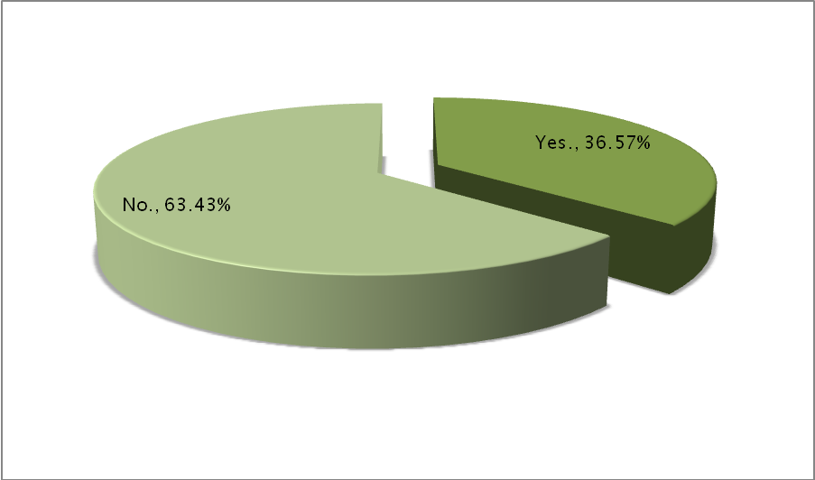
[Chart 9: Distribution (%)of the respondents if it comes to being responsible for employing pharmacists in a hospital. N=864]

Comments
“As head of pharmacy, I am responsible for the employment of my staff – Head of hospital pharmacy, the Netherlands
“In our country for public area ministry is following a centralized procedure” - Head of hospital pharmacy, Greece
“Previously held the post of Clinical Pharmacy Services manager” – Hospital pharmacist, Ireland
“Only to cover my vacation periods”– Head of hospital pharmacy, Spain
“I have been a guide pharmacist for European HP students “– Hospital pharmacist, Finland

11) Have you ever employed (or tried to employ) a pharmacist with hospital pharmacy qualifications gained in another country?
Possible answers were: Yes, No.
The respondents who answered yes were asked to share their motivation for employing foreign hospital pharmacists.
This question was answered by 309 respondents. 686 respondents therefore skipped this question or the question was not applicable for them as they were not responsible for the employment of pharmacists.
62 (20.06%) respondents stated that they have employed (or tried to employ) foreign pharmacists in a hospital, whereas 247 (79.94%) declined.
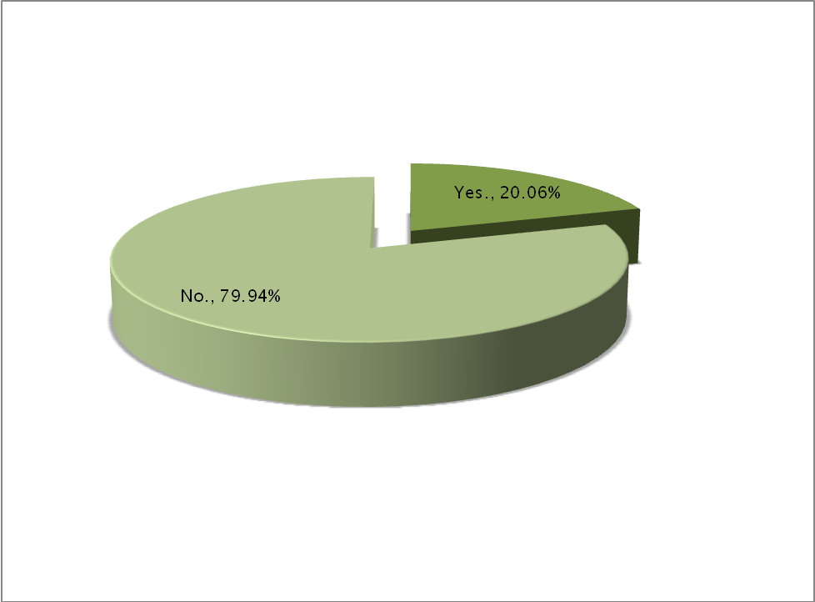

[Chart 10: Distribution (%)of the respondents if it comes to trying to employ a foreign hospital pharmacist. N=864]

Comments

“Pharmacists from Germany (no language problems). Some problems occurred because of cultural differences.”
Head of hospital pharmacy, Switzerland

“We wanted to try pharmacists from other European countries. We have good and positive experience.”
Hospital pharmacist, Norway

“Only after having the qualification from Finnish authorities = FIMEA as pharmacist. To get this qualification from FIMEA, one has to prove the he/she speaks and writes fluently Finnish language and to knows the Finnish pharmaceutical legislation.”
Head of hospital pharmacy, Finland

“As long as the pharmacist has licence to work as a pharmacist i Norway and speak Norwegian they can work in Norway.”
Head of hospital pharmacy, Norway

“I have employed pharmacists with qualifications gained outside Europe as pharmaceutical technicians as their qualifications are not recognised in Ireland.”
Hospital pharmacist, Ireland

“From UK, Portugal and Italy. All very positive experiences. We take qualified Pharmacists and then train them to work in accordance with the practices in this hospital.”
Head of hospital pharmacy, Ireland

“Possibility to find clinical pharmacy skills in a time, where these skills were not common in Denmark”
Head of hospital pharmacy, Denmark

“In Germany you don't have to have a qualification as hosp pharm. So I employed someone from Czeck because of her qualification from her PhD (that is the usual way)”
Head of hospital pharmacy, Germany

“During the war in Balkans many people from Bosnia and Herzegovina moved to Slovenia, seeking for job. At the same time, there was lack of pharmacists in Slovenia who would like to work in a hospital pharmacy due to the new Drug act that allowed better (paid) jobs within branch offices of foreign pharmaceutical companies in Slovenia. It took quite a long time and lot of resources to obtain the certification of the diploma /master degree for pharmacists. Unfortunately when we finally managed to achieve that, we realised the language was a problem in communication with patients.”
Hospital pharmacist, Slovenia

“Employed a Portuguese pharmacist ~ 10 years ago, who has remained in Ireland and been promoted to a managerial post in another hospital. The experience was extremely positive.”
Hospital pharmacist, Ireland

“Both positive and negative, Availability of candidates was a key factor. Building a team with different backgrounds and perspectives adds to the whole team.”
Head of hospital pharmacy, Ireland

“Quite a large number of Irish hospital pharmacists have trained in the UK and gained postgraduate qualifications in the UK. We have a number of UK trained pharmacists in post currently. It is great to have experience of working in a different health system as this bring fresh ideas and innovations however in some instances additional training may be required. In addition, many Irish trained pharmacists undertake UK post graduate qualifications due to the lack of Irish post graduate courses. The qualifications are to a very high standard. We have also recruited Spanish and Polish pharmacists qualified in the past however, I was not involved in their recruitment.”
Head of hospital pharmacy, Ireland

“Excellent experience with a pharmacist from France. Full member of the team for many years”
Hospital pharmacist, Germany

“Until recently there was no university on Cyprus offering a Pharmacist degree therefore all pharmacists were trained abroad”
Head of hospital pharmacy, Cyprus

“Negative experience. I could not evaluate his/her knowledge due to poor Hungarian.”
Head of hospital pharmacy, Hungary

Conclusion
To be entered
References:
To be entered

