Curriculum vitae |  |  |  |  | 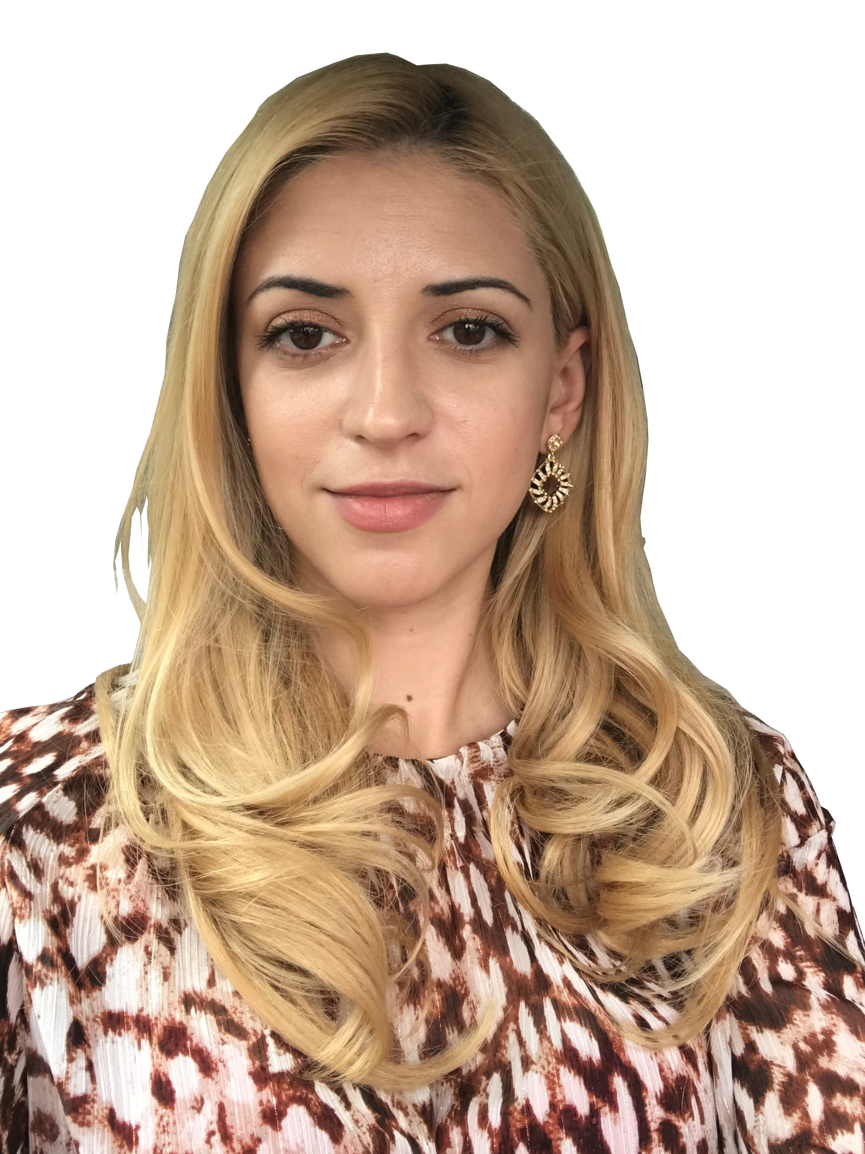
Personal information
First name : | Plesan
Name : | Claudia Roxana
Date of birth : | 02.10.1987
Place of birth : | Drobeta Turnu Severin
Nationality: | Romanian
Adress: | Bld. Alunis 10, Drobeta Turnu Severin, Romania
Mobile: | 0040747644687
E-Mail: | claudia.plesan@yahoo.com
Civil state: | Married, one child
Qualifications and studies
Bachelor’s degree in Philology |  |  |  | 2009
Master’s degree – Intercultural communication |  |  |  | 2011
Translator degree ( social studies, literature, law, medicine, pharmacy, economy ) |  |  |  | 2012
Bachelor’s degree in Pharmacy |  |  |  | 2015
Translator on behalf of ANFSR for EAHP |  |  |  | 2017
Ambassador on behalf of ANFSR for EAHP |  |  |  | 2017
Current workplace
Oncology Center Drobeta Turnu Severin |  |  | Pharmacist in charge
Education
University of Medicine and Pharmacy – UVVG Arad , Romania |  |  |  |  | 2010-2015
Faculty of Letters, Intercultural Communication, UVT Timisoara, Romania |  |  |  |  | 2009-2011
Faculty of Letters, UVT Timisoara, Romania |  |  |  |  | 2006-2009
Highschool – Drobeta Turnu Severin, Romania |  |  |  |  | 2002-2006
Secondary school - Drobeta Turnu Severin, Romania |  |  |  |  | 1998-2002
Language competency
English |  | Profficient – writing, reading, speaking ( Cambridge Profficiency – C2 level )
French |  | Good - writing, reading, speaking
Spanish |  | Beginner - writing, reading, speaking

