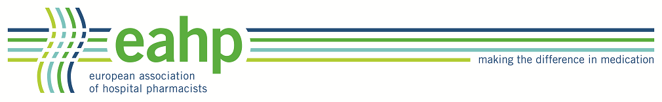
EAHP ACADEMY SEMINAR
2019
Qualitative research methodology…
ACPE Universal Activity Number (UAN): …..

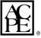
An ACPE application based activity
The European Association of Hospital Pharmacists (EAHP) is accredited by the Accreditation Council for Pharmacy Education as a provider of continuing pharmacy education.

Programme (draft – version)
Friday,
08.00 – 08.30 | Welcome – Needs and Objectives of the Academy Seminar  Chair SC or Pres. EAHP or both  Invitational speech: the President of the X Pharmaceutical Society  Assessment of learning success - Survey Monkey
08.30 – 09:15 | Example(s) of new exciting service(s) that should be evaluated using qualitative research methodology (or mixed-methods) Rationale for this is presented.  Jonathan Underhill.
09:15 – 10:00 | Qualitative research methodology – an overview  Raisa Laaksonen  - Interview studies  - Focus groups  - Questionnaires (with open ended questions)  - Observation studies  - Confounding/bias
10:00 – 10.30 | Coffee Break
10.30 – 11:15 | Which method do you choose for your study? Pros and cons, rationales  Derek Stewart Aberdeen?
11.15 – 12.00 | Analyse methods (brief overview) How are results presented in qualitative research? What differs from quantitative abstract?  Sofia Kälvemark Sporrong?
12.00 – 13.30 | Lunch break
13.30 – 14.15 | Examples (publications) of services studies that have been successfully evaluated (using Qual RM) that have changed practice  ??
14.15 – 15.00 | How to write a protocol and plan your study  ??
15.00 – 15.30 | Coffee Break
15.30 – 16.15 | Introduction to the workshop/interactive part  Ulrika Gillespie  - The participants work in groups of 6(?) and get to select one out of 3 services to write a study protocol for
16.15 – 17.15 | Interactive Part 1  Formulation of research question and choosing method  Facilitators
17.15 – 17.30 | Summary day 1
19.00 – 22.00 | Dinner at the hotel
Saturday

08.30 – 10.00 | Interactive Part 2  Continuing to work on the study protocol  Facilitators
10.00 – 10.30 | Coffee Break
10.30 – 11.30  11.30 – 12.30 | Interactive Part 3  All or divided into two groups  - Presenting the resulting protocols for a medical ethical committee, i.e. role play where someone plays the person from eth com and ask questions and for clarifications
12.30 – 14.00 | Lunch break
14:00 – 15:00 | What should you think about when you use your results and present them? Success stories, storytelling,  Jonathan Underhill or person he mentioned
15.00 – 15.45 | Coffee Break
15.45 – 16.30 | Final Podium and Plenary Discussion – wrapping up  All Presenters and Workshop Coaches, all Delegates  - Bringing experiences together
16.30 – 16.45 | Assessment of Learning success – SurveyMonkey®  Delegates
16.45 – 17.30 | Summary and closing remarks
19.30 – 22.30 | Academy Dinner
Sunday, 2 October 2016

08.45 | Meet in hotel lobby
09:00 – 12.30 | City Tour. Departure by bus from the hotel.

