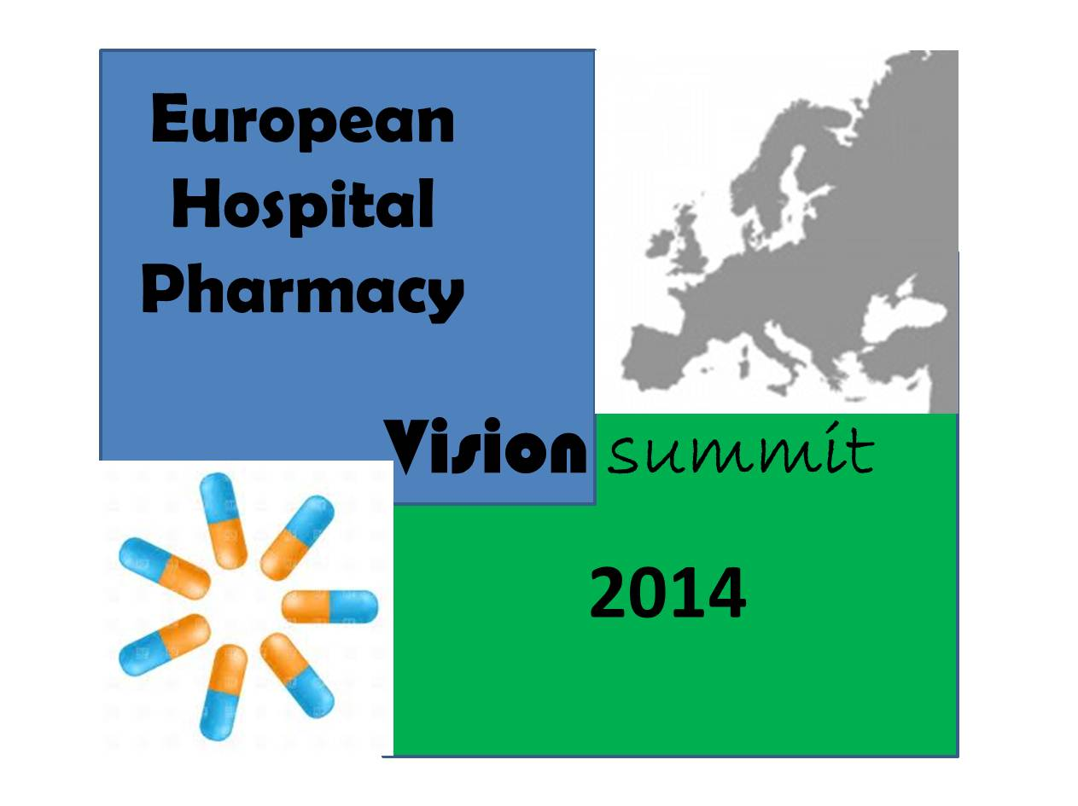

Working Group 2 – Basel Statements

Working groups:

In order to make it a slightly more logical order for external the Working Groups were renumbered:
WG 1: Stakeholders (the event, governance etc)
WG 2: Basel Statements (the key areas of practice activity to be developed in Europe)
WG 3: Best Possible Practice (models of how to develop those areas of practice)
WG 4: Metrics (How to measure development in those areas)
WG5: Implementation (Frameworks for implementation)
The composition of WG2 is:
Aida Batista
Ana Crnkovic
Brigitte Waldispuehl
Elaine Conyard
Francesca Venturini
Helena Farinha
Jacqueline Surugue
Joan Peppard
Leonidas Tzimis
Marika Saar
Valdis Pirsko
And with the collaboration of the Board Members from Portuguese Association of Hospital Pharmacists (APFH)

Actions taken:

1. The members of WG2 were invited to elect among the 75 Basel Statements (BS) those which are more important to hospital pharmacists, based on the hospital pharmacy main fields of activity:
- procurement and distribution (P&D);
- production and compounding (P&C);
- clinical services (CS);
- quality assurance and patient safety (QA&PS);
- education and research (E&R);
It was asked to rank all the statements according to the impact on patients (direct or indirect impact) and also according to the relevance to hospital pharmacy practice in Europe (very important, important, not so important).

2. Only missed two answers.

The BS were classified by the members of the group and a spreadsheet complete with all the data.
To facilitate the task of the group, the BS were grouped by area of activity and interest. Some suggestions have been put in comments for deleting statements, or to merge some of them into one.
What we ask now is that this document be reviewed and commented. The suggestions should be sent as soon as possible (until April 1), all doubts and questions will be discussed during the April meeting.

Future Actions:

After electing the BS the group will rewrite them considering the following:
- The “new” statements must be patient oriented and specific, measurable, achievable, realistic and time scaled.
- They must give to all European pharmacists a vision how to move on towards the best possible practice and excellence.
- Whenever necessary they should give a pathway to achieve the goal (from basic to excellence)
- They must be simple, short and clear.

Examples:

To help the redefinition of the BS consider n. 30:
Hospital pharmacists should be an integral part of all patient rounds to assist with therapeutic decision-making and advise on clinical pharmacy and patient safety issues
Bearing in mind that the translation of the Basel statements must give a way to what we do, for whom and what we are going to do in the future in order to ensure a safe environment for our patients the above statement could be translated as:
The presence of a pharmacist during rounds to assist in therapeutic decision making and advise on patient safety issues improves the outcomes of the patients
Pharmacists should be able to participate in rounds and advice doctors, nurses and patients
Pharmacists should document the impact of their intervention and communicate this to doctors, nurses and patients

Timeline

January, 31 | Sending working paper
February, 21 | Identify the most important Basel statements
March, 21 | EAHP send to WG4 the BS to be rebuilt
April, 1 | Gathering all contributions
April, 13 | WG4 meeting - Brussels for discussion and redefine timeline
 | Future actions after April meeting

