MEDICINES SHORTAGES IN EUROPEAN HOSPITALS

The evidence and case for action

Results of the largest pan-European survey on medicines supply shortages in the hospital sector, its prevalence, nature and impacts for patient care.

July 2014

Table of contents
Table of Contents
Table of contents 2
Foreword by Dr Roberto Frontini, President of the European Association of Hospital Pharmacists 3
EXECUTIVE SUMMARY 6
Results 7
Prevalence of shortages 7
1) Are shortages of medicines a current problem in the hospital you work in, in terms of delivering the best care to patients and/or operating the hospital pharmacy? 7
2) Approximately how often does you hospital pharmacy experience medicine shortages? 9
3) Which type of medicine do you most commonly experience to be in short supply? 11
4) In which area of medicine does your hospital experience shortage most commonly? 12
5) Please tell us some of the most common medicines you have experiences shortages with during the past year. If possible please include their brand name, INN (International non-proprietary name) and common indications as appropriate or available. 16
Sources of Supply 16
6) Which of the below categories best describes the main external source of supply of medicines to your hospital? 16
7) From which category of external supply does your hospital most frequently encounter problems with sourcing specific required medicines? 19
Duration of shortages 20
8) In your experience, how long would you estimate the average or typical medicines shortage normally lasts for? 20
9) What is the longest duration that you can recall a medicines being in shortage for? 22
Impact of shortages 22
10) In the case of a medicine in short supply, how often do you estimate your hospital is able to provide treatment to a patient by providing a therapeutic equivalent or near equivalent medicine, without major disruption to their treatment? 22
11) In an average week in your hospital, how much time (staff working time) do you estimate is diverted because of drug shortage problems? 25
12) Do you agree with the following statement? ''Medicines shortages in my hospital are having a negative impact on patient care." 27
13) Please provide any relevant examples from your hospital over the past year of the impact medicines shortages have had on patient safety welfare. 30
14) Please describe practically how a medicine in short supply is usually dealt with to minimise the impact on patient care. (Please tick all that apply) 30
15) What changes (if any) in practice has your hospital needed to make in order to deal with the shortages problem? (Please tick all that apply) 32
16) Please provide any relevant anecdotal evidence from your hospital over the past year of the impact medicines shortages have had on patient safety and welfare. 33
17) Please tell us some of the most common experiences of medicines in shortage you have experienced in the past year. If possible, please include their brand name, INN name and common indication, as appropriate or available. 33
18) Which of the following proposed policy solutions on medicines shortages would you personally support? (tick all that apply) 34

Foreword by Dr Roberto Frontini, President of the European Association of Hospital Pharmacists

[Reflections and thoughts on key results – key messages and calls for action to national Governments and the Commission]
Background
[REFERENCES TO BE INSERTED]
Medicines shortages are an ongrowing problem for the provision of healthcare not only in Europe’s hospital sector, but also in the community sector. Not only are shortage problems contained in their prevalence to within the borders of Europe either, but are evidenced to be worldwide problem.
Countries like the USA, Italy, and the Netherlands have made notable steps in both documenting and responding at a regulatory level to the problem. At a pan-European level, however, there remains both a gap in the known and circulated evidence of the shortages problem at the pan-European level, and a corresponding failure to take active international regulatory measures.
EAHP’s 2014 medicines shortage survey is therefore an EAHP organisational response to provide policy and decision makers with the clearer picture required to adequately assess the nature and available solutions to the problem.
The survey results are presented in several sections:

- Prevalence
- Nature
- Sources of supply
- Duration of shortages
- Impact of shortages
- Managing problems caused by shortages
- Solution

The survey was primarily available online, though some paper based contributions were also accepted. Distributed amongst EAHP’s 34 member countries a total of 607 responses were received from 36 European countries (including non EAHP members Monaco, Cyprus and Liechtenstein). Responses from non-European countries were also received including Lebanon, Israel and Saudi Arabia. These responses are not included in the analysis provided in the following pages, but are mentioned in Annex [y] on the international dimension of the shortages problem. The survey opened on 19th March 2014 and closed on 7th May 2014.
Country | Responses | % of total | Country | Responses | % of total
Austria | 21 | 3.5 | Latvia | 2 | 0.3
Belgium | 94 | 15.4 | Liechtenstein | 1 | 0.2
Bosnia and Herzegovina | 9 | 1.5 | Lithuania | 8 | 1.3
Bulgaria | 6 | 1.0 | Malta | 11 | 1.8
Croatia | 25 | 4.1 | Monaco | 3 | 0.5
Cyprus | 1 | 0.2 | The Netherlands | 14 | 2.3
Czech Republic | 4 | 0.7 | Norway | 11 | 1.8
Denmark | 25 | 4.1 | Poland | 13 | 2.1
Estonia | 15 | 2.5 | Portugal | 42 | 6.9
Finland | 1 | 0.2 | Romania | 2 | 0.3
F.Y.R.O.M | 4 | 0.7 | Serbia | 8 | 1.3
France | 3 | 0.5 | Slovakia | 16 | 2.6
Germany | 10 | 1.6 | Slovenia | 7 | 1.2
Greece | 14 | 2.3 | Spain | 105 | 17.3
Hungary | 12 | 1.8 | Switzerland | 7 | 1.2
Iceland | 4 | 0.7 | Turkey | 5 | 0.8
Ireland | 47 | 7.7 | UK | 7 | 1.2
Italy | 41 | 6.7 | Non European | 6 | 0.2

Table 1 – Table showing the number of responses and percentage (%). All countries included if at least 1 response was received. Number indicates responses received via any method including online (+/paper/conference app)
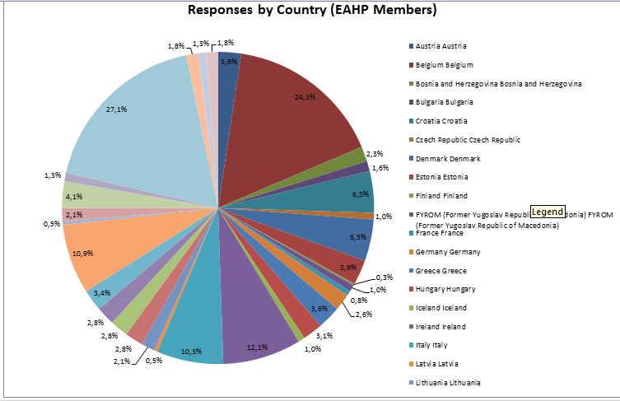
[Chart 1 – Chart showing the number (%) of responses by EAHP member countries. Monaco, Lichtenstein and Cyprus are excluded. The highest numbers of responses were from Spain, Belgium, Ireland, Italy and Portugal respectively. N=587 ]
The 2014 EAHP survey should be seen within the context of a previous, shorter and smaller survey conducted in 2013. Results can be found here.
EAHP thanks its members for the time given to distributing and responding to the 2014 survey

EXECUTIVE SUMMARY

[Insert key illustrative results in visual infographic manner]

Results

Prevalence of shortages

1) Are shortages of medicines a current problem in the hospital you work in, in terms of delivering the best care to patients and/or operating the hospital pharmacy?

Possible answers were:Yes, No or Unsure. Additional comments could be provided.
This question was answered by 537 respondents with 463 (86.3%) stating that medicines shortages were a current problem in terms of delivering the best care to patients and/or operating the hospital pharmacy.
44 (8.2%) respondents stated that medicines shortages were not a current problem.
The remaining 28 (5.2%) were unsure in regards to this question.
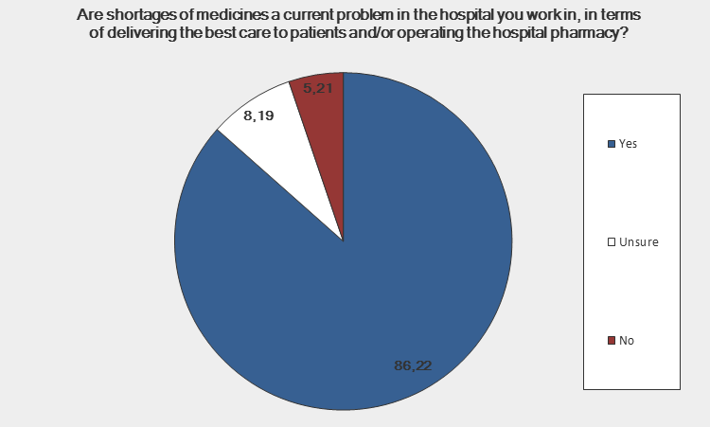
[Chart 2: showing the proportion of hospital pharmacists (%) stating that medicines shortages were a current problem in their country. N=537]
Comments received
“we always found an alternative – but took significant time to do this”
Hospital Pharmacist, Belgium (Antwerp)

“the last years shortages become more current”
Hospital Pharmacist, Belgium (West Flanders)

“This is a growing problem & takes up a lot of working time which could be spent on other tasks.” Hospital Pharmacist, Ireland (Dublin)

“Up to now we always solved a problem, but it takes much more energy and time”
Hospital Pharmacist, Slovakia (Bratislava)

“Not in terms of operating the hospital pharmacy, but maybe in terms of delivering the best care (in some cases a substitute drug is given).”
Hospital Pharmacist, Bosnia and Herzegovina

“Always shortage of one or more medicines, at any time”
Hospital Pharmacist, Norway (Oslo)

There is always, at any given time, shortage of one medicine or the other. Often essential medicines where there is no or poor alternatives. This problem has grown over the last decade. Hospital Pharmacist, Norway (Oslo)

Analysis
86.3% of hospital pharmacists (n= 537) stated that medicines shortages was a current problem in terms of delivering the best care to patients and/or operating the hospital pharmacy. This is a high proportion and corresponds to the results of the 2013 survey conducted by EAHP[1, 2].
Analysed by country with the highest responses) and indicated that shortages had an influence on patient care included 83 responses from Belgium (98.8%), 73 from Spain (83.0%), 44 from Ireland (97.8%), 34 from Portugal (87.2%) and 27 from Italy (77.1%).The results occur despite known attempts at a national level to address this problem.
Notably high levels of agreement came from Austria (100%, n=21), Slovakia (100%, n=15), the Netherlands (100%, n=13) and Norway (100%, n=11) and Denmark (91.3%, n=23).
23 responses were received from Croatia, with only 14 (60.87%) stating that it was a problem so this problem may not be so prevalent in all the countries surveyed. Comments sent by Croatian pharmacists included the following:
“There are shortages of medicines but nothing alarming” Hospital Pharmacist, Croatia (Zagreb)

2) Approximately how often does you hospital pharmacy experience medicine shortages?
Possible answers were: daily, weekly, monthly, or occasionally.
526 responses were received to this question.
111 (21.1%) said that they were affected by shortages on a daily basis with the most of responses 238 (45.25%) stating that they were affected on a weekly basis
112 (21.23%) replied that they were affected by shortages on a monthly basis with 65 (12.36%) stating that they were affected occasionally.
This resulted in a combined total of 461 (87.64%) of the respondents were affected by shortages at least monthly, with some affected on a daily but most on a weekly basis.

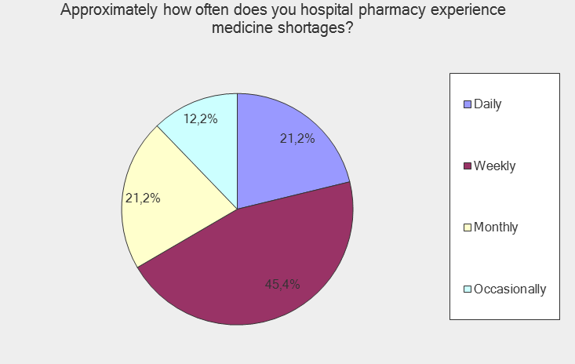
[Chart 3 – showing the frequency hospital pharmacists are faced with shortages. N=526]

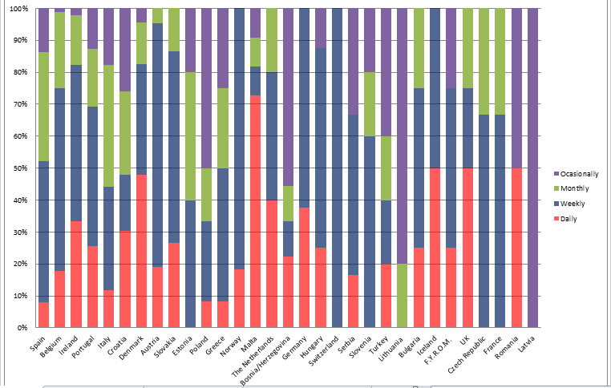

[Chart 4 – showing the frequency of shortages by country. N= 526]
Comments
It was not possible to insert comments when answering this question.
Analysis
The results of this question can be compared to results from EAHP’s 2013 survey in which 63.1% (n=214) stated that they experienced shortage problems as a weekly, sometimes daily occurrence[1]. 27.1% (n=92) stated that they experienced shortages at least once a month, with 9.7% (n=33) stating that they only experienced shortages a few times a year[1].

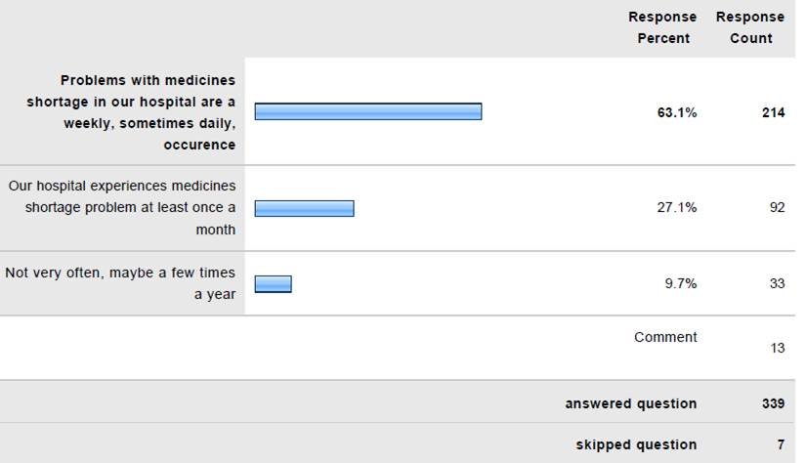
(Chart 4 - showing the occurrence of shortages in the 2013 survey as a comparison)
The countries with the highest percentage of respondents indicating that medicines shortages are daily occurrence were Malta (72.7%, n=11) and Denmark (47.8%, n=23).
The countries with the highest percentage of respondents indicating that medicines shortages are a weekly occurrence were Norway (81. 8%, n=11), Austria (76.2%, n=21)) and Slovakia (60%, n=15).
Out of the countries with the largest number of responses, it is important to note that shortages occurring weekly were the most common response reported by Belgium (57.1%, n=84), Spain (44.3%, n=88), Ireland (60%, n=45) and Portugal (43.6%, n=29).
Shortages on a monthly basis was the most common occurrence in Italy (38.24%, n=34), but they were also a large proportion in Croatia (30%, n=23) and Estonia (40%, n=15).
Occasional shortages were reported most frequently in Bosnia and Herzegovina (55.6%, n=9 responses) and Croatia (30%, n=23).
Overall shortages occur on a weekly basis in the majority of countries that were surveyed, but it is also clear that there is great variation within countries and between countries regarding how often shortages of medicines affect hospital pharmacists working in that country.
Nature

3) Which type of medicine do you most commonly experience to be in short supply?

Possible answers were: Originator (patented) medicines, Generic (off patent medicines including branded generics) or Unlicensed medicines.
This question was answered by 424 participants.
The most common type of medicines in short supply were originators/patented with 221 hospital pharmacists (52.1%) reporting as the most common category of shortage. Generic products were affected to a lesser degree, with 156 (37.5%) hospital pharmacists stating that they were the category most affected. 50 (11.8%) hospital pharmacists stated that that unlicensed medicines were the most common type of medicines in short supply.
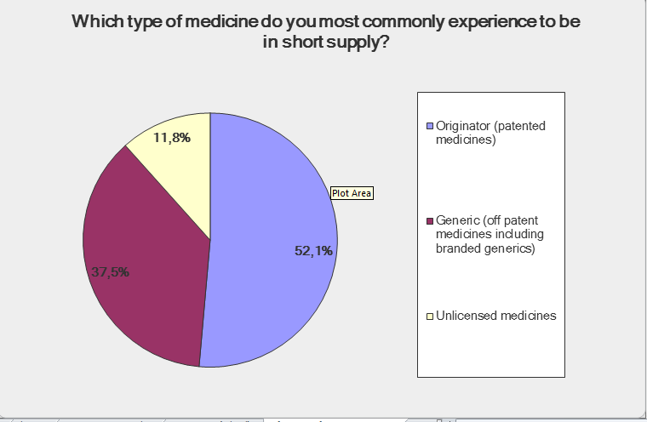

[Chart 6- Showing the nature of the shortages reported from all of the responses. N=424]
The countries with the highest recorded prevalence of patented shortages were Belgium (78.3%, n=69), Spain (64.5%, n=62), Austria (73.3%, n=15) and Slovakia (78.6%, n=14). The pharmaceutical markets of Bulgaria, Ireland, Switzerland, Italy, Norway, France, and Poland also experienced most of their shortages with patented products.
The countries with the highest recorded prevalence of generic shortages were Denmark (72.2%, n=18), the Netherlands (66%, n=11), Portugal (50%, n=32) and Croatia (50%, n=22). Respondents in the pharmaceutical markets of Germany, Hungary, Latvia, Turkey, F.Y.R.O.M, Serbia and the UK also reported most of their shortages from the generic industry.
Additionally unlicensed medicines in short supply was reported by respondents from Croatia, Greece, Slovakia, Iceland, Slovenia, Bosnia/Herzegovina and in Estonia it was the most frequent type of shortages experienced, (63.63%, n=11).

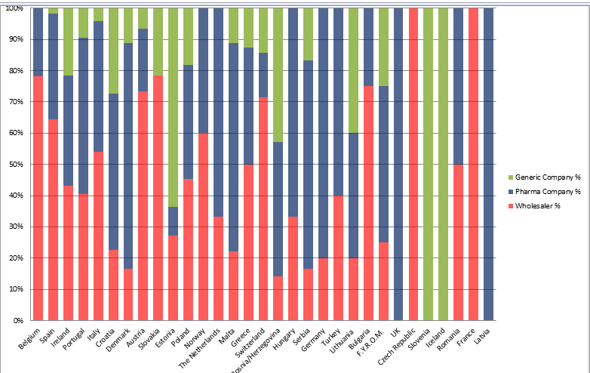

[Chart 7 – showing the type of shortages reported by country. N=424]
Comments
It was not possible to submit comments in this question.
Analysis
The results of this question can be compared to results from EAHP’s 2013 survey[1, 2] in which 57.1% (n=324) commonly experienced shortages with generic (off patent) medicines and 42.9% (n=324) described problems with originator (patented) medicines.
The terms of the question in the 2014 were amended from the 2013 survey. Feedback from the previous survey suggested that “generics” should also concern branded generics.
This change is one potential factor that accounts for a decrease in the number of respondents (%) from (57.1%, n=324 reduced to 37.5%, n=424) that reported generic medicines as the primary category of shortage. The situation may have changed of generic medicine shortage since the last survey.
Additionally unlicensed medicines were included as a separate category following feedback from the previous survey.
For patented (originator) medicines the number of respondents (%) reporting it as the primary category of medicine in short supply increased (from 42.9%, n=324 to 52.1%, n=424). Compared to the 2013 survey results, this might be an indication of a worsening patented (originator) shortage problem.

Overall, however a similar picture to that gained from the 2014 as that derived from the 2013 survey; that shortages are affecting both the supply of generic and originator products, though the causational factors behind both may differ.

4) In which area of medicine does your hospital experience shortage most commonly?

Possible answers were:
Antimicrobial agents (Antibiotics/Antivirals/Antifungals)
Oncology medicines
Emergency medicines
Cardiovascular medicines
Anaesthetic Agents
Endocrine Medicines
Preventative Medicines (e.g. Vaccines)
Haematology medicines
Paediatric medicines
Respiratory medicines
Topical Treatments
Gastrointestinal Medicines
Orphan medicines
Renal medicines
Urology medicines
Transplant medicines
Other
Additional Comments could be provided.
418 respondents replied to this question.
The areas in which shortages of medicines were most commonly reported were:
  - Antimicrobial agents (237, 56.7%,) – new from previous EAHP surveys
  - Oncology medicines (228, 54.5%)
  - Emergency medicines (127, 30.4%)
  - Cardiovascular medicines (127, 30.4%)
  - Anaesthetic agents (110, 26.3%) – new from previous EAHP surveys
It is interesting to note that at least 19 (4.5%) reports were received for the lowest affected category of Transplant medicines, indicating the widespread variety of the categories (16 in the question) affected.

[Chart 8– Chart showing the category of shortages reported overall. The categories with the highest number reported include Antimicrobials (56.7%), Oncology (54.5%) Emergency medicines (30.4%) and Cardiovascular medicines (30.4%), n=418]
Countries reporting the highest prevalence of shortage in antimicrobials included Poland (54.55%, n=11), Germany (100%, n=5), Austria (93.33%, n=15), Italy (62.5%, n=24), Belgium (86.76%, n=68) and Spain (51.67%, n=60).
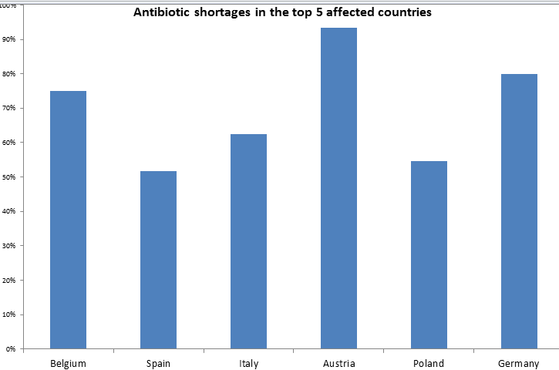

Chart 9 – showing the countries that reported the highest proportion of shortages relating to antimicrobials (including antivirals and antifungals). Across the x-axis the countries are in the order of the number of responses. Belgium (n=68) to Germany (n=5)
Countries reporting the highest prevalence of shortage in oncology medicines were Bosnia/Herzegovina (85%, n=6), Turkey (80%, n=5), F.Y.R.O.M (75%, n=3), Bulgaria (75%, n=3), Slovakia (76.92%, n=13), Serbia (83.33%, n=6), Switzerland (83%, n=6), Norway (77.78%, n=9), The Netherlands (70%, n=10), Hungary (100%, n=6), Greece (75%, n=6), Denmark (60%, n=15), Austria (86.67%, n=15), and Portugal (71.43%, n=28).
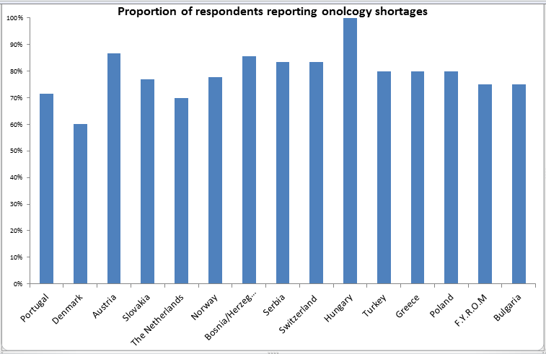

Chart 10 – showing the countries that reported the highest proportion of shortages relating to oncology . Across the x-axis the countries are in the order of the number of responses from Portugal (n=28) to Bulgaria (n=3)
The countries reporting the high prevalence of shortages in cardiovascular medicines were Malta (77.78%, n=7), Lithuania (60%, n=3) and Italy (60%, n=25). In the previous EAHP survey, 2012-13[1], this category was also in the top three categories affected.
Interestingly preventative medicines (including vaccines) were in short supply in Switzerland (83%, n=5); emergency medicines were affected in Estonia (63.64%, n=7) and Ireland (69.44%, n=36); transplant medications in the Czech Republic (100%, n=3) and in Croatia there was a supply problem with anaesthetic agents (47.62%, n=21).
Comments
83 comments were received on this specific question with examples provided below from a variety of countries :
- Gynaecological medicines, psychiatric drugs, ophthalmic medicines and pain medication was mentioned as a separate categories
- Contrast media used for x rays was mentioned a number of times.
- Specifically IV formulations
- Biologics including monoclonal antibodies
- Medicines coming off patent protection
- Nutrition
- Diagnostic agents
Analysis
The results again correspond to EAHP’s 2013 survey[1] with oncology, cardiovascular and emergency medicines featuring highly as areas of reported medicine shortage. A new entrant, as the top area of medicine shortage in 2014 is antimicrobial agents. In the 2013 survey, this was not listed as an option, but comments received to that question indicated it was an area of shortage. For similar reasons, the 2014 survey also listed anaesthetic agents as an option, and received a strong response.
The results underline and emphasise the concerns about medicines shortages being raised by health professionals and patients in the cancer sector ^{[3]} (Printz, C et al 2012) and are confirmed by the survey results. The entry of antimicrobial agents as the top reported area of shortage takes on additional dimension in the context of antimicrobial resistance and the need for better stewardship of these medicines. This evidence indicates the availability challenge that has to be overcome to achieve the responsible and prudent use of antimicrobials, in the fight to combat antimicrobial resistance.

5) Please tell us some of the most common medicines you have experiences shortages with during the past year. If possible please include their brand name, INN (International non-proprietary name) and common indications as appropriate or available.

This question was included in order to obtain examples that affect hospital pharmacists in different countries in Europe, to see where some shortages of the same medicine are clearly affecting numerous countries, and to make comparison to the catalogue of medicines in shortage held by the European Medicines Agency.

Sources of Supply

6) Which of the below categories best describes the main external source of supply of medicines to your hospital?
Possible answers were wholesaler (international/national), direct from the pharmaceutical (originator) company, direct from the generic company or “specials” company. Additional comments could be provided.
367 respondents answered this question.
170 (46.32%) stated that they obtain medicines mainly from a wholesaler (international/national)
146 (39.78%) stated that their main external source of supply for medicines was direct from the pharmaceutical (originator) company
44 (11.99%) stated that their main external sources of supply was from a generic company with 7 (1.91%) replying that their supply was from a “specials” company.
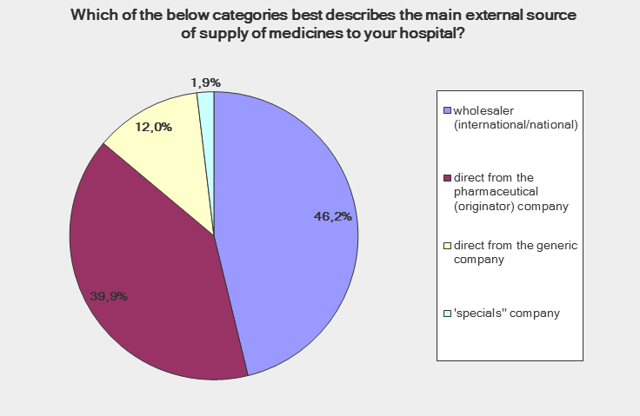

[Chart 11– showing the main external source of supply of medicines to the hospital. N=367]
The countries indicating the greatest use of wholesaler as the principal source of supply were: Ireland (97.14%, n=34), , the Czech Republic (100%, n=3), the Netherlands (100%, n=8), Norway (100%, n=9), Slovakia (100%, n=14), Estonia (100%, n=10), Malta (85.71%, n=7), Bosnia/Herzegovina (100%, n=6), Slovenia (100%, n=3), Bulgaria (100%, n=4), Croatia (89.47%, n=19), Hungary (66.67%, n=6), Serbia (83.33%, n=6),
The countries indicating the originator country was their principal source of supply were Spain (74.17%, n= 54), Belgium (84.38%, n=64), Italy (42.86%, n=21), and Austria (92.86%, n=14).
The countries indicating that the generic company was their principal source of supply were Portugal (44.00%, n=25), Iceland (100%, n=1), and Switzerland (85.71%, n=7)
In addition supply from “specials” companies were also prevalent in Denmark (25%, n=12).

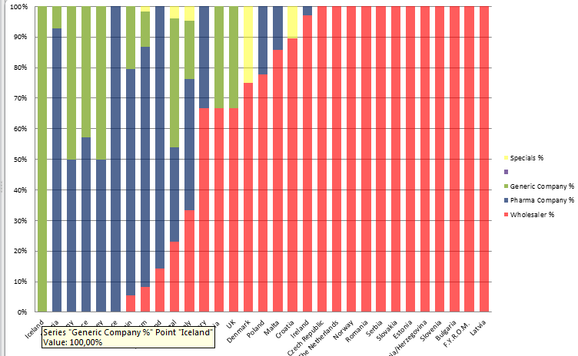

[Chart 12 showing the source of main purchasing by country (% of responses to question 8) n=366]
Comments
A noted comment out of the 20 received was that Amgros supplied all the hospitals in Denmark and this was a joint collaboration between the hospitals and the industry.
Analysis
Overall, wholesaler was indicated to be the most common source of supply for hospital pharmacists responding to this question, followed by the pharmaceutical (originator) company and then the generic company.
In the EAHP Practice Survey conducted in 2010 the supply of pharmaceutical products to hospitals was analysed[4]. Most supplies were sourced from wholesalers (51%) and the pharmaceutical industry (46%). This leaves a small proportion of supply from other hospitals, specialised production and ‘’in house’’ production. It is important to note here that there was no distinction in this survey between pharmaceutical companies producing originator (patented medication) and generic companies. Larger hospitals tend to obtain their supply from the pharmaceutical industry and less from wholesalers, and smaller hospitals tend to obtain their supply through wholesalers, with less from the pharmaceutical industry[4].
Within Europe there is a geographical division regarding supply between northern-eastern Europe and south-western Europe. The difference is that supply from the pharmaceutical industry is more common in north-eastern Europe and in the south-western part of Europe supply is more commonly from wholesalers[4]. It was commented that possible reasons for this could include the concentration of the pharmaceutical industry in western Europe, and potential pricing structures in eastern Europe which favour wholesale supply[4].

7) From which category of external supply does your hospital most frequently encounter problems with sourcing specific required medicines?

Possible answers were: wholesaler (international/national), direct from the pharmaceutical (originator) company, direct from the generic company or “specials” company. Additional comments could be provided.
There were 357 responses to this question.
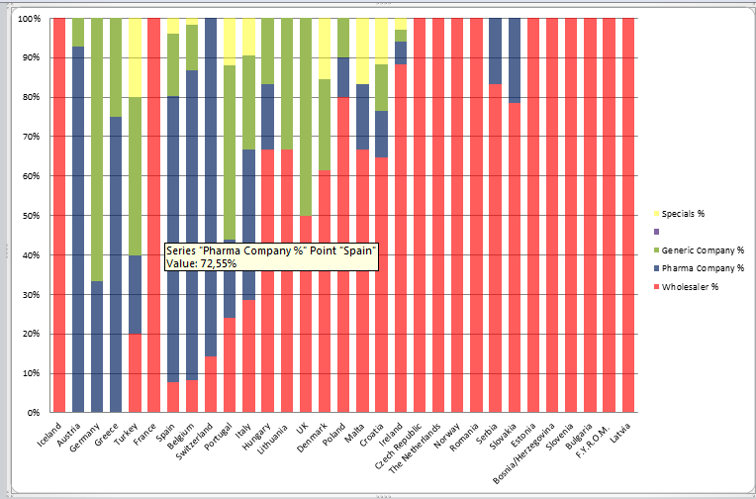
The most problems were seen with supply from wholesalers (155, 43.70%), then the originator company (137, 38.38%), 48 (13.46%) from the generic company and 16 (4.48%) from a “specials’’ manufacturer.

[Chart 13 – showing the countries and which shortages are most commonly associated with. N=357]
Countries with the greatest prevalence of supply difficulty from wholesalers included Ireland (88.24%, n=30), the Czech Republic (n=3), the Netherlands (87.5%, n=8), Norway (100%, n=9), Poland (77.78%, n=9), Serbia (78.57%, n=14), Estonia (100%, n=10), Malta (80.00%, n=5), Bosnia/Herzegovina (100%, n=6), Slovenia (100%, n=3), Bulgaria( 100%, n=4), Croatia (64.71%, n=17), Denmark (61.54%, n=13), and Hungary (66.67%, n=6).
Countries with the greatest prevalence of supply difficulty from originator companies included Spain (72.55%, n=51), Belgium (78.69%, n=61), Austria (92.86%, n=14), Greece (75%, n=8), Poland (80%, n=10), Serbia (83.33%, n=6), and Italy (38.10%, n=21),
Countries with the greatest prevalence of supply difficulty from generic companies included Germany (66.67%, n=3) and Switzerland (85.71%, n=7).
Shortages were reported from a variety of sources in Croatia, Denmark, Turkey and the UK.
Comments
Out of the 18 comments received, they included:
“usually it is not related to the type of company” – Hospital Pharmacist, Spain (Illes balears)
“exchange between other hospitals” – Hospital Pharmacist, Belgium (Brussels)
“The problem is manufacturer, not wholesaler” – Hospital Pharmacists, Croatia (Zagreb)
Analysis
Comparison with previous question still required

Duration of shortages

8) In your experience, how long would you estimate the average or typical medicines shortage normally lasts for?
Available answers were: a number of days, a number of weeks or a number of months.
397 participants answered this question.
29 (7.3%) respondents stated that the average shortage of medicines lasted “a number of days”
252 (63.47%) respondents stated that the average shortage of medicines lasted “a number of weeks”
117 (29.47%) stating that they lasted a number of months

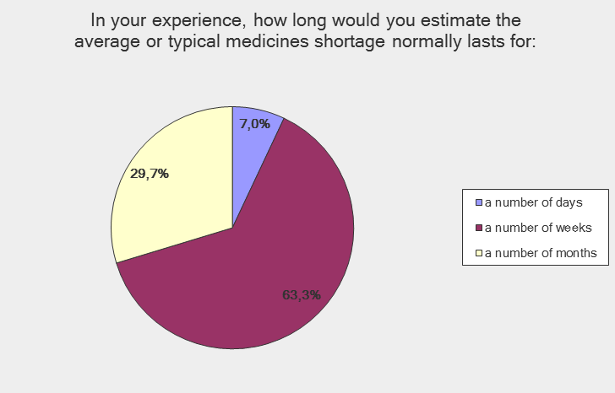

[Chart 14 - showing the duration of shortages reported by European Hospital pharmacists, n=387 ]
Comments
[To be inserted]
Analysis
The report authors note with interest the high percentage of responses indicating their perception that the average or typical medicines shortage normally lasts a number of months.
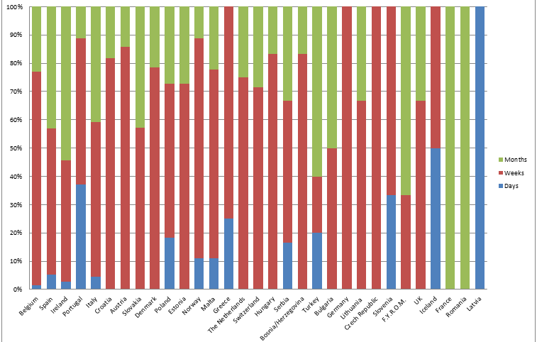

[Chart 15- showing the duration of shortages per country. The order of the countries is from the highest number of responses to the lowest, Belgium (n=65) to Latvia (n=1). Overall for this question n= 390]
Days – Portugal (37.04%, n=27)
Weeks – Switzerland (71.43%, n=7), Bosnia/Herzegovina (83.33%, n=6), Malta (66.67%, n=9), Estonia (72.73%, n=11), Slovakia (42.86%, n=14), Poland (54.55%, n=11), Norway (77.78%, n=9), The Netherlands ( 53.85%, n=11), Hungary (83.33%, n=6), Greece (75%, n=8),Germany (100%, n=4), Denmark (78.73%, n=14), Czech (100%, n=3), Croatia (81.82%, n=22), Austria (85.71%, n=14), Italy (52.83%, n=22), Portugal (51.85%, n=27), Ireland (42. 86%, n=35), Belgium (75. 38%, n=65), Spain (51.72%, n=58)
Months - Turkey (60.00%, n=3), Slovakia (57.14%, n=14), Croatia(18.18%, n=22), Italy (42.86%, n=22), Ireland (54.29%, n=35), Belgium (23.08%, n=65), Spain (43.1%, n=58)
Analysis
To be inserted

9) What is the longest duration that you can recall a medicines being in shortage for?
284 responses were received to this open ended question.
These include:
Caelyx (liposomal doxorubicin) affected for over a year and DepoCyte (liposomal cytarabine) – several months. Hospital Pharmacist, Norway, (Oslo)
Halothane (2-3 years) Hospital Pharmacist, Malta
Several years (Trifluoperazine, Praziquantel) – Hospital Pharmacist, Spain (Catalunya)
years (e.g. Decan multivitamins for parenteral nutrition) – Hospital Pharmacist, Spain (Madrid)
lorazepam IV - more than two years - Hospital Pharmacist, Italy
Fludarabine, more than one year – Hospital Pharmacist, Belgium (Antwerp)
More than 1 year magnesium sulphate ampules dexamethasone IV (aacidexam) colimycin (powder, vrac) – Hospital Pharmacist, Belgium (East Flanders)
Synacthen and Nuvacthen. They have not been available for 9 months. We do not know when they will become available again. – Hospital Pharmacist, Spain
Analysis
The high number of answers to this open-ended question and the frequent responses about shortages lasting longer than the year is notable. It provides an indication that medicines shortage problem are that not of a temporary nature and for some patients can mean long term diversion from the recommended treatment, relying on other (possibly more expensive) alternatives.

Impact of shortages

10) In the case of a medicine in short supply, how often do you estimate your hospital is able to provide treatment to a patient by providing a therapeutic equivalent or near equivalent medicine, without major disruption to their treatment?

Possible answers were: all of the time, most of the time, sometimes, rarely, or never.
371 respondents answered this question.

Providing treatment without major disruption to the patient’s treatment happened ‘’all of the time’’ according to 41 (11.05%) of those who responded.

Providing a therapeutic equivalent or near equivalent medicine could occur ‘’most of the time’’ according to the majority of those who answered this question, 246 (66.31%).

This meant that treatment could be provided without major disruption in all or most cases according to 287 (77.36%) of those who answered.

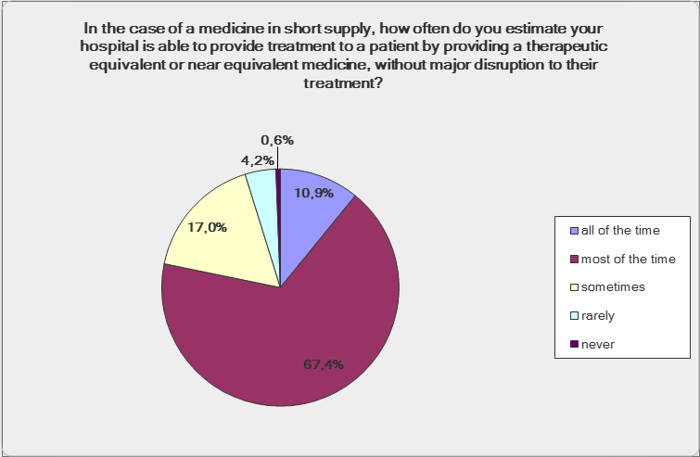

[Chart 16 to show the ability of pharmacists to manage shortages in their hospitals, n= 359]

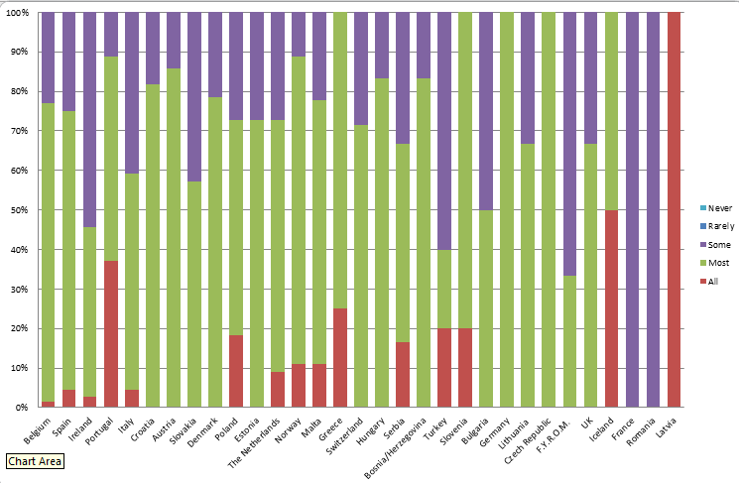

(Chart 17 to show the ability of pharmacists to manage shortages in each of the countries. The order of the countries is due to the number of responses from Belgium (n=65) to Latvia (n=1). Overall n=359)
As Chart 17 indicates (in Green) a large proportion of the countries felt that they could provide care to patients without major disruption in the event of a shortage. Nevertheless the chart also shows that for nearly all countries there is a proportion of hospital pharmacists that feel that that this can only happen some of the time, and therefore some of the time patients do suffer major disruption to their treatment.
In Ireland 54.3% of the responses (n=35) stated that sometimes patients can be given pharmaceutical care, without major disruption. Large responses for this option were also seen with answers from Turkey (60%, n=5), F.R.O.Y.M (66.7%, n=3), Slovakia (42.9%, n=14) and Italy (40.91%, n=22).
Comments
[To be inserted]
Analysis
The results indicate that whilst most of the time the hospital pharmacist is able to take steps to secure a therapeutic alternative for a medicine in shortage, all to often this is not the case. There is a hidden story here of patients not being able to get the medicines they require due to supply shortage that deserves further investigation.
The results also give medication of the enormous work conducted by hospital pharmacists to track down alternative supplies in order to maintain levels of patient care.

11) In an average week in your hospital, how much time (staff working time) do you estimate is diverted because of drug shortage problems?

Possible answers were: less than one hour, up to 5 hours, up to 10 hours, up to 15 hours or more than 15 hours. Respondents were also to make comments.
379 respondents answered this question.
Regarding the time members of hospital pharmacy staff were required to work due to medicines shortages the most common answer was up to 5 hours per week, reported by 213 (56.2%) of those who replied.
Less than 1 hour was spent on this problem by 51 (13.45%) of the respondents.
More than 5 hours a week were reported by 119 (31.40%) respondents, with 70 (18.47%) stating up to 10 hours, 22 (5.80%) choosing up to 15 hours and 27 (7.12%) stating that pharmacy staff spent more than 15 hours attempting to solve the problem.
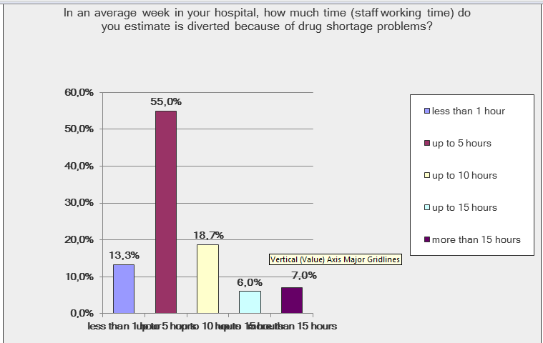

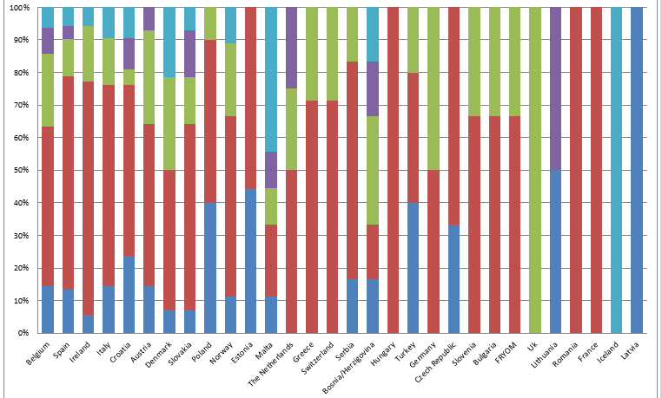
[Chart 18 – chart to show the amount of time that staff working in the hospital pharmacy have to allocate to dealing with medicine shortages. N=369]

[Chart 19 showing the number of hours (as a proportion) pharmacy staff had to devote to managing the shortages problem by country. The order of the countries are in order of the number of responses. N = 379]
The countries with respondents reporting the most time being lost to shortages problems were…
>15 hours/week included
Iceland (100%, n=1), Malta (44.4%, n=9) Denmark (21.4%, n= 14) and Bosnia/Herzegovina (16.6%, n=6)
Up to 15 hours per week included:
Lithuania (50%, n=2), Portugal (19.2%, n=26), The Netherlands (18.2%, n=11)

Up to 10 hours per week included
UK (100%, n=3), Germany (50%, n=3), Bosnia / Herzegovina (16.67%, n=6)
Up to 5 hours per week included
Hungary (100%, n=5) Romania (100%, n=1), France (100%, n=1), Greece (71.4%, n=7), Switzerland (71.4%, n=7)and Ireland (55.6%, n=35)
Less than 1 hour per week included
Latvia, (100%, n=1), Lithuania, (50%, n=2), Estonia (44.4%, n=9)and Poland (40%, n=10)
Comments
12 comments were received on this question with examples provided below:
More than 15 hours – the accumulation of pharmacist, technician and pharmacy assistant would = 19.25 hours - Hospital Pharmacist, Belgium (East Flanders)
More than 15 hours – not personally but as a pharmacy department in general 1.5 FTE pharmacists work solely on chasing out-of-stock items. Hospital Pharmacist, Malta
15 working hours is only administration of shortages. Unknown number of hours are spent on the wards with information and new routines - Hospital Pharmacist, Norway
Up to 10 hours – this applies to the staff only in the hospital pharmacy - Hospital Pharmacist, Slovenia
Analysis
The lost and diverted time in the hospital pharmacy given over to trying to track down medicines to meet a patient’s prescribed needs is one of the most frequent anecdotally reported problems to EAHP of the damaging impact medicines shortages have on the delivery of healthcare. These results confirm that problem and it is well noted that many comments estimated over 15 hours of lost time due to shortages with some hospital pharmacies needing to employ full time equivalents to deal with the problem. In the context of cost-efficient health services, the problem of medicines shortages is creating drag and inefficiencies for the hospital sector and, beyond the patient impact, reemphasises the need for health system managers and political decision makers to take action.

12) Do you agree with the following statement? ''Medicines shortages in my hospital are having a negative impact on patient care."

Possible answers were: strongly agree, agree, unsure, disagree or strongly disagree.
The majority (285, 75.20%) of the 379 who answered this question strongly agreed (110, 29.02%) or agreed (175, 46.17%) with the statement relating to the negative impact on patient care.
68 (17.94%) were unsure of the effect.
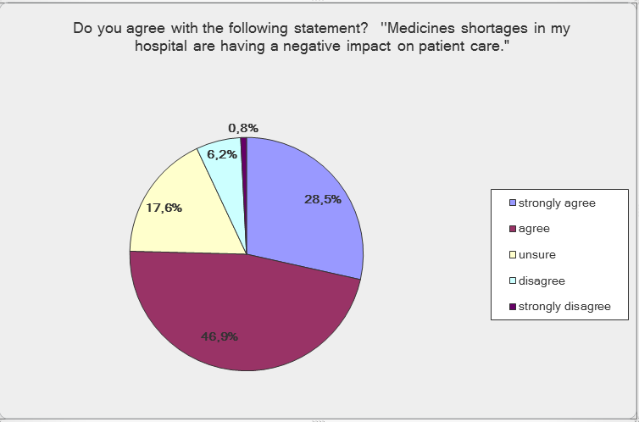
23 (6.07%) disagreed with the statement, with 3 (0.79%) strongly disagreeing.

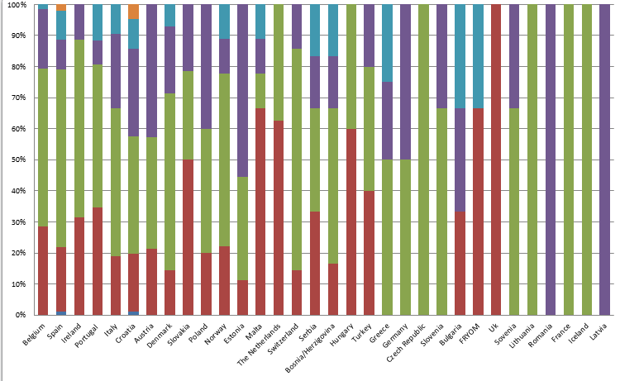
[Chart 20 – showing the level of agreement with the statement “Medicines shortages in my hospital are having a negative impact on patient care” n =369]

[Chart 21 – showing the level of agreement (as a proportion) with the statement by country. N= 369]
The countries agreeing most strongly with this statement were:…
Strongly Agree: UK (100%, n=3), Malta (66.6%, n=9), FRYOM (66.6%, n=3), The Netherlands (62.5%, n=8) and Hungary (60%, n=5)
Agree: Czech Republic (100%, n=3), Lithuania (100%, n=2), France (100%, n=1), Iceland (100%, n=1), Switzerland (100%, n=7)
The countries disagreeing most strongly with this statement were:
Strongly Disagree Croatia (4.76%, n=21), Spain (1.92%, n=52)
Comments
“I work as a clinical pharmacist in the gastroenterology department in the past year mesalazine rectal preparations have always been problematic causing a lot of undue hassle to patients and also to staff working within this fields.” Hospital Pharmacist, Malta
Analysis
The strong agreement with the statement indicates the general perception of hospital pharmacists on the question. Reasons for how shortages negatively impact patient care are evidenced in other parts of EAHP’s 2014 survey but include not being able to provide the patient with a therapeutic equivalent, delays in the getting the medicine to the patient, diversion of hospital pharmacist time from other tasks important to patient care, and raised stress levels in a safety critical environment.

13) Please provide any relevant examples from your hospital over the past year of the impact medicines shortages have had on patient safety welfare.

184 responses were received including:
“A shortage of kwells (Hyoscine) has meant our clozapine patients are suffering from hypersalivation unnecessarily.” Hospital Pharmacist, UK (Staffordshire)
“Teicoplanin shortage prompted review and change of antibiotics for many patients in our hospital. These alternative agents had a higher association with clostridium difficile and was not the optimum choice for patients” Hospital Pharmacist, UK (Cheshire)
“We had a shortage of bosentan for two months, due to which most PAH patients had deterioration of their disease” Hospital Pharmacist, Bosnia and Herzegovina
“Change of antimicrobial therapy for less efficient, for example: shortage of amikacyne caused that for some resistant bacteria (that amikacyne showed best efficiency in treatment and antibiotic therapy) had to be changed for less efficient, or the change had to be changed in the middle of therapy”, Hospital Pharmacist, Croatia
“There were delays in treating patients or having to maintain a patient on intravenous treatment just because the oral alternative was not available. In addition, patients who get their out-patient treatment from an NHS pharmacy sometimes require hospital admission because they are not available” Hospital Pharmacist, Malta
They result in much higher use of unlicensed medicines which carries an inherent risk. – Hospital Pharmacist, Ireland
Oncology: therapy has to be postponed, which is very stressful and sometimes harmful for the patient – Hospital Pharmacist, The Netherlands
Analysis
Key themes within replies to this question include…

14) Please describe practically how a medicine in short supply is usually dealt with to minimise the impact on patient care. (Please tick all that apply)

Possible answers were:
- substitute (without consultation with the prescriber/the patient)
- inform prescriber and recommend an alternative
- inform prescriber of the shortage
- investigate when supply will be restored and plan stock accordingly.
- attempt to source the medicine from an alternative suppler (including another country)
- change the formulary based on the information provided
Additional comments could have been provided.
345 hospital pharmacists responded to this question.
The most common action that was taken practically was ‘’informing the prescriber and recommend an alternative’’ with 286 (83.0%) selecting this option.
121 (35.07%) of the respondents substituted the medicine with an available alternative without consulting the prescriber or the patient.
200 (57.97%) informed the prescriber of the shortage.
227 (65.79%) investigated when supply would be restored and planned accordingly.
231 (66.95%) attempted to source the medicine from an alternative supplier (including another country).
The least common action was changing the formulary based on the available information with only 59 (17.1%) choosing this action.

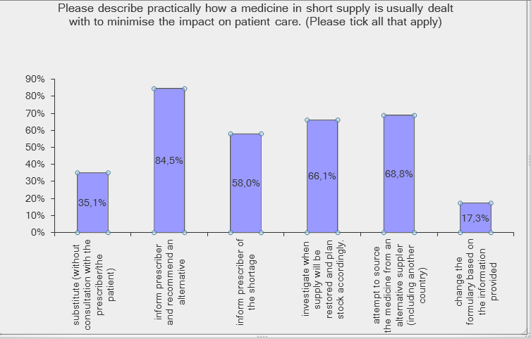

[Chart 22 - showing the typical actions hospital pharmacists undertook in the event of a shortage. N=336)
Comments
12 comments were also received in response to this question, summarised below
Changes may be needed to the IV Guidelines – Hospital Pharmacist, Ireland (Dublin)
Borrow from other hospitals if possible
Hospital Pharmacist, Portugal (Lisbon) and Croatia (Zagreb)
Discussion in the Pharmacy and Therapeutic Committee – Hospital Pharmacist, Portugal (Lisbon)
Change formulary only if no other solution – Hospital Pharmacists, Greece (Athens)
Due to shortage of Trandate inj we had to relocate the last packages through hospitals within the region in order to treat patients who did not respond on alternative therapies. – Hospital Pharmacist, Norway
Analysis
When asked how a medicine shortage is handled within a hospital pharmacy it is clear that a combination of measures are used to varying degree, although all the proposed solutions at a local level were described by respondents.
The difference seen with recommending an alternative and just informing the prescriber shows that hospital pharmacists are taking responsibility for proactively advising the prescribers of the available products, and what would be appropriate for individual patients. This shows the skill and importance of hospital pharmacists as suppliers of medicines.

15) What changes (if any) in practice has your hospital needed to make in order to deal with the shortages problem? (Please tick all that apply)

Possible answers were:
- Reassign staff work profiles and job descriptions (I.e. devote staff resources more specifically to dealing with shortages)
- create new communication systems and tools to alert prescribers and other hospital staff about the presence of shortages and the need to substitute replacement therapies
- readjust budget plans due to additional expenditure caused by shortages (e.g. needing to use more expensive replacement therapies)
- cancel practice improvement and development initiatives due to resources having to be reassigned to dealing with the shortage problem
- no changes required
Additional comments could have been provided.
328 hospital pharmacists responded to this question.
The most common change in practice was the creation of communication tools to inform prescribers and other healthcare professionals of the situation. This was selected by 205 (62.5%) and was followed by a review of the budget (114, 34.76%)
98 (29.88%) reassigned staff to cope with this situation and 66 (20.12%) cancelled service improvement, with 44 (13.41%) not requiring any change in practice to cope.
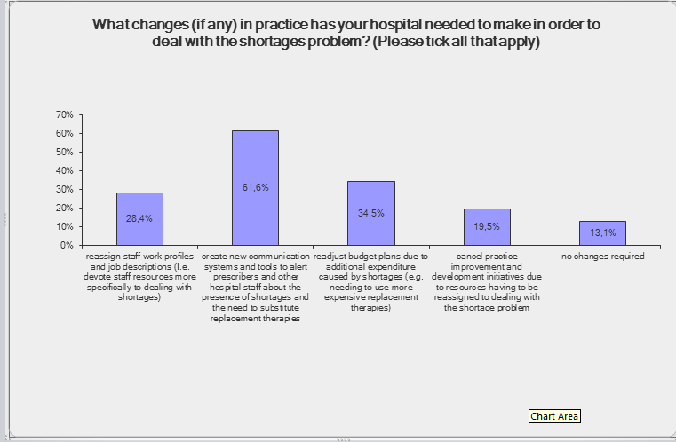

[Chart 23 - showing the new actions required of hospital pharmacists in the event of a shortage. N=328]
Comments
13 comments were received and are summarised below:
‘’No changes required because it has been like this forever, we just adjusted to it’’ Hospital Pharmacist, Belgium (Brussels)
‘’Increased the role of hospital pharmacy in the supply of medicines and decision making process.’’ Hospital Pharmacist, Portugal (Lisbon)
‘’We needed to increase production of medicines’’, Hospital Pharmacist, Poland (Wroclaw)
Analysis
The responses to this question underline the communication challenges posed by medicines shortages, both for pharmacists to get the right information to prescribers, nurses, patients and others; but also to receive the right information to pass on, for example why the shortage is in occurrence, how long it may last, and what alternatives are available. Only a few countries have national databases to support this activity, including Italy and the Netherlands. Such informational databases have been in existence in the USA for some time. EAHP and its members are calling for a European wide database of current shortages, their causes and available alternatives, to be run by the European Medicines Agency, and based on a similar basis to the FDA database in the USA.
The results also underline the deleterious impact shortages have on hospital budgets, with often more expensive medicines needing to be procured as an alternative, and an additional drain being placed on staff resourcing.
A high percentage of respondents also indicated that other services offered by hospital pharmacy (such as clinical pharmacy services) have suffered as a consequence of shortage problems.

16) Please provide any relevant anecdotal evidence from your hospital over the past year of the impact medicines shortages have had on patient safety and welfare.
70 responses were received
Amongst comments made were……
Analysis
Key themes within replies to this question include…

17) Please tell us some of the most common experiences of medicines in shortage you have experienced in the past year. If possible, please include their brand name, INN name and common indication, as appropriate or available.
104 responses were received
Amongst comments made were……
Analysis
Key themes within replies to this question include…
Solutions

18) Which of the following proposed policy solutions on medicines shortages would you personally support? (tick all that apply)
327 respondents answered this question. It was possible to tick more than one answer.
The available options were as follows:
Greater legal clarity on the responsibility of manufacturers to openly report forthcoming disruption in supply at an early stage, underpinned in European level legislation | 75.84%  n=248
A comprehensive database, run by the European Medicines Agency, of all medicines reported to be in current shortage in at least 5 EU Member States, with advice on how long the shortage may last and available replacement therapies, similar to databases in the USA | 72.48%  n=237
A high level investigation, led by the European Commission, of the holistic causes of medicines shortages in Europe (including production issues, pricing impacts and parallel trade), their impacts on patient care and healthcare delivery, with recommended solutions to be taken forward at European and national levels | 64.83%  N=212
Annual reporting of the extent of the medicines shortage problem within Europe by the European Medicines Agency, and suggested ameliorative actions, presented to the public, European Commission, European Parliament and all European national governments | 55.35%  N=181
[Table 1 showing the level of support for the proposed solutions/improvements in dealing with shortages. ]
Comments
(Hospital)pharmacists should not only go for the lowest possible price during the acquisition of medicines. Companies that can guarantee a reliable and better supply should be rewarded with a better price! -Hospital Pharmacist, the Netherlands (Limburg)
“In this case we increase the purchasing and define the safe procedure (LASA, High risk meds and so on. Sometimes it is a big problem to ensure the continuity of care.” Hospital Pharmacist, Italy (Sicily)
Analysis
The two most popular options (over 70% of those who responded) were a central database hospital pharmacists could consult with recommendations, and more legal clarity on the responsibility of manufacturers to openly report forthcoming disruption.
Once more, the results underline the communication challenge hospital pharmacists face in advising prescribers, patients and others about shortages problems, and receiving far too little information about the cause and likely length of medicines shortages to make robust contingency plans.
The results underline the strong support from the profession for EAHP’s principal advocacy messages about medicines shortages at the European level – the need for a European database of medicines in shortage across Europe, managed and overseen by the European Medicines Agency, including information on the likely duration of the shortage, and available alternatives. This should be underpinned by strengthened legal requirements on manufacturers to report forthcoming disruptions in supply. Such actions have been taken in the United States of America (USA) with positive impact ^{[5]}(Gupta, D.K. and S.M. Huang 2013) and should be replicated in the European Union.
Q21: In the country you work in, are there national level approaches in place to address the medicines shortage problem e.g. websites with information about current shortages. If so, please give a short description of these, including reference to both your country of practice, and the extent to which you consider the approach is working.
Greece: National Drug Association Website
Cyprus: Informal communication with the suppliers
“There does not appear to be any comprehensive plan to address shortages in Ireland nor any consistent approach to the requirement of manufacturers or suppliers to notify customers of shortage or make substitute available.” Hospital Pharmacist, Ireland (Cork)
Austria: www.basg.gv.at
Germany: http://www.bfarm.de/DE/Arzneimittel/Pharmakovigilanz/Risikoinformationen/Lieferengpaesse/_node.html (Last updated 1st July 2014)
Netherlands: www.farmanco.knmp.nl
“this website works very well and provides you with alternatives, if possible” Hospital Pharmacist, The Netherlands
www.farmanco.knmp.nl is a website that provides all information about shortage, duration and replacement therapies. (initiated bij KNMP, the Dutch Association of pharmacists). The information provided is very accurate and helpful in our hospital. Hospital Pharmacist, The Netherlands
Italy: - AIFA
UK:“Not that I know of” Hospital Pharmacist, UK (Staffordshire)
Croatia:
- National healthcare insurance company's website with information about current shortages with advice on how long the shortage may last.
- Website of Agency for medicines and medical devices with information about current shortages with advice about available replacement therapies
“Website of the Croatian medical agency with information about current shortages and oral information from the wholesaler. But it should also have the information of the solution of the problem (alternative drug or what to do if there is not any alternative).” Hospital Pharmacist, Croatia

Bulgaria:

We can write to the Ministry of Health – Hospital Pharmacist, Bulgaria
Norway:
There is a national coordinator for information on drug shortages in hospitals. Information is supplied to all hospitals and hospital pharmacies on a regular basis. A medicine shortage team consisting of pharmacists and doctors meet with the Medical Agency once a month. – Hospital Pharmacist, Norway
National medicines authority in Norway; "Statens legemiddelverk". Information is ok, and alternatives are often provided - but the information comes too late. – Hospital Pharmacist, Norway
Serbia
National-health-fund (RFZO - Republučki fonda za zdravstveno osiguranje) is getting info about shortages from phapmacys weekly, and the only step that RFZO is making is: putting once or twice a year shortage drug (INN, way of administration and quantitative information) to "D-List"; it is a list of drugs wich are not registered in our coountry and may be imported with special licence from Agency for drug s and medical supplies (ALIM - Agencija za lekove i medicinska sredstva) – Hospital Pharmacist, Serbia
Ireland
The Irish Pharmacy Union, which represents community pharmacists, maintains a list of short items on their website. However, this has a community focus and often does not include the products which have the most impact on hospital practice when they are short. There is no national initiative that I am aware of. – Hospital Pharmacist, Ireland
Conclusion
To be entered
References:
Annex 1
Shortages outside of Europe – including EAHP non European Data and USA, Canada, Australia etc.

