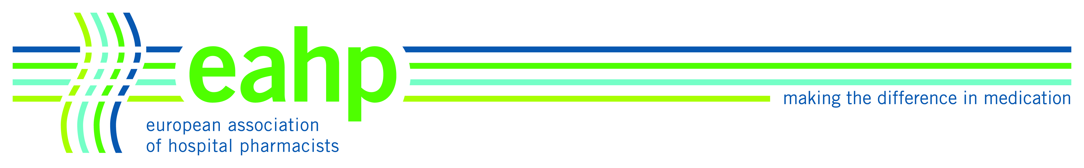
AGENDA
Scientific Committee Meeting
27 September 2014
08.00 – 17.00

Sheraton Brussels Airport Hotel
Brussels Airport
1930 Zaventem
Belgium

- Welcome and apologies

- New SC members
a. Raisa Laaksonen (Finland)
b. Thomas De Rijdt (Belgium)

- Approval of minutes from Hamburg meeting, May 2014

- Update on Hamburg congress
  - overview of programme
  - keynotes and presenters
- update on confirmed speakers

5. Confirm facilitators and review room allocations

6. Review of TG & LOs including the ACPE verbs to use for LOs

7. Update on the 2015 Synergy programme

8. National highlights during future congresses

9. Update on the Academy programme
- Feedback on the September academy seminar (KN & HJ)
- Proposals of topics for 2015 & 2016 academy seminars

10. Posters
- Evaluation teams for abstracts
- Poster prize committee
- Election of Barcelona Poster Prize judges
- 12 nominees (winner decided during Thursday lunch) (1st 2nd 3rd)

11. EAHP survey on the topics to address in next congresses: analysis of results

12. Discussion on the programme of the Vienna congress
a. Selection of theme
b. Update on the request from The United Kingdom Clinical Pharmacy Association (UKCPA) to be involved in the 2016 EAHP Congress

13. Update on the EAHP application for funding support to the European Commission’s COST programme – HJ

14. A joint worshop with C-KIN (Cancer and the Kidney International Network) at their first congress on 14-15 April 2015, Brussels

15. Request from the First class agency to build-up an academy programme for the Saudi Arabia hospital pharmacists

16. Proposals following ACPE recommendations (GS, HJ, JDG)

17. Future meeting dates

  - 7-9 November 2014: 8.00 – 18.30 on the 7th, 8.00 – 18.30 on the 8th, and 9.00 – 12.00 on the 9th (Brussels).
  - 16- January 2014: 11.00 - 18.00 on 16th and 09.00 - 14.00 on 17th (Brussels)
  - 24 March 2015, Hamburg: 17:30 - 19:30
  - May 2015: dates to be chosen
  - September 2015: dates to be chosen

18. Any other business

