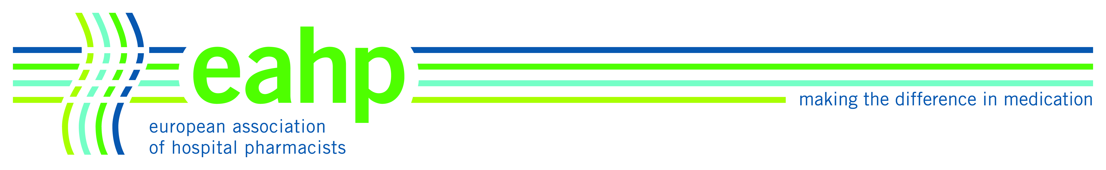

AGENDA
Scientific Committee Meeting
22 September 2012
11.00 – 18.00

NH Brussels Airport
De Kleetlaan, 14
1831 DIEGEM

- Welcome and apologies

- New SC and SAG members

- Approval of minutes from Paris meeting, May 2012

- Update on Paris congress
  - overview of programme
  - keynotes and presenters
- update on confirmed speakers

5. Confirm facilitators and review room allocations

6. Review of TG & LOs

7. Update on the Synergy programme

8. Update on the Academy programme: structure and business case

9 . Posters

  - Evaluation teams for abstracts
  - Review of revised abstract review module and update on modifications/splitting of groups
  - Poster prize committee
- Election of Paris Poster Prize judges
- 12 nominees ( winner decided during Thursday lunch) (1st 2nd 3rd)

10. Review of titles for the EAHP "Pearl” sessions

11. Creation of a speaker data base

12. Discussion on theme for Barcelona congress

13. Future meeting dates

- 26-28 October 2012,
- 12 January 2013,
- 12 March 2013,
- 10-11 May 2013,
- September 2013 : dates to be chosen
- November 2013: dates to be chosen

14. Any other business

