Meeting Notes

Virtual meeting
FIP Members in Europe
Regional Engagement Meeting (Virtual)
Tuesday 27 July 2021 (13:00 – 15:00 CEST)

Present from FIP Team:  Dr Catherine Duggan  Ms Farah Aqqad  Mr Christopher John  Ms Rachel van Kesteren  Dr Dalia Bajis  Ms Sherly Meilianti  Mr Aniekan Ekpenyong  Ms Ozge Ozer  Ms Aysu Selcuk  Dr Marwan Akel ​  Present from Bureau:  Mr Dominique Jordan  Other FIP attendees  Arijana Mestrovic  Josep M. Guiu  Francois-Xavier Lery  Gabrielle Wiederkehr  Louisa Sullivan  Vedran Raguz  Inês Coelho  Bram Wagner  Present from FIP member organisations:  Present from FIP observer organisations:  Apologies | Chief Executive Office  FIP Regional Engagement and Project Coordinator  Lead for Data and Intelligence  FIP Executive Secretary  FIP Lead for Provision and Partnerships  FIP Technical Officer and Data Analyst  Practice Development Projects Coordinator  FIP Educational Partnership Coordinator  FIP Educational Partnership Coordinator  Project Manager for workforce​  FIP President  FIP-Academic Pharmacy Section  FIP-Board of Pharmaceutical Practice, Hospital Pharmacy Section (VP-Europe)  European Directorate for the Quality of Medicines and Healthcare  FIP-Board of Pharmaceutical Practice, Industrial Pharmacy Section ExCo  Young Pharmacy Group (FIP-YPG)  IPSF EuRO Secretary  IPSF EuRO RRO  IPSF Chairperson of EuRO  ABDA – Federal Union of German Associations of Pharmacists  Dr Jens Gobrecht, Director of the European Representation (FIP contact person)  Associação Nacional das Farmácias  Ms Sonia Queirós, Head of Institutional Affairs/ Head of Brussels Office  Association of Danish Pharmacies  Mr Helle Jacobsgaard, Pharmacist, Specialist Consultant  Association Pharmaceutique Belge  Mr Koen Straetmans, Interim Chair (President APB)  Dr Jan Saevels, Professional Programmes  Bulgarian Pharmaceutical Union  Prof Assena Sebezova, President  Mr Venelin Sapunarov, Chairman of the Management Board of the Regional Pharmaceutical College Sofia Capital city at BphU  Mr Dimitar Marinov  Consejo General de Colegios Oficiales de Farmacéuticos  Mr Jésus Aguilar Santamaría, President  Mr Benjamin Cid Bourié, Representative  Cyprus Turkish Pharmacist Association  Ms Safiye Çagansel, Treasurer 2019-2021  Ethica Independent Pharmacies Association  Ms Cristina Pavel, President  European Association of Hospital Pharmacists  Prof Petr Horàk, Immediate Past President  European Federation for Pharmaceutical Sciences  Dr Erem Bilensoy, Past President  French Chamber of Pharmacists  Ms Carine Wolf-Thal, President of the National Council  Hungarian Society for Pharmaceutical Sciences  Prof Eva Szoko, President  Irish Pharmacy Union  Mr Darragh O’Loughlin, CEO  Malta Chamber of Pharmacists  Ms Mary Ann Sant Fournier, President  Kosova Chamber of Pharmacists  Prof Arianit Jakupi, President  Pharmaceutical Chamber of Montenegro  Dr Milanka Zugic, President  Pharmaceutical Society of Iceland  Ms Sigríður Siemsen, CEO  Ms Inga Lilý Gunnarsdóttir, President  pharmaSuisse  Ms Mélanie Brülhart  Portuguese Pharmaceutical Society – Ordem dos Farmacêuticos  Mr Jorge Batista, International Affairs Lead & Senior Editor of the Magazine  Royal Pharmaceutical Society  Mr Paul Bennett, CEO  Ms Claire Anderson, Chair of RPS English Pharmacy Board  Swedish Pharmacists Association  Ms Carin Svensson, Interim CEO  The Academy of Pharmaceutical Sciences  Ms Jo Craig, Chairwoman  Dr Linda Hakes, Independent consultant  The Royal Dutch Pharmacists Association  Dr Ka-Chun Sheung, Manager Medicine Information Centre  Slovenian Pharmaceutical Society  Dr Matjaž Tuš, President  Association of Pharmacists of Portuguese-Speaking Countries  Prof Helder Mota-Filipe  Pharmaceutical Group of the European Union  Ms Ilaria Passarani  Spanish Society of Family and Community Pharmacy  Dr Lola Murillo Fernández  European Association of Faculties of Pharmacy  Prof Lilian M Azzopardi  Fédération des Syndicats Pharmaceutiques de France Dr. Eric Garnier, International Liaison Officer  PharmaSuisse Ms Martine Ruggli, President  Commonwealth Pharmacists Association Ms Victoria Rutter  The Finnish Pharmacists Association Mr Antti Kataja, President  Portuguese Pharmaceutical Society - Ordem dos Farmacêuticos Mrs Carla Torre, Secretary General  ABDA - Federal Union of German Associations of Pharmacists Ms Regina Gabriele Overwiening, President  European Association of Hospital Pharmacists Ms Jennie De Greef, Chief Operating Officer  French Chamber of Pharmacists Ms. Hélène Leblanc, Head of public and international affairs  Association of Finnish Pharmacies Ms. Merja Hirvonen, Chief Operating Officer  Norwegian Pharmacy Association Mr Per T. Lund, CEO  Finnish Pharmacists Society Mr. Teemu Ali-Kovero, Executive Director  (Please add your name/affiliation to the above to confirm your attendance) TBC:  Luís Lourenço  Dragana Rajković

1. Opening, apologies for absence and adoption of the agenda

Some of our colleagues from Europe will not join this meeting because of annual leave. We have sent them two proposed dates to arrange for an additional regional meeting:

• Thursday, September 2nd (11.00-13.00 h CEST)

• Friday, September 3rd (14.00-16.00 h CEST)

The CEO, Dr Catherine Duggan, opened the meeting and welcomed all attendees and invited colleagues to introduce themselves.

Widening the breadth of engagement there has been an update on FIP-team regional account responsibilities which will be effective from the beginning of August.

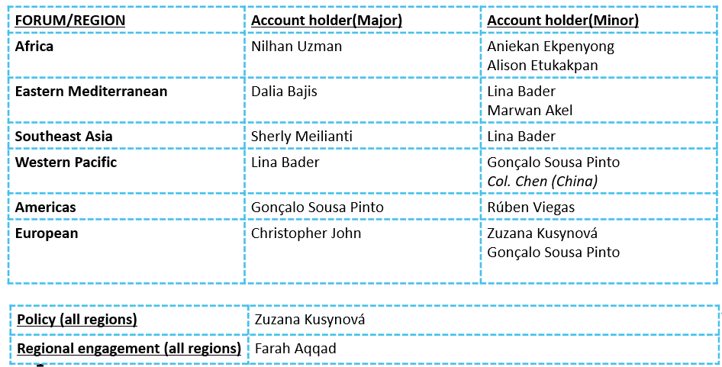

Presidential remarks were given by the CEO on behalf of Mr Dominique Jordan, FIP President. We are working together across all domains, not only science, practice, education, and workforce, but also across all regions and nations; with FIP serving as the umbrella organisation. FIP is seeking input from members on their needs, and FIP will work with members to achieve their priorities.

Activity 1: President Jordan has emphasized the following words during his presidency: TRUST – SOLIDARITY – ACTION

What values/principles do you consider important to advance pharmacy worldwide. Results:

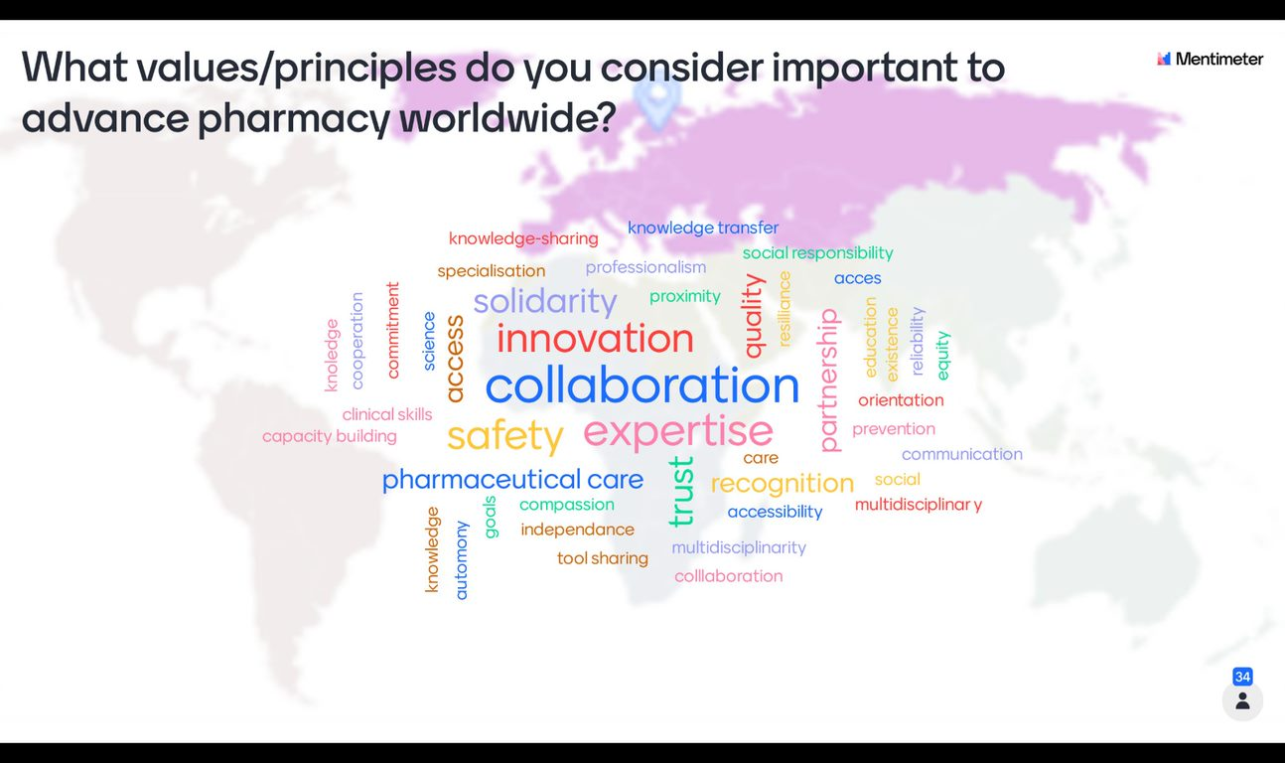

Members who attended the previous regional meeting were asked to fill in a poll and score between 1 and 10, where 1 is not engaging or informative and 10 is completely engaging and informative – results below:

Score | Number of attendees who voted
1 | 1
2 | 0
3 | 0
4 | 0
5 | 2
6 | 3
7 | 5
8 | 6
9 | 2
10 | 3

2. Member and regional engagement

a. April 2021 regional engagement meetings

The CEO highlighted the work accomplished during the April regional engagement meetings, expressed gratitude for the members efforts and support, and emphasised that we are now mapping global, regional, and national goals. The CEO stated that we would track our progress toward 2030 using the development goals and priorities of our members.

Ms Farah Aqqad presented the engagement and the attendance statistics for the April regional engagement meeting.

Action: In order to align with our future steps, we are requesting that the remaining member organisations submit their top priority development goals or priority projects that align to goals.

b. Reflections/Actions/ Next steps

The CEO highlighted the next steps in addressing our three global priorities (Astana priorities), which include noncommunicable diseases, prevention, and safety. The CEO mentioned that we will examine how that works regionally, as well as the differences and similarities between members in one or more regions, and how we might support members in describing the journey to 2023.

The CEO presented the regional mapping and members priority areas aligned to the FIP development goals, noting that there are several overarching goals, such as DG 10 (Equity & Equality) and DG 17 (Antimicrobial stewardship).

c. Feedback from our needs assessments - Multinational Education and Training Needs Assessment project (METNA)

Mr Christopher John, Lead for Data and Intelligence presented an overview of the data collection process as well as some significant findings from the analysis.

3. Feedback from members

a. Presenting back priorities and needs across the region and alignment with the FIP business plan

Dr Catherine Duggan, CEO, and Ms Farah Aqqad, Regional Engagement and Project Coordinator, presented how we intend to present and visualise the data we have collected from the members.

b. Feedback from our needs assessments - Overview of results from the prioritisation survey

A video was played by Dr Dalia Bajis, FIP Lead for Provision and Partnerships sharing results from the prioritisation survey using a visualisation tool. To receive the link for the survey please send an email to (dalia@fip.org).

Questions from the chatbox:

Ms Claire Anderson, Chair of RPS English Pharmacy Board asked if members will have access to this visualisation tool. Answer: As a member-only benefit, this will be available to all member organisations.

Ms Mary Ann Sant Fournier, President of the Malta Chamber of Pharmacists asked if this tool will be updated as new data from members is received. Answer: We endeavour to update this useful information regularly and new information is retrieved.

Activity 2: We have just presented some data about your priorities and projects, your areas of expertise and experience.

Results:

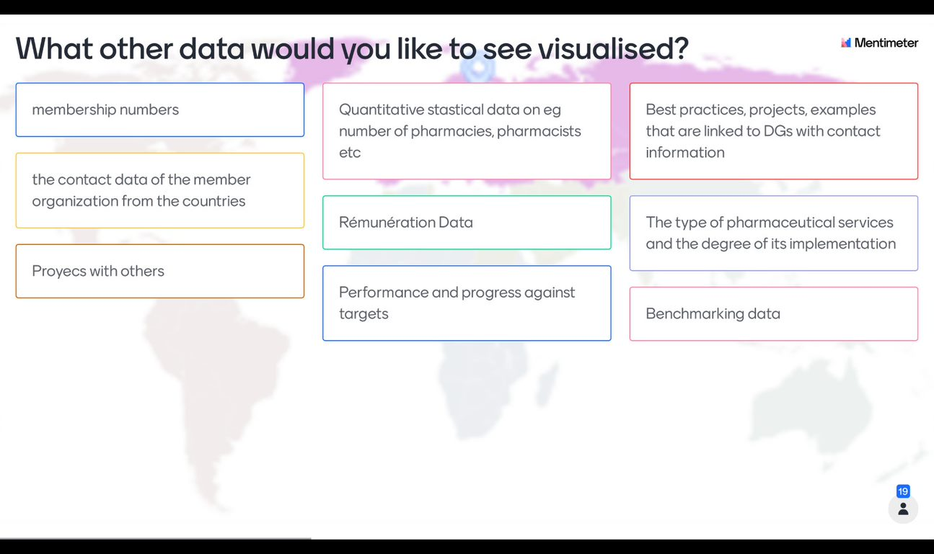

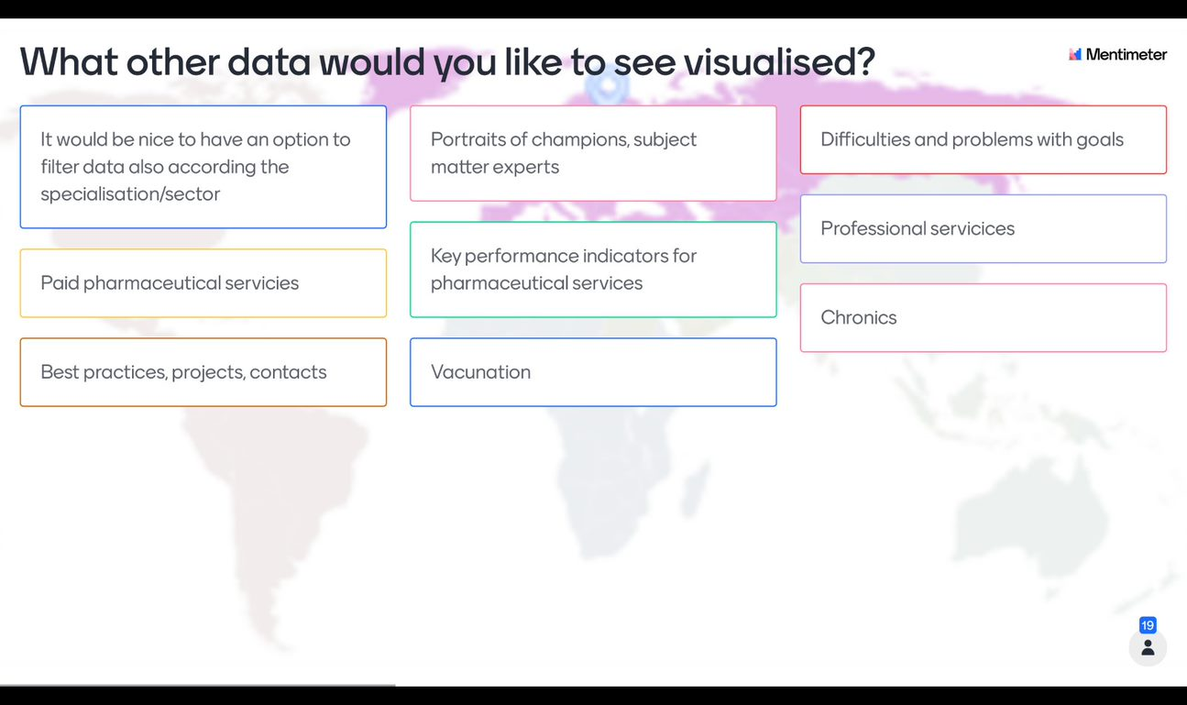

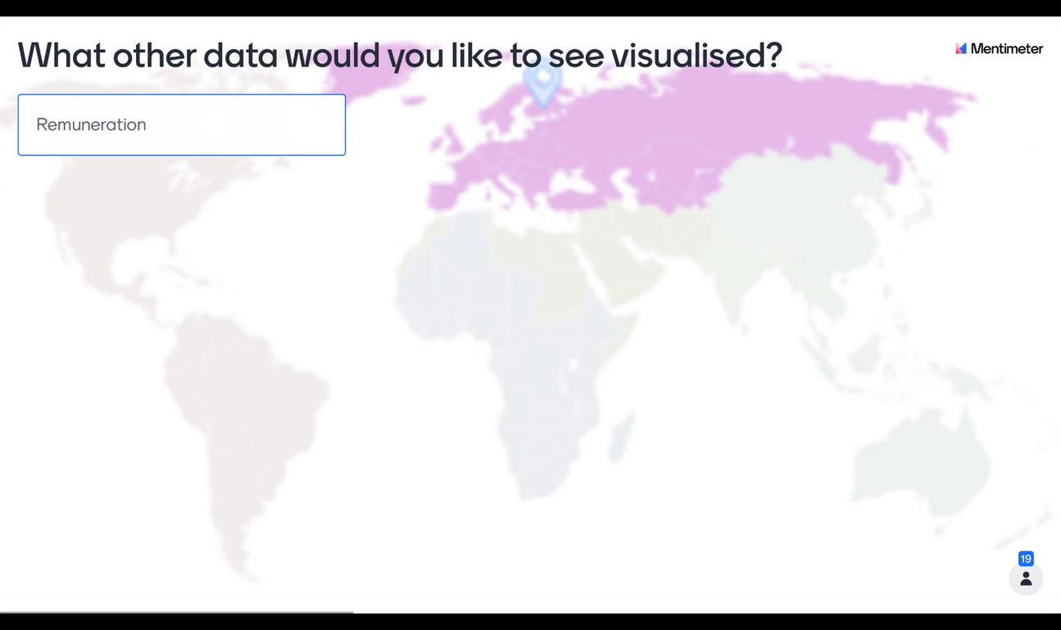

c. Members’ engagement activity

Activity 3: In your opinion, what are the three top health priority areas in your country? Results:

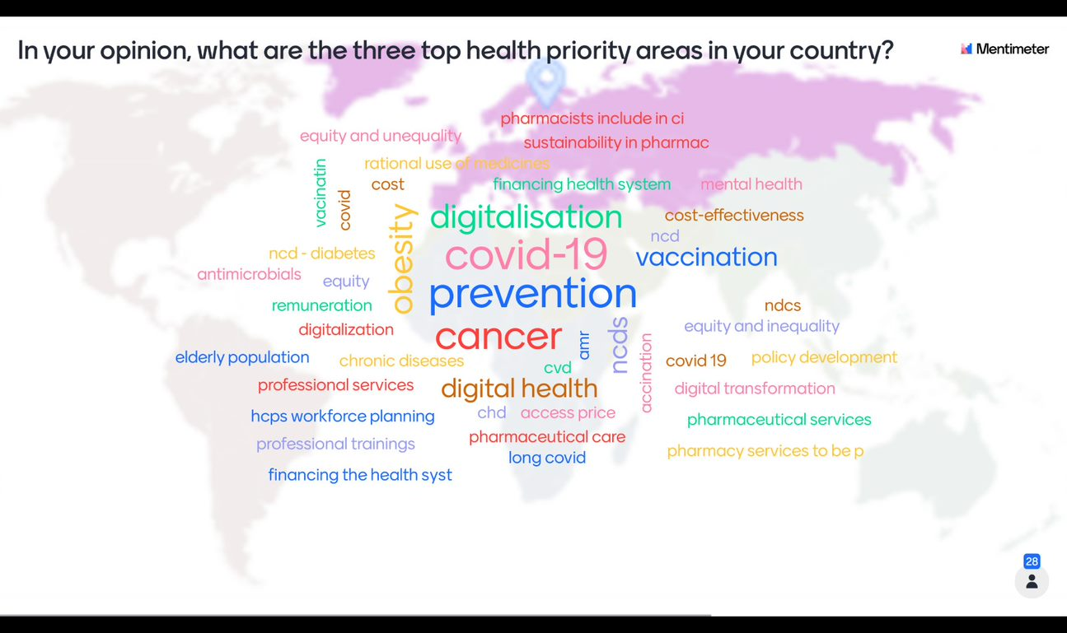

4. Plans for pandemic preparedness- WHO initiative and FIP wide approach by end of year

The CEO provided an update on some new initiatives to demonstrate the importance of pharmacy in future pandemic preparedness. By the end of 2021, the WHO will have gathered evidence and data and will be developing a plan for pandemic preparedness and COVID learning. In a digital publication, FIP will collect examples of the journey, activities, priorities, and learnings. COVID has been declared a pandemic since January 30th; we will map and follow important outputs from different nations and stages.

We will present a visualisation to Council in September and will urge our members to support us in this; we will gather key examples and priorities between October and December and then submit it to the WHO. As well as showcase this on our Sustainability Rx microsite for all Members to access.

5. ONE FIP plans to 2023

The CEO addressed how the development goals give a narrative and how we must implement them globally, regionally, and nationally. The CEO demonstrated how we are compiling on DGs throughout FIP and the regions, as well as how they connect to the global FIP priorities. The CEO mentioned that we will prepare an externally facing visionary document outlining our development goals' plans and priorities for the decade ahead to 2030.

6. FIP reports underway for 2021

The CEO announced two reports that are being developed for the years 2021 and 2022 which will be available digitally.

1- Global FIP development goals report and 2- Membership engagement report

7- Summary of all regionally focused digital events

The CEO encouraged members to participate in regionally focused events and provided a list of digital activities with a regional focus, developed in collaboration with regional forums.

The CEO provided an overview of the Transforming Vaccination programme and invited members to participate, share their experiences, and attend the regional roundtable titled (Sustainable and equitable access to vaccines: Establishing priorities and setting policies in the European region) on October 14, 2021.

We would like to ask member organisations within the region interested in joining and presenting their national and regional perspectives to contact (farah@fip.org).

Note: FIP member organisations may also use the template letter to ministers of health to propose/claim a broader role for pharmacists in vaccination. The letter is available in English, French and other languages. Please let us know if you would like to use this letter (or have any changes to propose to the text), and we can add the FIP president's signature, so you can send to your MoH.

A plan for regional forums to lead events that address the humanitarian and emergency issues in each region. we will learn from the event to be held on August 3rd where we provide a platform for colleagues from Lebanon to share the tribulations since the 2020 Beirut blast (on top of COVID and on top of years of financial and political pressures). This can form a template for each forum and FIP will support these events. Dr Dalia Bajis, FIP Lead for Provision and Partnerships and Dr Marwan Akel, Project Manager for workforce and FIP-GPO member invited members to attend the event, or listen to it afterwards. The link is https://us02web.zoom.us/webinar/register/7216185793127/WN_WHhy_ArdQBGP9CUwsXWZSA

8- ONE FIP programmes- UPDATES SINCE APRIL

a- Updates from the Data & intelligence commission Mr Christopher John, Lead for Data and Intelligence presented an update on the Data & intelligence commission which oversees the work of the Global Pharmaceutical Observatory.

b- Updates from the AMR commission The CEO presented an update on the AMR commission.

c- NCD programme update across all Boards- linked to PRACTICE Aniekan Ekpenyong, Practice Development Projects Coordinator, briefly presented the ONE FIP Practice Transformation Programme on Diabetes.

d- UNITWIN / UNESCO update- linked to EDUCATION Ms Ozge Ozer, FIP Educational Partnership Coordinator provided an overview of the FIP-UNESCO UNITWIN Programme, the FIP UNITWIN pathfinder toolkit, the new FIP UNITWIN regional centres.

e- Biowaivers project update- linked to SAFETY and SCIENCE The CEO briefly presented the WHO and FIP Collaboration on biowaivers.

9. Any other business- Inputs from our officers

Dr Arijana Mestrovic provided an overview about the FIP Academic Section Strategic Implementation Plan and the projects in progress. We will seek to provide initiatives from other sections and hubs to share with our members, since each of them has been aligned with the FIP development goals. A finding from all regional engagement events is that we will:

Set up meetings with FIP sections, Sigs, hubs and boards and the regions, so that all work and priorities can be shared

We will seek MORE engagement from the MOs in these regional engagement meetings and ensure this is the priority for the meetings in Q4

We will consider setting up meetings for the shared priorities ACROSS regions so we see some sharing and showcasing.

Activity 4: What could we include in future regional engagement meetings that you would be interested to see?

Results:

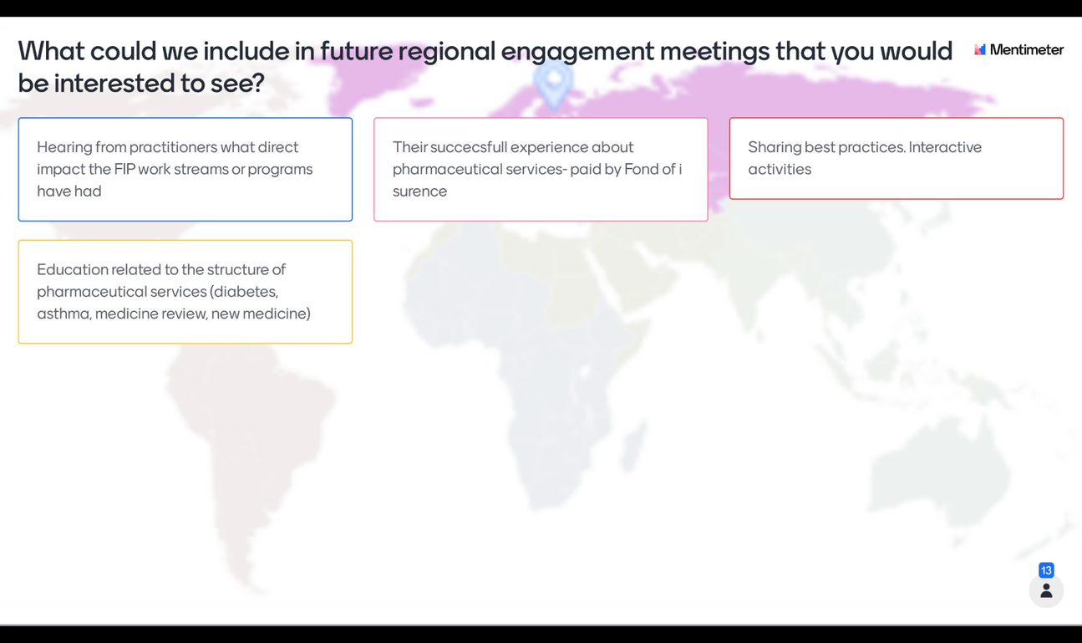

10. Closing

Date of the next meeting TBC. See you at the council meeting on the 16th-17th September.

