JOINT REFLECTIONS ON THE CURRENT CHALLENGES AND OPPORTUNITIES IN GENERIC, BIOSIMILAR AND VALUE-ADDED MEDICINES’ PROCUREMENT IN THE EUROPEAN HOSPITAL SECTOR

An exploration of current challenges and opportunities by the European Association of Hospital Pharmacists and European Generic and Biosimilar Medicines Association

[Image of single unit bar coding/bedside scanning]

TABLE OF CONTENTS:

Foreword

Executive Summary

The procurement of generic medicines by the European hospital sector and the challenge of achieving sustainability of supply
The current challenges
The opportunities for improvement

The procurement of generic medicines by the European hospital sector and the challenge of achieving sustainable uptake of added value services
Added value services
The single unit barcoding case study

Reflections on the uptake of Biosimilar medicines in the European hospital sector

Conclusions and final reflections

[to be adjusted at end]
FOREWORD

The origins of this joint reflection paper by the European Association of Hospital Pharmacists (EAHP) and the European Generic and Biosimilar Medicines Association (EGA) stem from a shared concern and desire to:
- Resolve, where possible, pharmacist experience of supply shortages, where these relate to generic medicines;
- Achieve greater provision of value-added services and value-added medicinesby generic manufacturing companies to the hospital sector, especially where these can enhance patient safety, such as, but not limited to, bar coding of medicines to the single unit, and the provision of medicines in healthcare professional and patient-safety focused forms, such as pre-filled syringes;
- Reflect on the challenges and opportunities for biosimilar uptake in the European hospital sector.

Each of the three chapters sets out why these topics are of joint interest to the two associations, and uses case study and reference material to guide some general shared conclusions and recommendations.

The overall purpose of the paper is to make a meaningful contribution to public policy debates on these questions at the European level, and to advance the cause of high quality and sustainable patient care, that continuously improves in respect of patient safety.

In this respect we welcome engagement with, scrutiny of, and indeed endorsement of, the paper’s conclusions and recommendations by all interested parties. Both organisations seek a real policy conversation on these topics, conversations are never monologues, and every good conversation starts with good listening.

[THIS CAN BE IMPROVED/EXPANDED/REWRITTEN…. JUST TO GIVE A SENSE OF EARLY DIRECTION]

EXECUTIVE SUMMARY

[TO BE COMPLETED AT END]

The chief recommendations of the European Association of Hospital Pharmacists (EAHP) and the European Generic and Biosimilar Medicines Association (EGA) stemming from this reflection paper are:

On achieving sustainable supply of generic medicines to the hospital sector

[INSERT]

On achieving ongoing and continuous evolution of added value services from the generic medicine industry to the hospital sector

[INSERT]

On improving the uptake of biosimilar medicines in the hospital sector

[INSERT]
CHAPTER 1: HOSPITAL PROCUREMENT OF GENERIC MEDICINES AND SUSTAINABILITY OF SUPPLY

The problem statement

Medicines shortages are a clear and disruptive reality for hospital pharmacies across Europe.

Evidence from EAHP research in 2014 found that:

- 86% of hospital pharmacists report that medicines shortages are a current problem in the hospital they work in, in terms of providing the best care to patients and/or operating the hospital pharmacy;
- 66% of respondents say that medicines shortages affect their hospital pharmacy on a daily or weekly basis; and,
- 74% either agree or strongly agree that medicines shortages in my hospital are having a negative impact on patient care

Whilst this causes a range of inconveniences in terms of the operation of patient services, including large diversion of pharmacist time and resource to securing alternative sources of medicine, or alternative treatments, as well as increasing stress levels in a safety critical environment, the most serious impacts are for patients, their carers and families. Delays and disturbances to a patient’s prescribed treatment can affect patient care, including contributing to medication error. The distress to patients, their family, and carers, when faced with disruptions to critical treatments such as chemotherapy, has been amongst the powerful testimony provided to EAHP as a result of survey activity with its membership.

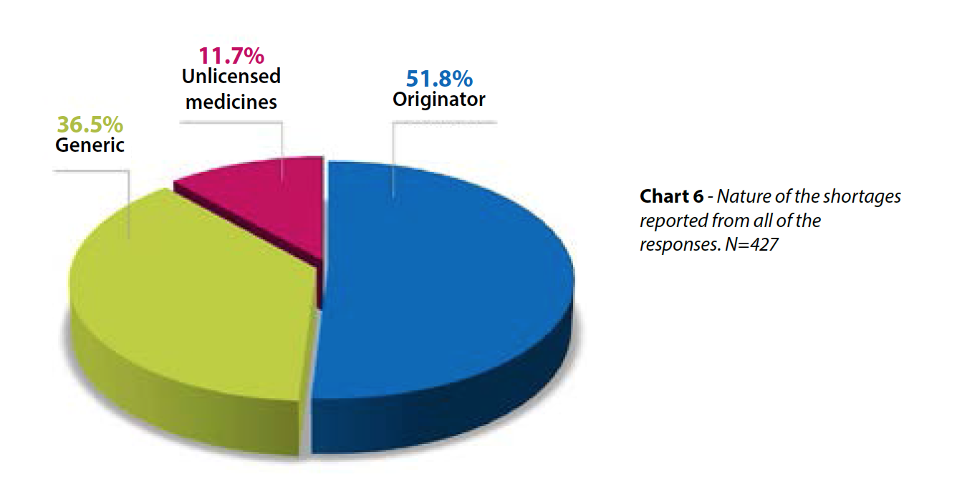
EAHP research indicates that whilst hospital pharmacist perception of medicine shortage across Europe is largely associated with originator products (52% of hospital pharmacists consider the problem to be mostly associated with originator products, as opposed to 37% believing shortages to be most commonly associated with generic medicine), shortages can also occur with generic medicines. Indeed, national response rates from countries such as the Netherlands, Hungary, Latvia, the United Kingdom and Denmark suggest in those EU Member States, generic medicine was the most prevalent kind of shortage experienced in a hospital environment.

From an industry perspective, one reason that is often provided for how a situation of shortage has come to exist in respect of hospital demand, relates to emergent tendering processes. An increasingly common procurement practice in the European hospital sector, in many cases the result can be the tender for provision being awarded to a single company. The result can unfortunately mean the creation of a new supply chain vulnerability.

Demand for a given medicinal product in the hospital sector may not always be stable. In such scenarios where that demand outstrips that individual company’s capacity to supply, a supply chain shortage can therefore occur.

Although the medicinal product which won the tender may not be available within the hospital, the multi-source nature of generic medicines mean that the medicinal products with the same active ingredient are available from other manufacturers (see Figure 1), provided that generic versions exist and are authorised in the concerned country.

It therefore occurs to both EAHP and EGA, that for purposes of supply chain security, a tendering system which provides scope for more than one winner can lead to an enhanced availability of the active ingredient, an avoidance of time spent on and stress associated with managing shortages and increased access to medicines and decreased inconvenience for patients.

Tender systems within hospital settings should ideally be designed to allow for more than one winner, which will provide for a more resilient medicines supply chain, better positioned to respond to the peaks and troughs of hospital demand.

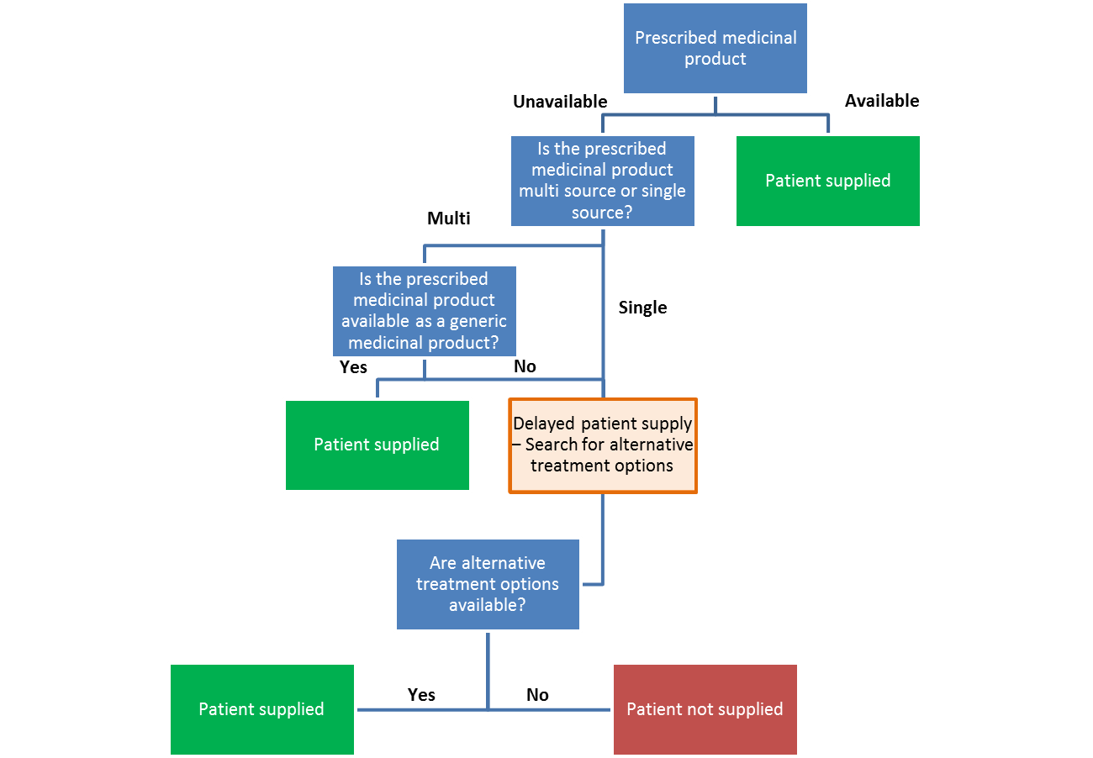
Figure 1

When there are substitutable generic medicinal products available within the hospital, pharmacists have an important role to play in ensuring that their colleagues and other healthcare professionals are well-informed of these options, which should be supported by good medicines information systems within the hospital. In addition, pharmacists have important counseling roles to conduct with inpatients and outpatients so that they understand the existence of generic medicines and that they have the same therapeutic and safety profile as the reference originator product. Such professional roles are outlined further in the 44 European Statements of Hospital Pharmacy, the vision for the profession agreed in partnership between EAHP’s member organisations and European patient and healthcare professional organisations.

Some case studies

[EAHP to gather evidence and perspective from member countries in the Netherlands, Hungary, Latvia, UK and Denmark]

Reflections and recommendations

Drawing from the above described problem statement and case studies, the European Association of Hospital Pharmacists and European Generic and Biosimilar Medicines Association make the following reflections and recommendations:

- Redesign tender systems to allow for more than one winner

- Ensure hospital pharmacists in all European health systems are enabled to educate all relevant fellow healthcare professionals in the hospital setting on the availability of generic medicinal products

- Ensure patients are counselled on the existence of generic medicines and that they have the same therapeutic and safety profile as the reference originator product

CHAPTER 2: HOSPITAL PROCUREMENT OF VALUE-ADDED MEDICINES AND VALUE ADDED SERVICES

The problem statement

Both the European Association of Hospital Pharmacists (EAHP) and European Generic and Biosimilar Medicines Association (EGA) understand that the value of a medicine extends beyond simply the component pill, cream or liquid, the treatment it delivers and its price. This value also extends to:

- Services provided around the medicine, including, but not limited to:
- packaging format and
- information provision (e.g. single unit barcoding);
- pharmacovigilance systems; and,
- assurance against counterfeit intrusion.

- Additional benefits provided by the medicine, which are delivered through value-added medicines. These are medicines based on known molecules which deliver significant improvements for patients, payers and/or healthcare professionals (e.g. physicians, pharmacists and nurses). For example, the added value may be created thanks to:
- better health outcomes
- improved quality of life
- improved tolerability
- better adherence
- less dosing frequency
- reduction of medical errors
- any other innovative solution addressing unmet medical needs for patients and healthcare systems

As chapter 1 evidenced, the hospital pharmacist certainly wishes to see sustainable and reliable supply of generic medicines. However, in order to fulfill his or her professional role in protecting patient safety, and continuously improvepatient care, the hospital pharmacist also wishes to work together with the generic medicines industry to:
- achieve reductions in medication error, by facilitating the achievement of point-of-care scanning in hospitals and elsewhere;
- improve delivery of care by increasing the use of value-added medicines; and
- ensure an environment in which innovation by the generic industry can be embedded and sustained for the purposes of patient safety, patient convenience and health system efficacy.

This chapter now examines some case studies in this respect before drawing a number of related conclusions and recommendations.

Some case studies

- Barcoding of medicines to the single unit: the patient safety need

With patient safety a guiding mission of the hospital pharmacy profession, across the globe there has been a decades long search for new innovations and approaches that can help to prevent medication error in the hospital setting.

Since the advent of popular use of barcode technology in the 1980s, hospital pharmacists and others in the secondary care setting were quick to identify the possibilities afforded by enabling nurses to conduct a bedside scan of an identifying patient bracelet against the medication about to be administered. This enables a final check to occur that the medicine to be given is indeed the correct selection for the right patient, being given at the right time, by the right route of administration and in the right dose form. Indeed, preliminary studies have suggested the use of bar codes on medicines up to the single unit can help to reduce medication error rates by 41.4%.

Yet to implement such a system in a hospital setting requires more than simply a patient bracelet with an identifying barcode. It also requires the nurse to be able to easily scan the medication, which in a hospital environment, will typically be split from the original outer packaging. Unless a barcode is placed on the primary packaging of the medicine therefore, for sadly too many hospitals, the resources required to relabel the medication with identifying barcodes becomes simply too burdensome to implement.

Whilst in the USA, federal regulations now mandate medicines supplied to hospital to contain such a bar code to the primary package level (the “single unit”), in Europe no such requirement exists.

This does not mean individual companies are unwilling to help meet this expressed packaging desire from the hospital sector. Generic companies such as Teva have made admirable efforts to meet the expressed market demand [TO ADD REFERENCE]

Sadly however, procurement practices have too often operated blind to the benefits achieved by such voluntary actions by companies, and when a tender is subsequently lost, a sense of lost investment can be felt when previous efforts to meet hospital pharmacist requests for single unit barcoding were made.

What European health systems require therefore, is a more holistic approach to tendering, that is cogniscent and mindful of the value provided by enhanced packaging and labeling practices by the generic industry, and other services that might be achieved via the tender process.

[TO INVESTIGATE THIS EXAMPLE FURTHER. I AM WRITING ON THE BASIS OF SECOND HAND ANECDOTAL ACCOUNTS. I’D IDEALLY LIKE TO CHECK THIS WITH RELEVANT OFFICERS AT TEVA]

- Value-added medicines: Improving the delivery and management of care

Value-added medicines can considerably improve the delivery and management of care, and therefore should be increasingly used by patients and healthcare professionals. A concrete example of value-added medicines is pre-filled syringes (PFS), which are especially beneficial for healthcare professionals and patients in a hospital setting. Medicines delivered through PFS are convenient to use for healthcare professionals as they require a reduction of re-constitution steps when compared to glass or COC vials, which leads to decreased medication errors and increased safety for patients. PFS are also safer to use for healthcare professionals, as they decrease the risk of needle-stick injuries, and reduce wastage of the medicine.

- A system that encourages innovation:

Tendering criteria other than price
The example of PFS provides an able demonstration of the benefits of value-added medicines. However at a time when there is increasing pressure across Europe to generate savings, it can be difficult to ensure that these medicines reach patients. The effects of the economic crisis have brought an unwelcome return of budgetary mindsets that focus once more on lowest cost, as opposed to best value. Yet higher acquisition costs related to PFS compared to multi-dose vials can be offset by lower administrative costs and increased safety. The stakeholder benefits and long-term efficiency gains generated by value-added medicines are one of a number of criteria that should be considered by hospital systems when procuring medicines.

Health Technology Assessments
Health Technology Assessments (HTA) could be used to support this change in tendering criteria, as HTAs demonstrate the value of innovative products. Developers of value-added medicines should be given the option to demonstrate the value that their products bring to patients, healthcare professionals and health systems through HTA. If a manufacturer chooses to undergo an optional HTA for a value-added product then the assessment methodology should involve both healthcare professionals and patients, in addition to other key stakeholders. This is because value-added medicines bring direct benefits to healthcare professionals and patients, and their opinion is essential in assessing the value of new technologies.

Reflections and recommendations

- Incorporate criteria within tender processes other than price, such as the services provided around the medicine and the additional benefits of the medicine, into tender bidding procedures;
- The developers of value-added medicines should be given the option to undergo an HTA to demonstrate value.
- HTA methodologies should incorporate the voice of patients and healthcare professionals, to reflect more accurately the value that medicines provide

Whilst recognizing the long term challenges posed in achieving a scenario across Europe’s fragmented healthcare systems in which medicines provided to hospitals might systematically be barcoded to the single unit, both EAHP and EGA understand the patient safety benefits that are delivered when bedside scanning practices are implemented within a hospital. The two organisations therefore commit to remain in dialogue about how improvement in barcoding practices might be achieved. This paper, and its reflections on how such added value services can be made more sustainable in Europe, is therefore a first joint action in this direction.
CHAPTER 3: REFLECTIONS ON UPTAKE ON BIOSIMILARS IN THE HOSPITAL SECTOR

The problem statement

[EGA to author first draft]

[Need for healthcare professional education to be described]

To deal with interchangeability issue, healthcare costs and sustainability.

Some case studies

- Education
- Competition

Reflections and recommendations

http://www.eahp.eu/press-room/patients-suffering-medicines-shortages-all-european-countries
www.eahp.eu/sites/default/files/shortages_report05online.pdf
http://www.eahp.eu/practice-and-policy/european-statements-hospital-pharmacy
Poon EG et al. Effect of Bar-Code Technology on the Safety of Medication Administration. N Eng J Med 2010;362:1698-707

