Draft Joint Stakeholder Statement on Information and Medicine Shortages
Nb EAHP has made drafting contributions to this version, but reserves its position on a number of points.

Introduction
Medicines shortages are a growing issue of concern across the European Union,, and indeed globally. There is increasing evidence that shortages occur across the EU and that a wide range of medicines are affected,,,,,. Several factors can give rise to medicines shortages,,. The causes of shortages are understood to be multifactorial, including problems in production, global consolidation of manufacturing, unintended impacts of pricing and tendering policies,, , as well as problems within the supply chain. This paper does not expand further on issues of causation and, by extension, solution. It does, however, point to the need for better information collection and sharing in order to improve policy understanding of the extent and nature of the problem.
Despite the steps which have previously been taken to address some of the causes of medicine shortages, the problem persists. What is clear, however, is that without reliable information regulators, industry, distributors, health professionals and, of course, patients, cannot take steps to limit the negative effects of interruptions in the medicines supply.
European associations representing medicines manufacturers, parallel distributors, pharmaceutical wholesalers and pharmacists have come together to work jointly on collection and publication of information on medicines shortages. We are in agreement that reliable information systems are an essential step in addressing the problems of shortages. While we recognise that such systems need to be implemented at national level, and therefore to be responsive to specific national concerns, we believe that a number of principles should underpin efficient and effective information systems.
Our primary and overarching concern, and the motivation for forming this joint statement, is the health and wellbeing of patients. It is our ethical and public duty as manufacturers, distributors and health professionals in the pharmaceutical sector to minimise the impact of shortages, where our capacity enables us. This statement is part of this process and focuses solely on one issue of potential redress: improved information and collection and publication about shortages.
Better information about medicines shortages is required in order to:
- Make contingency arrangements to minimise negative impacts to patient care (e.g. urgent communication to prescribers, conduct hospital medicines production)

- Enable best management of existing stocks, in an ethical manner (“fair distribution”)

- Provide honest information to patients about why a disruption, delay or change in their therapy is necessary, and when resumption of supply is anticipated

- Improve understanding of the nature of the problems, the balance of causes and main policy dynamics to be addressed to prevent shortages occurring in the first place

- Mitigate the impact on patients by providing clear information to healthcare professionals (e.g. the INN) to facilitate:
  - Generic substitution or, where this is not an option,
  - Therapeutic alternative medicine provision
The purpose of this statement is to outline guiding principles regarding medicines shortages and to make recommendations with regard to the specific features of the ideal information systems. We hope that these recommendations will help stakeholders who wish to develop or enhance systems at national level, and will potentially form the basis of future European level action and beyond.
Throughout the document examples are given to illustrate our principles and, in addition, more examples of best practice can be found in the Annexes.

Principles

1 Definition of a Shortage
We adopt a patient centred view and, as such, we define a medicine shortage as “an inability of a community or hospital pharmacy, as a result of factors beyond their control, to supply a medicinal product to a patient within 72 hours. While creating such a definition, it should be noted that it is the impact on patients arising from the unavailability of the medicine they require that is paramount.
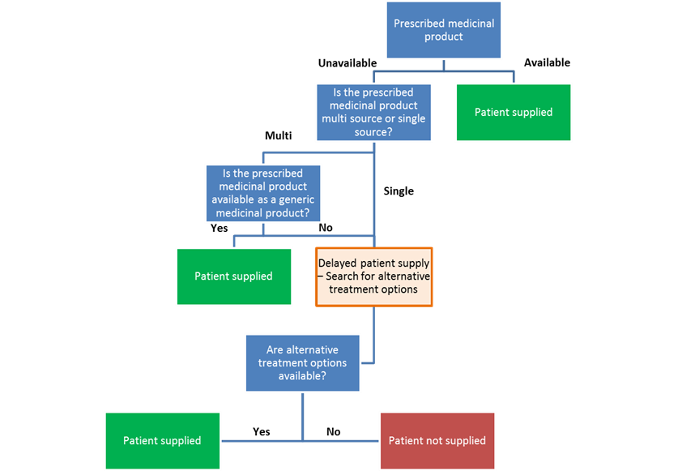
We also consider that further categorisation of medicine shortages based on regions affected (International, European or National), severity or category (possibly using the EMA defined critical medicine criteria) and duration, would be useful for meaningful dialogue and understanding of the problem by all stakeholders. Further actions, for example a Delphi panel consultation on sub-category definitions, could be considered in the future.

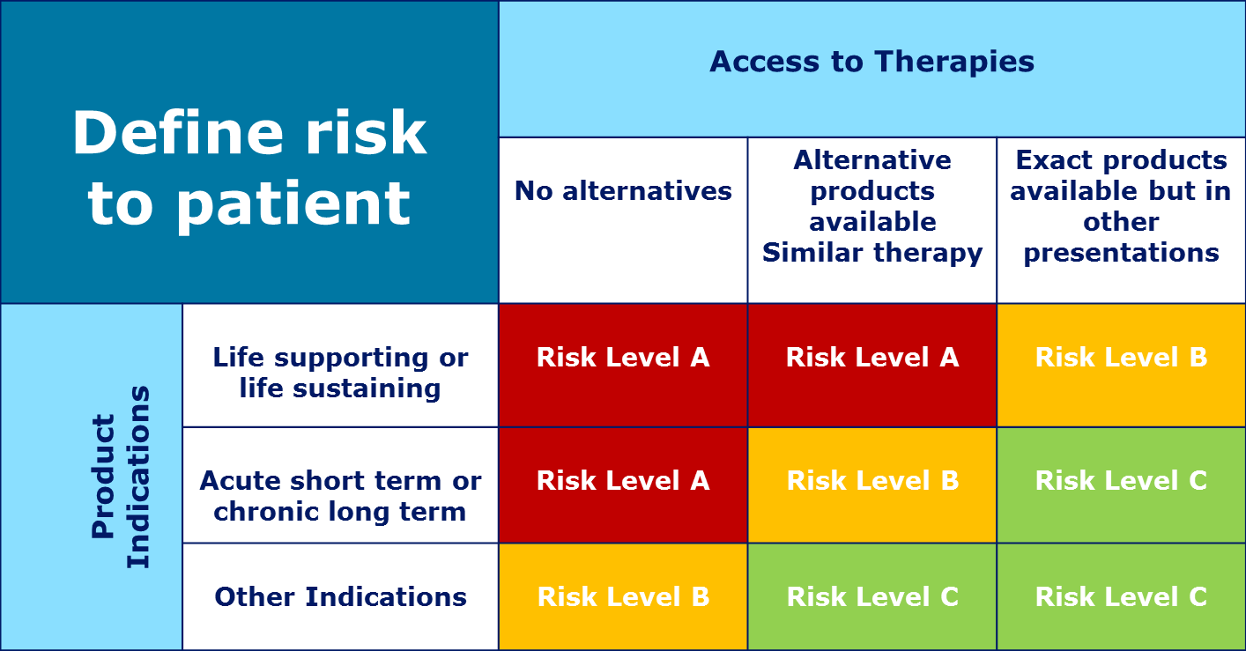
(Ref: ‘Risk Based Approach for Preventing and Managing Drug Shortages’: presentation at 2013 Annual PDA/FDA Joint Conference, Washington D.C. and 2014 Annual PDA Conference, San Antonio, TX)
2 Sources of Information
Information and awareness of shortages is dispersed among the supply chain. For example, often manufacturers will be aware of the potential for a shortage before it occurs. Sometimes, pharmacists experience supply difficulties before the industry is aware that there is a problem.
It is important to reference the origins of reports of shortages, e.g. whether they are from stakeholders, public authorities or elsewhere.
We believe that information systems should therefore be open to reports from manufacturers, wholesalers, parallel traders, pharmacists and other healthcare professionals, with reference to the origin of reports of shortages. We are also aware that in an age of widespread use of social media, often patient associations can be approached by patients experiencing a shortage, with the patient association lacking a formal mechanism to address the matter or to provide reassurance or guidance. Therefore in the future, it may be desirable to consider a mechanism by which patients/the public could make reports of shortages experienced by them, for example via a pharmacist or patient organisation.
We recognise, however, that some reports may be inaccurate – for example, they may be out of date. Reports therefore should, where possible, be verified with relevant stakeholders. The process of verification does not grant stakeholders a veto over the shortage reports. Disputes about the veracity or accuracy of a report should be settled by agreement among stakeholders in accordance with the Stakeholder Code (see below).
In order to aid clear and consistent reporting of shortages, a standardised reporting template is suggested and the reporting template of the Parenteral Drug Association (PDA) in their “Technical Report No. 68 (TR 68), Risk-Based Approach for Prevention and Management of Drug Shortages” provides a good case study.

Example:
Netherlands:
The system operating in the Netherlands (“Farmanco”) is hosted by KNMP – the Dutch pharmacy association. The submission system is open to reports from manufacturers, wholesalers, pharmacists, other healthcare professionals and patients. Submissions are usually made by pharmacies and each submission is checked by the respective MAH.

3 Level of Access
Patients and the public, the ultimate payers of medicine, should have access to information about current and past medicines shortages, an area of strong public interest. Privately held information is of limited use if we wish to mitigate the potentially harmful effects of shortages. Furthermore, with causation factors acknowledged to be wide-ranging, placing information in the public domain can assist the multi-disciplinary search for long-term solutions.
Principles of disclosure and transparency are being adopted in a number of areas in the pharmaceutical sector as a whole. In this spirit, we believe that access to information on shortages should be generally available. Information should be collated and verified, non-alarmist, non-prescriptive and made available to all who provided it.
We recognise that general access to certain information could lead to supply distortions, potentially exacerbating or even causing shortages. The potential for such distortions needs to be addressed within an appropriate ethical context, and should not be considered a blanket objection to open access.
We believe therefore that open access should be the default position of information systems, such as that of the FDA, ASHP and EMA,, with restricted access imposed only on reasonable and justifiable grounds, on an ad hoc basis, and in accordance with the Stakeholder Code. Assurances should be established about the information flow and where the publication of specific information should be restricted to stakeholders as fear of inappropriate publication of certain sensitive information may act as a disincentive to its disclosure.
To avoid the potential for misattribution of blame by lay readers of the database, information about known, or indeed unknown, causes should be provided e.g. “temporary disruption to manufacturing process by required upgrade”, “no disruption at manufacturing level, “unknown supply chain problem.”

Example:
Netherlands:
The Dutch systems described above allows for public access to the information.

4 Content
We believe that information systems should be as reliable, up-to-date and as comprehensive as possible. They should identify the medicine in short supply (in accordance with the principles above, this should be by brand where appropriate), and where possible the cause and likely duration of the shortage.
Information systems should ideally contain forms of archiving to enable an overview of trends in shortages to be provided. This can further enhance public understanding of the nature of the problem and help to better direct policy interventions.
We also believe that if a medicine in short supply has an alternative, i.e. via generic substitution or, in the case of a proprietary OTC medicine, because there is an alternative with the same ingredients available, the shortage should still be reported. This is because, in some cases, pharmacists require proof of a shortage in order to enable substitution and, in the case of the OTC medication, the information held on the database (for example the expected duration of delay) could be used to inform their patients when their preferred proprietary OTC medicine will be available again for purchase. As such, this could facilitate the work of pharmacists in finding the appropriate replacement therapy or action, and treatment of patients will not be interrupted. Pharmacists, with their knowledge of medicines and products, may be in position to offer training or support to other professionals on the correct selection and use of substituted products.

Example:
Netherlands:
The following content is contained in the system: product name; reason for shortage; expected data of availability, and possible solution for patients (substitution; compounding; importing, and possible alternatives).
The information remains visible in the system for the duration of the shortage plus one additional month.

5 Alternative Treatments
The effects of shortages can be mitigated if patients have access to suitable alternatives, either by way of generic substitution or the use of therapeutic alternatives as appropriate. Generic substitution, where possible, has been demonstrated to be an important solution to medicines shortages. KNMP’s “Farmanco” system reports that 62% of shortages in the Netherlands are effectively managed through substitution with generic medicines. The multi-source nature of generic medicines means that this might entail substitution of a branded medicine for a generic, or one generic for another.
Information systems could therefore include information which would assist healthcare professionals and mitigate the effect of shortages on patient health. Distinctions could be made as follows:
5.1 Shortage of a multi-source or single source product
The rationale behind this approach is that the shortage of a multi-source product can be mitigated relatively easily, by generic substitution, compared to a single-source product. Making such a distinction would guide healthcare professionals in predicting the effect of the shortage and the time necessary for its management. Once it is clear if the product is multi or single source, options for generic substitution or the need for therapeutic alternatives could be identified by the pharmacist where appropriate.
This will considerably relieve the burden on pharmacists’ management of shortages and ensure that patients receive a continued supply of medicines.
5.1.1 Generic Substitution
The system could report which multi-source medicinal products that are in shortage can be substituted by a pharmacist and options for substitution could be given. This will considerably relieve the burden on pharmacists’ management of shortages and ensure that patients receive a continued supply of medicines.
5.2 Therapeutic alternatives
In cases where the medicinal product is single source, or when substitution is not legally permitted, we suggest that information systems could state this, with the potential to suggest alternatives. However, decisions on alternative treatments would, in these circumstances, be a question for patients, health professionals and the wider healthcare system. Health professional bodies could consider assisting their membership in providing suggestions for alternatives where appropriate and when desired by national stakeholders.

6 Governance
Stakeholders are fundamental to the provision of information. As argued above, we believe sector stakeholders have a duty to mitigate the effects of shortages. Where information systems are not in place at national level, we believe that stakeholders should be proactive in cooperating to develop systems.
Stakeholder involvement in the governance of information systems – including the participation of patients – would help to ensure that systems are broadly based, responsive and efficient. We recognise that national competent authorities have a role in the governance of information systems for medicines shortages. Partnership between authorities and stakeholders may be preferred in some Member States, and is welcomed by stakeholders. We believe that for an effective system, there should not be any barriers to reporting of shortages.
We do believe however that the principles laid out in this statement are essential to ensure that information systems are truly effective, and should as such also be respected by national competent authorities.

Example:
Austria:
Both systems deployed in Austria are governed by the wholesalers (PHAGO) (in conjunction with pharmaceutical manufacturers) for “system 1” and by the pharmacists (Austrian Chamber of Pharmacists (in conjunction with pharmaceutical manufacturers - PHARMIG) for “system 2”.

7. Competition Rules
We recognise that collaboration between stakeholders potentially gives rise to competition law issues, especially in the market based manufacturing sector. Stakeholders should be aware of their obligations in this respect, and should seek legal counsel where appropriate. It is of paramount importance that any initiatives by stakeholders are undertaken in the public interest with the sole objective of improving the provision of information on shortages.

8. A Stakeholder Code
Given the potential consequences for patients of an inability to access medication, medicines shortages are both a practical and a moral problem.
Collaboration between stakeholders to provide information systems should be underpinned by a Code of collaborative action. The Code should address, as a minimum:
- The provision of information to the system;
- Removal of information from the system;
- Advisory timeframes
- Verification
- Withholding of information from the system which may have detrimental effects;
- Mutual assistance to mitigate the effect of shortages;
- Resolution of disputes between stakeholders.

Recommendations
- What should stakeholders do?
- What is the concrete action to be carried out?
- Establishment of an (or, potentially a harmonised) information system
- All stakeholders work collaboratively
- Way of mitigating the shortages situation

Annexes
- List of data parameters etc
- Various systems / examples – expanded from examples in “Principles” section we believe are appropriate

- Remaining best practice examples (below)

2 Sources of Information
Austria:
Two systems exist in Austria which support the above.
The first (System 1) is operated by wholesale distributors (hosted by Datacare – a company with PHAGO (formerly ARGE Pharmazeutika)) in conjunction with pharmaceutical manufacturers. It is ‘Electronic Data Interchange’ which facilitates communication between pharmaceutical manufacturers and wholesale distributors (“ePharm”) for the purposes of a) making wholesale distributors aware of the likelihood of a shortage and b) reporting medicines shortages.
The second (System 2) is operated by pharmacies (hosted by Österreichischer Apothekerverlag) in-conjunction with pharmaceutical industry. The system is based on the “index of medicines” to which a ‘box’ was added for the purpose of informing about a shortages. The box is populated by the pharmaceutical industry – including probable length of shortages, potential replacement, cause, and contact person for questions.

Belgium:
In Belgium the federal medicines agency (Federaal Agentschap voor Geneesmiddelen en Gezondheidsproducten (FAGG)/ Federal Agency for Medicines and Health Products (FAMHP)/ L’Agence Fédérale des Médicaments et des Produits de Santé (AFMPS)) publishes on a daily basis a list of medicines experiencing shortages which is established on the basis of information received from all stakeholders (manufacturers, wholesale distributors, pharmacies, etc…).

France:
The system for reporting of medicines shortages is based on the premise of enforcing supply chain operators respective regulatory obligations. Pharmaceutical manufacturers inform the national medicines agency L’Agence nationale de sécurité du médicament et des produits de santé (ANSM) when there is a likelihood of a potential shortage. While continuing to deliver medicines as part of their Public Service Obligation (PSO) (to the extent supplies are available from manufacturers), wholesale distributors are obliged to inform the respective manufacturer when any particular medicine is experiencing a shortage. Equally pharmacies are obligated to inform pharmaceutical manufacturers. All information must be transmitted through a common information system that is accessible by all operators (manufacturers, wholesale distributors and pharmacists).

Portugal:
Reports on medicines shortages to the national agency (Infarmed) are governed by legislation and follows the pathways below:
a) Information is submitted by the pharmaceutical manufacturers through an online application designed specifically for this purpose, “Shortages Notification System” and is available on www.infarmed.pt
b) Information can be submitted by other supply chain operators and healthcare professionals – in a two-step approach. Doctors and / or patients are considered as sources of information for the purpose of reporting a medicine shortage. However, the report of the shortage is made in a second step by the manufacturer, in the same way as above, after confirming stock levels with wholesale distributors.

3 Level of Access
Example:
Austria:
System 1 as described above is accessible to wholesale distributors and pharmaceutical manufacturers. Information is passed to pharmacies in the event of a stock out at the level of the wholesale distributor.
System 2 as described above is hosted by the Österreichischer Apothekerverlag and is accessible to all healthcare providers and supply chain operators.
Belgium:
All stakeholders have access to the data on the medicines shortages system.
France:
The system described above is hosted on the website of the ANSM. The agency publishes and circulates emails and mails to health professionals (doctors, pharmacists, and their associations).

4 Content
Austria:
For system 1 as described above in the event of a wholesale distributor experiencing a stock-out, the concerned wholesaler initiates via DATACARE a request for the manufacturer to upload information onto the database. Manufacturers also can proactively upload information onto the database. The following content appears in the system – reason for delivery problem; explanation for shortage; contact person (if possible), and helpful information for healthcare professional.
For system 2 as described above the following content appears in the system – product; probable length of the shortage; potential replacement; cause of the shortage and a contact person for questions.

6 Governance
Netherlands:
The system is governed by the pharmacy association (KNMP).

http://www.ema.europa.eu/ema/index.jsp?curl=pages/regulation/general/general_content_000588.jsp&mid=WC0b01ac05807477a5
http://www.pgeu.eu/en/policy/20-medicine-shortages.html
http://www.epha.org/5920
FIP calls attention to medicines shortages. 2012 [cited 08/03/2014]; Available from: http://www.fip.org/www/ index.php?page=news_publications&news=newsitem&newsitem=118.
Why drug shortages occur. Drug Ther Bull. 2015 Mar;53(3):33-6. [http://www.ncbi.nlm.nih.gov/pubmed/25765598]
15.03.30E PGEU Fact Sheet FS005 on Medicines Shortages. 2015
Pauwels, K. et al. Drug shortages in European countries: a trade-off between market attractiveness and cost containment? BMC Health Serv Res. 2014; 14: 438. [http://www.ncbi.nlm.nih.gov/pmc/articles/PMC4263120/#]
Chabner, B A. Drug Shortages — A Critical Challenge for the Generic-Drug Market. N Engl J Med. 2011; 365:2147-2149. [http://www.nejm.org/doi/full/10.1056/neJmp1112633]
De Weerdt, E. et al. Causes of drug shortages in the legal pharmaceutical framework. Regul Toxicol Pharmacol. 2015 Mar;71(2):251-8 [http://www.ncbi.nlm.nih.gov/pubmed/25591547]
Bogaert, P. et al. A Qualitative Approach to a Better Understanding of the Problems Underlying Drug Shortages, as Viewed from Belgian, French and the European Union’s Perspectives. PLoS One. 2015; 10(5). [http://www.ncbi.nlm.nih.gov/pmc/articles/PMC4420462/]
Chabner, B A. Drug Shortages — A Critical Challenge for the Generic-Drug Market. N Engl J Med. 2011; 365:2147-2149. [http://www.nejm.org/doi/full/10.1056/neJmp1112633]
De Weerdt, E. et al. Causes of drug shortages in the legal pharmaceutical framework. Regul Toxicol Pharmacol. 2015 Mar;71(2):251-8 [http://www.ncbi.nlm.nih.gov/pubmed/25591547]
Bogaert, P. et al. A Qualitative Approach to a Better Understanding of the Problems Underlying Drug Shortages, as Viewed from Belgian, French and the European Union’s Perspectives. PLoS One. 2015; 10(5). [http://www.ncbi.nlm.nih.gov/pmc/articles/PMC4420462/]
http://www.apmhealtheurope.com/home.php, Belen Diego, 13 March 2015
SFK (Foundation for Pharmaceutical Statistics), Pharmaceutisch Weekblad, 9 May 2014
An International Comparison of Best Practice Approaches to Drug Shortages, IMS Health, 21 January 2015
15.01.06E European Supply Chain Roundtable Briefing Paper, 2015
Where permitted by national rules
In consultation with, or with referral to the prescriber
Agreed definition by the Supply Chain Stakeholders Working Group on 8th July 2015, adapted definition from the French Public Health Code
http://www.pda.org/scientific-and-regulatory-affairs/regulatory-resources/drug-shortage
http://www.accessdata.fda.gov/scripts/drugshortages/default.cfm
http://www.ashp.org/DrugShortages/Current/
Where permitted by national rules
KMNP Farmanco internal data
Where national rules permit
Subject to National Stakeholders’ preferences

