European Association of Hospital Pharmacists (EAHP) response to FIP Education Development Team’s Global Vision Statement consultation

AUGUST 2016 [First Draft]

Vision Statement

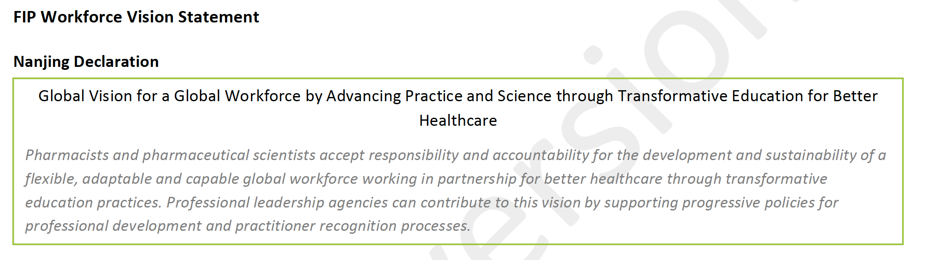

Comments:

EAHP makes suggestions for shortening this statement.

The words 'flexible' and 'adaptable' appear to be largely describing the same thing. For succinctness, one could be deleted.

Equally, perhaps given that the headline already has the word 'global' twice, the fact that the statement is global in scope is already established. Therefore the word 'global' in sentence one could be removed.

One definition for the word responsibility is "the state or fact of being accountable or to blame for something." From this perspective, the word 'accountable' may not be necessary in the first sentence as 'responsibility' already covers the matter.

In the second sentence, are ‘professional leadership agencies’ the same thing as ‘professional leadership societies’? Societies appear to EAHP as a more commonly used term.

The word ‘progressive’ in the second sentence appears redundant. It is unlikely professional development policies will be regressive.

Leading Change

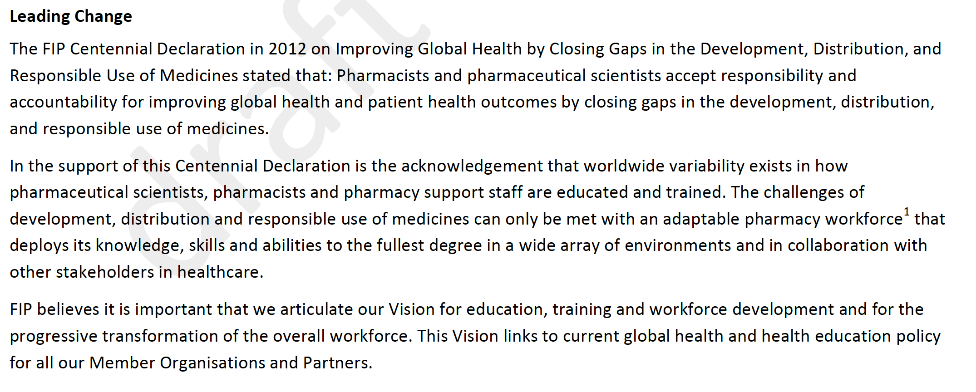

Comments:

EAHP suggests one amendment, at the end of the final sentence:

“This Vision links to current global health and health education policy for all our Member Organisations and Partners, and anticipated health challenges and opportunities of the future.

It appears important that a Vision have strong future-focus.

Supporting and developing high standards of education and training

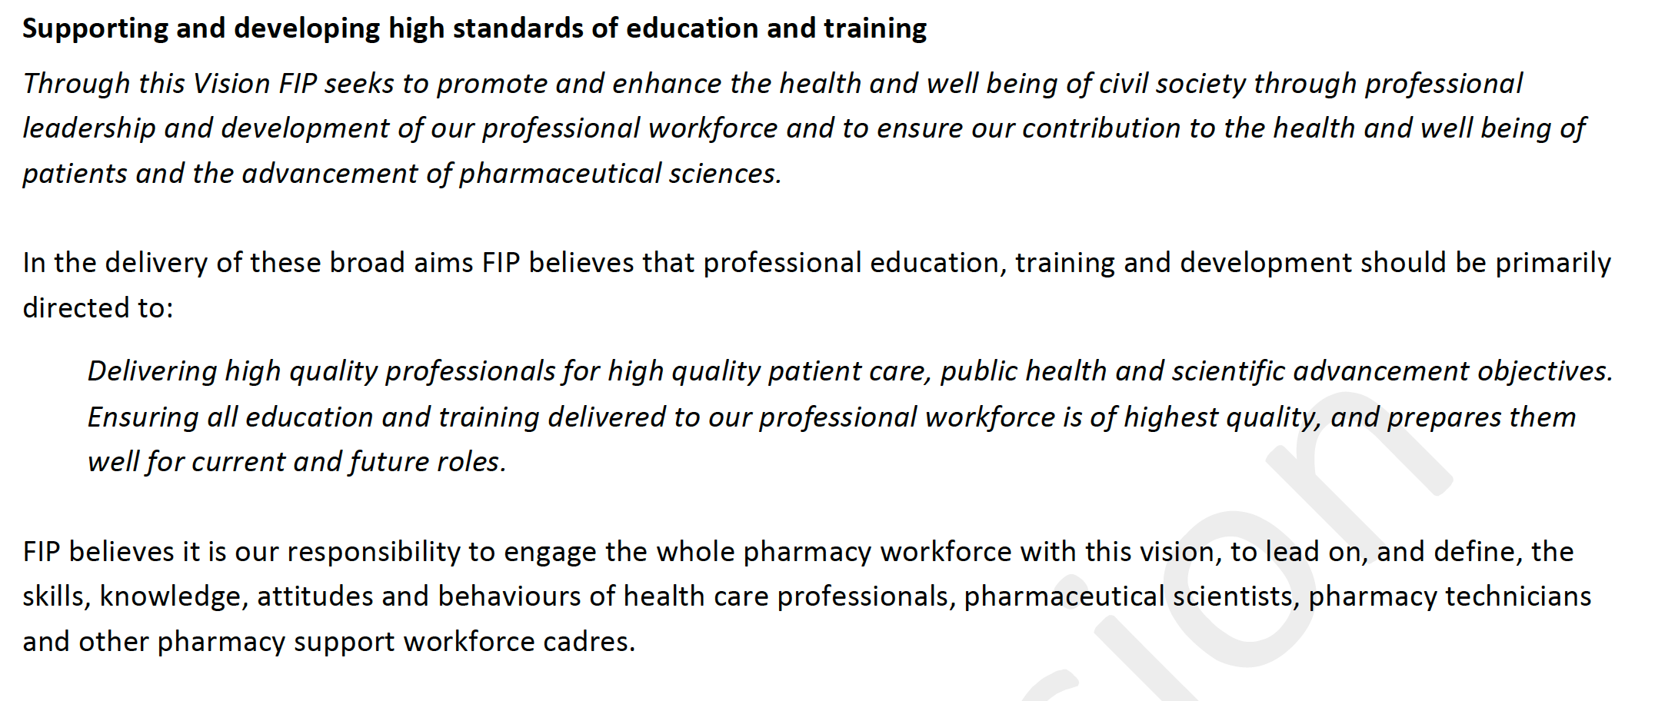

Comments:

EAHP suggests amendment to the final sentence:
“FIP believes it is our responsibility to engage the whole pharmacy workforce with this vision, to lead on, and define, the skills, knowledge, attitudes and behaviours of health care professionals pharmacists in their various settings, pharmaceutical scientists, pharmacy technicians and other pharmacy support workforce cadres staff.”

Developing our Vision for all workforce

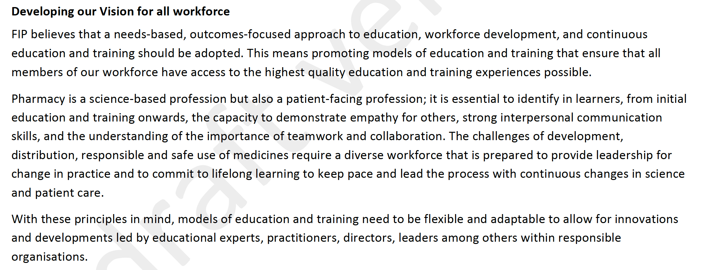

Comments:

EAHP suggests amendment to the heading of this section:

“Developing our Vision for all the pharmacy workforce.

EAHP suggests amendment to the second sentence:

“members of our the pharmacy workforce”

EAHP suggests amendment to the second paragraph:

“and the understanding of the importance of teamwork and collaboration.”

EAHP suggests amendment to the final sentence:

“With these principles in mind, models of education and training need to be flexible to allow for innovation and reflection of emerging scientific and practice developments.”

The global education, training and development context

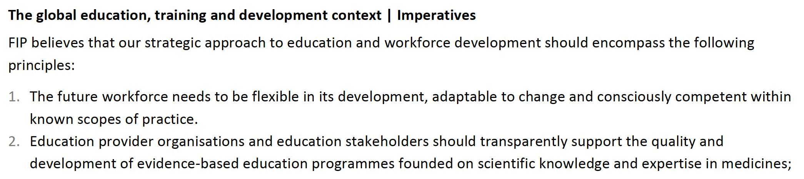

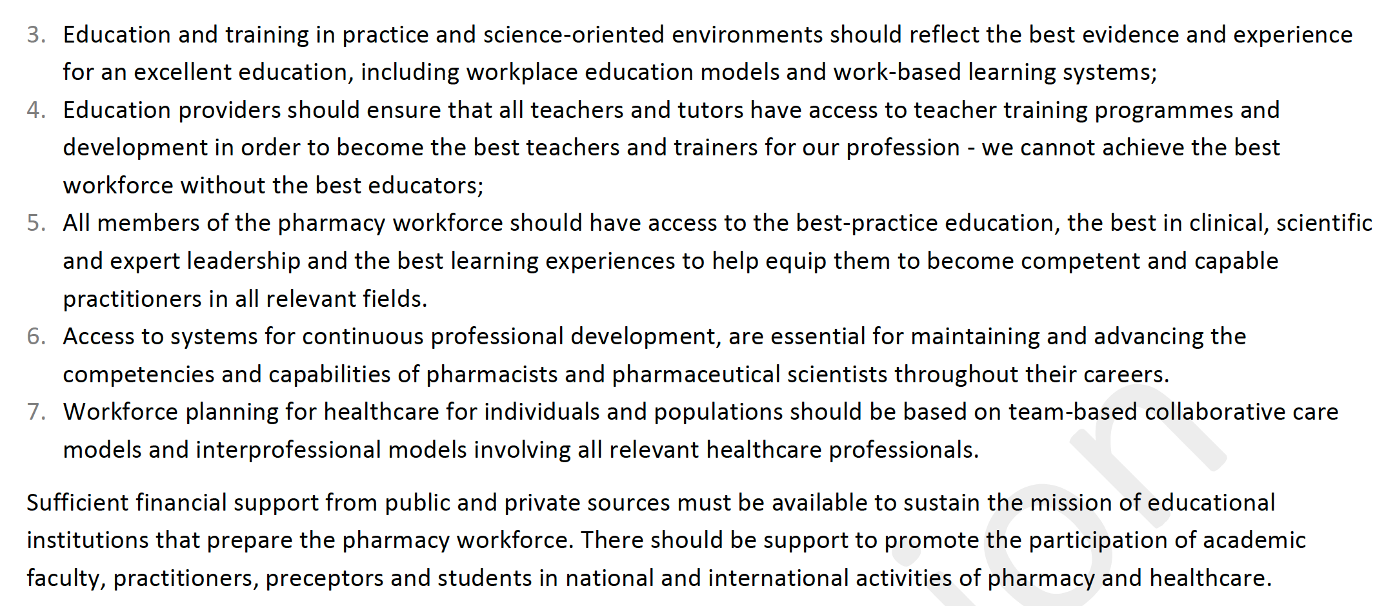

Comments:

EAHP suggests amendment to the heading of this section: “Global education, training and development principles”

EAHP suggests amendment to the first sentence: “should encompass be grounded in the following principles”

EAHP suggests amendment to the penultimate sentence: “educational institutions that prepare the pharmacy workforce and provide continuing professional development opportunities.”

A needs-based approach to workforce and patient care

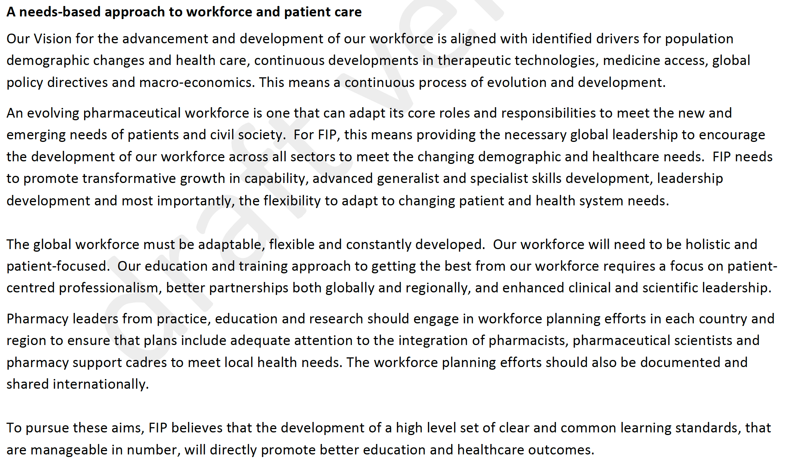

Comments:

EAHP suggests amendment to the penultimate paragraph: “pharmacy support cadre staff”.

“staff” would appear a more commonly understood term than ‘cadre’.

Our commitment: the FIP Vision for the pharmacy workforce

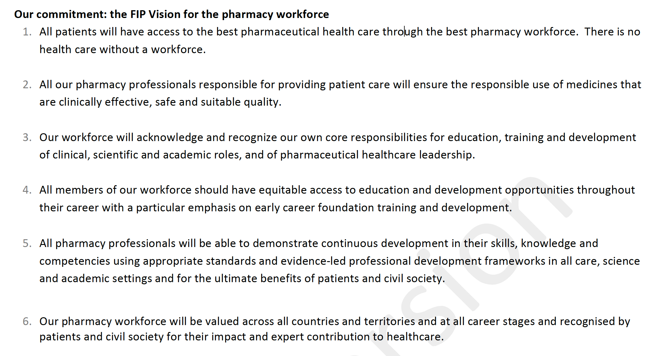
Comments:

It appears unclear at point 5 whether “all pharmacy professionals” includes pharmacy technicians and pharmacy support staff.

The FIP commitment to supporting this Vision

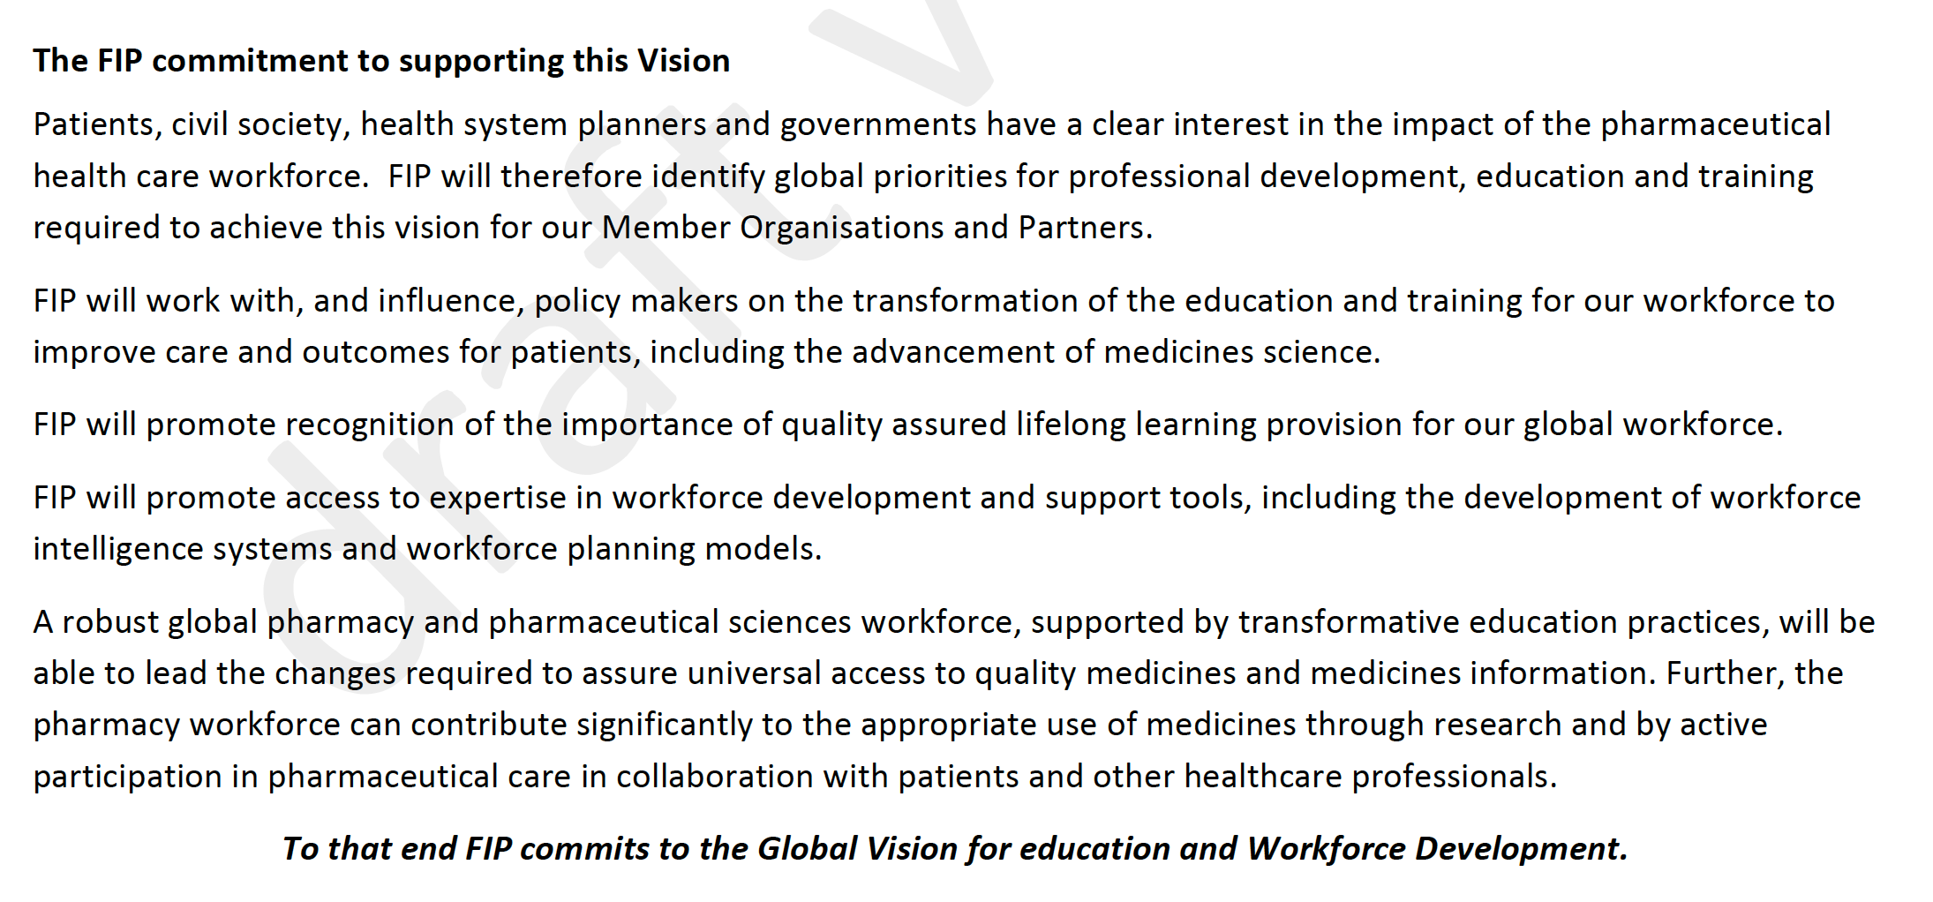

Comments:

EAHP suggests amendment to the first sentence:

“Patients, civil society, health system planners, governments and the healthcare professionals we work with, have a clear interest in the impact of the pharmaceutical health care workforce.”

EAHP suggests amendment to the second sentence:

“required to achieve this vision for our Member Organisations and Partners.”

EAHP suggests amendment to the final sentence:

“to that end FIP, its Member Organisations and partners, commits to this Global Vision for education and Workforce Development.”

